Regression analysis is a conceptually simple method for investigating functional relationships among variables.

The predictor or explanatory variables are also called by other names such as independent variables, covariates, regressors, factors, and carriers.

STEPS IN REGRESSION ANALYSIS
Regression analysis includes the following steps:
• Statement of the problem
• Selection of potentially relevant variables
• Data collection
• Model specification
• Choice of fitting method
• Model fitting
• Model validation and criticism
• Using the chosen model(s) for the solution of the posed problem.

next step after the statement of the problem is to select a set of variables that are thought by the experts in the area of study to explain or predict the response variable.

If all predictor variables are qualitative, the techniques used in the analysis of the data are called the analysis of variance techniques. Although the analysis of variance techniques can be introduced and explained as methods in their own right, it is shown in Chapter 5 that they are special cases of regression analysis. If some of the predictor variables are quantitative while others are qualitative, regression analysis in these cases is called the analysis of covariance.

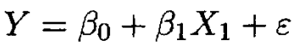
Linear function:

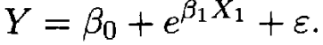
while a nonlinear function is:

Note that the term linear (nonlinear) here does not describe the relationship between Y and X_{l}, X₂,· .. ,X_{p}. It is related to the fact that the regression parameters enter the equation linearly (nonlinearly). Each of the following models are linear:
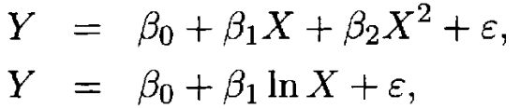

because in each case the parameters enter linearly although the relationship between Y and X is nonlinear.

All non-linear functions that can be transformed into linear functions are called linearizable functions. Accordingly, the class of linear models is actually wider than it might appear at first sight because
it includes alllinearizable functions. Note, however, that not all nonlinear functions are linearizable.

some authors refer to nonlinear functions that are not linearizable as intrinsically nonlinear functions.

In certain applications the response variable can actually be a set of variables, Y_{I} , Y₂,· .., Y_{q} , say, which are thought to be related to the same set of predictor
variables, X_{l}, X₂, ..., X_{p.}

When we deal only with one response variable, regression analysis is called univariate regression and in cases where we have two or more response variables, the regression is called multivariate regression.

In this book we will deal mainly with the least squares method and its variants (e.g., weighted least squares). In some instances (e.g., when one or more of the assumptions does not hold) other estimation methods may be superior to least squares. The other estimation methods that we consider in this book are the maximum likelihood method, the ridge regression, and the principal components method.

It is generally not recommended to predict the response variable for a set of values of the predictor variables far outside the range of our data.

The validity of a statistical method, such as regression analysis, depends on certain assumptions. Assumptions are usually made about the data and the model. The accuracy of the analysis and the conclusions derived from an analysis depends crucially on the validity of these assumptions. Before using (1.5) for any purpose, we first need to determine whether the specified assumptions hold. We need to address the following questions:
1. What are the required assumptions?
2. For each of these assumptions, how do we determine whether or not the assumption is valid?
3. What can be done in cases where one or more of the assumptions does not hold?

We emphasize here that validation of the assumptions must be made before any conclusions are drawn from the analysis. Regression analysis is viewed here as a iterative process, a process in which the outputs are used to diagnose, validate, criticize, and possibly modifythe inputs. The process has to be repeated until a satisfactory output has been obtained. A satisfactory output is an estimated model that satisfies the assumptions and fits the data reasonably well. This iterative process is illustrated schematically in Figure 1.1. This dynamic iterative regression process can be implemented with the aid of the flowchart in Figure 1.2.

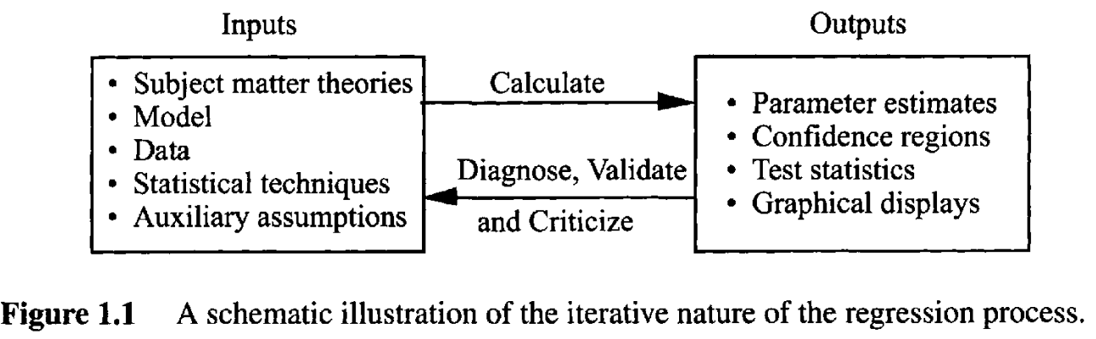

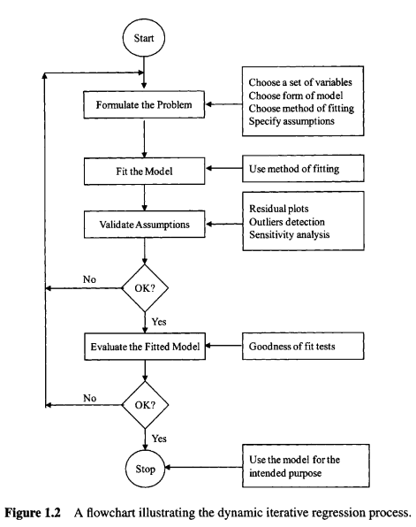

The explicit determination of the regression equation is the most important product of the analysis. It is a summary of the relationship between Y (the response variable) and the set of predictor variables X_{l}, X₂,... ,X_{p}. The equation may be used for several purposes. It may be used to evaluate the importance of individual predictors, to analyze the effects of policy that involves changing values of the predictor variables, or to forecast values of the response variable for a given set of predictors. Although the regression equation is the final product, there are many important by-products. We view regression analysis as a set of data analytic techniques that are used to help understand the interrelationships among variable in a certain environment. The task of regression analysis is to learn as much as possible about the environment reflected by the data. We emphasize that what is uncovered along the way to the formulation ofthe equation may often be as valuable and informative as the final equation.

Suppose we have observations on n subjects consisting of a dependent or response variable Y and an explanatory variable X. We wish to measure both the direction and the strength of the relationship between Y and X. Two related measures, known as the covariance and the correlation coefficient.

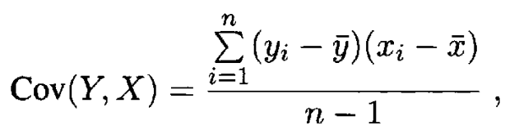

Covariance indicates the direction of the linear relationship between Y and X. If Cov(Y, X) > 0, then there is a positive relationship between Y and X, but if Cov(Y, X) < 0, then the relationship is negative. Unfortunately, Cov(Y, X) does not tell us much about the strength of such a relationship because it is affected by changes in the units of measurement. For example, we would get two different values for the Cov(Y, X) ifwe report Y and/or X in terms of thousands of dollars instead of dollars. To avoid this disadvantage of the covariance, we standardize the data before computing the covariance. To standardize the Y data, we first subtract the mean from each observation then divide by the standard deviation. We compute:
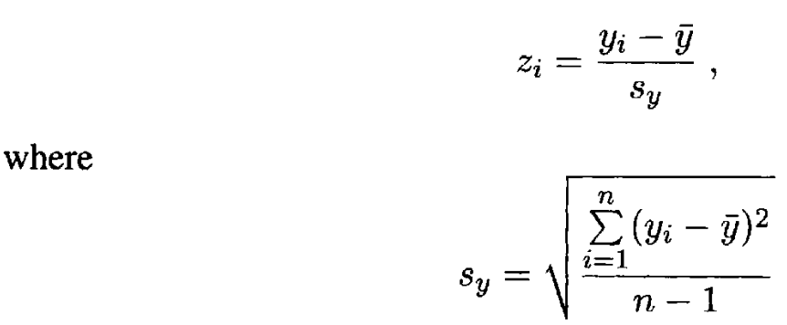

is the sample standard deviation of Y. It can be shown that the standardized variable Z has mean zero and standard deviation one. We standardize X in similar way by subtracting the mean from each observation X_{i} and then divide by the standard deviation S_{X}. The covariance between the standardized X and Y data is known as the correlation coefficient between Y and X and is given by
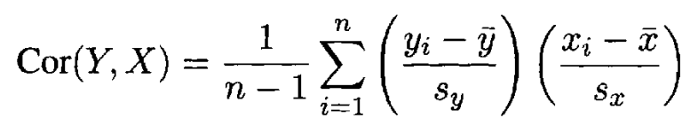

=
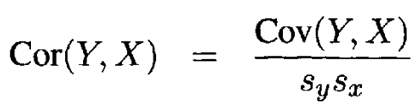

=
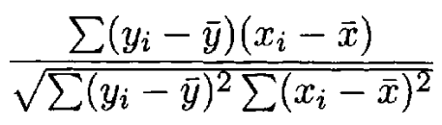

Thus, Cor(Y, X) can be interpreted either as the covariance between the standardized variables or the ratio of the covariance to the standard deviations of the two variables.
The correlation coefficient is symmetric, that is, Cor(Y, X) = Cor(X, Y).
Unlike Cov(Y, X), Cor(Y, X) is scale invariant, that is, it does not change if we change the units of measurements. Furthermore, Cor(Y, X) satisfies:
-1 ≤ Cor(Y, X) ≤ 1
These properties make the Cor(Y, X) a useful quantity for measuring both the direction and the strength of the relationship between Y and X. The magnitude of Cor(Y, X) measures the strength of the linear relationship between Y and X. The closer Cor(Y, X) is to 1 or -1, the stronger is the relationship between Y and X. The sign of Cor(Y, X) indicates the direction of the relationship between Y and X.
That is, Cor(Y, X) > 0 implies that Y and X are positively related. Conversely, Cor(Y, X) < 0 implies that Y and X are negatively related. Note, however, that Cor(Y, X) = 0 does not necessarily mean that Y and X are not related. It only implies that they are not linearly related because the correlation coefficient measures only linear relationships. In other words, the Cor(Y, X) can still be zero when Y and X are nonlinearly related.
Furthermore, like many other summary statistics, the Cor(Y, X) can be substantially influenced by one or a few outliers in the data. To emphasize this point, Anscombe (1973) has constructed four data sets, known as Anscombe quartet, each with a distinct pattern, but each having the same set of summary statistics (e.g., the same value of the correlation coefficient). The data and graphs are reproduced
in Table 2.4 and Figure 2.3. The data can be found at the book's Website. An analysis based exclusively on an examination of summary statistics, such as the correlation coefficient, would have been unable to detect the differences in patterns.
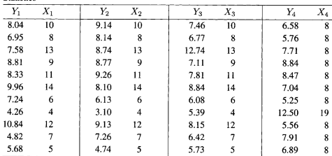

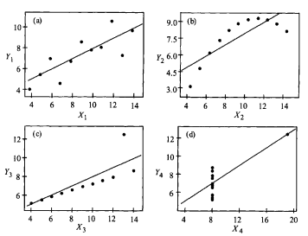

Before drawing conclusions from this value of Cor(Y, X), we should examine the corresponding scatter plot of Y versus X.

Although Cor(Y, X) is a useful quantity for measuring the direction and the strength of linear relationships, it cannot be used for prediction purposes, that is, we cannot use Cor(Y, X) to predict the value of one variable given the value of the other. Furthermore, Cor(Y, X) measures only pairwise relationships. Regression analysis, however, can be used to relate one or more response variable to one or more predictor variables. It can also be used in prediction. Regression analysis is an attractive extension to correlation analysis because it postulates a model that can be used not only to measure the direction and the strength of a relationship between the response and predictor variables, but also to numerically describe that relationship.

Regression analysis differs in an important way from correlation analysis. The correlation coefficient is symmetric in the sense that Cor(Y, X) is the same as Cor(X, Y). The variables X and Y are of equal importance. In regression analysis the response variable Y is of primary importance. The importance of the predictor X lies on its ability to account for the variability of the response variable Y and not in itself per se. Hence Y is of primary importance.

We estimate the parameters using the popular least squares method, which gives the line that minimizes the sum of squares of the vertical distances from each point to the line.

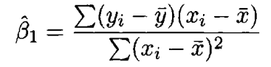
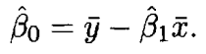

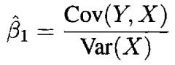
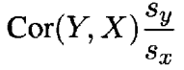

Note that a least squares line always exists because we can always find a line that gives the minimum sum of squares of the vertical distances. In fact, as we shall see later, in some cases a least squares line may not be unique. These cases are not common in practice.

These vertical distances are called the ordinari least squares residuals. One property of the residuals is that their sum is zero. This means that the sum of the distances above the line is equal to the sum of the distances below the line.

It can be seen that , Cov(Y, X), and Cor(Y, X) have the same sign. This makes intuitive sense because positive (negative) slope means positive (negative) correlation.

So far in our analysis we have made only one assumption, namely, that Y and X are linearly related. This assumption is referred to as the linearity assumption. This is merely an assumption or a hypothesis about the relationship between the response and predictor variables. An early step in the analysis should always be the validation of this assumption. We wish to determine if the data at hand support the assumption that Y and X are linearly related. An informal way to check this assumption is to examine the scatter plot of the response versus the predictor variable, preferably drawn with the least squares line superimposed on the graph. If we observe a nonlinear pattern, we will have to take corrective action. For example, we may reexpress or transform the data before we continue
the analysis.
If the scatter of points resembles a straight line, then we conclude that the linearity assumption is reasonable and continue with our analysis. The least squares estimators have several desirable properties when some additional assumptions hold. The required assumptions are stated in Chapter 4. The validity of these assumptions must be checked before meaningful conclusions can be reached from the analysis. Chapter 4 also presents methods for the validation of these assumptions. Using the properties of least squares estimators, one can develop statistical inference procedures (e.g., confidence interval estimation, tests of hypothesis, and goodness-of-fit tests).

As stated earlier, the usefulness of X as a predictor of Y can be measured informally by examining the correlation coefficient and the corresponding scatter plot of Y versus X. A more formal way of measuring the usefulness of X as a predictor of Y is to conduct a test of hypothesis about the regression parameter (31. Note that the hypothesis (β1 = 0 means that there is no linear relationship between Y and X. A test of this hypothesis requires the following assumption. For every fixed value of X, the errors are assumed to be independent random quantities normally distributed with mean zero and a common variance σ². With these assumptions, the quantities, and are unbiased estimates of β⁰ and β¹, respectively. Their variances are:
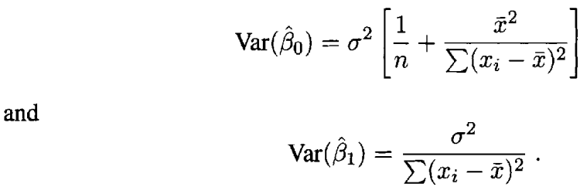

Furtherrmore, the sampling distributions of the least squares estimates and are normal with means β0 and β1 and variance as given respectively.
The variances of and depend on the unknown parameter σ². So, we need
to estimate σ² from the data. An unbiased estimate of σ² is given by:

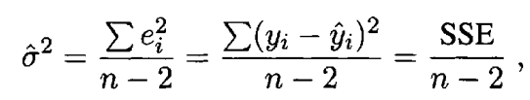

where SSE is the sum of squares of the residuals (errors). The number n-2 in the denominator of is called the degrees of freedom (df). It is equal to the number of observations minus the number of estimated regression coefficients.
Replacing σ² by ² , we get unbiased estimates of the variances of and . An estimate of the standard deviation is called the standard error (s.e.) of the estimate. Thus, the standard errors of and :
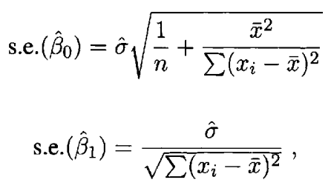

respectively, where is the square root of ² . The standard error of is a measure of how precisely the slope has been estimated. The smaller the standard error the more precise the estimator.
With the sampling distributions of and , we are now in position to perform statistical analysis concerning the usefulness of X as a predictor of Y. Under the normality assumption, an appropriate test statistic for testing the null hypothesis Ho : β1 = 0 against the alternative HI : β1 ≠ 0 is the t-Test:
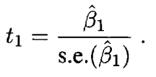

The t statistic t_{l} is distributed as a Student's t with n - 2 degrees of freedom. The test is carried out by comparing this observed value with the appropriate critical value obtained from the t-table, which is t(n-2,α/2), where α is a specified significance level. Note that we divide α by 2 because we have a two-sided alternative hypothesis. Accordingly, H_{o} is to be rejected at the significance level α if

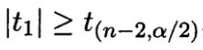

where |t₁| denotes the absolute value of t_{l}. A criterion equivalent to that is to compare the p-value for the t-Test with α and reject H_{o} if
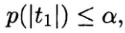

where p(|t_{l}|) , called the p-value, is the probability that a random variable having a Student t distribution with n-2 degrees of freedom is greater than |t_{l}| (the absolute value of the observed value of the t-Test).

Testing H_{o}: β1= β⁰_{1:}
The above t- Test can be generalized to test the more general hypothesis H_{o}: β₁= β⁰_{1,} where β⁰₁ is a constant chosen by the investigator, against the two-sided alternative H_{I}: β₁≠ β⁰₁. The appropriate test statistic in this case is the t- Test.

