Words not occurred:

khat
anabolic steroids
metanfetamina
drone
amphetamines
cocaína
narco trafficking
ketamine
traficar drogas
meow meow
crystal meth
pregabalin
4-mmc
4-methyl methcathinone
ecstasy
methylamphetamine
narca
el tráfico de drogas
psilocybin
lsd
pwid
narcotics traffickers
el sporífero
drug dealing
mephedrone
dealing drugs
phencyclidine
ghb
m-cat
drug abuse
benzodiazepines
bath salts
psilocyn
nicotine
narco
white magic
narcóticos
buprenorphine
magic mushrooms
substance abuse
opiate
mdma

Plot for each word occurrence [before delete duplicate rows].
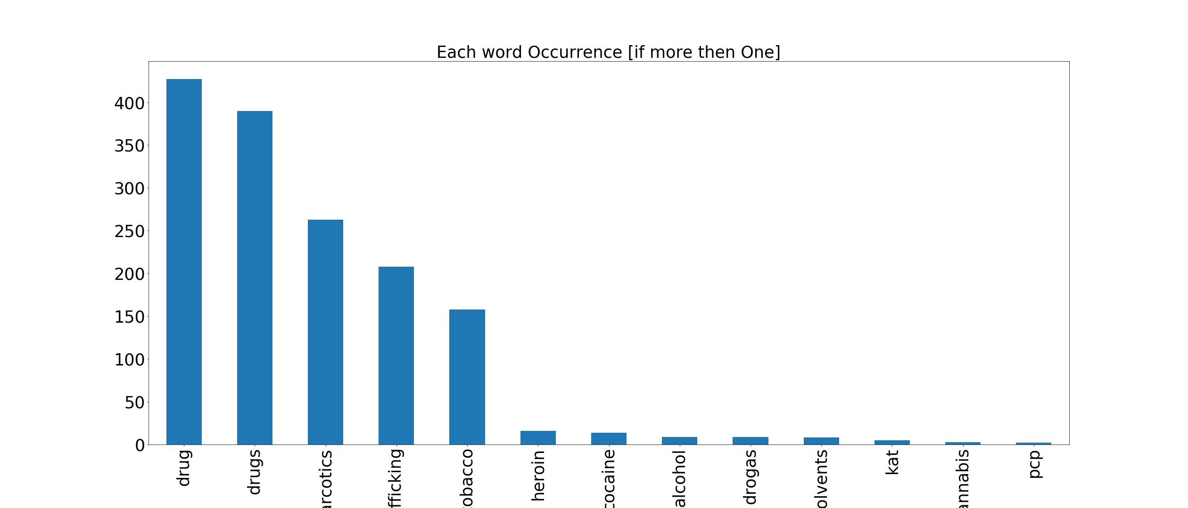

Plot for each word occurrence [after delete duplicate rows].
