**Name: Amir Sarfraz**

**Roll no: 22-11016**

**Test Report**

**The following program was tested:**

package testing;

public class JunitTesting {

public int square(int x) {

return x*x;

}

public int doubl(int x, int y) {

return x+x;

}

public int substract(int x, int y) {

return x-y;

}

public int devide(int x, int y) {

return x/y;

}

public int modulus(int x, int y) {

return x%y;

}

}

**The following were the test cases:**

package testing;

import static org.junit.Assert.*;

import org.junit.Test;

public class substractTest {

@Test

public void test() {

JunitTesting test = new JunitTesting();

int output = test.substract(5,5);

assertEquals(0, output);

}

}

public class devideTest {

@Test

public void test() {

JunitTesting test = new JunitTesting();

int output = test.devide(6,2);

assertEquals(3, output);

}

}

public class modulusTest {

@Test

public void test() {

JunitTesting test = new JunitTesting();

int output = test.modulus(2,2);

assertEquals(0, output);

}

}

public class squareunit {

@Test

public void test() {

JunitTesting test = new JunitTesting();

int output = test.square(5);

assertEquals(25, output);

}

}

public class doublTest {

@Test

public void test() {

JunitTesting test = new JunitTesting();

int output = test.doubl(5,5);

assertEquals(10, output);

}

}

package testing;

import org.junit.runner.RunWith;

import org.junit.runners.Suite;

import org.junit.runners.Suite.SuiteClasses;

@RunWith(Suite.class)

@SuiteClasses({ devideTest.class, doublTest.class, modulusTest.class, squareunit.class, substractTest.class })

public class AllTests {

}

}

}

SCREENSHOTS OF TEST CASES RUNNING AND SUCCESFULLY TESTING THE UNITS

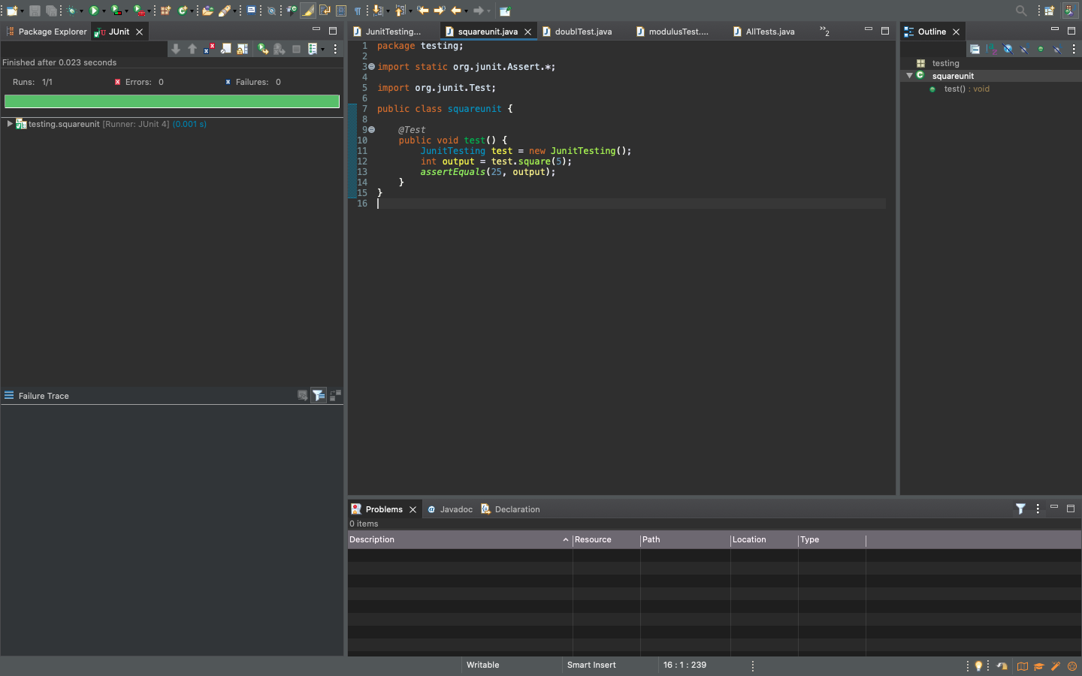

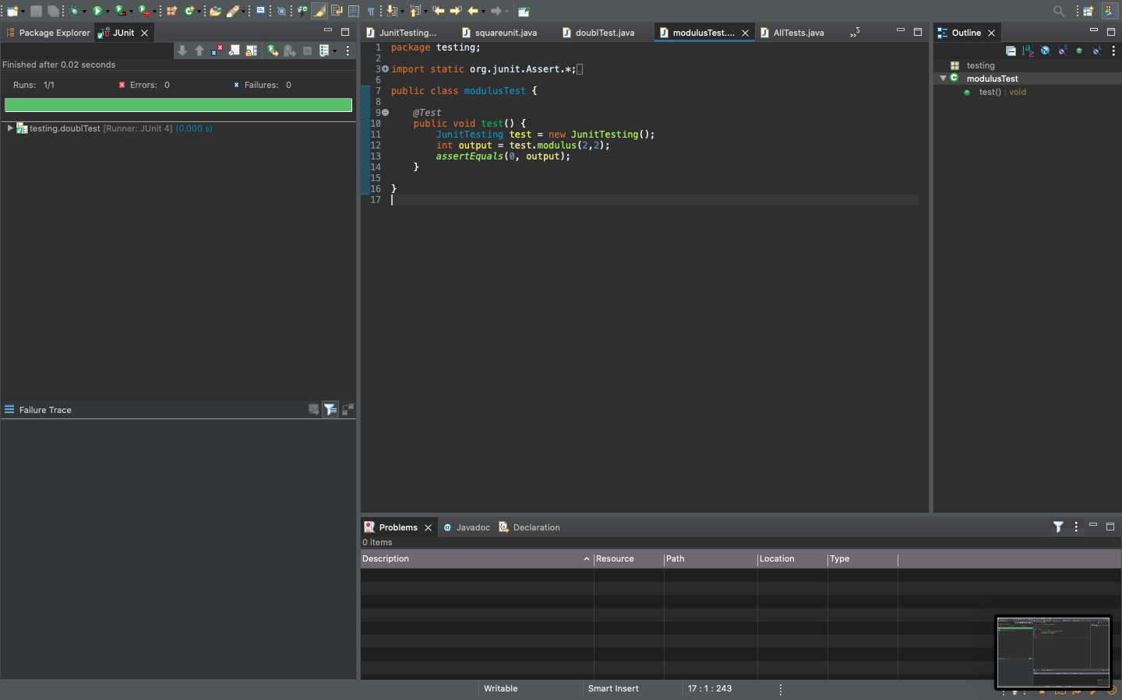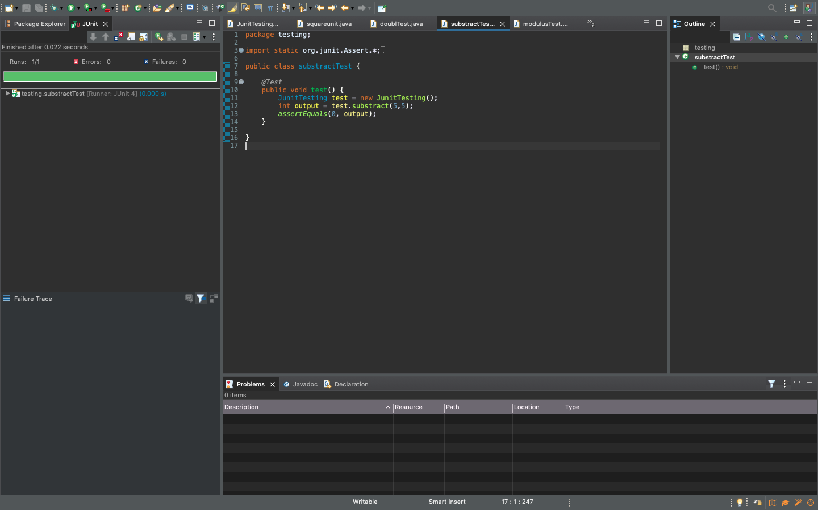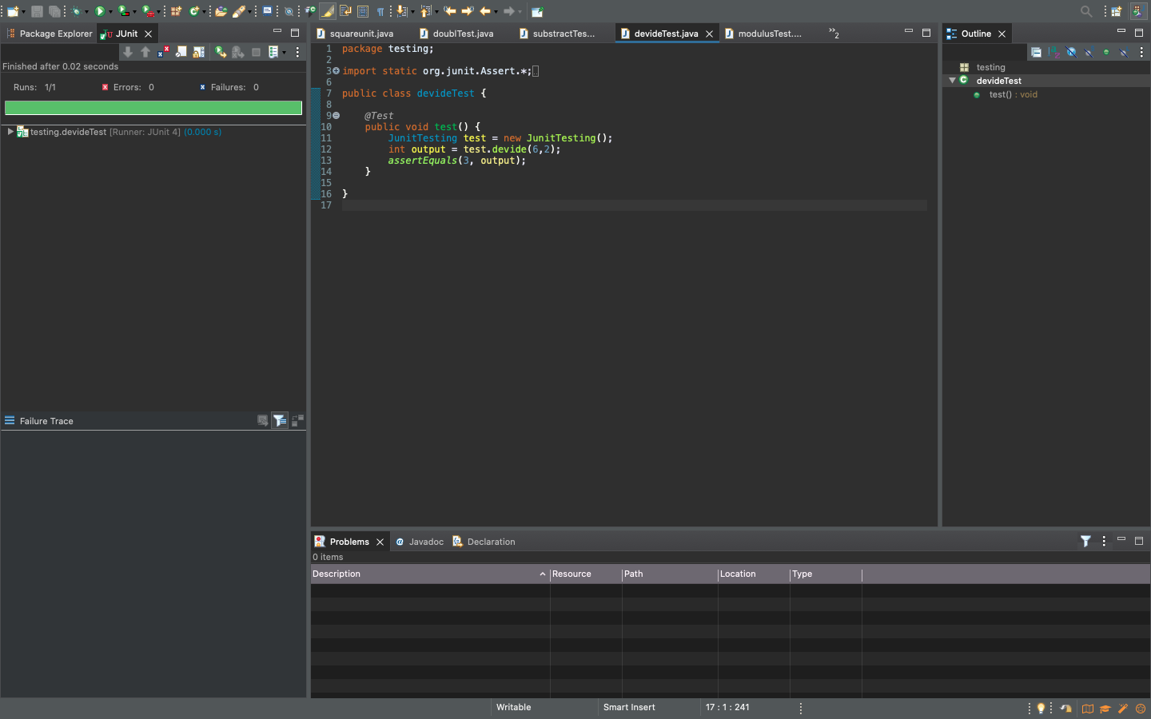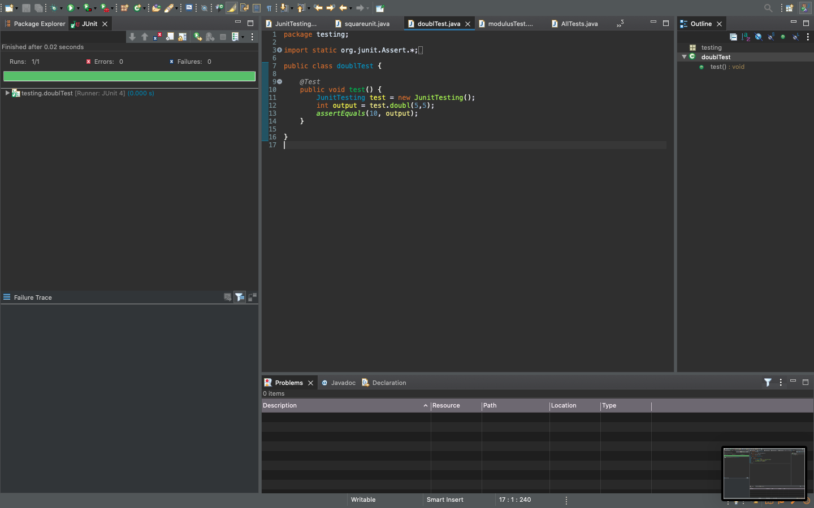

**All the test cases running and being tested together:**

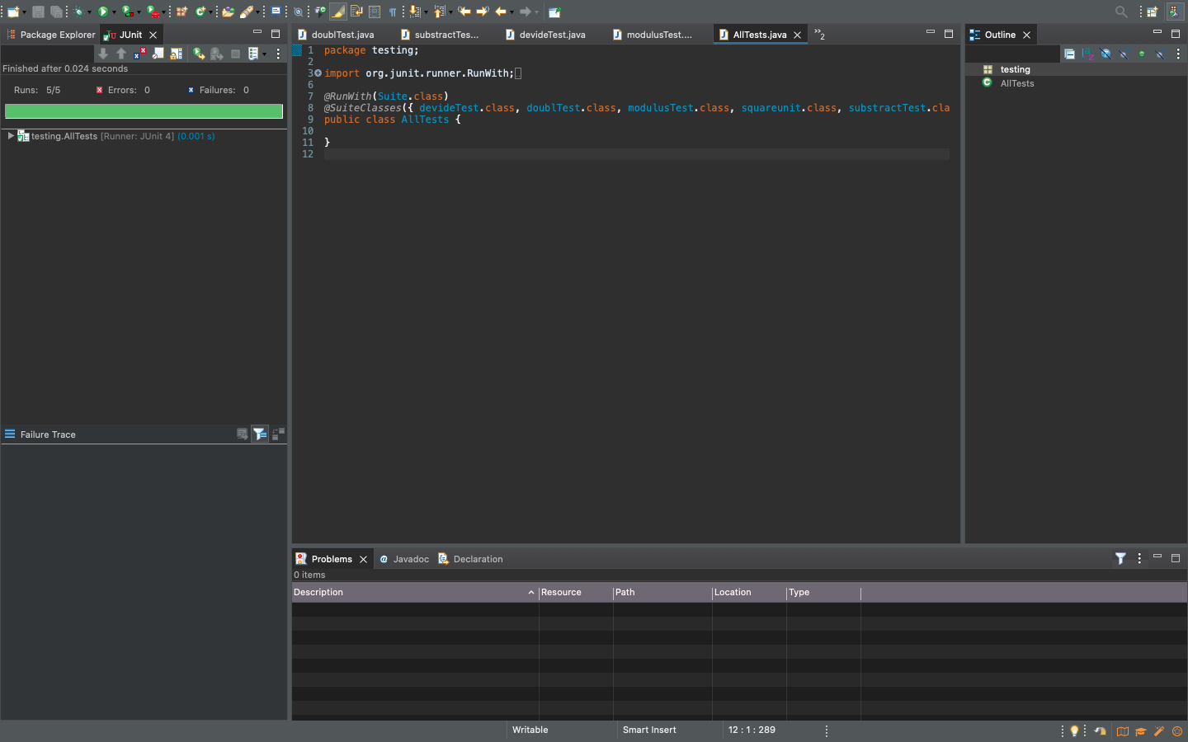

**As we can see that the eclipse shows in the upper left corner that 5 Out of 5 operations executed/run (Runs: 5/5 )**