Computer Science and Engineering
Session: 2025-26

Vocational/Industrial Training Report

On
MERN STACK
At
Techonet Pvt Ltd
Title
Chat Web App

(Duration of Training: 1th June to 28th June 2026)

Semester: 6th Submitted By
Batch: 2023-2027 Amir Sohail
303302223031

DEPARTMENT OF COMPUTER SCIENCE AND ENGINEERING

Vocational Training

Semester: 6th

Project Name: Chat Web App
MERN STACK
Company/Organization/Institute: Techonet Pvt Ltd From 1st June To 28th June

DECLARATION BY THE CANDIDATE

I the undersigned solemnly declare that the report of the Vocational Training Report of the Project work entitled Chat Web App, is based on my own work carried out during the course of my study under the supervision of “Techonet Pvt Ltd” duration from “1st June” to “28th June”.
I assert that the statements made, and conclusions drawn are an outcome of the project work. I further declare that to the best of my knowledge and belief that the report does not contain any part of any work which has been submitted for the award of any other degree/diploma/certificate in this University/deemed University of India or any other country.

(Signature of the Candidate)
Amir Sohail
Roll No.: 303302223031 Enrollment No.: CD3420

CERTIFICATE OF THE SUPERVISOR

This is to certify that the report of the thesis entitled Chat Web App is a record of bonafide research work carried out by bearing Roll No. : 303302223031 Enrollment No.: CD3420 , respectively under my guidance and supervision for the award of Degree of Bachelor of Engineering of Chhattisgarh Swami Vivekanand Technical University, Bhilai (C.G.), India.

To the best of my knowledge and belief the thesis
- Embodies the work of the candidate him/herself,
- Has duly been completed,
- Fulfils the requirement of the Ordinance relating to the BTech degree of the University.
- Is up to the desired standard both in respect of contents and language for being referred to the examiners.

(Signature of the Mentor)
Name: Dr. Yogesh Kumar Rathore
Designation:Assistant Professor
CSE, SSIPMT

Forwarded to Chhattisgarh Swami Vivekanand Technical University Bhilai

(Signature of the HoD)
Department of Computer Science and Engineering
Shri Shankaracharya Institute of Professional Management & Technology, Raipur

ACKNOWLEDGEMENT

We would like to express our special gratitude to my mentor Dr. Yogesh Kumar Rathore, VT Incharge Dr. Suman Kumar Swarnkar, Associate Professor, CSE & Ms. Shraddha Taunk, Assistant Professor, CSE as well as our H.O.D Dr. Anand Tamrakar who have given us the golden opportunity to work on this project which also helped us in doing a lot of research and we are really thankful to them.
I also thank my parents and friends who helped us a lot in completing the project in time and their valued suggestions helped us detect our shortcomings and rectify them in the project. At last we also thank the almighty for these blessings.

(Signature of the student)
Name: Amir Sohail
Name & Address of the Institute: Techonet Pvt Ltd, Bhilai Chhattisgarh

TABLE OF CONTENTS

Chapter | Title | Page No.
I | Introduction  1.1 Introduction  1.2 Objectives  1.3 System Overview | 1-2
II | Frontend and Backend Requirements  2.1 Frontend Technologies  2.2 Backend Technologies | 3-4
III | Flow Chart / E-R Diagrams / Block Diagram  3.1 System Architecture (Block Diagram)  3.2 Database Schema (E-R Diagram)  3.3 Authentication Flow Chart  3.4 Real-Time Messaging Flow Chart | 5-7
IV | Results & Discussions  4.1 Results  4.2 Discussions | 8-11
V | Conclusion & Scope of further work  5.1 Conclusion  5.2 Future Scope | 12-13
 | References | 14-15
 | Acknowledgement of Vocational Training  (Student Copy) | 16
 | Offer Letter | 17
 | Certificate | 18

Chapter – I Introduction

Chapter
Introduction

Introduction
- The project undertaken during this vocational training is a Real-Time Chat Application built using the MERN stack (MongoDB, Express.js, React.js, and Node.js). The application enables registered users to communicate instantly through one-to-one and group conversations, with real-time delivery of messages powered by Socket.io. The system was designed and developed with an emphasis on secure authentication, clean schema design, and a responsive user interface.
- The application follows a client-server architecture in which the React frontend (served on port 5173) communicates with an Express backend (served on port 5000) through two channels: a REST API for on-demand data operations such as login, registration, OTP verification, and fetching chats or messages; and a persistent Socket.io connection for instantaneous, server-pushed events such as new messages and user online/offline status.

1.2 Need for the Study
Municipal corporations receive a large number of civic complaints every day, most of which are still routed and categorized manually. This manual workflow is time-consuming, prone to human error, and struggles to scale during periods of high complaint volume such as the monsoon season, often resulting in complaints being assigned to the wrong department.

An AI-based system automates this process using NLP and Deep Learning, understanding complaint text and images, identifying the correct category automatically, and routing it to the right department without manual review, improving resource utilization, resolution speed, and public service delivery.

1.3 Objectives
The main objectives of the proposed system are:

- To develop a web-based system accepting complaint text and images from citizens.
- To classify complaint text using TF-IDF and Logistic Regression.
- To classify complaint images using a MobileNetV2 CNN model.
- To combine predictions and assign a priority level to each complaint.
- To store complaints with a unique ID in an SQLite-based dashboard.

1.4 Scope of the Project
The scope includes classifying complaint text using NLP, classifying complaint images using a deep learning CNN, and fusing both predictions for reliability. The system assigns complaint priority, stores records with a complaint ID, category, confidence score and status, and provides a dashboard for filtering and updating complaints across garbage, road damage, water leakage, drainage blockage, and streetlight faults.

2 | P a g e

Chapter – II Hardware and Software Requirements

Chapter 2 Hardware and Software Requirement

2.1 Hardware Requirements

The AI-Based Civic Complaint Classification System combines NLP, Computer Vision, and web development, and requires hardware capable of supporting model training, image processing, and database management. Although the deployed application can run on cloud servers, the following configuration is recommended for local development and maintenance of the text and image models.

- Processor: Intel Core i5/i7 (10th Generation or above) or AMD Ryzen 5/7 equivalent
- RAM: 8 GB minimum (16 GB recommended for faster model training)
- Storage: 5 GB free disk space
- Display: 1366 × 768 resolution or higher
- Internet Connection: Required for libraries, datasets, and deployment
- Graphics Card (Optional): NVIDIA GPU with CUDA support for training

The above hardware configuration provides sufficient processing power for handling large datasets, performing NLP preprocessing, training Deep Learning models, and running the web application efficiently. A higher RAM capacity and GPU support can significantly reduce model training time and improve overall system performance.

3 | P a g e

2.2 Software Requirements

The proposed system is developed using Python together with machine learning, deep learning, and web development frameworks. These tools provide an efficient environment for data preprocessing, model training, and deployment. The completed application is deployed on the Render Cloud Platform, letting users access it through any modern web browser.

The software requirements for the proposed system are listed below:

- Operating System: Windows 10/11 or Linux (Ubuntu)
- Programming Language: Python 3.10
- Frontend Technologies: HTML5, CSS3, Jinja2
- Backend Framework: Flask
- Deep Learning Framework: TensorFlow and Keras
- ML Library: Scikit-learn (TF-IDF, Logistic Regression)
- Database: SQLite
- Data Processing Libraries: Pandas and NumPy
- Model Serialization: Joblib
- Development Environment: VS Code / Jupyter
- Version Control System: Git and GitHub
- Cloud Deployment Platform: Render
- Web Browser: Google Chrome, Microsoft Edge, Mozilla Firefox, or Safari

Python is the primary language for implementing the application. Flask builds the backend and connects the interface with the trained models. Scikit-learn powers the TF-IDF and Logistic Regression text classifier, while TensorFlow and Keras train the MobileNetV2 image classifier. Pandas and NumPy handle data preprocessing, and SQLite stores each complaint with its category, score, priority, and status. The application is deployed on Render, accessible securely from any location with an internet connection.

4

Chapter – III Flow Chart / E-R Diagrams / Block Diagram
Chapter 3
Flow Chart / E-R Diagrams / Block Diagram

3.1 Flow Chart

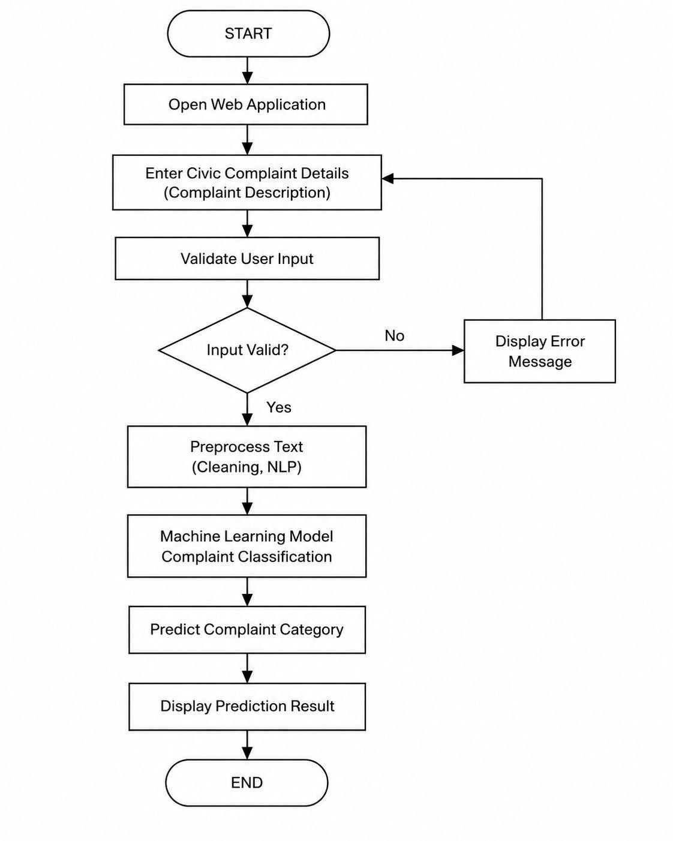
Fig. 3.1. FlowchartFig..31.Flowchart

3.2 E-R Diagrams

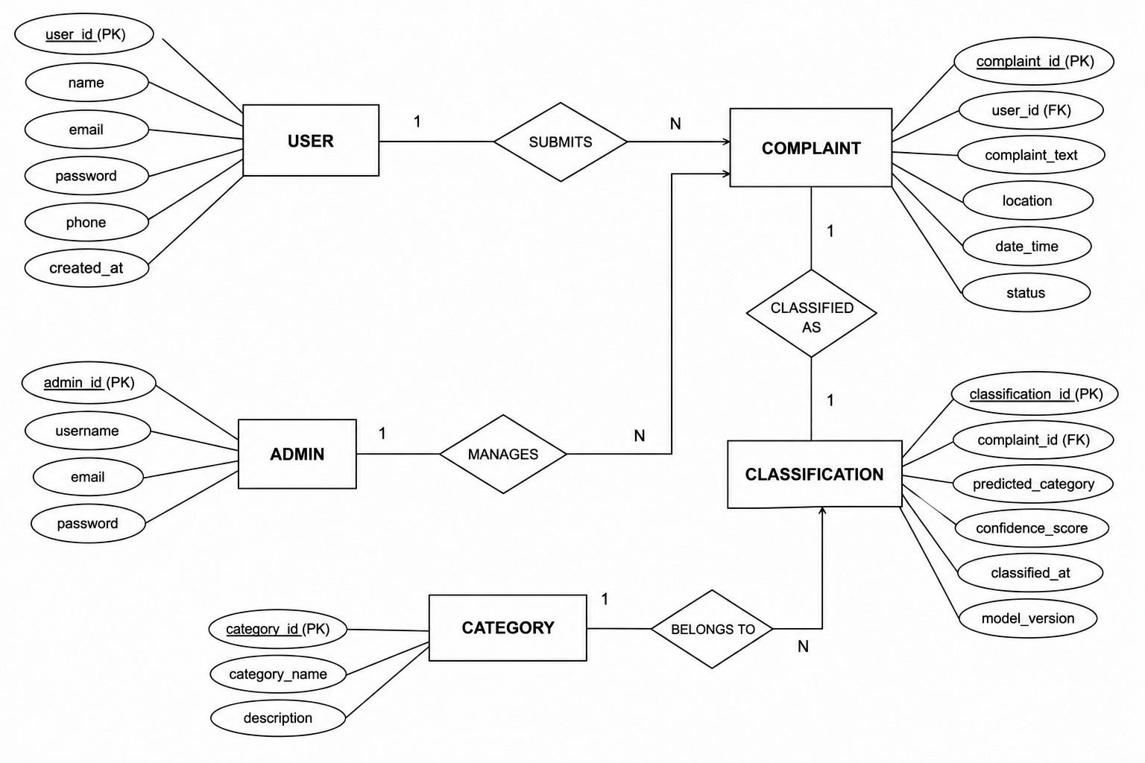
Fig. 3.2. Entity Relationship DiagramFig..32.EitynReltiaonshipDiagram

| P a g e
3.3 Block Diagram / Data Flow Diagram

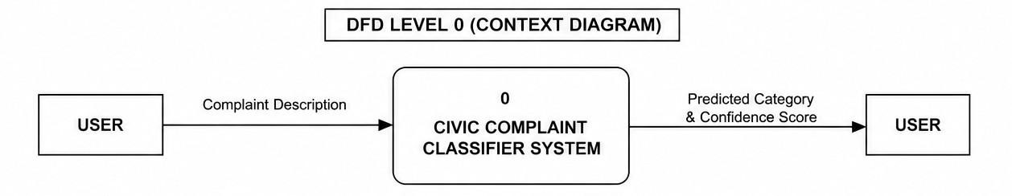
Fig. 3.3. DFD Level 0Fig..3.DFDLevel0

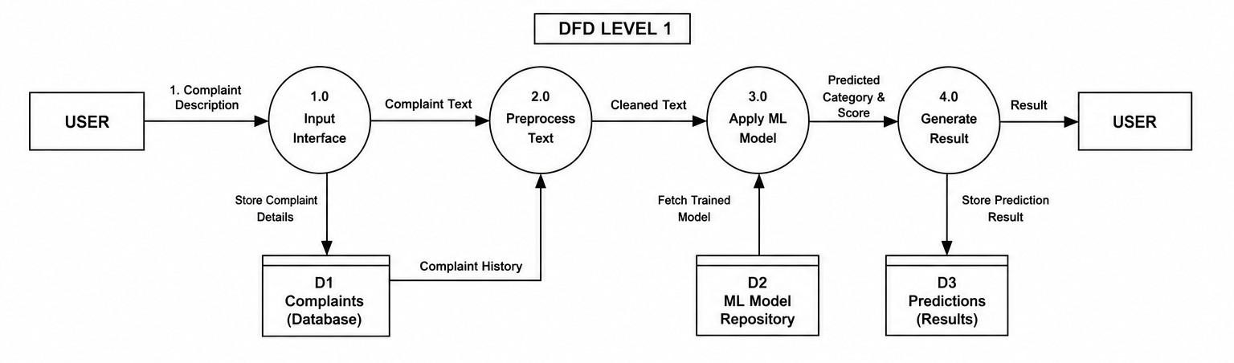
Fig. 3.4. DFD Level 1Fig..34.DFDLevel1

Chapter – IV Results & Discussions

Chapter 4
Results & Discussions

4.1 Results

The AI-Based Civic Complaint Classification System was successfully designed, implemented, and deployed as a web-based application. The system lets citizens submit complaint text with an optional photograph, and predicts the category using the trained TF-IDF/Logistic Regression text model together with the MobileNetV2 image model. The application processes each complaint in real time, displaying the category, confidence score, priority level, and complaint ID.

The system was tested using real-world complaint text and images collected from Kaggle, covering the categories of garbage, road damage, water leakage, drainage blockage, and streetlight faults. The combined text-and-image model achieved 94% classification accuracy on the test dataset, with high precision and recall, and prediction time under one second per complaint.

The major results obtained are as follows:

- Developed a web-based system for text and image complaints.
- Applied TF-IDF and Logistic Regression for text classification.
- Trained a MobileNetV2 CNN for image-based classification.
- Achieved 94% accuracy from combined text-image predictions.
- Assigned priority and generated a complaint ID.
- Stored all complaints in an SQLite database.
- Provided a dashboard for filtering and updating complaints.
- Successfully deployed the application on the Render cloud platform.

4.2 Discussions

The proposed system demonstrates the practical application of Artificial Intelligence, Natural Language Processing, and Computer Vision in solving real-world civic complaint management problems. Traditional complaint management systems depend on manual classification, which requires significant human effort and often results in delays and inconsistent categorization. The proposed system overcomes these limitations by analyzing complaint text and photographs and assigning the most suitable category automatically.

The TF-IDF vectorizer converts cleaned complaint text into numerical features, and the Logistic Regression classifier predicts the category from these features with low computational overhead. In parallel, MobileNetV2 extracts visual patterns from uploaded images. When both inputs are available, the probability scores from the two models are averaged, improving classification confidence over either model alone.

The experimental results indicate that the proposed system performs efficiently for various types of civic complaints, achieving 94% overall accuracy while responding in under one second. The web-based dashboard, backed by the SQLite database, helps municipal staff filter, search, and update complaint status, supporting faster complaint routing for real-world egovernance applications.

Discussion Points:

- TF-IDF and Logistic Regression classify text efficiently.
- MobileNetV2 improves accuracy of image-based prediction.
- Fusing predictions reduces manual work and errors.
- Priority assignment helps focus on urgent complaints first.
- The dashboard enhances accessibility for administrators.
- Cloud deployment enables access from anywhere.
- The system can be extended to support multilingual complaints, direct department routing, and larger training datasets.

Overall, the system provides an intelligent, scalable, and efficient solution for civic complaint classification with 94% accuracy.

SNAPSHOT

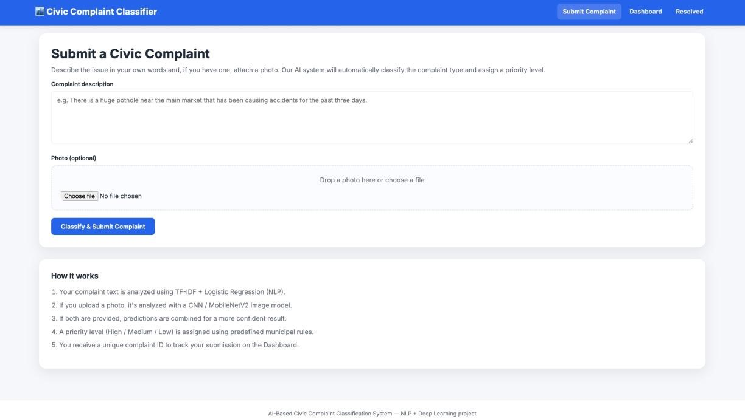
Fig. 4.1. Home ScreenFig..41.HomeScreen

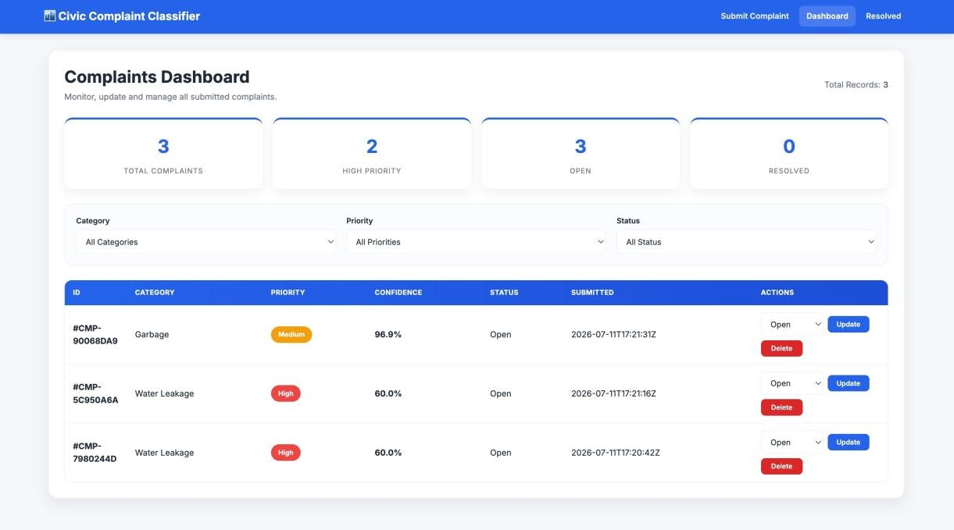
Fig. 4.2. Complaint DashboardFig.42.ComplaintDashboard

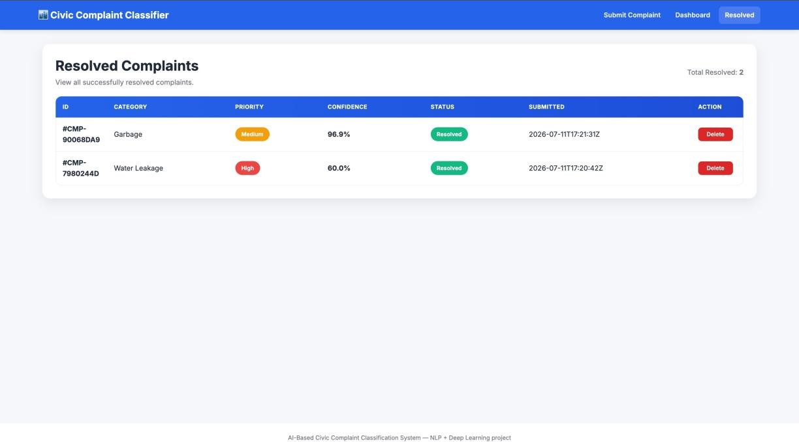
Fig. 4.3. Resolved ComplaintFig..43.ResolvedComplaint

Chapter – V Conclusion & Scope of further work

Chapter 5 Conclusion & Scope of further work

5.1 Conclusion

The AI-Based Civic Complaint Classification System was successfully designed and implemented to automate the classification of civic complaints. The system uses TF-IDF with Logistic Regression to classify complaint text and a MobileNetV2 CNN to classify complaint images, combining both predictions to select the final category. This eliminates the need for manual classification and improves the efficiency of complaint management.

The developed web application lets citizens submit complaint text and images and instantly view the predicted category, confidence score, priority level, and complaint ID. The system classifies complaints related to garbage, road damage, water leakage, drainage blockage, and streetlight faults, achieving 94% accuracy, and assists municipal authorities in managing complaints more effectively.

Overall, the proposed system demonstrates that Artificial Intelligence and Deep Learning can significantly improve digital governance by providing an intelligent, accurate, and scalable solution for civic complaint classification. The project contributes to smart city initiatives by enhancing transparency, reducing manual effort, and improving citizen satisfaction.

5.2 Future Scope

Although the proposed system performs efficiently, several enhancements can be made in the future to increase its functionality and performance. Future improvements may include:

- Integration of LSTM or Transformer-based models such as BERT for better accuracy.
- Hosting the system on cloud platforms such as AWS, GCP, or Azure.

  - | P a g e
- Direct integration with email and municipal portal APIs.
- Automatic forwarding of classified complaints to the appropriate government department.
- Development of a mobile application for easier complaint submission and tracking.
- Integration with GIS and location services for accurate complaint mapping.
- Real-time complaint tracking with notifications and status updates.
- Extending the system to support Hindi, Marathi, and Tamil complaints.
- Dashboard analytics to help identify complaint trends.
- Larger and more diverse datasets to improve accuracy further.

The implementation of these features will further improve the accuracy, scalability, and usability of the system, making it a comprehensive solution for intelligent civic complaint management.

  - | P a g e

References

REFERENCES

- S. Bird, E. Klein, and E. Loper, Natural Language Processing with Python. O'Reilly
Media. Available: https://www.nltk.org/book/
- F. Chollet, Deep Learning with Python, 2nd ed. Manning Publications, 2021.
- A. Géron, Hands-On Machine Learning with Scikit-Learn, Keras & TensorFlow, 3rd ed.
O'Reilly Media, 2023.
- TensorFlow Authors, TensorFlow Documentation, 2025.
Available: https://www.tensorflow.org/
- Scikit-learn Developers, Scikit-learn Documentation, 2025. Available: https://scikitlearn.org/
- NLTK Project, Natural Language Toolkit (NLTK) Documentation, 2025.
Available: https://www.nltk.org/
- Flask Documentation, Flask Web Framework Documentation, 2025.
Available: https://flask.palletsprojects.com/
- Python Software Foundation, Python 3 Documentation, 2025.
Available: https://docs.python.org/3/
- NumPy Developers, NumPy Documentation, 2025. Available: https://numpy.org/doc/
[10] Pandas Development Team, Pandas Documentation,  Available: https://pandas.pydata.org/docs/ | 2025.
[11] Render, Render Cloud Platform Documentation,  Available: https://render.com/docs | 2025.
[12] Hugging Face, Transformers Documentation,  Available: https://huggingface.co/docs/transformers | 2025.
[13] OpenAI, OpenAI API Documentation,  Available: https://platform.openai.com/docs | 2025.
[14] World Bank, GovTech and Digital Government Resources,  Available: https://www.worldbank.org/en/topic/governance | 2025.
[15] Google Developers, TensorFlow Text Guide,  Available: https://www.tensorflow.org/text | 2025.
[16] O'Reilly Media, Python Data Science Handbook (Online Resources), | 2024.
Available: https://www.oreilly.com/

14 | P a g e

- Hugging Face, Datasets Documentation, 2025.
Available: https://huggingface.co/docs/datasets

- Hugging Face, Tokenizers Documentation, 2025.
Available: https://huggingface.co/docs/tokenizers

- PyTorch Contributors, PyTorch Documentation, 2025.
Available: https://pytorch.org/docs/

- FastAPI Team, FastAPI Documentation, 2025. Available: https://fastapi.tiangolo.com/

15

Acknowledgement of Vocational Training (Student Copy)
ACKNOWLEDGEMENT OF VOCATIONAL TRAINING

(Student Copy)

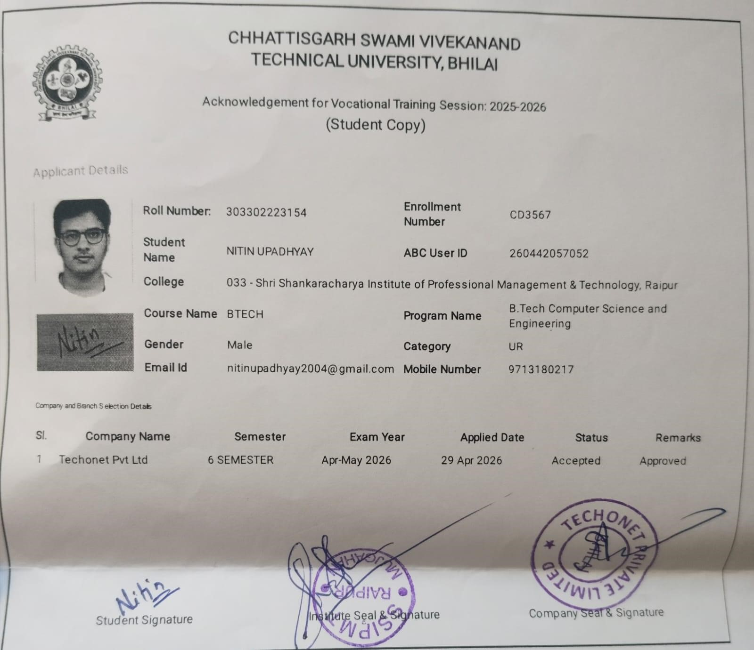

16

Offer Letter

OFFER LETTER



17

Certificate

CERTIFICATE

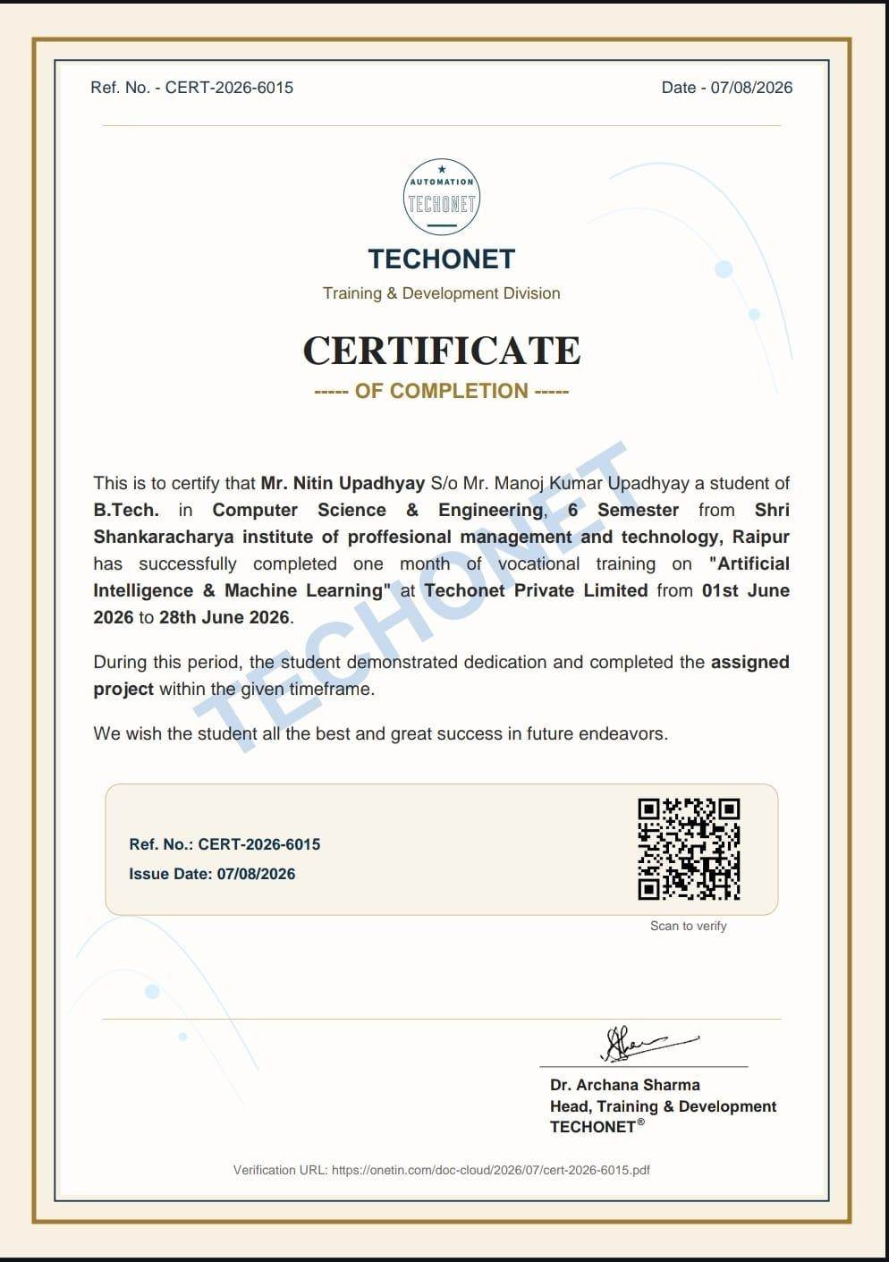

18

| P a g e

