HydroTex Business Model Validation Memo
  - Rewritten investor-facing draft based on business model review feedback
Founder: Dr. Amir Talebi, Environmental Technology Researcher & Founder
Location: Freiburg, Germany
Date: May 2026
Status: Early-stage venture concept; proof-of-concept completed with synthetic dye solution; real wastewater validation pending.
Core recommendation. Use this memo as the front-facing business model document. Keep the longer compendium as a technical appendix. The business should be presented as promising but pre-validation: the next milestone is not broad commercialization, but disciplined proof that HydroTex works with real textile wastewater at a defensible cost and with acceptable environmental, health, and safety performance.

1. Executive Positioning
HydroTex is an early-stage environmental technology concept for textile wastewater treatment. The process uses a regenerable solvent-based extraction system to remove dyes from wastewater, reduce sludge generation, and potentially lower total treatment cost compared with conventional coagulation-flocculation, activated carbon, ozone/AOP, and membrane-based alternatives.
The business case is attractive because textile dyeing and finishing facilities face a visible, recurring, and increasingly regulated wastewater problem. Color removal is a compliance and reputational issue; sludge generation is an operating cost issue; and export-oriented mills face growing pressure from brands, regulators, and sustainability standards.
The current investment case should be framed carefully. HydroTex has a credible technical principle and encouraging early laboratory results, but it is not yet a validated commercial technology. The claims that matter most - real wastewater performance, solvent loss, solvent lifetime, sludge reduction, residual solvent safety, and cost per cubic meter - still require structured validation.
Investor-ready thesis. HydroTex is a retrofit, low-sludge color-removal module for textile dyeing wastewater. The first commercial milestone is to prove real-wastewater color removal with low solvent loss, safe treated-water quality, stable regeneration, and a lower total cost than the customer's current treatment route.

2. Customer Problem and Buying Trigger
The strongest target customers are textile dyeing and finishing mills with high color loads, difficult reactive dyes, meaningful sludge disposal costs, and exposure to export-market sustainability requirements. These customers will not buy HydroTex because the chemistry is novel. They will buy only if it reduces cost, lowers compliance risk, improves operational reliability, or helps them satisfy customer and audit requirements.
- Compliance pressure: Visible color in discharge can trigger regulatory attention even when other parameters are partly controlled. Mills need reliable color reduction under variable production conditions.
- Operating cost pressure: Conventional treatment can require continuous chemical dosing, sludge dewatering, transport, and disposal.
- Sludge burden: Coagulation-flocculation can solve color but transfers pollutants into large volumes of wet sludge. A smaller concentrated waste stream can be valuable if it is safe and cheaper to handle.
- Export-market pressure: Export-oriented suppliers increasingly need evidence of wastewater performance for brands, auditors, and sustainability programs.
- Operational simplicity: Plant owners and operators prefer systems that are robust, understandable, and compatible with existing wastewater treatment infrastructure.

3. Solution Definition
HydroTex should be positioned as a modular retrofit process, not as a complete replacement for every part of a textile wastewater treatment plant. The practical first use case is color removal and sludge reduction for selected dyeing effluents, especially reactive cotton dyeing and related knitwear or garment dyeing wastewater.
- What HydroTex does: Transfers dyes and selected organics from wastewater into a reusable organic phase, regenerates the solvent, and concentrates contaminants into a smaller waste stream.
- What HydroTex should not promise yet: Universal treatment of all textile wastewater, zero waste, full water reuse, or guaranteed lower cost before pilot data exists.
- Best initial claim: Potentially lower sludge generation and lower total treatment cost if solvent loss, regeneration chemistry, and secondary waste handling are controlled.
- Current proof point: Laboratory proof-of-concept with synthetic dye solution has reportedly achieved high color removal. This is useful but must be followed by real industrial wastewater testing.

4. First Market Wedge
The most credible first market wedge is not the entire textile wastewater sector. It is a narrower segment: reactive cotton dyeing and related garment/knitwear dyeing facilities in Malaysia and Southeast Asia, especially export-oriented mills with visible wastewater challenges and brand/customer pressure.
Segment | Why it matters | HydroTex fit | Validation need
Reactive cotton dyeing | High dissolved dye load, high salinity, visible color | Strong first target | Real wastewater across multiple mills
Knitwear/garment dyeing | Variable batches and cost-sensitive operations | Good first expansion | Robustness under variable pH, salt, surfactants
Export-oriented mills | Brand audits and ESG pressure | Strong commercial trigger | LOIs and customer discovery
Denim and sulfur dye systems | Important but chemically different | Secondary opportunity | Dye-specific extraction testing
Polyester/disperse dyeing | Possible hydrophobic fit but lower dissolved load | Selective opportunity | Economic case by wastewater type
Market size claims should be treated as working assumptions until sourced. The current draft's Malaysia opportunity estimate can remain directionally useful, but it should be supported by a bottom-up calculation: number of target mills, average wastewater flow, expected adoption rate, price per cubic meter, module price, service revenue, and gross margin.

5. Business Model: Recommended Sequence
HydroTex should avoid presenting too many revenue models as equally near-term. A staged sequence is stronger. The company should first sell evidence-generating services and pilots, then move into modules and recurring service revenue once process reliability is proven.
Stage | Offer | Customer reason to pay | HydroTex objective
1. Feasibility | Wastewater testing, benchmark cost review, TEA, pilot plan | Low-risk assessment before equipment decisions | Generate data, samples, and customer trust
2. Paid pilot | 50-200 L/day lab pilot or 1-5 m3/day demo pilot | Prove performance on the customer's wastewater | Create reference data and validate OPEX
3. Retrofit module | 10-50 m3/day modular system sale or lease | Reduce sludge/cost without replacing the entire ETP | Commercial launch with manageable scope
4. Service contract | O&M, solvent management, chemical supply, monitoring | Keep system reliable without specialist staff | Build recurring revenue and data moat
5. BOO or licensing | Charge per m3 treated or license to local partners | Lower CAPEX barrier or expand through partners | Scale after operating playbook is mature
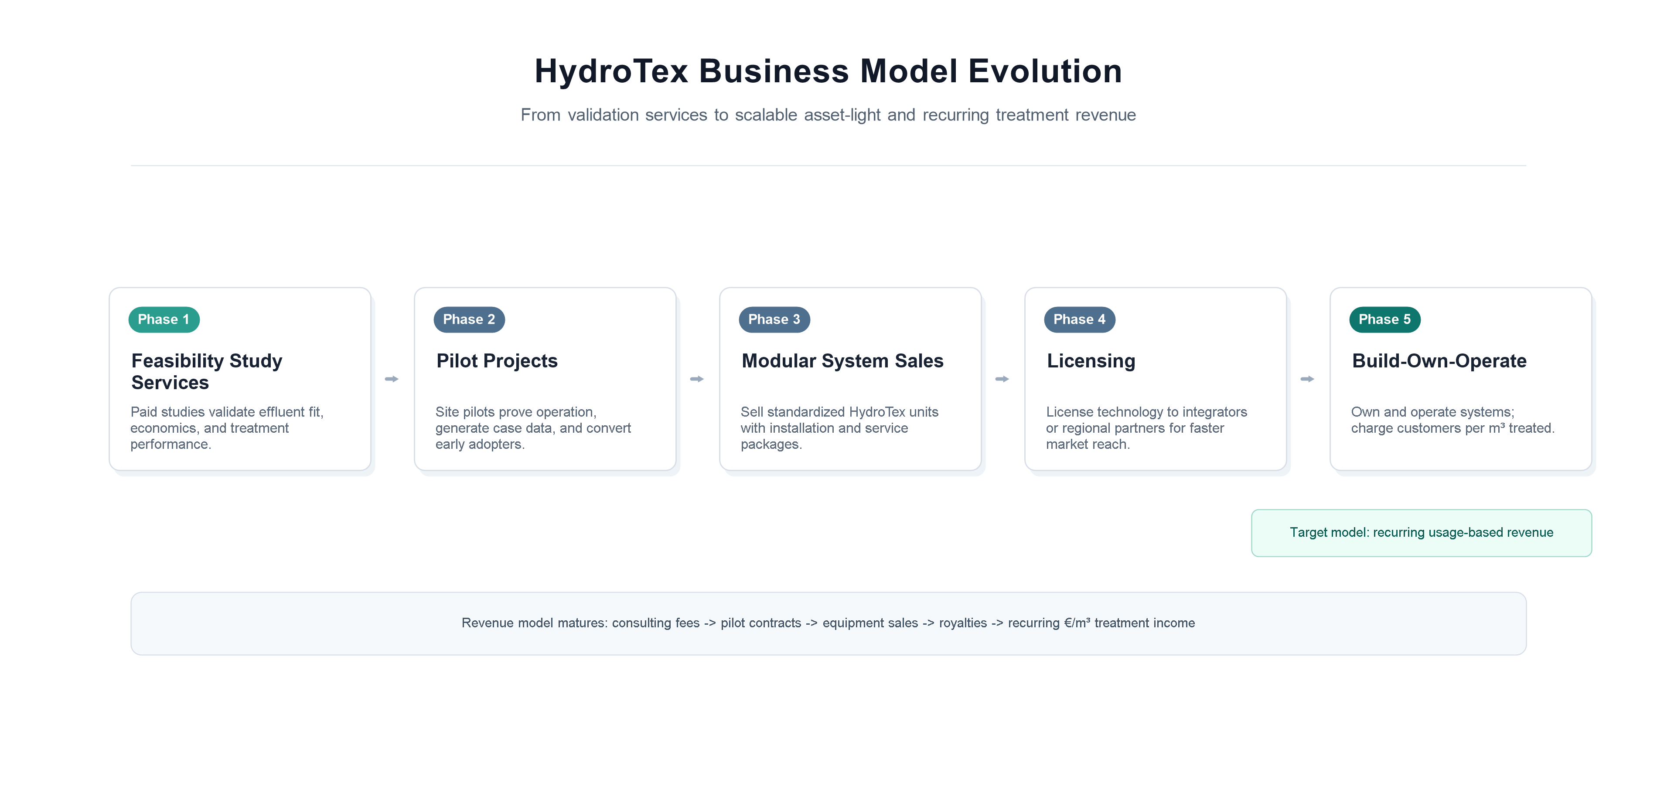
Figure 1. Revenue model evolution for HydroTex.

6. Revised Unit Economics
The financial model needs one important correction: revenue per customer must be tied directly to wastewater flow. A small mill treating 50 m3/day cannot support EUR 200,000-1,000,000 per year in treatment-as-a-service revenue unless the price per cubic meter is very high or the number includes one-time equipment sales.
Economic discipline. Every customer-level revenue claim should be traceable to this equation: annual revenue = wastewater flow per day x operating days x price per cubic meter, plus any one-time system sale, pilot fee, chemical supply, or service fee.

Customer flow | Annual volume | Revenue at EUR 0.60/m3 | Revenue at EUR 1.00/m3 | Strategic implication
50 m³/day | 18,250 m³/year | EUR 10,950/year | EUR 18,250/year | Good for feasibility/pilot or module sale; weak for BOO alone
250 m³/day | 91,250 m³/year | EUR 54,750/year | EUR 91,250/year | Possible service revenue if margins are strong
1,000 m³/day | 365,000 m³/year | EUR 219,000/year | EUR 365,000/year | More plausible BOO/service customer
Cluster of mills | Variable | Depends on aggregate flow | Depends on aggregate flow | Could justify shared service or regional operator model
For early commercialization, HydroTex should therefore emphasize paid feasibility work, paid pilots, module sales or leasing, and service contracts. A pure build-own-operate model is attractive later, but only when customer flow is large enough, financing is available, and operational risk is well understood.

OPEX hypothesis
The target HydroTex OPEX range of EUR 0.3-1.0/m3 is commercially compelling but still unvalidated. The most important cost drivers are solvent makeup, extractant loss, sodium hydroxide or other stripping reagents, energy for mixing/pumping, labor and maintenance, concentrated waste disposal, analytics, and CAPEX amortization.
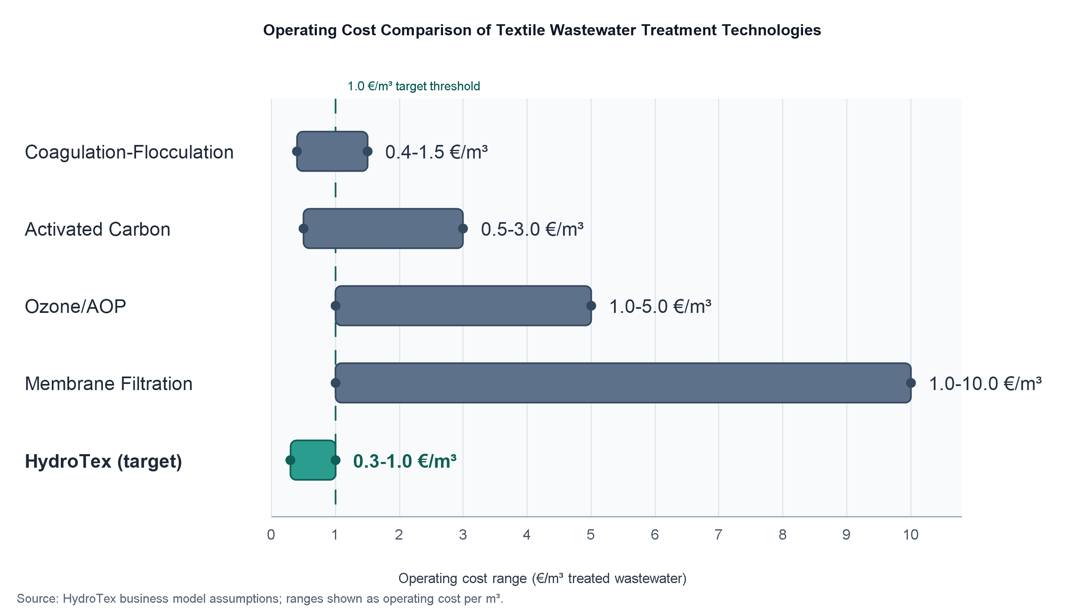
Figure 2. Indicative operating-cost comparison. HydroTex values remain target estimates pending pilot validation.

7. Technical Validation Plan
The next 12 months should reduce uncertainty, not attempt a full commercial launch. The validation program should answer five investor questions: does it work on real wastewater, does the solvent remain reusable, does the treated water meet customer/regulatory requirements, does the waste burden really fall, and does the cost per cubic meter beat alternatives?
Validation area | Target evidence | Proposed acceptance metric
Color removal | Multiple real wastewater samples from target mills | >90-95% color removal, refined by customer/discharge need
COD and broader quality | Before/after COD, turbidity, pH, conductivity, residual organics | No hidden deterioration of regulated parameters
Solvent loss | Mass balance and treated-water residual solvent testing | Loss low enough to support EUR/m3 target and safe discharge
Phase separation | Settling time, emulsion tendency, carryover | Reliable separation under surfactants, oils, salt, and temperature variation
Solvent lifetime | Repeated extraction/regeneration cycles | Stable performance across tens to hundreds of cycles
Secondary waste | Volume, composition, classification, disposal route | >50% reduction in waste burden versus baseline, if validated
Pilot reliability | Continuous or semi-continuous operation | Several weeks of stable operation with limited operator intervention
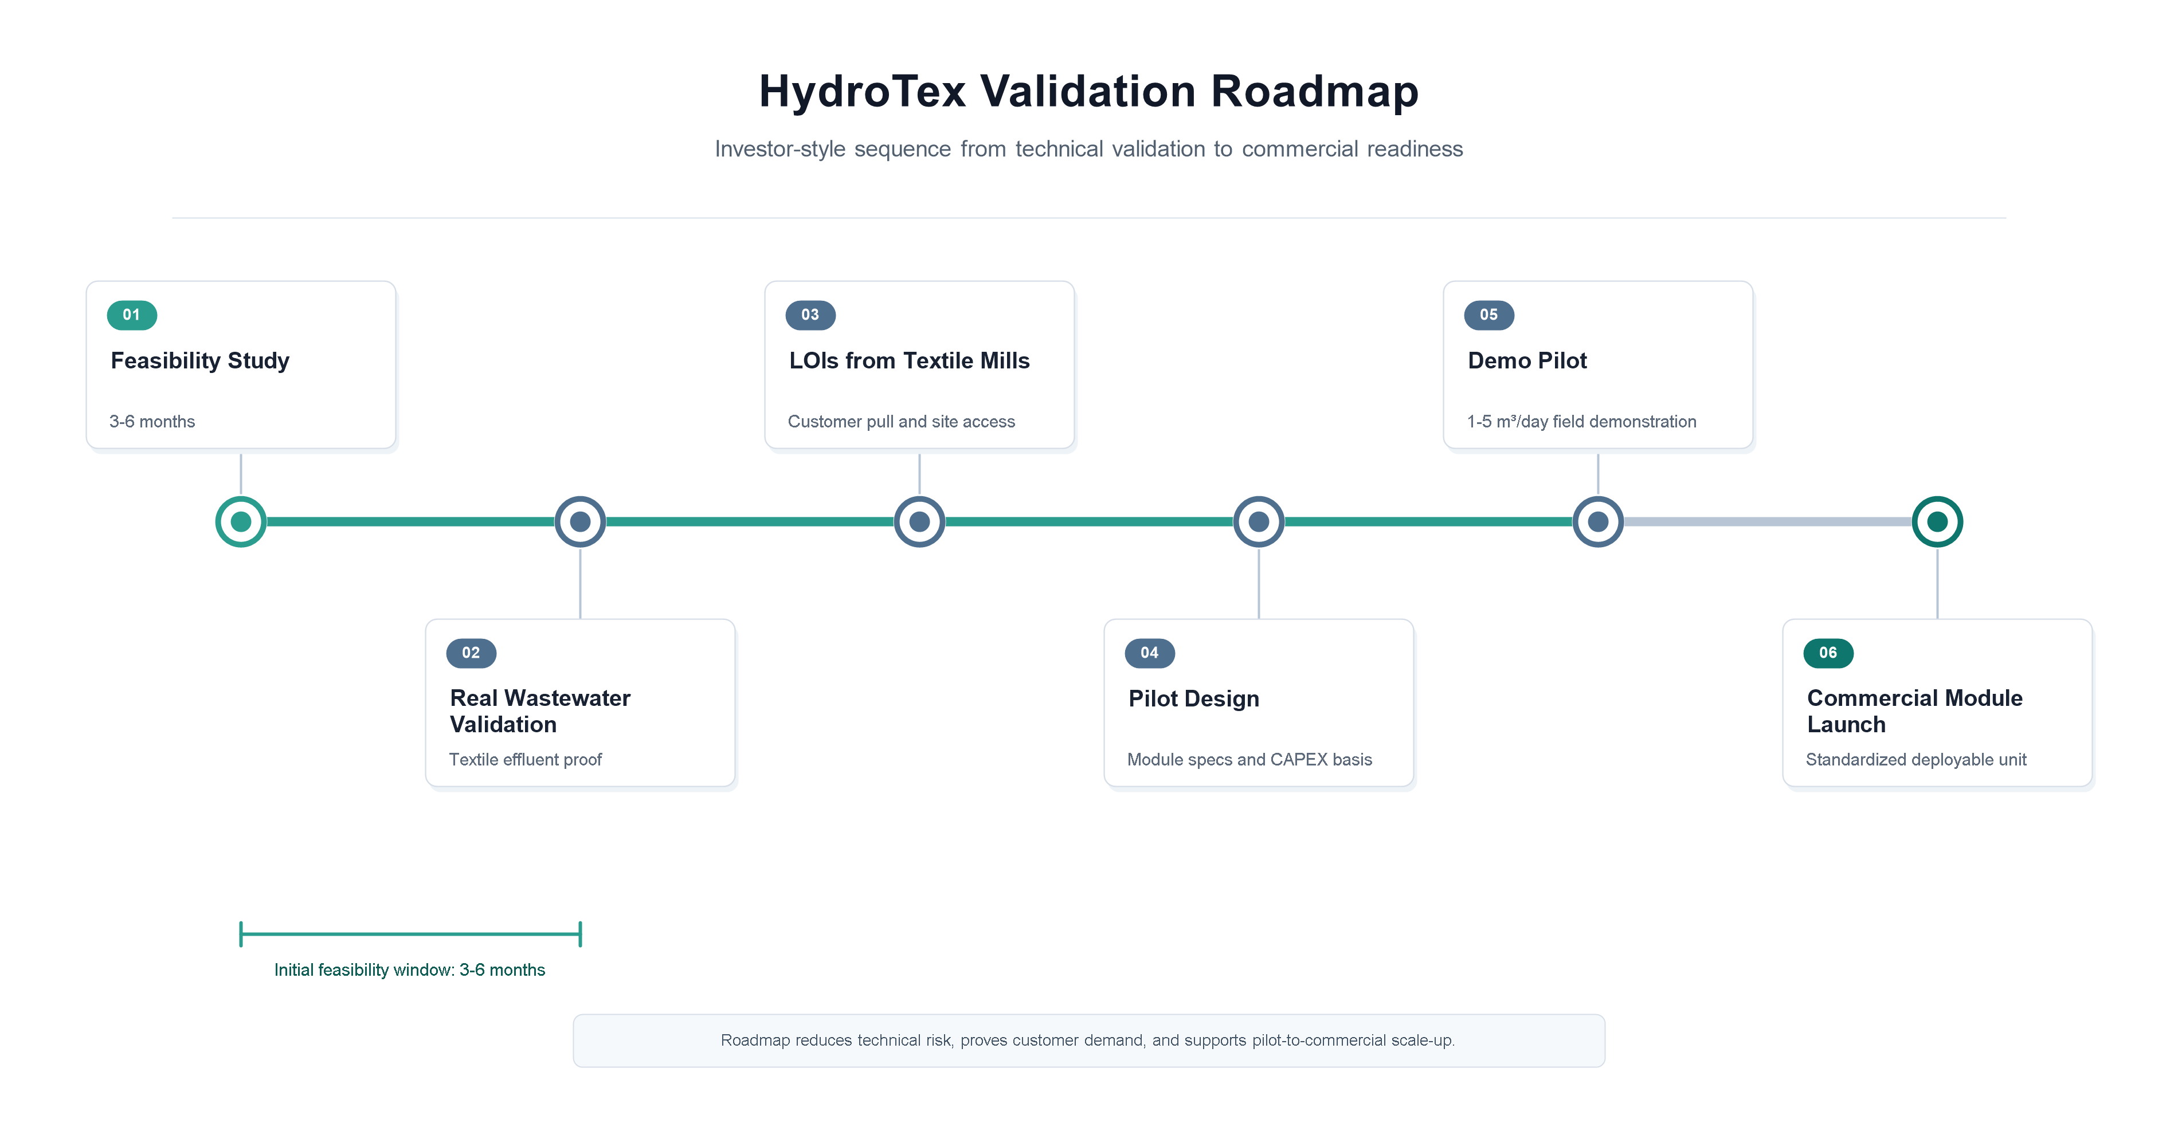
Figure 3. Validation roadmap from feasibility to commercial launch.
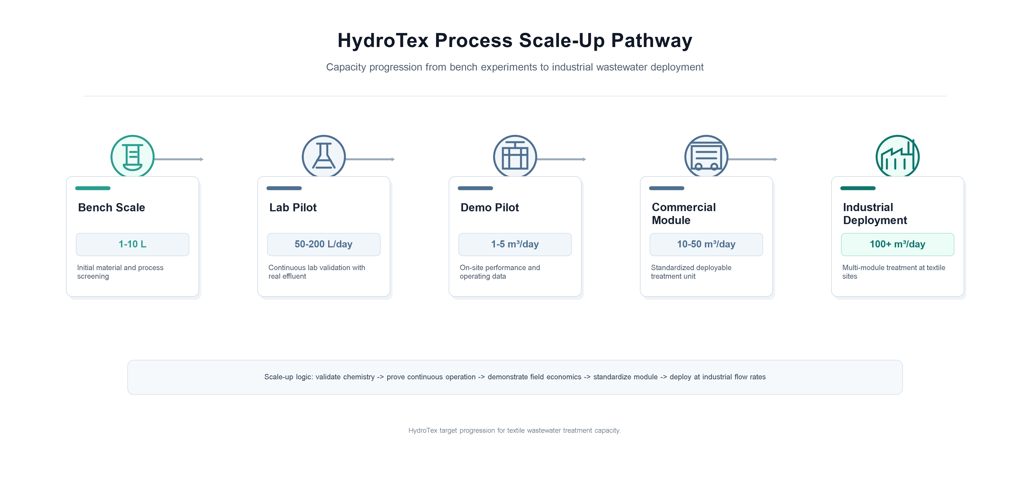
Figure 4. Process scale-up pathway for HydroTex.

8. EHS and Regulatory Case
Because HydroTex uses an organic solvent system, the EHS and regulatory case is not a side issue. It is central to adoption. Textile mills, regulators, and investors will ask whether the technology solves one environmental problem while introducing another.
- Residual solvent: Measure residual organic phase and extractants in treated water, and compare results against applicable discharge and customer requirements.
- Solvent handling: Define flash point, odor, VOC potential, worker exposure controls, storage requirements, and spill-response procedures.
- Solvent quality: If waste cooking oil is used, define feedstock specification, purification needs, oxidation stability, impurity limits, and supplier quality control.
- Secondary waste: Characterize the stripping stream or concentrated dye waste, including hazard classification, disposal route, and cost.
- Regulatory pathway: Engage early with DOE Malaysia and potential pilot-site environmental managers. Align pilot design with local industrial effluent rules and relevant customer standards.
- Customer confidence: Prepare a one-page EHS assurance note before asking mills to host a pilot.

9. Competitive Positioning
HydroTex should not claim that competitors cannot remove color. Many existing technologies can. The sharper claim is that HydroTex may remove color with lower sludge generation, lower recurring chemical burden, and simpler integration than some advanced alternatives, provided that solvent stability and safety are proven.
Alternative | Customer reason to use it | HydroTex counter-position
Coagulation-flocculation | Familiar, low CAPEX, broadly available | High sludge and chemical demand create room for a low-sludge retrofit
Activated carbon | High color removal and simple concept | Consumable replacement/regeneration cost can be high
Ozone/AOP | Strong decolorization, low solids | Energy and oxidant cost can be significant
Membranes | Excellent polishing and reuse potential | Fouling, concentrate management, and CAPEX can be barriers
Electrocoagulation | Mature alternative with moderate automation | Still produces metal-containing sludge and requires electrodes
Upstream dyeing innovation | Avoids wastewater at source | HydroTex retrofits existing mills without replacing dyeing process

10. IP and Defensibility
The most credible defensibility strategy is layered. Broad protection over solvent extraction itself is unlikely because the underlying principle and many extractants are known. The protectable value is more likely to sit in specific solvent formulations, operating windows, regeneration procedures, surfactant/emulsion management, performance datasets, and the operating know-how required to run the process reliably.
- Run an early patentability and freedom-to-operate screen before making strong IP claims.
- Protect exact solvent ratios, operating conditions, demulsification strategy, and regeneration know-how as trade secrets where appropriate.
- File patents only where the claims are specific, defensible, and commercially meaningful.
- Treat pilot data as a strategic asset: wastewater characteristics, settings, removal performance, solvent loss, and cost outcomes should be systematically logged.
- Register and consistently use the HydroTex brand once the commercial identity is stable.

11. Funding and Milestone Roadmap
The current EUR 15,000-20,000 feasibility ask is plausible for early travel, customer discovery, sample collection, and focused laboratory validation. It should be presented as the first tranche, not as the full funding need to reach commercial readiness.
Funding stage | Indicative need | Purpose | Milestone unlocked
Feasibility | EUR 20k | Real wastewater access, lab matrix, customer interviews, preliminary TEA | Evidence for grants and paid pilots
Pilot preparation | EUR 100k-250k | Pilot engineering, equipment, safety review, analytical testing | 50-200 L/day or customer-site demo readiness
Demo pilot | EUR 500k-1.5M | 1-5 m3/day pilot, operations team, monitoring, customer reference | Commercial module decision
Commercial launch | Project-specific | 10-50 m3/day modules, service infrastructure, regulatory documentation | First repeatable sales model

12. Priority Questions Before Fundraising
- What is the measured solvent and extractant loss per cubic meter treated?
- Does treated water contain residual solvent or extractants, and are levels acceptable for discharge or further treatment?
- Does HydroTex work on real wastewater from at least three representative textile mills?
- What happens to the extracted dye and stripping stream, and what does disposal cost?
- What is the true OPEX after solvent makeup, chemicals, energy, labor, waste handling, and maintenance?
- What installed CAPEX is required for 50, 250, and 1,000 m3/day applications?
- What customer segment has enough wastewater volume and pain to pay for the first pilot?
- Which part of the technology is actually patentable or defensible?
- Which customer will provide wastewater, operational data, and a conditional LOI for a pilot?
- What is the narrowest first product that can be sold without overpromising?

13. Revised Summary Recommendation
HydroTex is worth continuing. The problem is real, the initial concept is differentiated, and the staged commercialization route is sensible. However, the business plan should be more disciplined about what is proven and what is still a hypothesis. The strongest next move is to run a focused feasibility program that produces hard data on real wastewater performance, solvent loss, residual solvent, sludge/waste reduction, and cost per cubic meter.
The company should present itself as a specialized environmental technology venture moving through a validation pathway, not as a fully proven treatment platform. If the next 6-12 months confirm stable real-wastewater operation and credible economics, HydroTex can become a fundable pilot-stage company with a clear path toward modular systems, service contracts, and eventually licensing or BOO models.

Appendix A. Assumption Register
Assumption | Current status | Validation action
EUR 0.3-1.0/m3 OPEX | Target hypothesis | Build TEA and validate through real wastewater pilot
High color removal | Synthetic dye proof point | Test mixed real effluents from target mills
Low sludge generation | Core value proposition | Measure all secondary waste streams and compare to baseline
Low solvent loss | Commercially decisive unknown | Mass balance and residual solvent analytics
Malaysia initial market | Strategically plausible | Source mill count, wastewater volumes, customer budgets, adoption rate
Paid pilots possible | Commercial hypothesis | Secure LOIs with budget owner or pilot sponsor
AI/digital value | Future upside | Defer until core process data exists

Appendix B. Selected External Context
These references support the external context for wastewater expectations, regulatory pressure, and textile supply-chain sustainability. They do not independently validate HydroTex performance or economics.
- ZDHC Wastewater Guidelines: https://knowledge-base.roadmaptozero.com/hc/en-gb/articles/10445358115869-ZDHC-Wastewater-Guidelines
- Malaysia DOE Environmental Quality (Industrial Effluents) Regulations 2009: https://www.doe.gov.my/en/environmental-quality-industrial-effluents-regulations-2009-p-u-a-434-2009/
- European Commission EU Strategy for Sustainable and Circular Textiles: https://environment.ec.europa.eu/strategy/textiles-strategy_en
- European Commission Corporate Sustainability Due Diligence: https://commission.europa.eu/business-economy-euro/doing-business-eu/corporate-sustainability-due-diligence_en

