A Software Engineering-3 Report on
Prototype Auction and Catalogue System for Fotheby's

Amir Tamang
UN ID: 21422018
BSc Computing

Supervisor: Mr. Ramesh Parajuli
NAMI College
University of Northampton
New Baneshwor, Kathmandu, Nepal

September 2023

Contents
1. Introduction 2
1.1. Project Background 3
1.2. Project Aims and Objectives 4
2. Requirements Engineering 5
2.1. Elicitation Activities 5
2.1.1. Individual Workshop 1 Plan (Problem Domain Understanding) 5
2.1.2. Group Workshop 1 Plan (Problem Domain Understanding) 8
2.1.3. Workshop 1 Findings (Problem Domain Understanding) 10
2.1.4. Individual Workshop 2 Plan (Problem Resolution and Specification Formulation) 11
2.1.5. Group Workshop 2 Plan (m Resolution and Specification Formulation) 13
2.1.6. Workshop 2 Findings (Problem Resolution and Specification Formulation) 15
2.1.7. Workshop Observation Critical Review 17
2.1.8. Other Problem Domain Research 17
2.2. Requirements Specification 19
2.2.1. Problem Domain Description 19
2.2.2. Functional Requirements 21
2.2.3. Proposed Prototype Development Blocks/Priority of Development 22
3. System Analysis & Design (Software Development Block/Sprint 1) 24
3.1. Flow chart of Auction System 24
3.2. Use case Diagram. 24
3.3. Database Design 25
3.3. Wireframe 26
4. System Build and Technical Notes (Software Development Block/Sprint 1) 26
5. System Testing & Evaluation Strategy (Software Development Block/Sprint 1) 26
6. Conclusion 28
Reference 30
Appendix 1 31

Introduction
Unprecedented expansion and diversification of the art market have presented auction houses with both opportunities and difficulties. With a rich history and dedication to excellence, Fotheby's has set out on a transformative path to update its customer engagement and inventory management. The creation and execution of a cutting-edge prototype auction and catalogue system sit at the core of this endeavour.
This report captures the thorough process I went through to develop a prototype that reflects Fotheby's future vision. The objective is to show the enormous potential of a computerised system that not only streamlines our internal procedures but also provides our distinguished clientele with an immersive and flawless experience.
We explore the nuances of project start, requirements collecting, system design, development, integration of complicated features, user acceptability testing, refinement, documentation, deployment, and maintenance in this report (Ilie et al., 2019). Here, each phase's painstaking preparation and execution are described in depth, demonstrating our dedication to providing a solution that adheres to accepted "good" design criteria.
In summary, this prototype shows Fotheby's taking a big stride forward by embracing a future where technology and tradition are combined to bring art lovers closer to their passions. We encourage you to learn more about how Fotheby's is changing to become a more approachable, effective, and customer-focused institution as we describe the journey, successes, and future potential of this prototype.

Project Background
Fotheby's, a distinguished auction house renowned for its expertise in fine art auctions, has long held the top position in the art market. Fotheby's has a long history of presenting art enthusiasts with outstanding pieces of art, and it has long been a symbol of the art world's dedication to tradition and excellence.
Fotheby's is aware of how crucial it is to transform and reinvent its business practices to stay on top of the industry as the art market evolves in the digital era. The art market has grown tremendously in both size and variety. This transition has presented opportunities as well as difficulties for auction houses like Fotheby's.
The handling of documents related to auctions has been one of Fotheby's operations' top challenges. For this purpose, Fotheby's has historically used a clerical inventory system that, while dependable, requires a lot of labour and is prone to human mistakes. This outdated technology not only reduced operational effectiveness, but also made it difficult to give clients the most recent details on auction items.
Fotheby's has traditionally relied on printed catalogues that are issued in small quantities to exhibit things up for auction in terms of client engagement and item visibility. Although these catalogues have been a mainstay of Fotheby's marketing plan, customers have expressed worries about their scarcity. Fotheby's has investigated the possibility of switching to a web-based auction catalogue considering the possibilities for a wider audience. A change like this might raise final sale pricing in addition to improving item exposure and fostering greater client interest.

1.2. Project Aims and Objectives
Aims
Fotheby's prototype auction and catalogue system project's primary goal is to modernize the company's processes and improve customer involvement within the changing context of the art market. By utilizing technology while upholding Fotheby's essential principles, this innovative project aims to establish the auction house as a pioneer in the modern era of online art auctions.

Objectives
- To ensure effective and error-free management of auction-related records, create a computerized inventory system to replace the current clerical system. Processes should be streamlined, human error should be decreased, and real-time data updates should be available.
- To replace printed catalogues, develop a user-friendly web-based auction catalogue. Clients should be able to view this catalogue whenever they want, and it should include multimedia presentations of the auction items as well as sophisticated search and filter tools to improve item exposure.
- To answer client complaints about the restriction of only five categories, and broaden the scope of the current classification system to include a wider variety of art forms and styles. Make sure the new system allows for a variety of artistic expressions.
- Expand the system to integrate buyer and seller client record information. With the help of this feature, Fotheby's should be able to keep thorough records of all its clients, improving client management and engagement.
- Integrate accounting components into the system so that Fotheby's can precisely track each item's sale price and determine commissions. For transactions to be transparent and effective, this financial functionality is essential.
- Ensure that only authorized personnel have access to certain system components and information by implementing strong security and access control measures to protect sensitive data.

Requirements Engineering

2.1. Elicitation Activities
The effort to develop a prototype auction and catalogue system for Fotheby's depends significantly on knowing the requirements, demands, and preferences of our key stakeholders. We are starting a series of extremely informative and collaborative elicitation activities to accomplish this. The planning was done (Mind Tools Content Team, 2023). We will be able to get insightful information from our stakeholders through these two workshops, which will help us ensure that the project completely satisfies their needs and wants.

2.1.1. Individual Workshop 1 Plan (Problem Domain Understanding)

2.1.1.1 Rationale
The first stage in gathering important requirements from our key stakeholders, such as Mr Max Fotheby, Mr. Mark Jones, and Mr. Paul Smith, was Workshop 1. The major objective is to ensure that the project scope, features, and functions fit with the expectations and demands of the stakeholders to lay a solid basis for Fotheby's prototype auction and catalogue system project.

2.1.1.2 Agenda/Tool Selection
- Approximately one hour long
- Participants include the project team as well as Mr. Max Fotheby, Mr. Mark Jones, and Mr. Paul Smith.
- Amir Tamang is the facilitator.
Workshop Flow:
- Project Overview
  - Objective: Ensure that everyone involved comprehends the significance and aims of the project.
  - Review the Fotheby's project, focusing on its goals, difficulties, and possibilities for change.
- Current Challenges Discussion
  - Objective: Describe the unique difficulties that Fotheby's is currently experiencing.
  - Encourage stakeholders to contribute their knowledge and opinions about the constraints of the classification system, the distribution of catalogues, and the current inventory system.
- Client Expectations and Desires
  - The goal is to learn in-depth information about what stakeholders want from the new prototype system.
  - Encourage open dialogue and brainstorming sessions so that stakeholders can express their ideas about the features and capabilities of the system.
- Additional Complex Features Review
  - Goal: Investigate the potential additional complicated features listed in Table 1 of the business brief and evaluate how well they meet the needs of the stakeholders.
  - Discuss each feature and solicit input on its significance and compatibility with the project's goals.
- Scope Definition
  - Objective: Collaboratively define the project's scope, ensuring that it captures the identified requirements and expectations.
  - Engagement: Encourage stakeholders to actively contribute to the scope definition process.
- User Stories and Use Cases
  - Goal: Start documenting user stories and use cases based on the information gathered.
  - Encourage participation from stakeholders in the development of user-centric narratives.
- Feedback Loop
  - Goal: Give interested parties a chance to voice their opinions, queries, or concerns right away.
  - Engagement: Allow the audience to provide any final insights or ideas.
- Wrap-Up and Next Steps
  - Goal: Outline the project's future stages and summarize the workshop's main lessons.
  - Engagement: Ensure that all relevant parties are kept up to date on the project's development and their contribution to the prototype.

2.1.1.3 Participant Engagement Commitment
The following engagement guidelines will be observed to guarantee a fruitful and cooperative workshop:
- Each participant is expected to respect and consider the ideas, opinions, and feedback of the others.
- It is recommended for participants to actively participate in conversations, offer their viewpoints, and pose questions.
- Focusing on requirement collection and project scope, discussions should stay in line with the workshop's goals.
- Feedback should be useful and geared toward making the project better. Participants should refrain from making personal remarks.
- The facilitator will control the flow of time to make sure that all agenda items are covered in the time allotted.
The focal point of my project is a workshop where we jointly determine the goals and specifications for the Fotheby's prototype auction and catalogue system. By enabling them to actively participate in the project's success, it ensures that our stakeholders' needs are addressed.

2.1.2. Group Workshop 1 Plan (Problem Domain Understanding)

2.1.2.1 Rationale
For the Fotheby's prototype auction and catalogue system, Group Workshop 1 is a crucial stage in gathering requirements and developing a thorough understanding of the issue area. The goal of this workshop is to promote cooperative discussions among the project team members so that there is a shared understanding of the project's goals, difficulties, and stakeholder expectations.

2.1.2.2 Agenda/Tool Selection
Duration: Approximately 1 hour
Participants: Mr. Max Fotheby, Mr. Mark Jones, Mr. Paul Smith, and the project team.
Facilitator: Amir Tamang
Workshop Flow:
- Project Overview
- Ensure that everyone in the project team is aware of the objectives and significance of the project.
- Review the Fotheby's project brief, focusing on its goals, difficulties, and potential for transformation.
- Current Challenges Discussion
- Objective: Describe the unique difficulties that Fotheby's is currently experiencing.
- Encourage team members to express their opinions and thoughts about the limitations of categorization, the distribution of catalogues, and the current inventory system.
- Stakeholder Analysis
- Goal: Examine the principal project stakeholders and their roles.
- Engagement: Collaboratively map out the expectations, worries, and interests of the various stakeholders.
- Project Scope and Objectives
- Determine the scope and main goals of the project.
- Discuss and agree upon the broad scope of the project, highlighting what it will and will not cover.
- Requirements Identification
- Establishing the requirements for the project is the goal.
- Encourage team members to contribute to a preliminary list of requirements based on talks by sharing their ideas.
- Additional Complex Features Review
- Objective: Explore the potential additional complex features outlined in Table 1 of the business brief and assess their relevance to stakeholder needs.
- Engagement: Discuss each feature, seeking feedback on its importance and alignment with project objectives.
- User Stories and Use Cases
- Establishing the requirements for the project is the goal.
- Encourage team members to contribute to a preliminary list of requirements based on talks by sharing their ideas.
- Feedback and Alignment
- Goal: Give team members a chance to voice any issues, questions, or immediate feedback.
- Engagement: Allow the audience to provide any final insights or ideas.
- Wrap-Up and Next Steps
- Goal: Outline the project's future stages and summarize the workshop's main lessons.
- Engagement: Ensure that team members are aware of the project's status and their contributions to the prototype's development.

2.1.2.3 Participant Engagement Commitment
The following engagement guidelines will be observed to guarantee a fruitful and cooperative workshop:
- Everyone taking part is required to actively participate in conversations, offer their opinions, and pose questions.
- Focusing on requirement collection and project scope, discussions should stay in line with the workshop's goals.
- Feedback should be useful and geared toward making the project better. Participants should refrain from making personal remarks.
- The facilitator will control the flow of time to make sure that all agenda items are covered in the time allotted.

2.1.3. Workshop 1 Findings (Problem Domain Understanding)
The main conclusions and findings from Workshop 1 (Problem Domain Understanding) are listed below in brief:
  - Project Overview
- Stakeholders now have a good knowledge of the project's goals, difficulties, and potential for transformation.
- It highlighted how crucial it is to switch from a conventional catalogue system to a digital one.
  - Current Challenges
- The necessity for a web-based catalogue and the difficulties the current clerical inventory system faces were highlighted.
- Stakeholders discussed their opinions and issues with the way that inventory is currently managed.
  - Client Expectations and Desires
- Stakeholders expressed their vision for the prototype system throughout discussions and actively participated.
- The main goals were to strengthen advertising capabilities, expand item categorization, and improve search algorithms.
  - Additional Complex Features Review
- The potential complex aspects listed in Table 1 of the business brief were considered by the stakeholders.
- On the significance of including sophisticated search parameters and client record information, there was agreement.
  - Scope Definition
- The high-level project scope was established with a focus on resolving present constraints and satisfying client requirements.
- The scope highlighted the demand for a powerful search tool and more thorough item categorization.
  - User Stories and Use Cases
- Based on stakeholder inputs, the initial user stories and use cases were started.
- These stories will act as the starting point for additional development and requirement collecting.
  - Feedback and Alignment
- The project's direction is in line with participant expectations thanks to their insightful feedback, which was greatly appreciated.
- Questions and concerns were answered, encouraging a cooperative environment.
  - Wrap-Up and Next Steps
- The session came to an end with a summary of the main lessons learned and an outline of the project's next steps.
- Stakeholders were excited about how the project could change how Fotheby's operates.
The objectives, difficulties, and stakeholder expectations of the project were successfully communicated during Workshop 1. It established the framework for future requirement elicitation and project development.

2.1.4. Individual Workshop 2 Plan (Problem Resolution and Specification Formulation)

2.1.4.1 Rationale

As the specs for Fotheby's prototype auction and catalogue system are being refined, Individual Workshop 2 is a crucial step in resolving any unresolved problems that were discovered during Workshop 1. The main objectives are to resolve any disagreements, obtain more information, and guarantee a thorough comprehension of the project requirements.

2.1.4.2 Agenda/Tool Selection
Duration: Approximately 2 hours
Participants: Mr. Max Fotheby, Mr. Mark Jones, Mr. Paul Smith, and the project team.
Facilitator: Amir Tamang
Workshop Flow:
- Review of Workshop 1 Findings
- Recap important findings and conclusions from Workshop 1.
- Content: Refresh your grasp of stakeholder expectations and identified challenges by reading the summary of Workshop 1 findings.
- Outstanding Issues Resolution
- Address any unsolved or incongruent concerns from Workshop 1. Engagement: Examine the problems and conflicts found, then work on possible remedies or clarifications.
- Refinement of Specifications
- Goal: Further hone project specs considering the prior workshop's learnings.
- Review and enlarge upon the initial requirements and specifications.
- Complex Features Discussion
- Goal: Examine the potentially complicated characteristics listed in Table 1 of the business brief in further detail.
- Engagement: Consider the ramifications and viability of adding these elements to the project.
- User Stories and Use Cases
- Goal: Keep recording user stories and use cases based on the improved specs.
- Engagement: Create in-depth narratives by the revised project scope.
- Feedback and Clarifications
- Goal: Get opinions on the improved standards and answer any queries or issues.
- Encourage self-reflection and helpful criticism of the suggested modifications to increase engagement.
- Wrap-Up and Next Steps
- Goal: Outline the project's future stages and summarize the workshop's results.
- Engagement: Ensure understanding of the changed project direction and the part these improvements will play in the creation of the prototype.

2.1.4.3 Participant Engagement Commitment
The upcoming participant involvement guidelines will be followed to guarantee a fruitful and narrowly focused workshop:
- Engage in conversation, provide ideas, and offer criticism.
- Approach unresolved problems with a problem-solving mentality, looking for answers and clarifications.
- Throughout the workshop, keep your communication respectful and helpful.
- Keep conversations focused on the project's goals and evolving requirements.
- Encourage candid and open input on any suggested modifications and improvements.
This workshop is an essential stage in fine-tuning the project specifications and resolving any outstanding problems, finally guaranteeing that Fotheby's prototype system is in line with stakeholder demands and expectations.

2.1.5. Group Workshop 2 Plan (m Resolution and Specification Formulation)

2.1.5.1 Rationale
The second Group Workshop is crucial for resolving any issues and defining the requirements for the Fotheby's prototype auction and catalogue system. To guarantee a thorough grasp of requirements and project alignment, this workshop attempts to leverage collective perspectives from stakeholders and project team members.

2.1.5.2 Agenda/Tool Selection
Duration: Approximately 2 hours
Participants: Mr. Max Fotheby, Mr. Mark Jones, Mr. Paul Smith, and the project team.
Facilitator: Amir Tamang
Workshop Flow:
- Review of Workshop 1 Findings
- Refresh participants' memories of the main results and outcomes from Workshop 1.
- Go over the summary of Workshop 1's conclusions, focusing on highlighted challenges and stakeholder expectations.
- Outstanding Issues Resolution
- Address any unresolved or conflicting concerns from Workshop 1 that have been carried over. Engagement: Work together to find answers or clarifications for problems that have been highlighted.
- Refinement of Specifications
- Goal: Further hone project specs considering the prior workshop's learnings.
- Engagement: To ensure accuracy, go through and improve the initial criteria and specifications.
- Complex Features Discussion
- In-depth investigation of the potentially complicated aspects listed in Table 1 of the business brief is the goal.
- Engagement: Assess the project's inclusion of these aspects for viability and potential effects.
- User Stories and Use Cases
- Goal: Continue compiling use cases and user stories while keeping them in line with the improved specs.
- Participation: Create in-depth narratives that reflect the revised project scope.
- Feedback and Clarifications
- Objective: Collect comments on the improved requirements and answer any queries or worries.
- Engagement: Encourage candid and helpful input on the suggested modifications.
- Finalizing Specifications
- Goal: Confirm that the project's updated specs comply with stakeholder expectations by summarising them.
- Engagement: Seek agreement on the requirements to ensure a shared understanding.
- Wrap-Up and Next Steps
- Goal: Outline the project's future stages and summarise the workshop's major findings.
- Engagement: Ensure that participants are informed of the project's finalised direction and how these specs will be used to construct the prototype.

2.1.5.3 Participant Engagement Commitment
The guidelines for participant engagement listed below must be followed to maintain a productive and cooperative workshop environment:
- Engage in conversation, provide ideas, and offer criticism.
- Focus your efforts on overcoming obstacles and improving project clarity.
- Throughout the workshop, keep your communication respectful and helpful.
- Make sure conversations adhere to the project's goals and specific specifications.
- Encourage frank discussion about suggested modifications and requirements.

2.1.6. Workshop 2 Findings (Problem Resolution and Specification Formulation)
Key Outcomes and Findings
Date: 10th September 2023
Participants: Mr. Max Fotheby, Mr. Mark Jones, Mr. Paul Smith, and project team members.
Facilitator: Amir Tamang
Summary:
The objective of Workshop 2 was to finish off loose ends and improve the project requirements for Fotheby's prototype auction and catalogue system. The meeting was crucial in bringing stakeholder expectations together and obtaining consensus on important project components. These are the main conclusions and results:
1. Outstanding Issues Resolution:
- The problem stemmed from the inadequate classification framework, which made it difficult to accurately categorize works of art.
  - Expanding the categorization system to incorporate more precise and adaptable categories was the resolution. This overcomes the constraint and enables a more precise classification of artwork.
- Client complaints regarding the scant distribution of printed catalogues were another issue.
  - Resolution: It was determined to switch to a web-based catalogue system to remedy this. The client's problem is addressed by this update, which considerably expands the reach and accessibility of catalogues.

Refinement of Specifications:
The workshop made it possible to thoroughly review the project requirements, which significantly improved their accuracy and thoroughness. To reflect stakeholder expectations and project scope more accurately, specifications were modified. Additionally, during this stage, the constructive criticism from Workshop 1 had to be included.

Complex Features Discussion:
An insightful conversation was had regarding the complicated characteristics listed in Table 1 of the business brief. We evaluated how adding these features to the prototype would affect both its viability and its impact. Choosing which complicated elements to integrate was decided upon based on how well they complemented the project's goals.

User Stories and Use Cases:
To comply with the revised project criteria, user stories and use cases were further developed and improved. To better convey the thorough nature of Fotheby's prototype system, narratives were improved. To ensure usability and efficacy, a user-centric approach was maintained.

Feedback and Clarifications:
Discussions on the suggested modifications and changes were open and positive. Feedback helped to clarify the project's objectives and fine-tune its course. A shared understanding among stakeholders was fostered by the discussion of important problems and questions.

Finalizing Specifications:
A decision on the completed project requirements was reached at the workshop's conclusion. To make sure that the specifications matched the project's objectives and stakeholder expectations, they were validated. The project's direction was agreed upon by everyone.

Conclusion:
Achieving agreement among stakeholders, addressing open issues, and improving project requirements were all made possible thanks to Workshop 2. The findings give Fotheby's the ability to build a prototype auction and catalogue system that will satisfy the demands and expectations of all relevant parties.

2.1.7. Workshop Observation Critical Review
Three members of our project team, Arpan Dahal, and Utsav Raj Kharel identified specific issues with the Fotheby's prototype auction and catalogue system. To solve these problems, each member put forward a different idea. We may better grasp the variety of obstacles faced by Fotheby's and the various tactics to overcome them by analyzing the problems they recognized and examining the solutions that were put forth.

Group Member 1: Amir Tamang Problem Identification and Solution
Arpan identified the shortcomings of Fotheby's current inventory classification method. He saw that the existing method makes it difficult to categorize art objects effectively, making it difficult for customers to locate works of interest.
Solution Suggestions: Arpan proposed broadening the system of categorization to include more granular and precise categories. This would make it possible to classify works of art more precisely, improving the client experience and allowing effective searches.
Evaluation:
We hope to obtain a thorough understanding of Fotheby's difficulties and possible directions for the prototype system by looking at the various problem identifications and solutions put forth by Arpan. We can choose the approaches that best meet the project's goals and the demands of the client by assessing the viability and impact of various solutions.
Conclusion:
The project team member Arpan’s discovery of the issue and suggestions for solutions are described in this case. The perspectives will be examined to acquire a more thorough understanding of Fotheby's requirements and to direct the creation of a prototype auction and catalogue system.

2.1.8. Other Problem Domain Research

2.1.8.1. Comparable Software System Review
Review of Artsy Auction Website
An internet network called Artsy links galleries, artists, and art collectors. Along with a huge selection of artworks for sale, it also provides educational materials and insider information about the art industry.
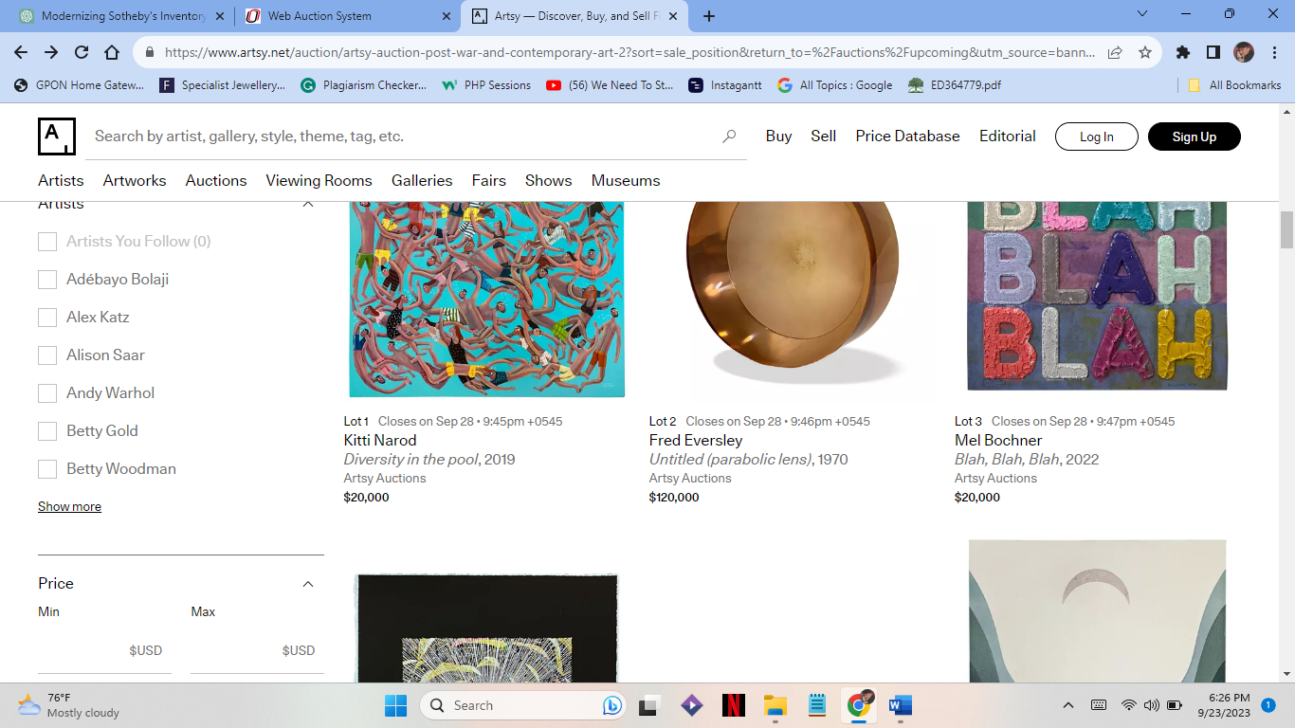
Figure 2.1.8.1 – 1: Comparable system items (Artsy, 2023).
The sleek and contemporary design of Artsy makes it a welcoming space for art lovers.
You can browse artworks, artists, galleries, auctions, and publications with ease using the top navigation bar. It's easy to find your way around.
Each listing for an artwork includes comprehensive information on the artist, the title, the medium, the size, and the price. Images with high resolution effectively display the artwork. Accessible information about current and upcoming auctions includes important dates and specifics about featured items.
Users can look up future sales and view auction catalogues using Artsy's interactive auction calendar. By allowing users to access previous auction results, including final sale prices, historical data is made available.
For registered customers, Artsy offers a simple bidding process with detailed instructions. Users have the option of making outright purchases of artworks or placing bids in auctions, catering to both seasoned collectors and novices.
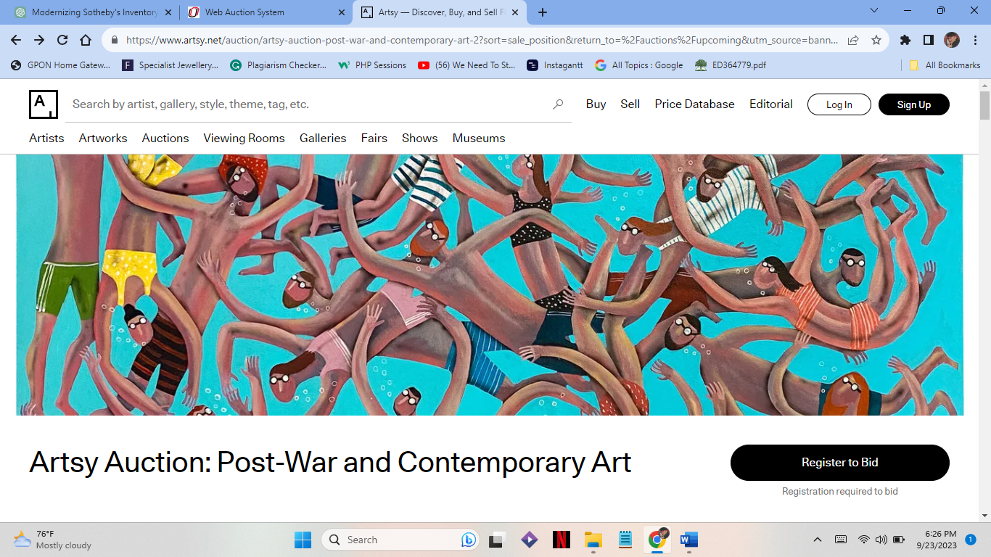
Figure 2.1.8.1 – 1: Comparable system home page.
Artsy places a high priority on user privacy and security, upholding a reliable setting for art transactions.
For users who have questions or problems, Artsy offers reachable customer service options.
By enabling users to follow artists, galleries, and particular works of art, Artsy encourages user involvement. Users can utilise this function to stay current on their favourite artists and listings.
Users can set up auction notifications for galleries, artists, or keywords to make sure they never miss the chance to place a bid on desired items.
In conclusion, Artsy offers an advanced and aesthetically pleasing platform for art fans and collectors. It is a priceless tool in the field of art because of its rich material, open auction results, and educational tools. Artsy's prominence as a key participant in the online art industry is a result of its global reach and dedication to user privacy and security. Artsy continues to be a popular destination for art enthusiasts all over the world thanks to ongoing updates and user-focused changes.

2.2. Requirements Specification

2.2.1. Problem Domain Description

2.2.1.1. Existing Business Operation
1. Cataloguing and Categorization Process:
The cataloguing and categorization of works of art is one of the main business operations at Fotheby's. Regardless of the category, this step involves writing down all pertinent information about each auction item. The following are the crucial actions in this process:
- Data Gathering: Art specialists and cataloguers gather information about each piece, such as the name of the artist, the year of creation, a basic topic category (such as landscape or portrait), a thorough text description, the auction date (if known), and an anticipated price.
- Paintings, drawings, photographic pictures, sculptures, and carvings are the five specified categories into which each object is divided. This classification aids in organizing the goods for sale.
- Record-keeping: Each item has a distinct record with an item lot number that is manually entered into the inventory system.
2. Catalogue Distribution Process:
Another essential commercial function at Fotheby's is the distribution of auction catalogues. These catalogues are the main means of promoting products to customers. The procedure entails:
- Production of Catalogues: Fotheby's produces printed catalogues with thorough details about the goods up for auction, including top-notch photographs, descriptions, and approximate values.
- Limited Distribution: For each auction, a small batch of catalogues—usually around 5000 copies—are printed. Customers receive these catalogues either before the sale or on the day of the auction.
- Accessibility for Customers: Customers frequently consult these printed catalogues to browse goods. However, some customers have trouble getting tangible copies, raising questions about accessibility.

2.2.1.2. Summary of Existing Business Limitations
Fotheby's, despite being well-known in the fine art auction sector, confronts several constraints and difficulties in its present business operations:
- Limited Categorization: The current categorization system only includes five categories, making it difficult to effectively classify and search for art objects. This restriction makes it difficult for customers to identify specific items that might not fit under these categories.
- Distribution Issues: To advertise auction products, Fotheby's mainly relies on printed catalogues. However, the reach and accessibility of item information are constrained by the small distribution of roughly 5,000 catalogues per auction, potentially resulting in missed chances.
- Fotheby's lacks a robust system for gathering and managing thorough client records, which results in incomplete client information. The inability to deliver individualized services and establish long-lasting client connections is hampered by the lack of adequate client data.
To maintain its position as a leader in the art industry, improve customer happiness, and adjust to changing market conditions, Fotheby's must address these restrictions. It is hoped that by creating a prototype auction and catalogue system, these difficulties will be lessened and Fotheby's operations will run more smoothly and effectively overall.

2.2.2. Functional Requirements

The RMS (Record Management System) and the Client Website are the two primary parts of the Fotheby's Auction and Catalogue System. According to its specialised function inside the system, each component will have unique functional needs.
The system will be in the Laravel framework using Bootstrap (Mark Otto and Jacob Thornton, 2018). MySQL (Oracle, 2023) will be used for databases whereas relational databases will be used to form databases. PHP language (The PHP Group, 2023) will be used to form the function of the website which will then run with the help of Docker (Docker Inc., 2023).
Features
- Adding auction and auction lot details to the database.
- Modifying existing auctions and lot details present in the database.
- Deleting/archiving auctions and auction lot details in the database.
- Displaying auctions and individual lot details for items within the database.
- Allowing simple search criteria to be used to interrogate the database to yield appropriately matching results.
Additional Features
- Allowing complex search criteria to be used to interrogate the database including finding items by, Artist, Category, Price, Auction Date, Subject Classification, or any combination of these, to find appropriate pieces for specific clients.
- Expanding the system to include client record details. (Details of both buyers and sellers)
- Expanding the prototype to include a client commission bidding facility.
- (Allowing clients to place advance bids before the day of the auction.)
- Include a graphical representation of lot items within the database.
- Incorporate appropriate financial elements into the system to allow Fotheby’s to record the sale price of each item and calculate commission.
- Extend the client records system to show all sales and pending sales (as a buyer or seller) for a given customer.
- Incorporate appropriate financial elements into the system to allow Fotheby’s to record the sale price of each item and calculate commission.
- Extend the client records system to show all sales and pending sales (as a buyer or seller) for a given customer.
- Incorporate suitable security/access control features into the prototype software solution.
- Generate automated and ad-hoc reports of critical business events.
- Potentially having online client areas to display essential information for existing clients (both buyers and sellers).

2.2.3. Proposed Prototype Development Blocks/Priority of Development

The Fotheby's Auction and Catalogue System development project will be broken up into prototype development blocks or sprints, each of which will concentrate on a particular capability or feature. Based on the importance and interdependencies of these functionalities, the priority of development is established. The suggested list of development blocks and their priority levels is below:

Function | Priority
 | High | Medium | Low
Adding auction and auction lot details to the database.
Modifying existing auctions and lot details present in the database.
Deleting/archiving auctions and auction lot details in the database.
Displaying auctions and individual lot details for items within the database.
Allowing simple search criteria to be used to interrogate the database to yield appropriately matching results.

Additional Features
Allowing complex search criteria to be used to interrogate the database including finding items by, Artist, Category, Price, Auction Date, Subject Classification, or any combination of these, to find appropriate pieces for specific clients.
Expanding the system to include client record details.
(Details of both buyers and sellers)
Expanding the prototype to include a client commission bidding facility.
(Allowing clients to place advance bids before the day of the auction.)
Include a graphical representation of lot items within the database.
Incorporate appropriate financial elements into the system to allow Fotheby’s to record the sale price of each item and calculate commission.
Extend the client records system to show all sales and pending sales (as a buyer or seller) for a given customer.
Incorporate appropriate financial elements into the system to allow Fotheby’s to record the sale price of each item and calculate commission.
Extend the client records system to show all sales and pending sales (as a buyer or seller) for a given customer.
Incorporate suitable security/access control features into the prototype software solution.
Generate automated and ad-hoc reports of critical business events.

Potentially having online client areas to display essential information for existing clients (both buyers and sellers).
Table 2.2.3 – 1: Proposed Prototype Development Blocks/Priority of Development

3. System Analysis & Design (Software Development Block/Sprint 1)

3.1. Flow chart of Auction System
The flowchart diagram for the auction system is shown in the image below. It can be succinctly put as follows. Through the website, anyone can access the auction system. The user must register before engaging in any actions, such as bidding or selling. If not, he is sent to the user registration page where he can do so to register for the auction system. Any user who registers can sell products and place bids on items. The user has the option of searching for any products up for auction.
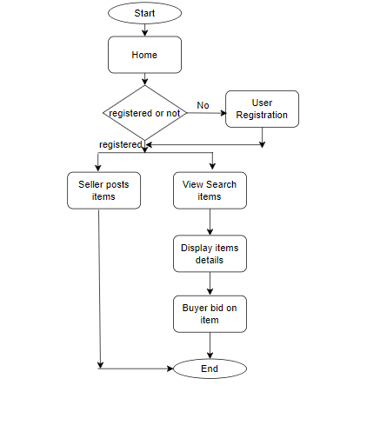
Figure 3.1 – 1: Flow chart of the system.

3.2. Use case Diagram.
The system's use case diagram is displayed as follows. Based on how they use the auction system, the system's users are categorised. Sellers, buyers, and anybody else are the users. Items can be posted by sellers. Items are up for bidders. Everybody has access to item searches, item lists, and item details.
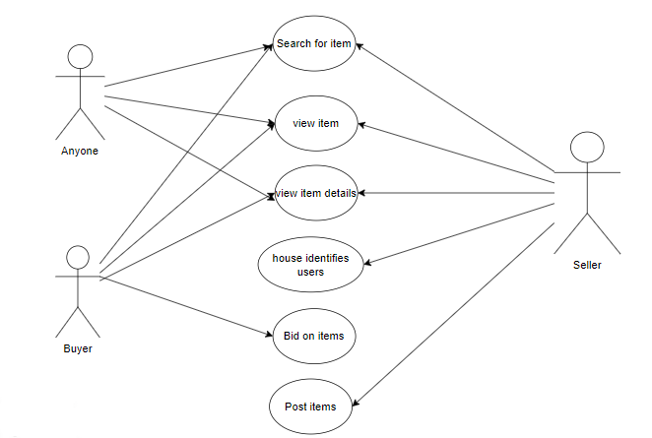
Figure 3.2 – 1: Use a case diagram of the system.

3.3. Database Design
The database design for the system is depicted in this diagram. The link between the tables is depicted in the figure below.
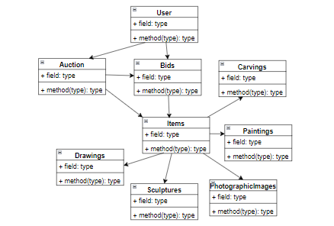
Figure 3.3 – 1: Database design for the system.

3.3. Wireframe
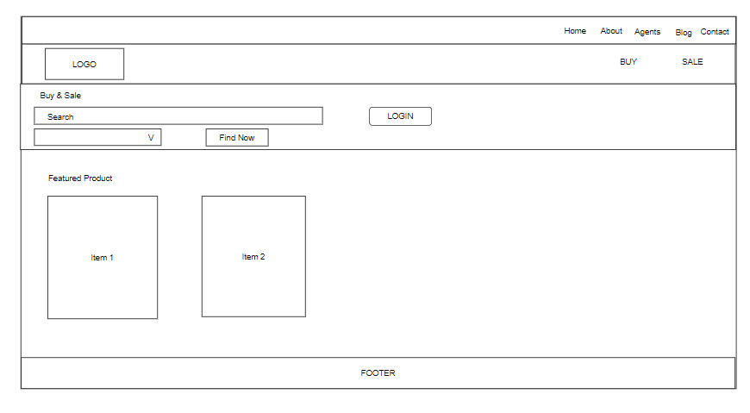
Figure 3.3 – 1: Wireframe of the home page for the system.

4. System Build and Technical Notes (Software Development Block/Sprint 1)
Add
Here, this is the code for adding, this code has been used to add different data like auction, items, users etc.
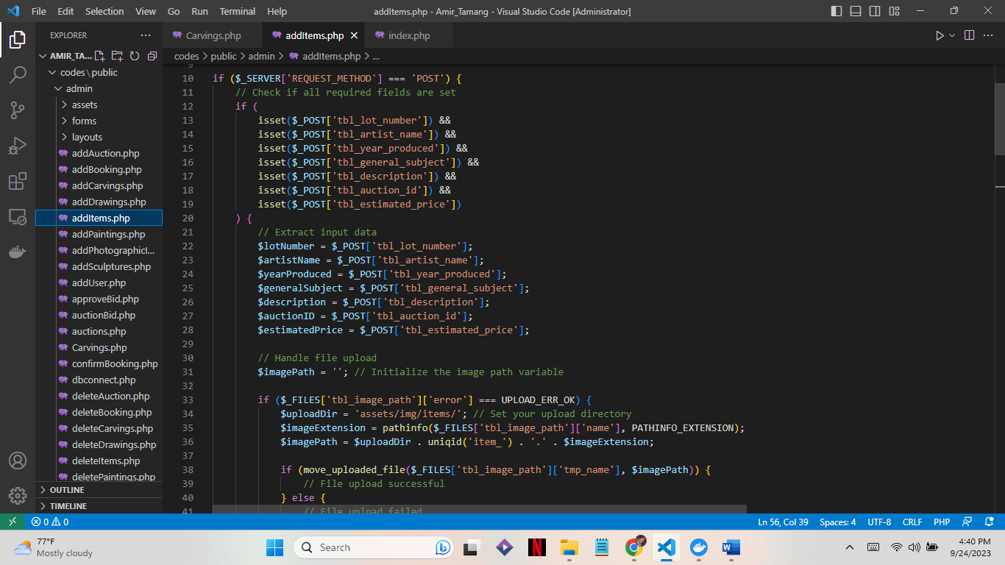
Figure 4 – 1: Add 1.
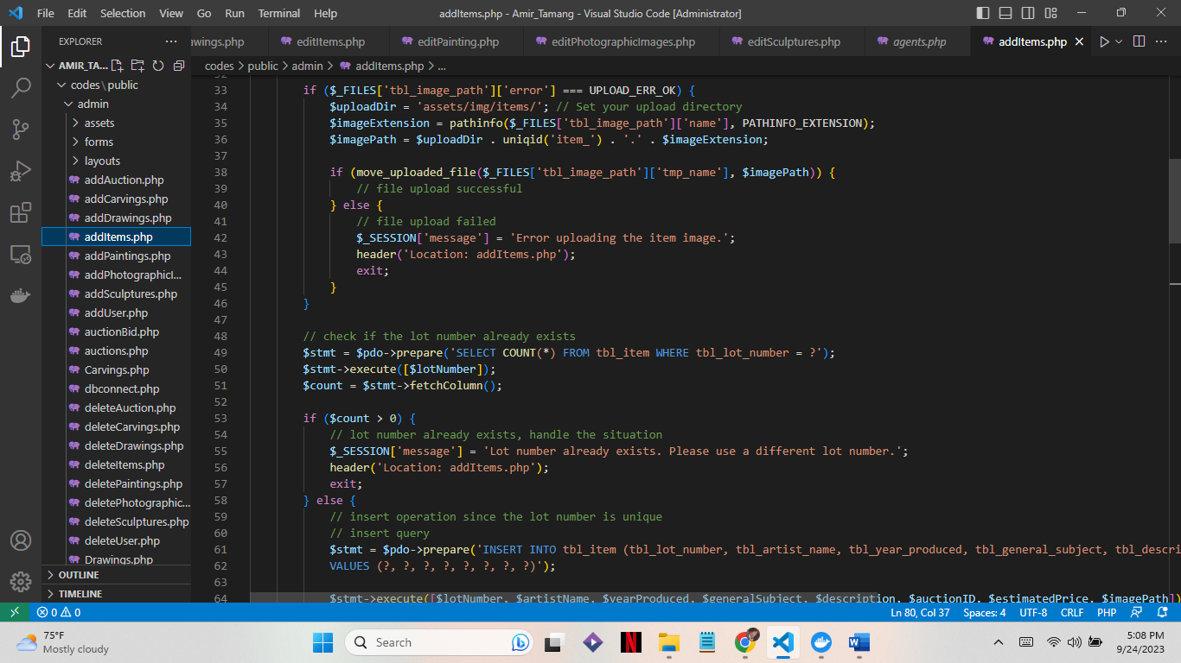
Figure 4 – 2: Add 2.
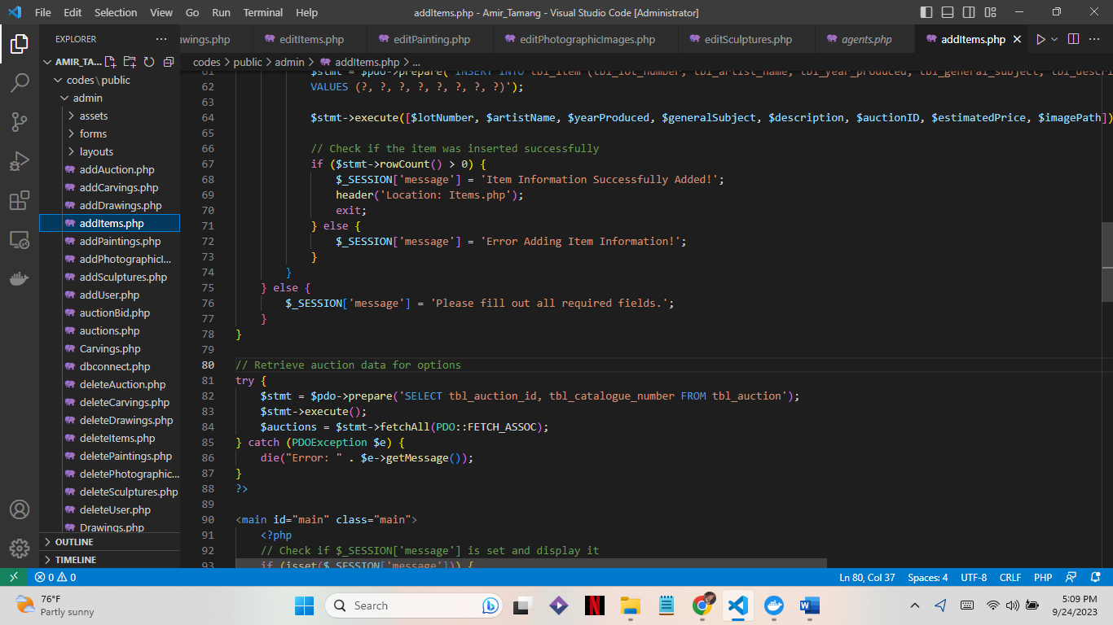
Figure 4 – 3: Add 3.
Edit
This the code for editing and same like adding this similar code has been used to edit many data.
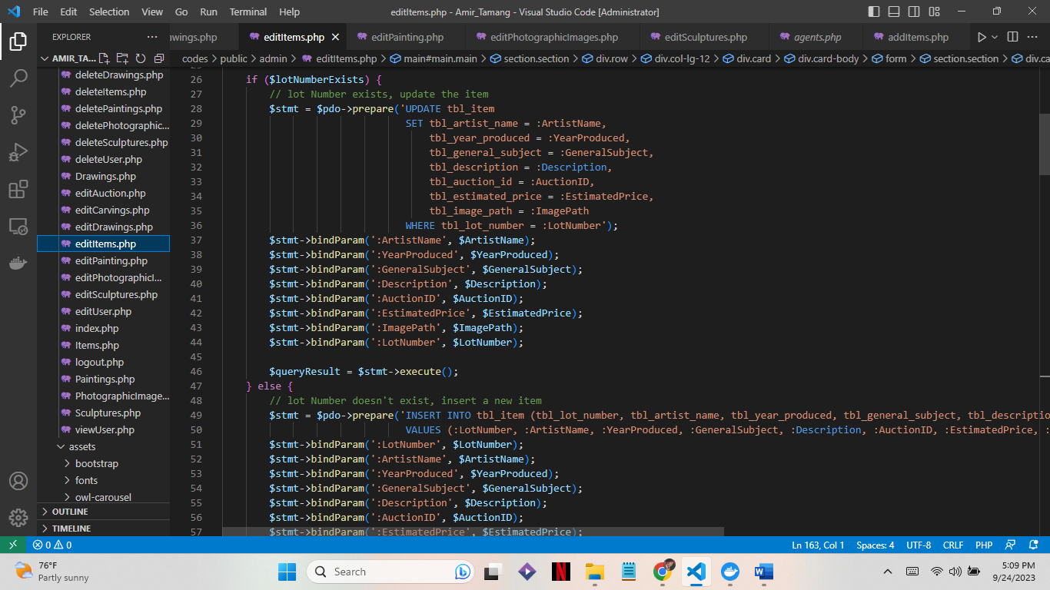
Figure 4 – 4: Edit.
Delete
Here is the code used to delete data.
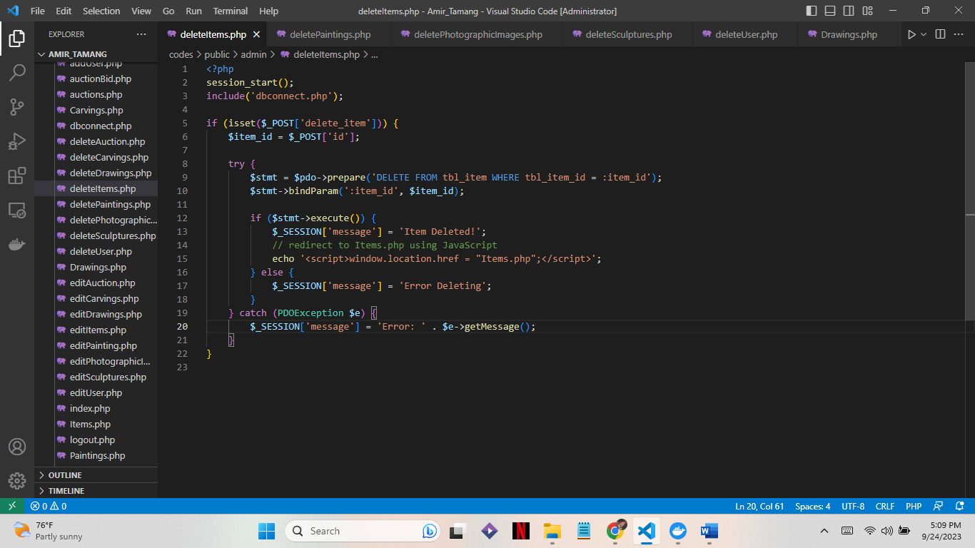
Figure 4 – 5: Delete.
Search
This code is used for searching by category of an item.
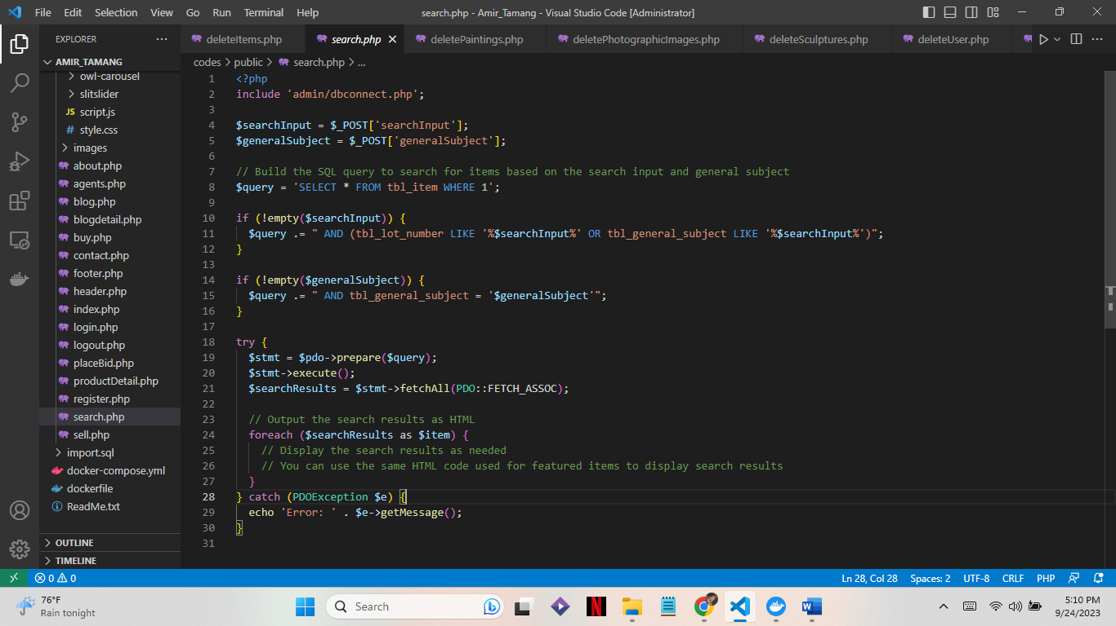
Figure 4 – 6: Search.
User information
This is the code to display the user information.
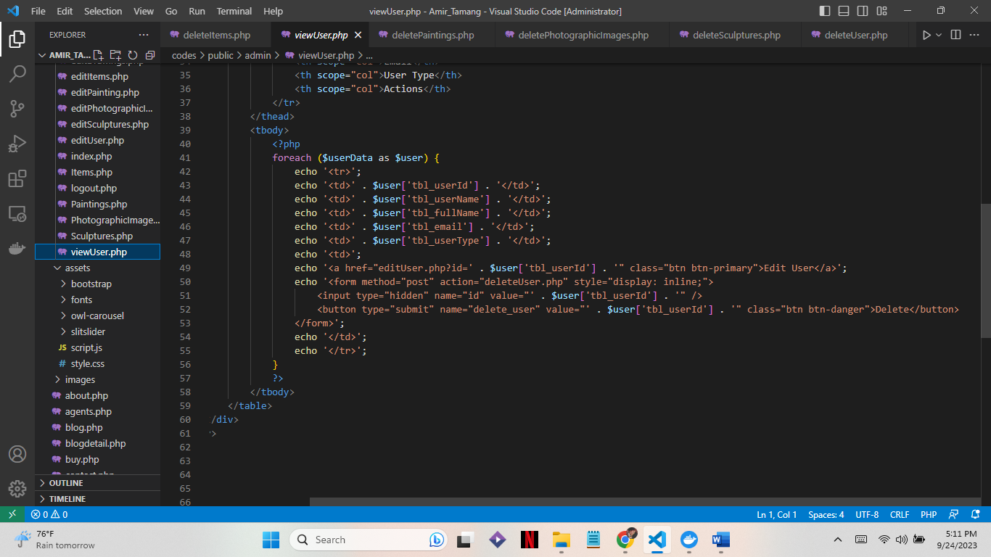
Figure 4 – 7: User Information.

System Testing & Evaluation Strategy (Software Development Block/Sprint 1)
Black Box Testing:
A testing technique known as "black box testing" focuses on testing a software application's functioning without looking at its core code or structure. Testing specialists examine the software's inputs and outputs as a "black box," determining whether it operates as planned. Because test cases are built based on the requirements and functionality of the product, testers do not need to be knowledgeable about the inner workings of the software. This type of testing is mostly focused on ensuring that the program functions as intended and can be used to detect vulnerabilities, errors, or unexpected behaviour.
These symbols are used to rate the functionalities:
- ‘✓’ a functionality that has been fully implemented.
- ‘?’ a functionality that has been partially implemented.
- ‘*’ is a functionality that has not been implemented.

Specification | Achieved (✓ /? /*) | Comments
Add auction and lot details | ✓ | Adding auction and auction lot details to the database.
Edit auction and lot details | ✓ | Modifying existing auctions and lot details present in the database.
Delete auction and lot details | ✓ | Deleting/archiving auctions and auction lot details in the database.
Display auction and lot details | ✓ | Displaying auctions and individual lot details for items within the database.
Search | ✓ | Allowing simple search criteria to be used to interrogate the database to yield appropriately matching results.
Additional Features
Advanced Search | ? | Allowing complex search criteria to be used to interrogate the database including finding items by, Artist, Category, Price, Auction Date, Subject Classification, or any combination of these, to find appropriate pieces for specific clients.
Client Record Details | ✓ | Expanding the system to include client record details.  (Details of both buyers and sellers)
Expanding prototype | * | Expanding the prototype to include a client commission bidding facility.  (Allowing clients to place advance bids before the day of the auction.)
Graph of lot items | * | Include a graphical representation of lot items within the database.
Payment Method | * | Incorporate appropriate financial elements into the system to allow Fotheby’s to record the sale price of each item and calculate commission.
Pending payments | ? | Extend the client records system to show all sales and pending sales (as a buyer or seller) for a given customer.
Security | * | Incorporate suitable security/access control features into the prototype software solution.
Automated ad-hoc report | * | Generate automated and ad-hoc reports of critical business events.
Client Information | ✓ | Potentially having online client areas to display essential information for existing clients (both buyers and sellers).

Table 5.1 – 1: Black box Testing.

6. Conclusion
We can make some preliminary judgments about the project's potential and constraints now that the first sprint of the Fotheby's Auction and Catalogue System prototype has been completed.
Project Success:
- Functional Milestones Attained: The first sprint was effective in bringing about several crucial capabilities, including adding, modifying, and deleting auction and lot data, displaying auction and lot details, and recording client record details. These accomplishments show that the project is moving closer to achieving its goals.
- User-Centric Approach: By addressing basic capabilities crucial to Fotheby's operations, such as cataloguing and maintaining auction goods and client records, the prototype development has taken a user-centric approach. The system will be in line with the demands and expectations of important stakeholders thanks to this strategy.
- Workshops held in collaboration with stakeholders, such as Mr. Max Fotheby, Mr Mark Jones, and Mr. Paul Smith, were crucial in establishing project needs, spotting obstacles, and determining the prototype's course. Stakeholder involvement has helped everyone comprehend the project's objectives.

Project Limitations:
- Unfinished Complex Features: Several complex features mentioned in the project brief have not yet been fully completed or have only been partially implemented despite the successful execution of essential functionality. Advanced search, client commission bidding, graphic representations, payment options, pending payments, security features, and automatic reporting are a few of them.
- Scope Expansion: During the first sprint, the project's scope increased, and new features were taken into consideration. While this might improve the system's capabilities, it might also make project management and deadlines more difficult.
In conclusion, the first sprint's conclusion shows that the prototype for the Fotheby's Auction and Catalogue System is progressing well. Stakeholder involvement helped the project successfully address fundamental functionalities. However, several areas need more focus and development in the following sprints, especially the integration of intricate features and thorough testing. Addressing these issues will be crucial as the project develops if a successful and reliable final prototype is to be produced.

Reference
Artsy. (2023). Artsy. https://www.artsy.net/
Docker Inc. (2023). Docker.
Ilie, S., Bădică, A., Ganzha, M., B˘, C., Muscar, A., B˘, A., Sandu, L., Sbora, R., & Paprzycki, M. (2019). Distributed agent-based online auction system. In Computing and Informatics (Vol. 33). https://www.researchgate.net/publication/281888649
Mark Otto and Jacob Thornton. (2018). Bootstrap.
Mind Tools Content Team. (2023). Planning a Workshop.
Oracle. (2023). MySQL.
The PHP Group. (2023). PHP.

Appendix 1
Diagram demonstrating the employment of several software components in the development of the solution.
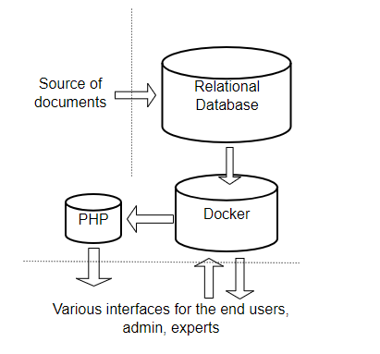
Figure Appendix – 1: Software components to develop the system.

