CSY2028
Web Programming Assignment 2
NAMI College
Baneshwor, Kathmandu

Submitted by:
Amir Tamang
UNID: 21422018 (L5)

Submitted to:
Sujita Parajuli
Tutor

Table of content Page

Introduction

Scope

Analysis

Conclusions & Recommendations

References

Introduction
This is the assignment of Web Designing CSY2028 Assignment 2. I am a web design agency developer in this assignment and have taken on a new client called Claire’s Cars. Claire runs a small car dealership and the company’s website lets customers see what she has for sale. Due to the nature of the business, customers like to view and test drive the cars in person before buying so online purchasing is not a concern, the website just acts as a catalog. The website was developed several years ago by Claire’s nephew but is now a little outdated and contains bugs that need fixing. So, I stepped up for this work to fix and remove the bugs from the website. According to the client’s demand, I have changed the systems on the website. Also, I removed the logo because my tutor said you can remove it as I was having trouble with the size of that logo which was covering the whole web page.
Scope
The text's description of the assignment's scope states that it entails fixing and modernizing Claire's Cars, a modest auto dealership, website. Customers can see the automobiles for sale on the internet like a catalog, however, online purchase is not an issue. The customer has asked for system modifications and the removal of the logo because the website was built many years ago and still has issues.

Therefore, to enhance user experience and increase website effectiveness, the scope of the project also covers bug fixes, system updates, and logo removal. Additionally, it entails creating a website of the highest caliber that exceeds the client's expectations and enhances the website's overall appeal.

To satisfy the demands and expectations of the customer, it is the purpose of the project to mend, improve, and update Claire's Cars' current website.

Analysis
I must take care to make sure that the website I offer is of a good caliber and fits the client's requirements. The user experience may be enhanced and the website can be made more efficient by removing bugs and upgrading the systems. Additionally, deleting the logo that was affecting the web page's size will help the website seem more polished and visually acceptable.
I now represent Claire's Car, a new customer that owns a modest auto business. The company's website was created by Claire's nephew many years ago, but it is now out-of-date and has issues that need to be fixed. I volunteered to take on this job as a developer for a web design company to improve the website and satisfy the client's expectations.
I modified the website's systems and got rid of the logo that was interfering with the web page's size by the client's requests. Customers can browse the cars for sale on the website like a catalog, but they don't like to buy them online since they prefer to see and test-drive the vehicles in person.
As the client's business and reputation may be affected, it is significant to emphasize that the website's quality is essential to this job. I can enhance user experience and increase website effectiveness by addressing issues and updating the systems. I can make the website look more polished and professional by getting rid of the logo.
In conclusion, it's critical to focus on the little things and produce a website that lives up to client expectations.

Checklist
Below is a checklist of the requested changes that I have implemented showing which changes I have/haven’t completed.

Feature | Completed? | Relevant files | Notes
Display “Sunday: Closed” | Yes | All PHP files | Every page displays Sunday: closed
Add Claire’s Career | Yes | career.php | Claire’s career page is added
Added manufacturers not showing- fixed? | Yes | Addmanufacturer.php,  Manufacturers.php | Manufacturers can be added
Added ‘Archive’ | Yes | Admin/archivecars.php Admin/archive.php | Cars can be stored in an archive when its booked
Display ‘was and now price’ | Yes | Admin/cars.php | The car’s before and present price is displayed
Add Admin | No | Admin/ | Claire’s assistance admin account isn’t created
Display ‘mileage and engine type’ | Yes | Admin/cars.php  Admin/editcars.php  Admin/addcars.php | The car’s mileage and the engine type are displayed when adding the car instead of in the description
Upload 4 photos | Yes | Admin/cars.php  Admin/addcars.php | Able to upload 4 photos of the car
Add stories to the homepage | Yes | Admin/index.php | Add stories to the homepage
Update Contact page | Yes | Index.php | The completed message is shown after the form is filled and submitted to the contact page

Testing

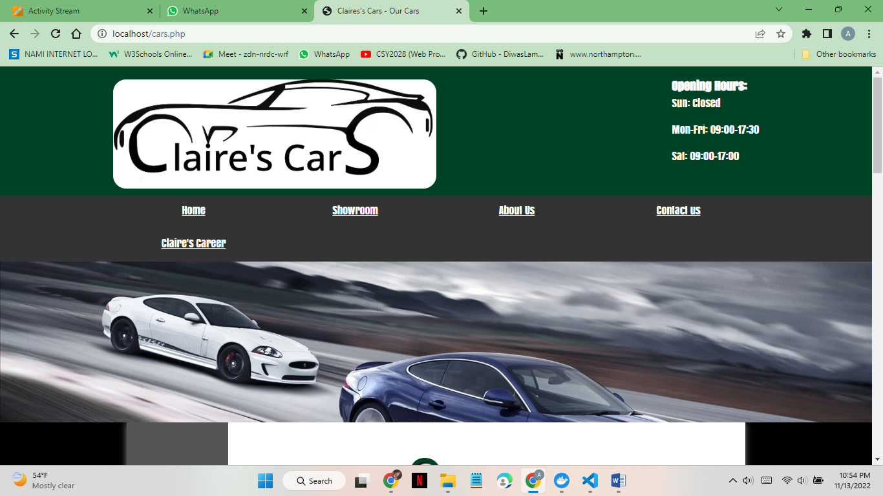

This is the test of my home page, as you can see there is the opening hour at the top right of the photo. Sunday is closed, which is changed according to the request of my client Claire. You can also see the extra button on the navigation bar which is ‘Claire’s career’. It is also added there at the request of my client.

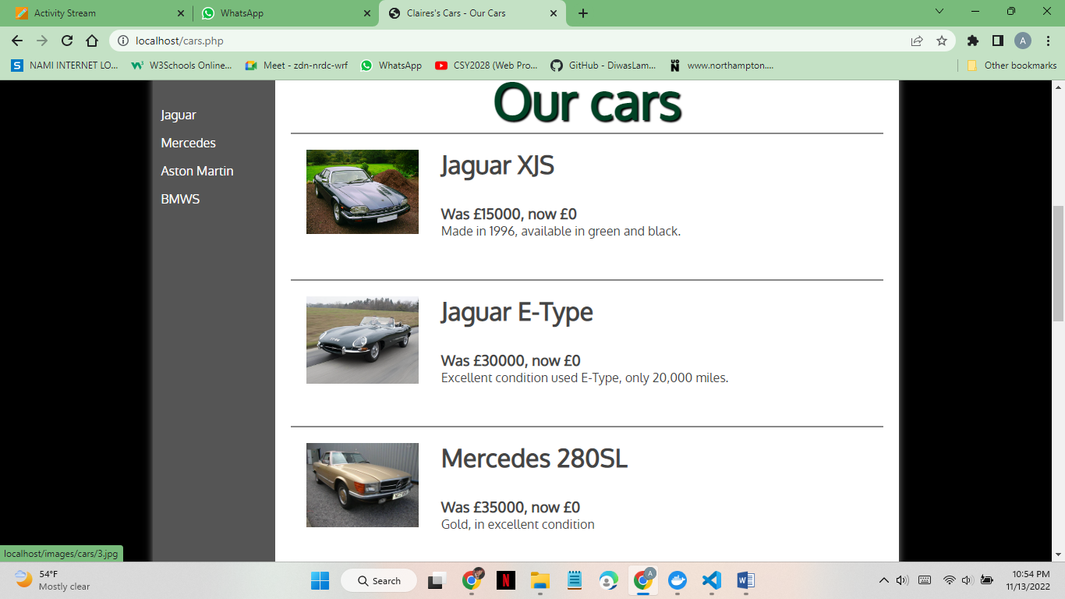

Here is the list of the cars with their manufacturers on the sidebar.

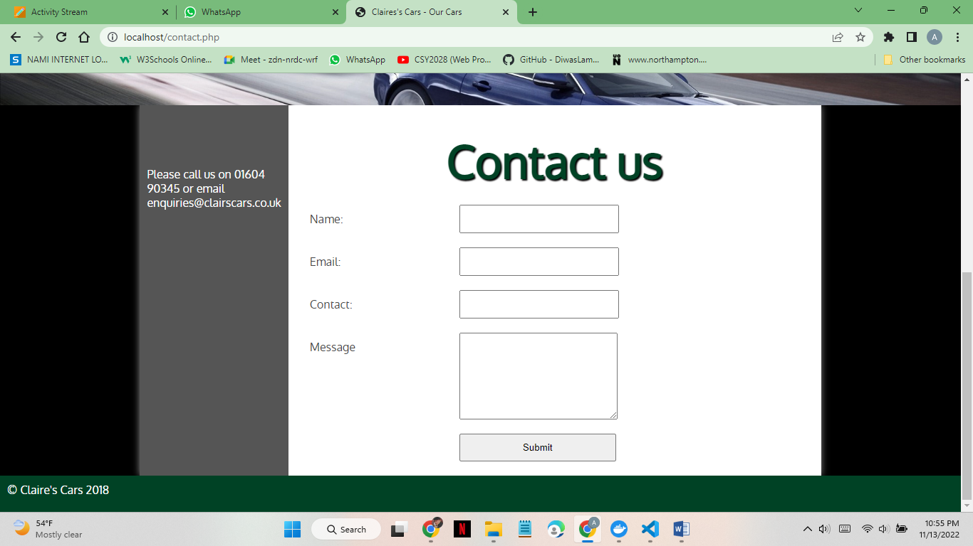

The contact us page is updated with a form.

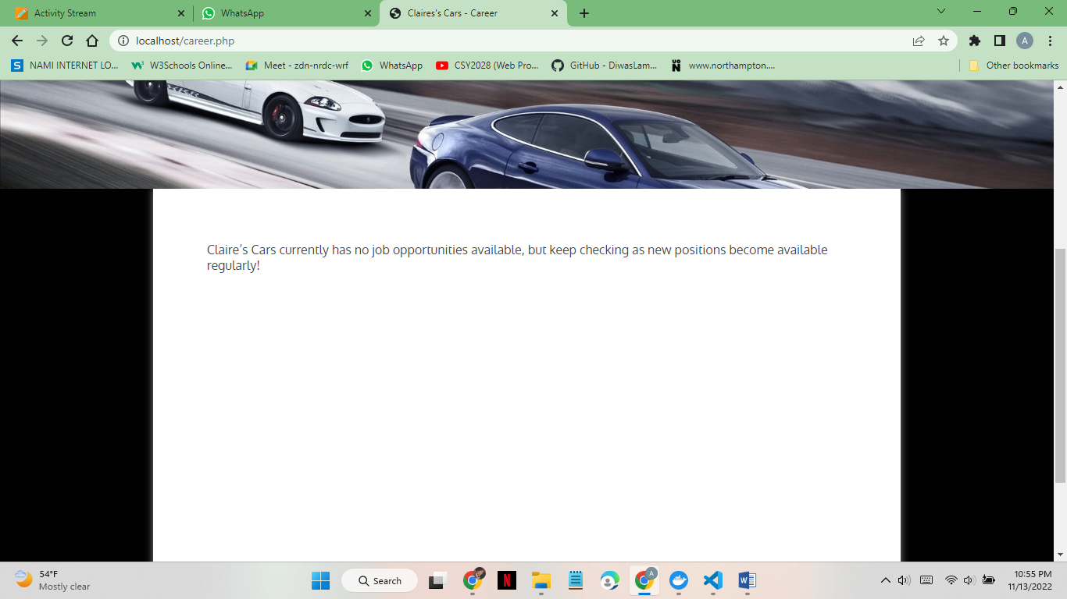

This message is shown on the career page as instructed by Claire.

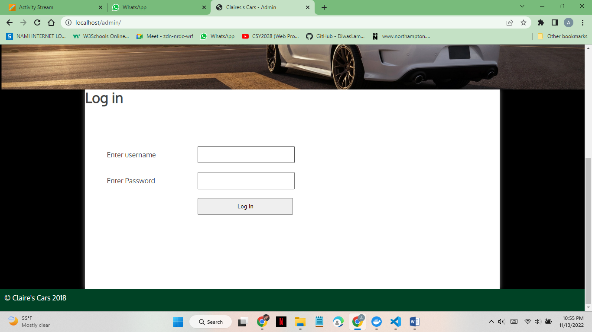

The login page for admins is there.

Conclusions and recommendations
This assignment aimed to assess my ability to modify and improve PHP code on an existing PHP/MySQL-driven website. I completed the assignment by meeting most of the requirements of my client. I have edited HTML and debugged PHP codes in this assignment. The client’s website was outdated and had so many bugs. I added many functions like adding the manufacturer and display before and after the price of the car, Displaying the mileage and engine type of the car with the car image as before it was shown in the description of the image of the car, giving a function to the admin to add 4 photos of the cars in the showroom page, Allow the admin to add and display stories on the homepage and I also have updated the contact page where a form is displayed and when the form is filled and submitted, a pop-up shows on the page saying completed and also admin can see the message that was written on the form while filling by the user.
I was able to complete the assignment effectively by altering and enhancing the PHP code of a PHP/MySQL-driven website that was already in existence. My efforts to edit HTML and troubleshoot PHP scripts have helped to eliminate errors and enhance the website's general operation.
I updated the contact page with a form that provides a pop-up confirmation and enables the admin to view the message submitted by the user. These new features include displaying the manufacturer and price of the car, adding the ability for the admin to upload multiple photos of the cars in the showroom, displaying stories on the homepage, and adding the ability for the admin to upload multiple photos of the cars in the showroom. The user experience and effectiveness of the website can both be significantly increased by these additions.
This assignment has shown me how to edit and enhance PHP code, which is an important skill in web development.
In conclusion, the work you have done in this assignment shows that you have the key web development skill of being able to edit and enhance PHP code. By addressing issues, including new features, and enhancing the website's general operation, you have effectively met the client's objectives. By displaying the manufacturer and price of the car, enabling the admin to post several photographs of the automobiles in the showroom, and upgrading the contact page with a form, among other changes, you have significantly improved the user experience and increased the website's effectiveness.
Based on my work, I'll continue to hone my PHP coding abilities and look into fresh approaches to enhancing website functioning. To improve my abilities and position myself as an even more valuable asset to clients, I also want to think about gaining knowledge of additional web development frameworks and technologies.
In general, I am pleased with my efforts and the strides I have achieved in web development. I'll continue to work on creating the website.
Thus, I have done most of the work to develop Claire’s website further.
In the future, the website can add the following details to make it better:
- Can change the CSS to make the website more welcoming.
- Have to add a search bar.
- More car manufacturers can be added.
- A member login can be created for members.
- Videos can be posted for better reviews of the cars.
- A delivery option can be added.
- Renting option should be added etc.

References

- (Stockfont, 2023). The font for the car website of assignment is used from the website.

