Name: Amir Tamang
Student ID: S00393664
Unit: ITEC618 - Programming Concepts
Assessment: Case Study (Assessment 3)

Part 2: Supermarket Product System (OOP Case Study)
Overview
This project demonstrates key OOP concepts, including:
- Inheritance
- Polymorphism
- Encapsulation
- Abstraction

Features
- Loads product data (fresh fruit and packaged items) from a `products.txt` file.
- Displays a menu of available items in the console.
- Allows users to select products by entering their IDs.
- Generates and prints a purchase docket with the total price and tax.
- Apply different tax rates depending on the item type.

OOP Concepts in Code
- Inheritance: FreshFruit and PackagedItem extend Product.
- Polymorphism: The list List<Product> stores both subclasses.
- Encapsulation: Class fields are mostly private/protected with getters/setters.
- Abstraction: Shared methods like getTaxComponent() are overridden in each subclass.

OOP Concepts Demonstrated
Concept | How it is Applied
Inheritance | `FreshFruit` and `PackagedItem` extend the base class `Product.’
Polymorphism | Products are stored in a `List<Product>`, allowing dynamic method calls like `toString()` and `getTaxComponent()` at runtime.
Encapsulation | Fields are protected/private with getters and setters.
Abstraction | Common methods like `getTaxComponent()` and `toString()` are defined in the base class and overridden in subclasses.

UML Diagram
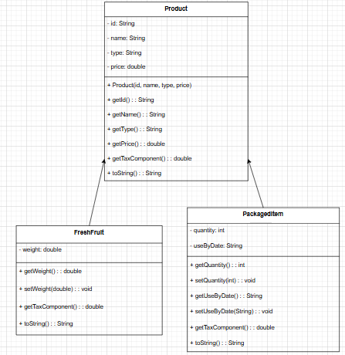
Figure 1: UML diagram of Supermarket.

Product (Superclass)
- Represents a general product.
- Contains common attributes:
  - id – unique identifier
  - name – product name
  - type – either “Fresh Fruit” or “Packaged Item”
  - price – product price
- Includes methods shared by all products:
  - getId(), getName(), getType(), getPrice() – accessors
  - getTaxComponent() – returns the tax on this item (overridden by subclasses)
  - toString() – returns a formatted string of the product details

FreshFruit (Subclass of Product)
- Inherits from Product.
- Represents fresh fruit products.
- Adds a specific attribute:
  - weight – measured in grams
- Overrides:
  - getTaxComponent() – always returns 0 (fresh fruit is tax-exempt)
  - toString() – includes weight in the output

PackagedItem (Subclass of Product)
- Inherits from Product.
- Represents packaged goods.
- Adds two attributes:
  - quantity – number of units inside the package
  - useByDate – expiry date
- Overrides:
  - getTaxComponent() – returns 10% of the product’s price
  - toString() – includes quantity and expiry date

Relationships
- Both FreshFruit and PackagedItem are connected to Product by inheritance (shown using a triangle arrow pointing up to Product).
- This demonstrates the "is-a" relationship:
  - FreshFruit is a Product
  - PackagedItem is a Product
- This enables polymorphism: both subclasses can be treated as a Product in a list or method call.

Output Screenshots
Product Menu
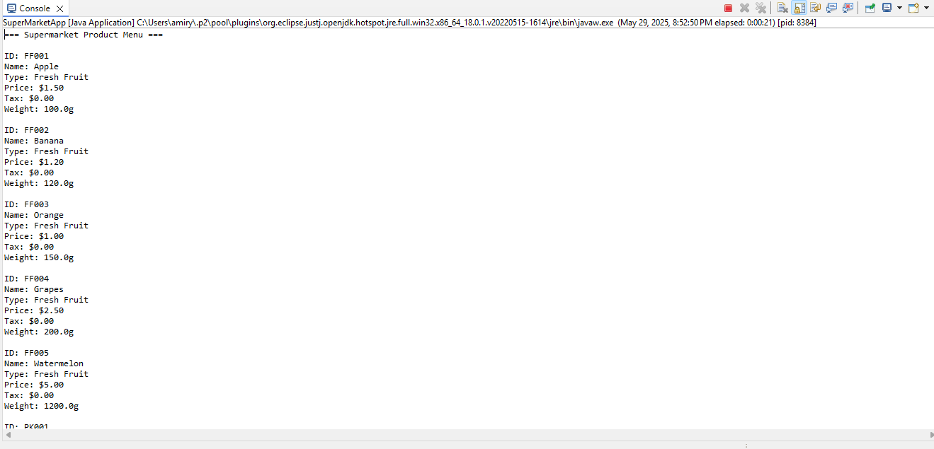
This is the first half of the menu in the Supermarket App.
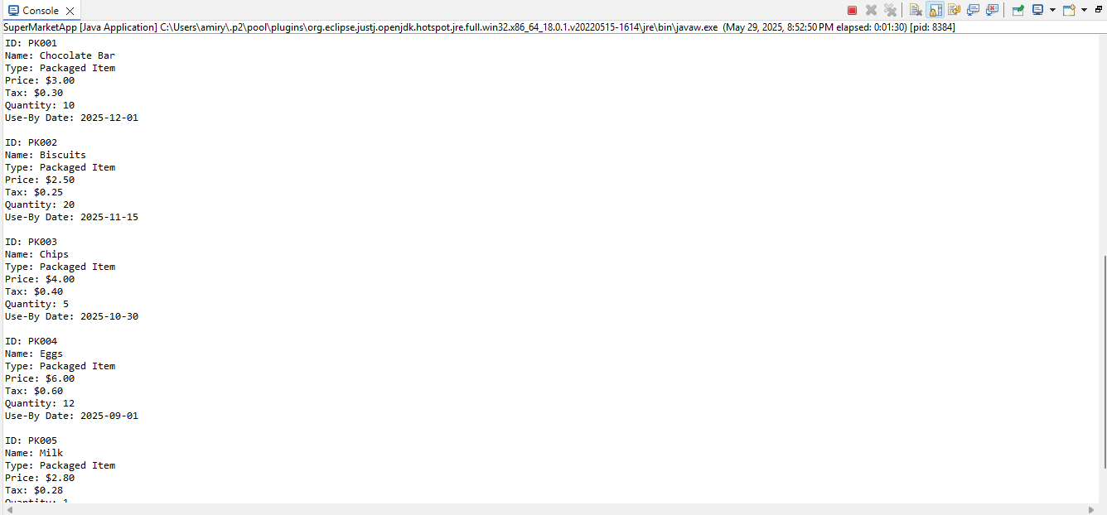
And this is the next half of the menu in the Supermarket App.

Purchase Docket
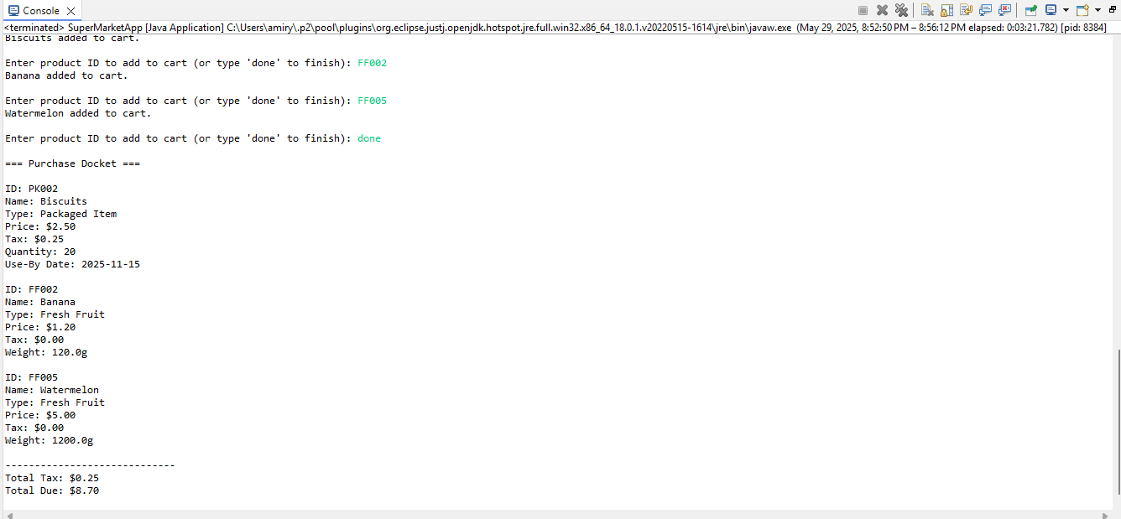
This screenshot shows the final output after I entered some product IDs to select and add the products to the cart. After that, I typed done to finish the selection. The program printed details of each item chosen, the total tax, and the total due.

