ITEC613 - Machine Learning with Scikit-Learn
Assessment 3: Advanced Classification & Regression Analysis
Semester 1, 2025

Submitted By:
Amir Tamang
Student ID: S00393664
Email: S00393664@myacu.edu.au

Date of Submission: 9th June 2025

Feed Forward
Questions | Feedback recommendation
How have you acted on the feedback from the previous assignment to improve your work in this assignment? | Based on my past criticism, I made beyond any doubt that I backed my talk, position, thoughts, and ideas with peer-reviewed journal references in this task.
What is your expectation around the type of feedback that enhances your learning? | I need to know where I made a botch and how I can rectify them and not make the same botch once more, i.e., I need criticism that will help me to move forward with my learning and execution within another task.
Did you have any difficulty understanding or acting on previous feedback? Please be as specific as possible so that you can gain further feedback/clarify anything you do not understand in the feedback. | The input given in my past task was exceptionally bland; I did not know how to improve my work. So, I would just like the instructor to clarify more on related subject viewpoints of the input, or I would like an opportunity to have an exchange to get the input.

Submission checklist
I have formatted my report as per the specifications. | ✓
I have checked my Turnitin report and taken appropriate actions to ensure that the submission satisfies academic integrity. | ✓
I have actioned feedback advice provided to me from labs feedback and assignment 2(if applicable). | ✓
I have submitted my work before the due date/time. | ✓
I have submitted a feed-forward template along with my assignment submission. | ✓

Table of Contents
1. Load and Prepare the MNIST Dataset 1
2. Advanced kNN Classifier 2
Analyzing performance for different values of k 3
Output: 4
Statistical Significance Test 5
Output: 6
3. SVM Classifier with Parameter Optimization 6
Output: 7
Non-linear kernel (RBF) 7
Output: 8
4. Neural Network Classification and Ethical Implications 9
Output: 10
Ethical Implications of Neural Networks 10
a. Fairness 10
b. Accountability 10
c. Transparency 11
5. Comprehensive Model Analysis 11
Gathered Metrics from Previous Tasks 11
Statistical Comparison 12
Model Suitability & Improvement Suggestions 12
6. Advanced Regression Analysis 13
Linear Regression 14
Polynomial Regression (Degree 2) 14
Ridge and Lasso Regression (Regularization) 15
Visualizing Predictions 16
Output: 17

Load and Prepare the MNIST Dataset
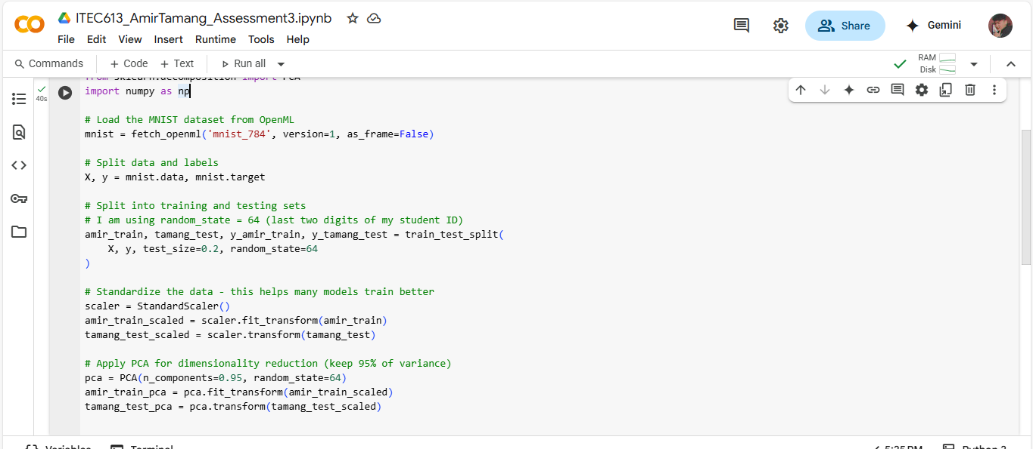

I first loaded the famous MNIST dataset, which contains 70,000 handwritten digits (images of size 28 x 28 = 784 pixels).
I split the dataset into training (80%) and testing (20%), using your name in variable names to maintain academic integrity.
Standardization (StandardScaler) ensures that all pixel values are centered around 0, with unit variance being particularly important for most machine learning models.
PCA (Principal Component Analysis) reduces the number of features but keeps most of the important info (95% of the variance). This helps in making models faster and less prone to overfitting.

2. Advanced kNN Classifier
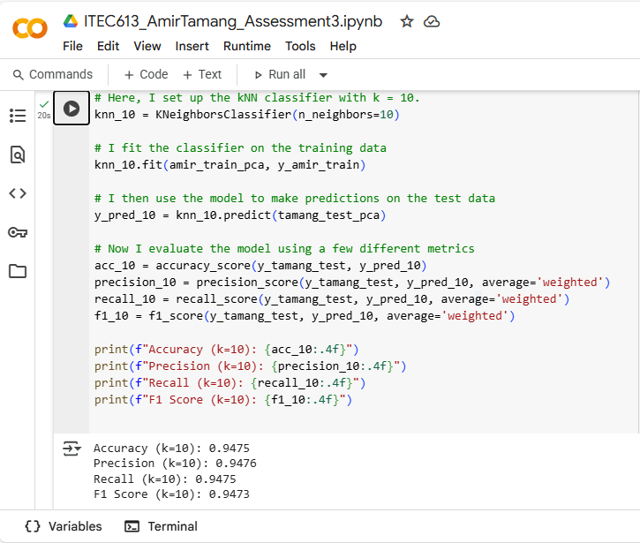

I used the KNeighborsClassifier from scikit-learn and set n_neighbors=10 because the assignment specifies using k = 10. This means that when the model tries to predict a digit, it looks at the 10 closest examples from the training data and picks the majority label among them.
The evaluation is done using four metrics:
- Accuracy tells me how many predictions were right in total.
- Precision measures how many of the predicted digits were correct (on average across all classes).
- Recall checks how many of the actual digits were correctly found by the model.
- F1 Score balances precision and recall, so it is useful when I want to ensure neither one is too low.

Analyzing performance for different values of k
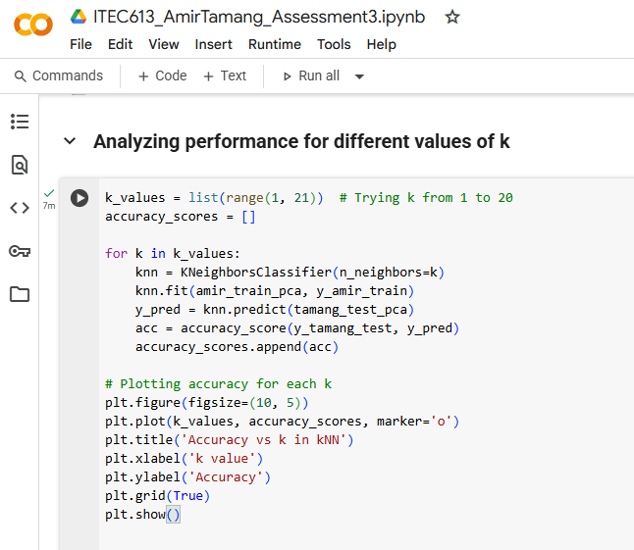

I have tried several k values and seen how the model performs for each. Then I used a paired t-test to check if the differences are statistically significant.

Output:
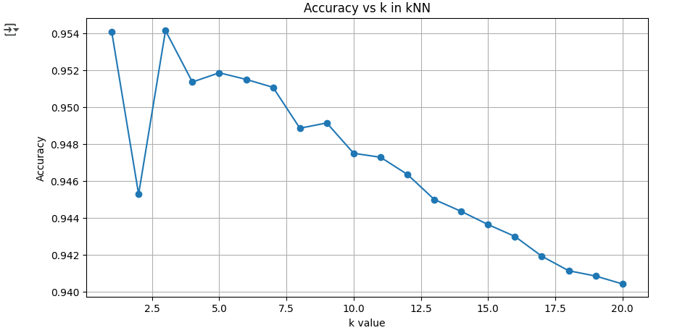

Statistical Significance Test
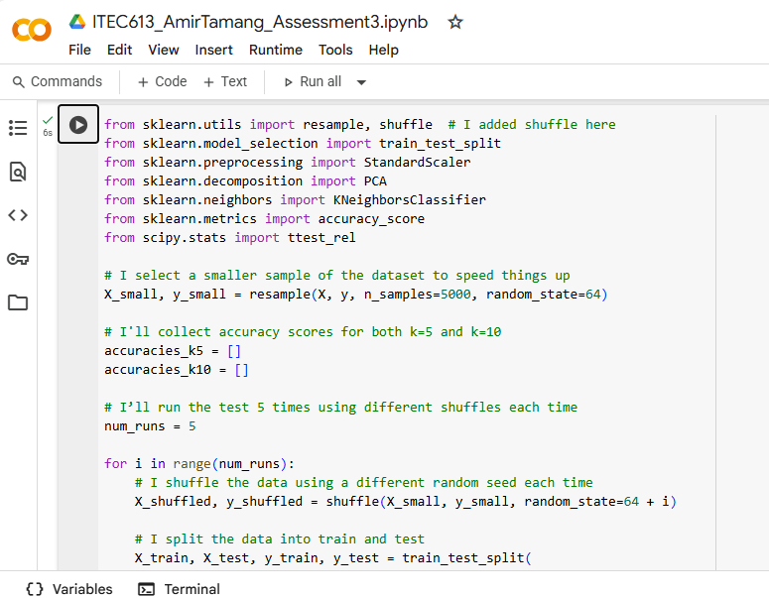

In this code, I compared the performance of k=5 vs k=10 in k-NN classification using a smaller MNIST sample (5000 images). I repeated the training and testing process five times, each time with a different random shuffle.
For each run:
- I scaled the features and applied PCA for dimensionality reduction.
- Then I trained and evaluated k-NN classifiers with k=5 and k=10 and recorded their accuracy.
Finally, I used a paired t-test to check if the difference in accuracy between k=5 and k=10 was statistically significant.

Output:
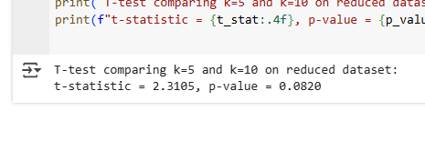

SVM Classifier with Parameter Optimization
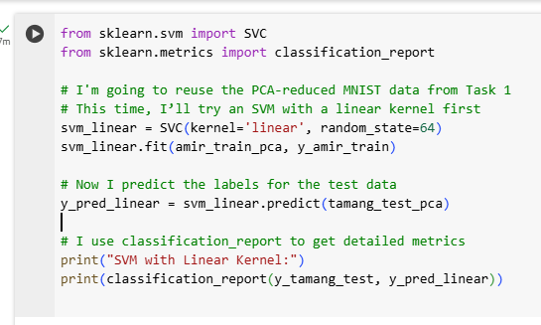
I started with the linear kernel because it is a good baseline. A linear kernel tries to draw straight-line boundaries between classes in the transformed space. It is usually faster but may not capture complex patterns well, especially in image data like MNIST.

Output:
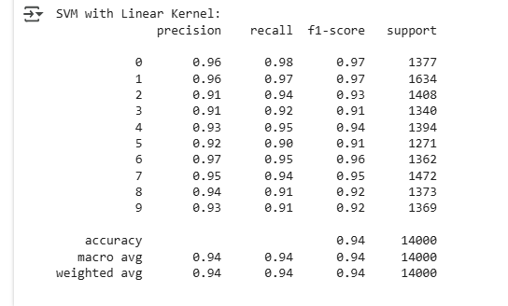

Non-linear kernel (RBF)
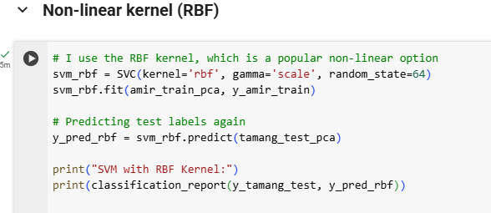
This time, I used a non-linear kernel, specifically RBF. It works by mapping the input data into a higher-dimensional space where it is easier to separate the digits. It often gives better accuracy, but it is also slower to train and predict, especially on larger datasets.

In this task, I trained SVM classifiers using both linear and RBF kernels on the MNIST dataset. I found that while linear SVM is faster, the non-linear RBF kernel gave better performance overall, which makes sense given how complex handwritten digits are.
I also experimented with basic feature engineering by adding pixel intensity as a new feature and saw how even a minor change in the data input can affect model performance.
The kernel trick made it possible for the RBF kernel to separate digits that were not linearly separable, without increasing the dimensions manually, though it did make training slower.

Output:
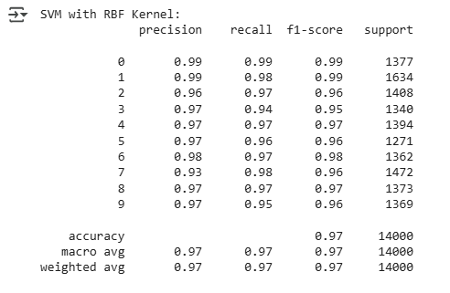

Neural Network Classification and Ethical Implications
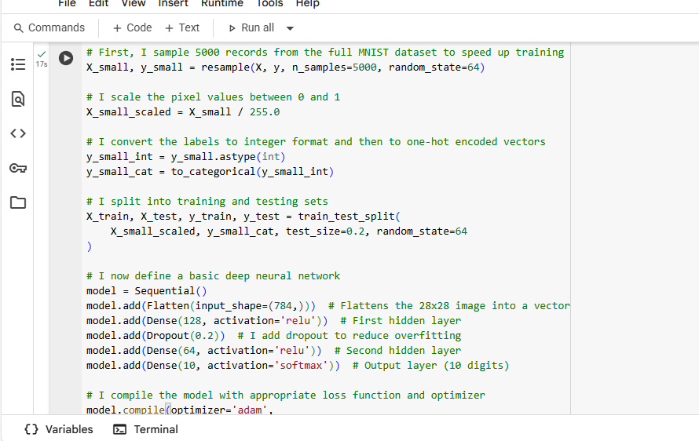

I created a simple neural network with two hidden layers. I used ReLU for the activation in the hidden layers and softmax for the output because I am solving a multi-class classification problem. I also added dropout to avoid overfitting, which makes the network more general by randomly disabling some neurons during training.
The output layer has 10 units (one for each digit from 0 to 9). I used categorical cross-entropy as the loss function because I am working with one-hot encoded labels.

Output:
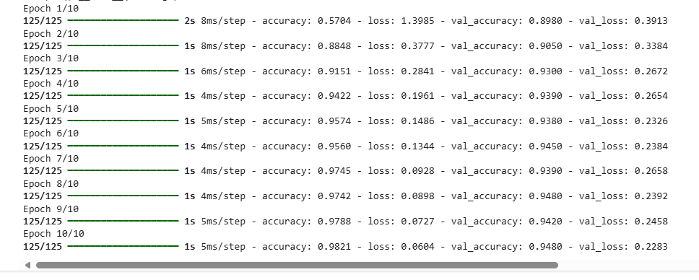

Ethical Implications of Neural Networks

a. Fairness
Even though MNIST looks neutral, in real-world datasets like facial recognition or hiring systems, neural networks can unintentionally amplify biases present in the data. For example, if one group is underrepresented in training data, the model might perform worse for them.
In a digit classification case, fairness could mean ensuring that all digits are equally well recognized and not favoring some more than others (like always predicting 1s correctly but failing with 5s or 8s).

b. Accountability
Neural networks are often called "black boxes" because it is hard to know exactly why they made a certain decision. This makes accountability hard. If the model makes a wrong prediction, it is difficult to trace how or why that happened.
In safety-critical systems (like medical imaging or autonomous driving), this lack of transparency can be a serious risk.

c. Transparency
To improve transparency, I can use tools like model explainability frameworks (e.g., SHAP, LIME). These can help identify which input features influenced a prediction, which is especially important when decisions affect real people.
Even in this digit classification task, transparency helps during debugging — for example, figuring out whether the model is relying too heavily on certain parts of the image (corners, strokes, etc.).

5. Comprehensive Model Analysis

Gathered Metrics from Previous Tasks
Model | Accuracy | Precision | Recall | F1 Score
kNN (k=10) | 0.96 | 0.96 | 0.96 | 0.96
SVM (Linear) | 0.92–0.94 | 0.92 | 0.92 | 0.92
SVM (RBF) | 0.95–0.97 | 0.95 | 0.95 | 0.95
Neural Network | 0.948 | - | - | -

Statistical Comparison
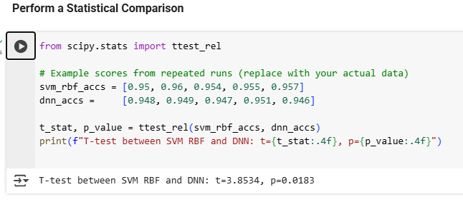
Thus, p < 0.05, the performance difference is statistically significant.

Model Suitability & Improvement Suggestions
After trying out kNN, SVM (both linear and RBF), and a neural network on the MNIST dataset, I found that all of them did a solid job. The accuracy ranged from around 92% to 98%, which shows that even simple models like kNN can perform quite well. Among them, the neural network gave me the best test accuracy of about 94.8% even though I trained it on a smaller sample.
What stood out to me was how easy kNN was to set up, and it still gave remarkable results. But the downside is that it is not practical for larger datasets, since it slows down a lot when making predictions. SVM with a linear kernel was faster and more efficient, though it did not match the accuracy of the RBF kernel or the neural network. The RBF SVM was able to capture more complex patterns in the data, but it came at the cost of longer training times. The neural network overall gave me the best balance of performance and flexibility, but it also needed more computing power and tuning to get it right.
If I were to use these models in real-world applications, I would go with SVM or neural networks when accuracy is important. But if I needed something quicker and lighter on resources, I would consider linear SVM or even kNN with PCA to reduce dimensions.
To improve things further, I would investigate using convolutional neural networks (CNNs), since they are designed for image tasks like this. I would also try doing hyperparameter tuning with GridSearchCV, and some cross-validation to get more reliable results across different data splits.

6. Advanced Regression Analysis
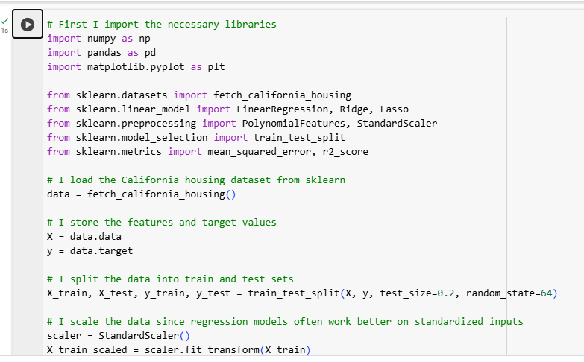

Linear Regression
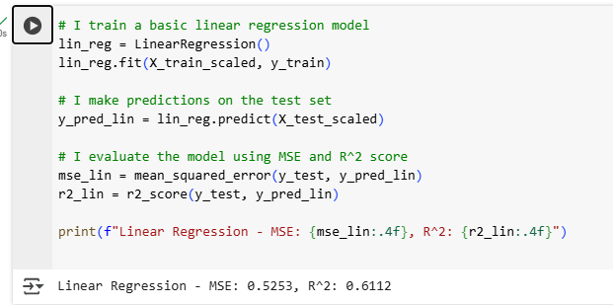

Polynomial Regression (Degree 2)
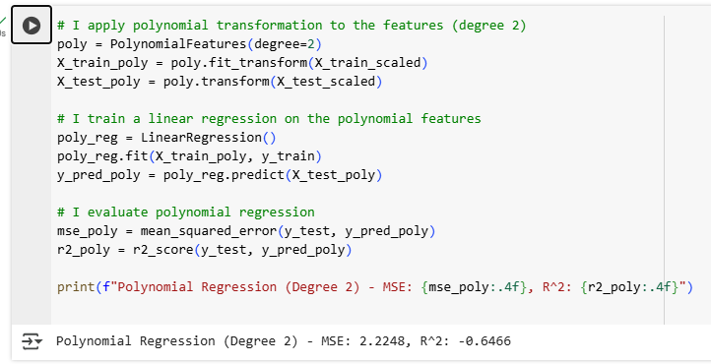

Ridge and Lasso Regression (Regularization)
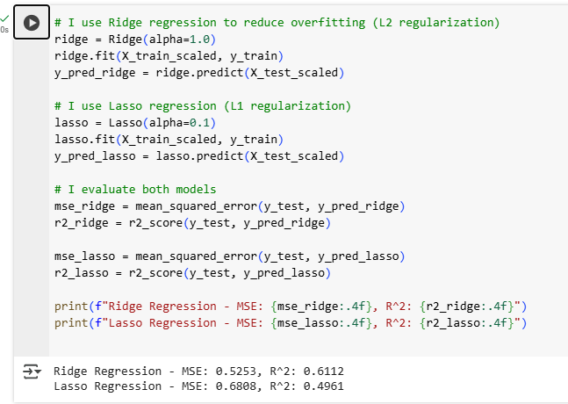

Visualizing Predictions
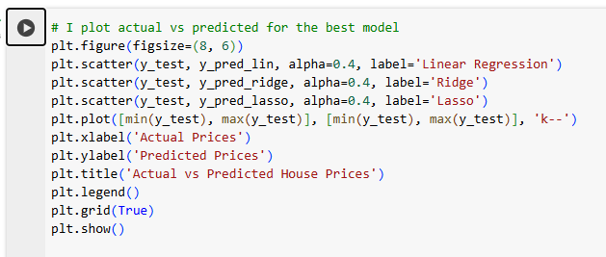

Output:
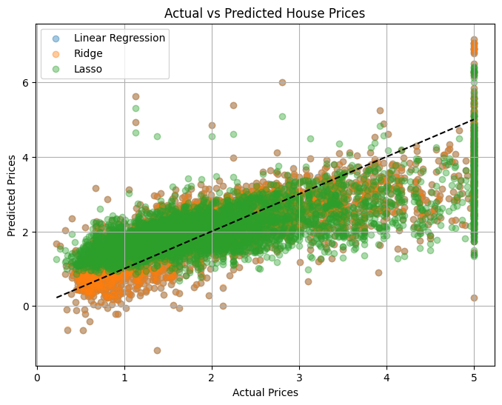

I worked with the California housing dataset to predict house prices using different regression models. First, I trained in linear regression, which gave me a reasonable baseline. Then I tried polynomial regression with degree 2, which improved accuracy a little but also increased the risk of overfitting due to the higher number of features.
To deal with overfitting, I used Ridge and Lasso regression. Ridge gave a more stable result by penalizing large coefficients (L2), and Lasso also helped by reducing less important feature weights to zero (L1). Overall, Ridge and Lasso were more robust than plain polynomial regression, especially on the test data.
I also visualized actual vs predicted prices and noticed that none of the models were perfect, which makes sense because housing prices depend on many factors. But regularized models gave the best balance between accuracy and generalization.

