Name: AMIRTHA A

Superset id: 6394120

**Week 5 Microservices Handson**

Creating Microservices for account and loan :

In this hands on exercises, we will create two microservices for a bank. One microservice for handing accounts and one for handling loans. Each microservice will be a specific independent Spring RESTful Webservice maven project having it's own pom.xml. The only difference is that, instead of having both account and loan as a single application, it is split into two different applications. These webservices will be a simple service without any backend connectivity.

**Account Microservice :**

* Create folder with employee id in D: drive   
  Create folder named 'microservices' in the new folder created in previous step. This folder will contain all the sample projects that we will create for learning microservices.
* Open https://start.spring.io/ in browser
* Enter form field values as specified below:
* Group: com.cognizant
* Artifact: account
* Select the following modules
* Developer Tools > Spring Boot DevTools
* Web > Spring Web
* Click generate and download the zip file

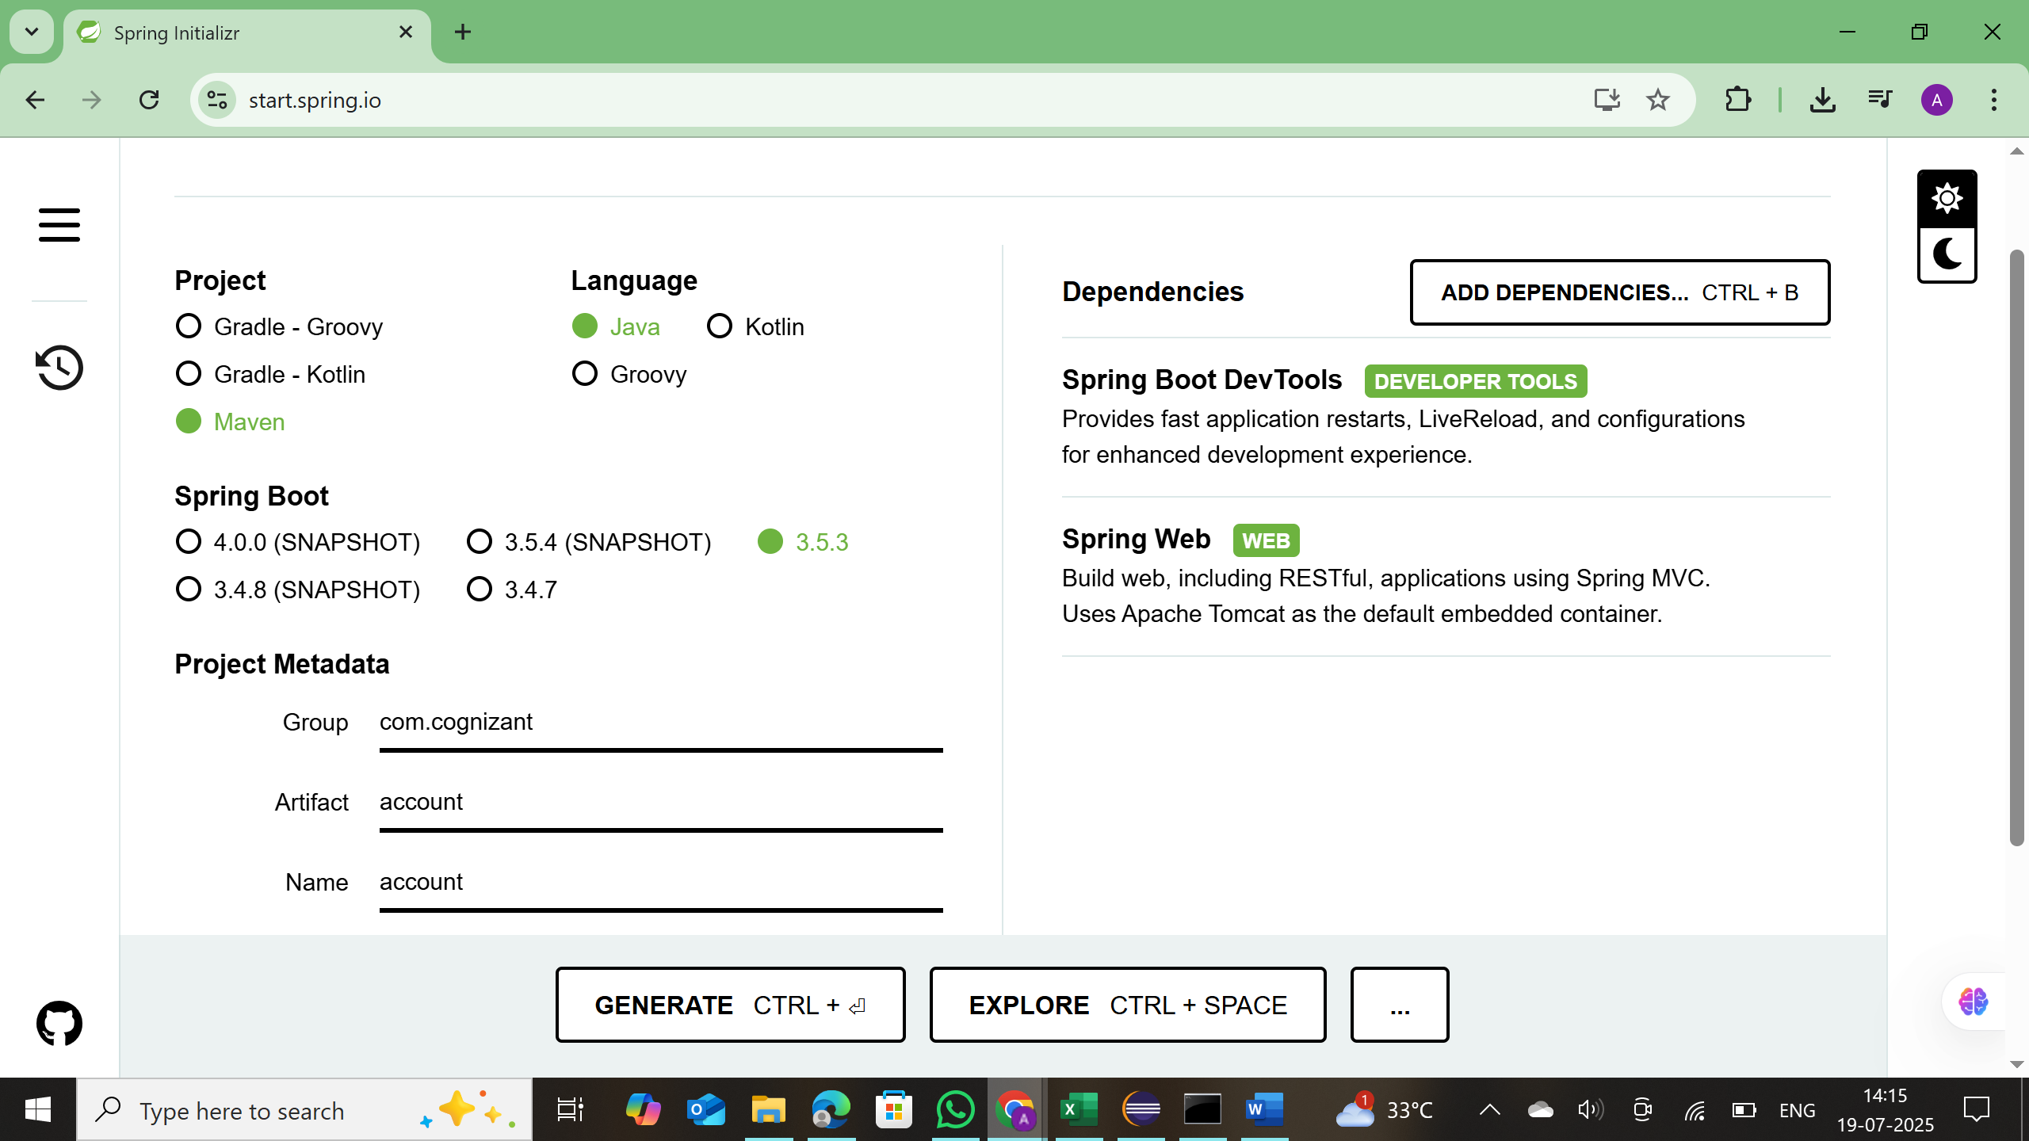

* Extract 'account' folder from the zip and place this folder in the 'microservices' folder created earlier
* Open command prompt in account folder and build using mvn clean package command
* Import this project in Eclipse and implement a controller method for getting account details based on account number. Refer specification below:
* Method: GET o Endpoint: /accounts/{number}
* Sample Response. Just a dummy response without any backend connectivity. { number: "00987987973432", type: "savings", balance: 234343 }

**Code: AccountController.java**

package com.cognizant.account;

import org.springframework.web.bind.annotation.GetMapping;

import org.springframework.web.bind.annotation.PathVariable;

import org.springframework.web.bind.annotation.RestController;

import java.util.Map;

@RestController

public class AccountController {

@GetMapping("/accounts/{number}")

public Map<String, Object> getAccountDetails(@PathVariable String number) {

return Map.*of*(

"number", number,

"type", "savings",

"balance", 234343

);

}

}

* Launch by running the application class and test the service in browser

output:

**Loan Microservice :**

* Follow similar steps specified for Account Microservice and implement a service API to get loan account details

* Method: GET
* Endpoint: /loans/{number}
* Sample Response. Just a dummy response without any backend connectivity. { number: "H00987987972342", type: "car", loan: 400000, emi: 3258, tenure: 18 }

* Launching this application by having account service already running
* This launch will fail with error that the bind address is already in use
* The reason is that each one of the service is launched with default port number as 8080. Account service is already using this port and it is not available for loan service.
* Include "server.port" property with value 8082 and try launching the application
* Test the service with 8082 port Now we have two microservices running on different ports.

**Code:**

**LoanController.java:**

package com.cognizant.loan;

import org.springframework.web.bind.annotation.GetMapping;

import org.springframework.web.bind.annotation.PathVariable;

import org.springframework.web.bind.annotation.RestController;

import java.util.Map;

@RestController

public class LoanController {

@GetMapping("/loans/{number}")

public Map<String, Object> getLoanDetails(@PathVariable String number) {

return Map.*of*(

"number", number,

"type", "car",

"loan", 400000,

"emi", 3258,

"tenure", 18

);

}

}

**Output:**

