Name: Amirtha A  
Superset id: 6394120

**4.ReactJS HOL**

1. Create a new react application using *create-react-app* tool with the name as “blogapp”

1. Open the application using VS Code
2. Create a new file named as **Post.js** in **src folder** with following properties

1. Create a new class based component named as **Posts** inside **Posts.js** file

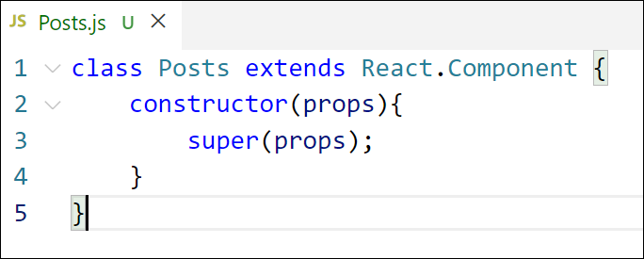

*Figure 3: Posts Component*

1. Initialize the component with a list of Post in state of the component using the constructor
2. Create a new method in component with the name as **loadPosts()** which will be responsible for using Fetch API and assign it to the component state created earlier. To get the posts use the url (<https://jsonplaceholder.typicode.com/posts>)

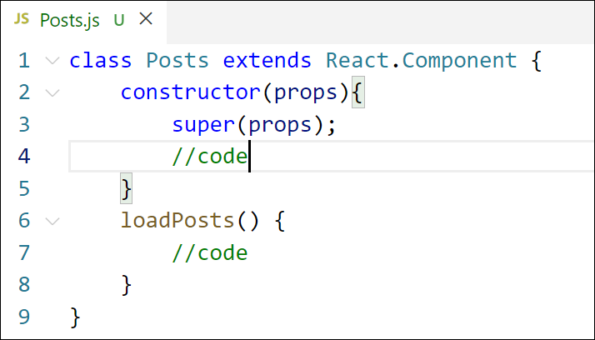

*Figure 4: loadPosts() method*

1. Implement the **componentDidMount()** hook to make calls to **loadPosts()** which will fetch the posts

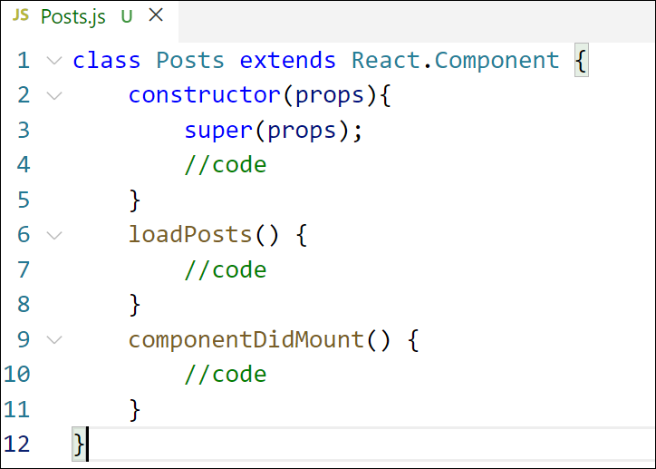

*Figure 5: componentDidMount() hook*

1. Implement the **render()** which will display the title and post of posts in html page using heading and paragraphs respectively.

*Figure 6: render() method*

1. Define a **componentDidCatch()** method which will be responsible for displaying any error happing in the component as alert messages.

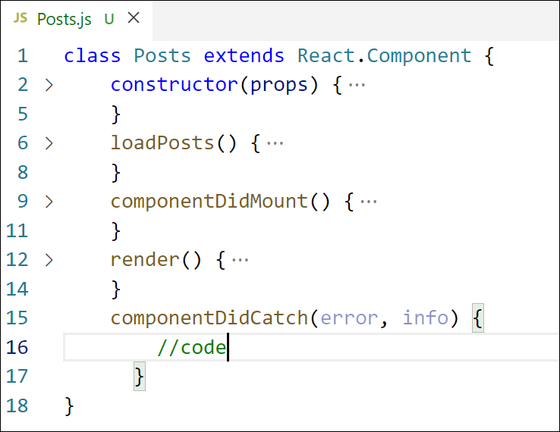

*Figure 7: componentDidCatch() hook*

***Posts.js:***

*import React from "react";*

*import Post from "./Post"; // make sure this is correct*

*class Posts extends React.Component {*

*constructor(props) {*

*super(props);*

*this.state = {*

*posts: [],*

*hasError: false,*

*};*

*}*

*loadPosts = () => {*

*fetch("https://jsonplaceholder.typicode.com/posts")*

*.then((response) => response.json())*

*.then((data) => this.setState({ posts: data }))*

*.catch((error) => {*

*console.error("Error fetching posts:", error);*

*this.setState({ hasError: true });*

*});*

*};*

*componentDidMount() {*

*this.loadPosts();*

*}*

*componentDidCatch(error, info) {*

*alert("Something went wrong.");*

*console.error("Error caught in Posts:", error, info);*

*}*

*render() {*

*const { posts, hasError } = this.state;*

*if (hasError) {*

*return <p>Error loading posts.</p>;*

*}*

*return (*

*<div>*

*<h2>Blog Posts</h2>*

*{posts.map((post) => (*

*<Post key={post.id} title={post.title} body={post.body} />*

*))}*

*</div>*

*);*

*}*

*}*

*export default Posts;*

1. Add the Posts component to App component.

**App.js:**  
import React from "react";

import Posts from "./Posts";

function App() {

  return (

    <div className="App">

      <h1>My Blog</h1>

      <Posts />

    </div>

  );

}

export default App;

1. Build and Run the application using *npm start* command.

