Name: Amirtha A  
Superset id: 6394120

**5.ReactJS HOL**

My Academy team at Cognizant want to create a dashboard containing the details of ongoing and completed cohorts. A react application is created which displays the detail of the cohorts using react component. You are assigned the task of styling these react components.

Download and build the attached react application.



1. Unzip the react application in a folder
2. Open command prompt and switch to the react application folder
3. Restore the node packages using the following commands

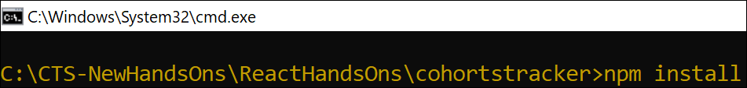

*Figure 1: Restore packages*

1. Open the application using VS Code

1. Create a new CSS Module in a file called “CohortDetails.module.css”
2. Define a css class with the name as “box” with following properties

*Width = 300px;*

*Display = inline block;*

*Overall 10px margin*

*Top and bottom padding as 10px*

*Left and right padding as 20px*

*1 px border in black color*

*A border radius of 10px*

**CohortDetails.module.css:**

.box {

  width: 300px;

  display: inline-block;

  margin: 10px;

  padding: 10px 20px;

  border: 1px solid black;

  border-radius: 10px;

}

dt {

  font-weight: 500;

}

1. Define a css style for html <dt> element using tag selector. Set the font weight to 500.
2. Open the cohort details component and import the CSS Module

1. Apply the box class to the container div
2. Define the style for <h3> element to use “green” color font when cohort status is “ongoing” and “blue” color in all other scenarios.  
   A screenshot of a computer

   AI-generated content may be incorrect.
3. Final result should look similar to the below image

*Figure 2: Final Result*

***CohortDetails.js:***import styles from './CohortDetails.module.css';

function CohortDetails(props) {

return (

<div className={styles.box}>

<h3

style={{

color: props.cohort.currentStatus.toLowerCase() === 'ongoing' ? 'green' : 'blue'

}}

>

{props.cohort.cohortCode} -

<span>{props.cohort.technology}</span>

</h3>

<dl>

<dt>Started On</dt>

<dd>{props.cohort.startDate}</dd>

<dt>Current Status</dt>

<dd>{props.cohort.currentStatus}</dd>

<dt>Coach</dt>

<dd>{props.cohort.coachName}</dd>

<dt>Trainer</dt>

<dd>{props.cohort.trainerName}</dd>

</dl>

</div>

);

}

export default CohortDetails;

***