**Name: Amirtha A**

**Superset id: 6394120**

**10.ReactJS-HOL**

Create a React Application named “officespacerentalapp” which uses React JSX to create elements, attributes and renders DOM to display the page.

Create an element to display the heading of the page.

Attribute to display the image of the office space

Create an object of office to display the details like Name, Rent and Address.

Create a list of Object and loop through the office space item to display more data.

To apply Css, Display the color of the Rent in Red if it’s below 60000 and in Green if it’s above 60000.

**Code:**

**App.js:**

import React from 'react';

import './App.css';

function App() {

  const element = "Office Space";

  const offices = [

    {

      Name: "DBS",

      Rent: 50000,

      Address: "Chennai",

      img: "https://images.squarespace-cdn.com/content/v1/5cbf44b101232c7b9bfb3a32/1560357296444-7ZG2UFGRAGGOGKREJHA4/OV+5.jpg"

    },

    {

      Name: "WeWork",

      Rent: 70000,

      Address: "Bangalore",

      img: "https://images.squarespace-cdn.com/content/v1/5cbf44b101232c7b9bfb3a32/1560357296444-7ZG2UFGRAGGOGKREJHA4/OV+5.jpg"

    }

  ];

  return (

    <div>

      <h1>{element}, at Affordable Range</h1>

      {offices.map((ItemName, index) => {

        let colors = [];

        if (ItemName.Rent <= 60000) {

          colors.push("textRed");

        } else {

          colors.push("textGreen");

        }

        return (

          <div key={index}>

            <img

              src={ItemName.img}

              width="25%"

              height="25%"

              alt="Office Space"

            />

            <h1>Name: {ItemName.Name}</h1>

            <h3 className={colors.join(" ")}>Rent: Rs. {ItemName.Rent}</h3>

            <h3>Address: {ItemName.Address}</h3>

          </div>

        );

      })}

    </div>

  );

}

export default App;

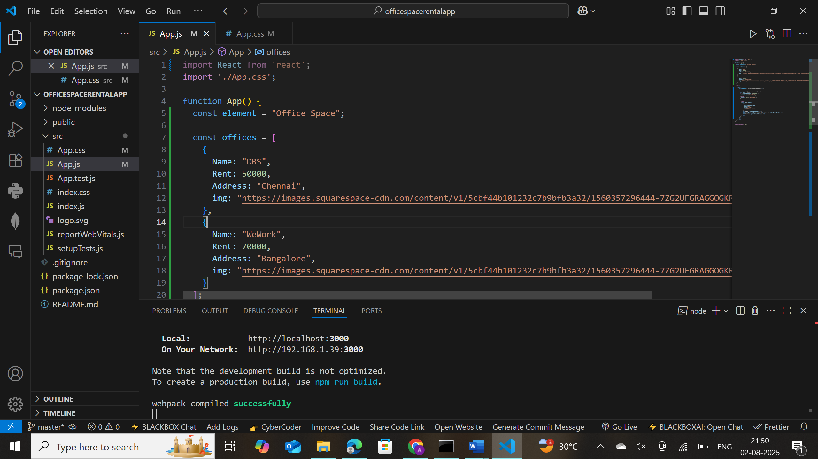

**App.css:**

.textRed {

  color: red;

}

.textGreen {

  color: green;

}

Output:

