**BLUETOOTH CONTROLLED HOME AUTOMATION SYSTEM**

By

**Amirtha Prasad 22BEC1002**

**D. Sherina Esther 22BEC1198**

**B. Deepika 22BEC1367**

**S. B. Gayathri 22BEC1501**

A project report submitted to

**Dr. Usha Kiran K**

**SCHOOL OF ELECTRONICS ENGINEERING**

in partial fulfilment of the requirements for the course of

**BECE304P – Analog Communication Systems**

in

**B. Tech. ELECTRONICS AND COMMUNICATION ENGINEERING**



**Vandalur – Kelambakkam Road**

**Chennai – 600127**

**APRIL 2024**

**BONAFIDE CERTIFICATE**

Certified that this project report entitled “**BLUETOOTH CONTROLLED HOME AUTOMATION SYSTEM” is** a bonafide work of **AMIRTHAPRASAD** (22BEC1002), **D. SHERINA ESTHER** (22BEC1198), **B. DEEPIKA** (22BEC1367),and **S. B. GAYATHRI** (22BEC1501) who carried out the Project work under my supervision and guidance for **BECE304P-Analog Communication Systems**

**Dr. Usha Kiran K**

Assistant Professor (Senior Grade)

School of Electronics Engineering (SENSE),

VIT University, Chennai

Chennai – 600 127.

**ABSTRACT**

**This project presents a Bluetooth-based home automation system designed to provide enhanced convenience and efficiency in household operations. The system leverages Bluetooth technology to enable seamless communication between a central control unit and various smart devices within the home environment. The proposed system encompasses a range of functionalities including lighting control, appliance automation, and security management.**

**The Bluetooth-based approach offers several advantages such as low power consumption, ease of integration, and compatibility with a wide range of devices. Additionally, it eliminates the need for complex wiring and facilitates quick installation, making it suitable for both new constructions and retrofitting existing homes.**

**Overall, this project demonstrates the potential of Bluetooth technology in revolutionizing home automation, offering users a seamless and intuitive solution to enhance comfort, convenience, and energy efficiency in their living spaces.**

**ACKNOWLEDGEMENT**

**We extend our heartfelt gratitude to Dr. Usha Kiran ma’am for their invaluable guidance, unwavering support, and mentorship throughout the duration of this mini group project. Their expertise and encouragement have been instrumental in shaping the project's direction and ensuring its successful execution.**

**We would also like to acknowledge the exceptional contributions of our dedicated team members, whose collaborative efforts, diverse skills, and commitment have significantly enriched the project's outcomes.**

**Furthermore, we express our appreciation to the technical staff and laboratory personnel for their indispensable assistance in providing the necessary resources, equipment, and infrastructure essential for the practical implementation of the project.**

**Lastly, we are thankful to the academic institution for fostering an environment that encourages experiential learning, innovation, and the practical application of theoretical knowledge.**

**The successful completion of this project has been made possible through the collective support, guidance, and contributions of all those mentioned above, and for that, we are truly grateful.**

**NAME WITH SIGNATURE NAME WITH SIGNATURE**

**AMIRTHA PRASAD (22BEC1002) B. DEEPIKA (22BEC1367) D. SHERINA ESTHER (22BEC1198) S. B. GAYATHRI (22BEC1501)**

**TABLE OF CONTENTS**

|  |  |  |  |
| --- | --- | --- | --- |
| **SERIAL NO.** |  | **TITLE** | **PAGE NO.** |
|  |  | ABSTRACT |  |
|  |  | ACKNOWLEDGEMENT | 3-4 |
|  |  |  |  |
| 1 |  | INTRODUCTION |  |
|  |  |  |  |
|  | 1.1 | OBJECTIVES AND GOALS | 6-7 |
|  | 1.2 | APPLICATIONS |  |
|  | 1.3 | FEATURES |  |
|  |  |  |  |
| 2 |  | DESIGN AND IMPLEMENTATION |  |
|  |  | BLOCK DIAGRAM | 7-10 |
|  | 2.1  2.2 | HARDWARE ANALYSIS  (SNAPSHOTS-PROJECT , TEAM, RESULTS) |  |
|  |  |  |  |
| 3 | 3.1 | SOFTWARE –CODING AND ANALYSIS | 11-12 |
|  |  | (SNAPSHOTS OF CODING AND RESULTS) |  |
| 4 |  | CONCLUSION AND FUTURE WORK | 13-14 |
|  | 4.1 | RESULT, CONCLUSION AND INFERENCE |  |
|  | 4.2 | FUTURE WORK |  |

5 REFERENCES 14

6 PHOTO GRAPH OF THE PROJECT ALONG WITH THE TEAM MEMBERS 15-16

1. **INTRODUCTION**
   1. **OBJECTIVES AND GOALS**

* Design the **BLUETOOTH CONTROLLED HOME AUTOMATION SYSTEM Using Arduino.**
* **The objective of this project is to develop a simple yet effective system that enables users to remotely control various electrical appliances and electronic devices within their homes using an Android device. By leveraging the capabilities of Bluetooth technology, the project aims to provide users with a convenient and intuitive means of managing their household devices wirelessly.**
* **The focus of this project is on product development, aiming to create a reliable and efficient Home Automation System and empowers users to optimize comfort, security, and energy usage, transforming traditional homes into smart, connected living spaces.**
  1. **APPLICATIONS**

1. **Lighting Control**: **Bluetooth-based home automation systems allow users to remotely control lighting fixtures throughout their homes. Whether adjusting brightness levels, changing colours, or setting schedules, users can customize their lighting preferences to suit different occasions and moods.**
2. **Security Management**: **Bluetooth technology can be utilized to integrate security devices such as smart locks, door/window sensors, and surveillance cameras into the home automation system. Users can receive real-time alerts on their smartphones, monitor access to their homes, and remotely control security features, thereby enhancing safety and peace of mind.**
3. **Accessibility and Assistive Technology**: **Bluetooth-enabled home automation systems can enhance accessibility for individuals with disabilities or special needs. By integrating voice-controlled interfaces, remote monitoring capabilities, and personalized settings, users can enjoy greater independence and quality of life within their homes.**
   1. **FEATURES**
4. **Developing a Bluetooth Controlled Home Automation System to address the need for convenient and efficient remote management of electronic appliances in modern households.**
5. **Enable users to wirelessly control appliances using smartphones or tablets, offering seamless integration, intuitive interfaces, and robust security features.**
6. **Design a cost-effective, user-friendly solution that enhances comfort, convenience, and energy efficiency while ensuring a seamless and secure user experience.**
7. **DESIGN AND IMPLEMENTATION**
   1. **BLOCK DIAGRAM**



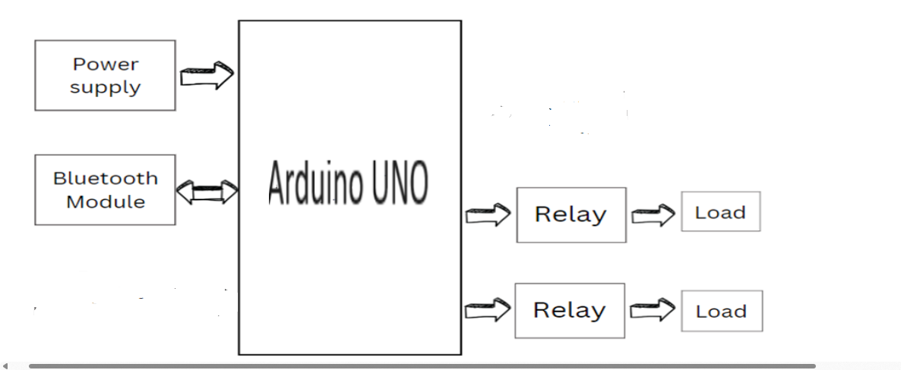

**2.2 HARDWARE ANALYSIS**

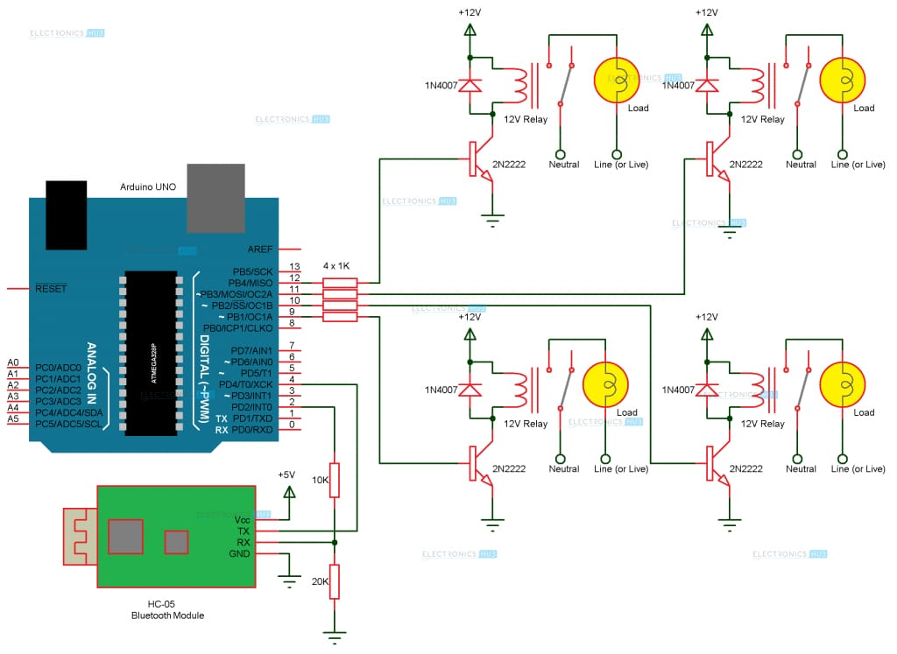

* 1. (SNAPSHOTS-PROJECT , TEAM, RESULTS)

1. CIRCUIT:

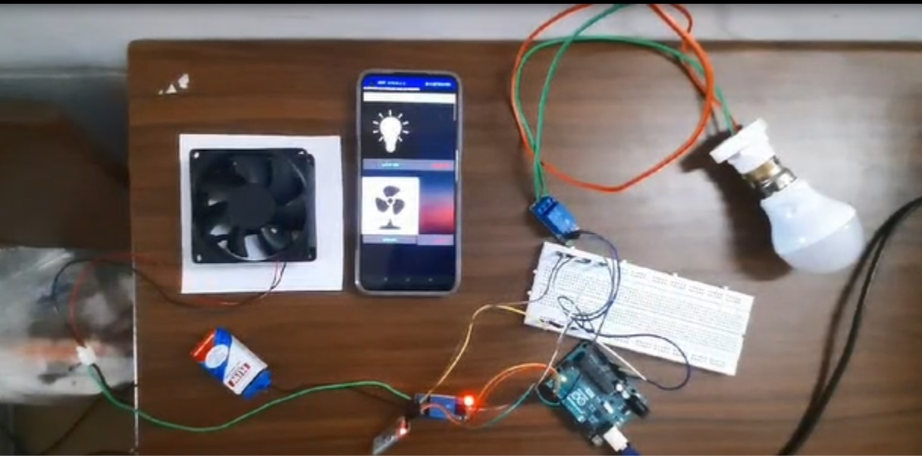

1. BULB ON

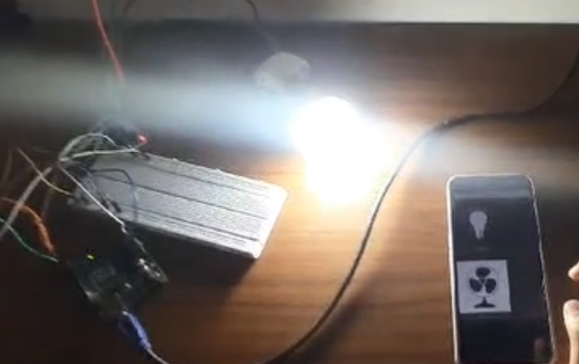

1. FAN ON:

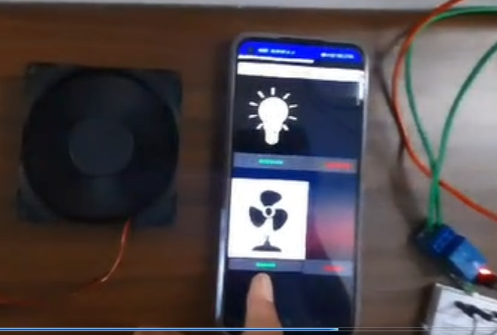

**Hardware video link:**

[**https://drive.google.com/file/d/1eCkisq_Hfrs5BreQb3hHvWn3k7AZ8QKp/view?usp=sharing**](https://drive.google.com/file/d/1eCkisq_Hfrs5BreQb3hHvWn3k7AZ8QKp/view?usp=sharing)

1. **SOFTWARE CODING AND ANALYSIS**
   1. CODING AND ANALYSIS (SNAPSHOTS OF CODING AND RESULTS)

**CODE:**

**#define light1 2**

**#define light2 3**

**#define fan1 4**

**#define fan2 5**

**void setup() {**

**Serial.begin(9600);**

**pinMode(light1, OUTPUT);**

**pinMode(light2, OUTPUT);**

**pinMode(fan1, OUTPUT);**

**pinMode(fan2, OUTPUT);**

**}**

**void loop() {**

**if (Serial.available() > 0) {**

**char command = Serial.read();**

**switch (command) {**

**case 'a':**

**digitalWrite(light1, HIGH);**

**break;**

**case 'b':**

**digitalWrite(light1, LOW);**

**break;**

**case 'c':**

**digitalWrite(light2, HIGH);**

**break;**

**case 'd':**

**digitalWrite(light2, LOW);**

**break;**

**case 'e':**

**digitalWrite(fan1, HIGH);**

**break;**

**case 'f':**

**digitalWrite(fan1, LOW);**

**break;**

**case 'g':**

**digitalWrite(fan2, HIGH);**

**break;**

**case 'h':**

**digitalWrite(fan2, LOW);**

**break;**

**}**

**Serial.println(command); // Echo the received command back for verification**

**}**

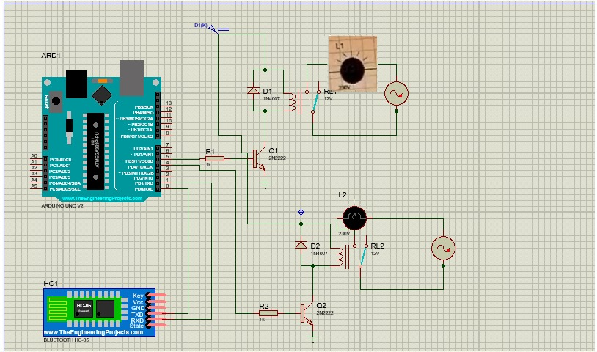

1. **CONCLUSION AND FUTURE WORK**
   1. **RESULT, CONCLUSION AND INFERENCE.**
2. **RESULT:**

**Results revealed robust system performance, with users expressing satisfaction regarding functionality and usability. Energy consumption analysis demonstrated notable savings, validating the system's efficiency. Security measures effectively safeguarded user privacy and data integrity. Integration with existing smart home devices proved seamless, enhancing overall functionality. User feedback highlighted areas for improvement, guiding future developments to further optimize performance and user experience.**

1. **CONCLUSION:**

**In conclusion, the Bluetooth-based home automation system has demonstrated its effectiveness in enhancing convenience, efficiency, and security within the household. Through robust performance, seamless integration, and positive user feedback, the system has proven its value in modernizing residential living. As technology continues to evolve, further refinements and advancements hold the potential to elevate the system's capabilities and benefits even further, promising a future of smarter, more interconnected homes.**

1. **INFERENCE:**

**The inference drawn from the Bluetooth-based home automation project is that the implementation of such a system has the potential to significantly improve various aspects of residential living. Through its demonstrated effectiveness in enhancing convenience, efficiency, and security, the project underscores the importance of leveraging technology to create smarter and more interconnected homes**.

* 1. **FUTURE WORK**

**Future works for Bluetooth home automation include advanced integration with AI and IoT platforms, enhancing voice control capabilities, and prioritizing advanced security measures. Energy harvesting solutions and scalability enhancements will further sustainability and interoperability. Optimization of user experience through predictive analytics and expanded environmental monitoring will ensure continued improvement. These developments promise to make Bluetooth home automation more intelligent, accessible, and environmentally friendly, meeting the evolving needs of modern households.**

1. **REFERENCES**
2. [**https://www.electronicshub.org/bluetooth-controlled-electronic-home-appliances/**](https://www.electronicshub.org/bluetooth-controlled-electronic-home-appliances/)
3. [**https://youtu.be/5cOf5s6OXGE?si=t6FGibErNm0JKh3Y**](https://youtu.be/5cOf5s6OXGE?si=t6FGibErNm0JKh3Y)

**REFERENCES(IN IEEE FORMAT)**

**LIST OF PUBLICATIONS**

**INTERNATIONAL JOURNALS:**

1. **Bluetooth Controlled Home Automation System using 8051 (**[**Saddam**](https://circuitdigest.com/users/saddam)**, January 6, 2016)**
2. **HOMES APPLIANCES CONTROL USING BLUETOOTH (**[**Jamil Abedalrahim**](https://www.researchgate.net/scientific-contributions/Jamil-Abedalrahim-2164135271?_tp=eyJjb250ZXh0Ijp7ImZpcnN0UGFnZSI6InB1YmxpY2F0aW9uIiwicGFnZSI6InB1YmxpY2F0aW9uIn19)**,** [**Jamil Alsayaydeh**](https://www.researchgate.net/profile/Jamil-Alsayaydeh?_tp=eyJjb250ZXh0Ijp7ImZpcnN0UGFnZSI6InB1YmxpY2F0aW9uIiwicGFnZSI6InB1YmxpY2F0aW9uIn19)**,** [**Mohamed Nj**](https://www.researchgate.net/scientific-contributions/Mohamed-Nj-2166190323?_tp=eyJjb250ZXh0Ijp7ImZpcnN0UGFnZSI6InB1YmxpY2F0aW9uIiwicGFnZSI6InB1YmxpY2F0aW9uIn19)**,** [**Syed Najib**](https://www.researchgate.net/scientific-contributions/Syed-Najib-2166176787?_tp=eyJjb250ZXh0Ijp7ImZpcnN0UGFnZSI6InB1YmxpY2F0aW9uIiwicGFnZSI6InB1YmxpY2F0aW9uIn19)**, November 2019)**
3. **PHOTOGRAPH OF PROJECT ALONG WITH TEAM MEMBERS**

**BIODATA**



Name : **AMIRTHA PRASAD**

Mobile Number : **9840067495**

E-mail : **amirtha.prasad2022@vitstudent.ac.in**

Permanent Address : **13/27 RAGA SARASWATI NIVAS, SOLAIAPPAN STREET,**

**MYLAPORE, CHENNAI 4**



Name : **D. SHERINA ESTHER**

Mobile Number : **8778135252**

E-mail **: sherinaesther.d2022@vitstudent.ac.in**

Permanent Address: **No 7, Ambal city, Queen Victoria road, poonamallee, Chennai-56**



Name : **DEEPIKA B**

Mobile Number : **6382987273**

E-mail : **deepika.b2022@vitstudent.ac.in**

Permanent Address: **Sri Bagya flats, 4th St, Rose Nagar, Kovilambakkam, Chennai-600 129**



Name : **S. B. GAYATHRI**

Mobile Number: **9600057841**

E-mail : **gayathri.sb2022@vitstudent.ac.in**

Address : **Q095, SBIOA unity enclave, mambakkam, Chennai- 600127**