Applied machine learning system ELEC0134 22/23 report

SN: 21022876

Abstract

This section provides a brief overview of the methodology/results presented in the report.

Index Terms— One, two, three, four, five

1. Introduction

This section introduces the problem, a brief bird's-eye view of the methodologies you adopted and the organization of this report.
A citation example is given here [1]. Use IEEE citation format.

2. Literature survey

This section should focus on an overview of potential approaches to solve the tasks. You can introduce some classical and state-of-the-art machine learning algorithms.
Say here that for image classification, there are multiple machine learning algorithm. The most popular is the CNN learning algorithm that is famous for image datasets. Another emerging popular choice is also Vision Transformers. However, vision transformers are proved to be better only when significantly large dataset is used to train model. Other options include Auto-ML which uses statistical approach(fact check) to find best model and tune hyperparameters to. A fully connected network is considered an option as the size of datasets is still quite small. This will later be compared to other models

3. Description of models

In this section, you should briefly describe the model you are using for each task, along with the rationale. You may opt to use a single learning algorithm to solve the problem or multiple ones, but bear in mind there are page limitations and that you should explain your rationale behind your choices. That is, the algorithmic description must detail your reasons for selecting a particular model.
You can clarify them with flow charts, figures or equations. An example of how to draw an image is demonstrated in Fig. 1.
For the initial building of the models. A FCL, CNN and pretrained network is used. For the FCL, a small 50-50-2 is used. This is to allow the calculations to be limited to a reasonable amount. For CNN, a simple conv1-pool-conv2-pool-fc architecture is used. Aside from these models, several other famous image classification architectures namely VGG16, AlexNet and ResNet 18 are experimented with to see how their performance on the dataset.

3.1. Task A: the task name

Show the images of model architechtures

3.2. Task B: the task name

Show images of model architechtures
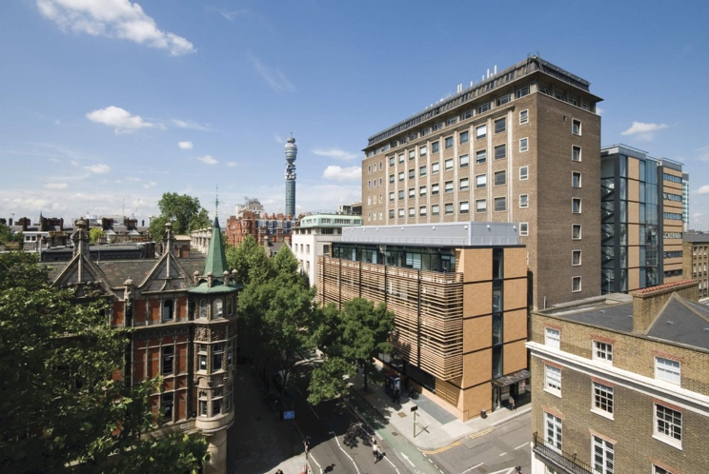
Fig. 1 A nice view of Roberts Building

4. Implementation

This section must provide the detailed implementation of your models. In particular, you must provide the name and use of external libraries, explain hyper-parameter selection, training pipeline (if any) and key modules/classes/functions/algorithms.
You also must provide a detailed description of the dataset (content, size, format, etc.), any data pre-processing that was applied and how you separate your dataset into training, validation and test sets.
The execution of your models also should be reported here. In particular, this section should include a thorough discussion on the training convergence and stopping criterion (it is recommended that learning curves graphs be used to this effect).
For implementation

4.1. Task A: the task name

4.1.1 module name

Hello world!

4.2. Task B: the task name

Hello world!

5. Experimental Results and Analysis

This section describes and discusses your results. Additionally, this section should include accuracy prediction scores on a separate test dataset, provided by the module organizers, but not used during your training and validation process.
We recommend you use a table to list the tasks, models and results before analysis.
Table 1. Example of Table
 | Col1 | Col2 | Col3 | Col4
Row1
Row2
Row3
Row4

6. Conclusion

This last section summarizes the findings and suggests directions for future improvements.

7. References

[1] A.B. Smith, C.D. Jones, and E.F. Roberts, “Article Title,” Journal, Publisher, Location, pp. 1-10, Date.

The code is provided link-to-download-your-project.com and GitHub project: link-to-your-github-project

