

**Eye Based Wheelchair Control and Task Manager for Disabled Person**



**Project Report**

**IEEE SS12: Innovation Challenge 2018**

**Team: KUET.CV**

MD Rahat-Uz-Zaman

Sakib Reza

M Asifur Rahman

Hasib Iqbal

**Khulna University of Engineering & Technology, Bangladesh.**

**Abstract**



In our society we have people who have different physical disability. For example some of them have paralysis and cannot move their body parts except their head or sometimes only eyes. The system developed by us will support them to overcome those disability. With our system they will be able to control their wheelchair just with their eye gaze, eye blinks, head gestures or voice commands. They can also operate different tasks like - sending SMS to someone, phone calling, listening to music, watching TV or video, operating light-fan on and off, operating keyboard and so on in the same manner. The system has been built in the raspberry pi platform including a display which will be placed in front user’s seat embedded with an electric wheelchair. The user can operate the system with a simple GUI and in different mode. User can change the mode as per his/her need. If only moving parts of any user is his/her eyes then he/she can use our system with only eye gaze and eye blinks. On the other hand, if he/she can also move their head, they can use their head gesture also to use this system more effortlessly.

**1. Introduction**



In this project, we designed and implemented a system that will use users’ eye gaze, eye blinks, head gestures or voice commands to control its functionality. The system has a task manager GUI which has functionality of wheelchair controlling, phone calling, SMS/email sending, e-book reading, web browsing, Google searching, light/fan operating, keyboard operating and so on. Peripheral devices of our system – electric wheelchair, Light, Fan etc. are hosted by a raspberry pi and communicate with the main system through a Wi-Fi network. We have different modes for person with different disability depending on users’ active body parts (figure-1.1)

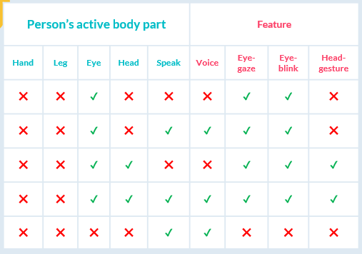

Figure .1: Different modes of operation with features depending on users’ active body parts

**2. Features**



In this project, Features of our system are –

* **Task manager control** with eye blinks/head gestures/voice command
* **Wheelchair contro**l with eye gaze/head gestures/voice command
* **SMS/Email sending** with eye/head controlled keyboard
* **Audio/Video player control** with eye blinks/head gestures/voice command
* **E-book reader control** with eye blinks/head gestures/voice command
* **Web browser control** with eye blinks/voice command
* **Light/Fan operating** with eye blinks/voice command
* **Emergency alert sending** with eye blinks/voice command

**Task manager control:**

User can control the task manager of the system using his/her eye blink / head gesture. The control specification is defined in figure-2.1 (eye blink) and figure-2.4(head gesture)

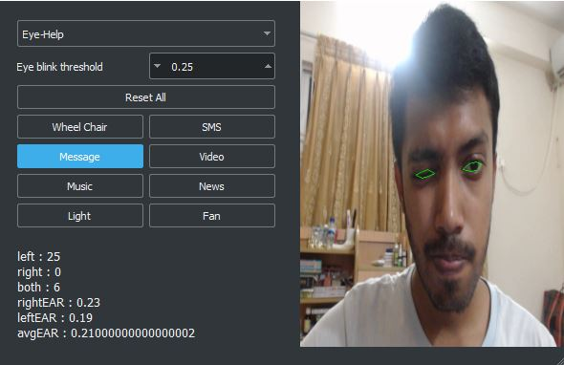

Figure 2.2: Screenshot of GUI while controlling task manager with eye blinks

Figure 2.1: Task manager control definition using eye blinks



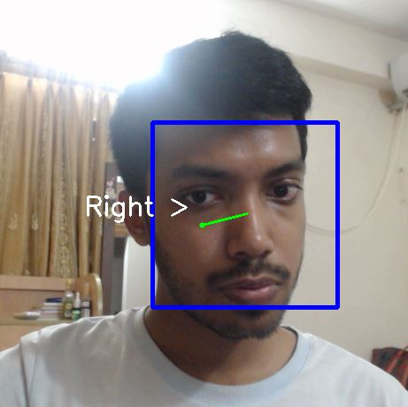

Figure 2.3: Task manager control definition using head gestures

Figure 2.4: Screenshot of GUI while controlling task manager with head gestures

**Wheelchair control:**

User can control the wheelchair using his/her eye blink / head gesture. The control specification is defined in figure-2.5 (eye blink) and figure-2.7(head gesture)

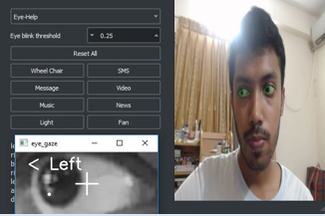

Figure 2.6: Screenshot of GUI while controlling wheelchair with eye gaze

Figure 2.5: Wheelchair control definition using eye gaze

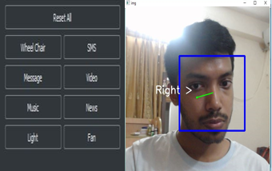

Figure 2.7: Wheelchair control definition using head gestures

Figure 2.8: Screenshot of GUI while controlling wheelchair with head gestures

**Sending SMS/Email:**

User can write any message using a specially designed virtual keyboard (figure 2.10) which can be controlled using eye gaze and eye blinks. The keyboard has 12 main keys and every main keys has 2-4 floating keys. Main keys are navigated using eye blinks and the floating keys are navigated using eye gaze. There has also some prewritten message to send.

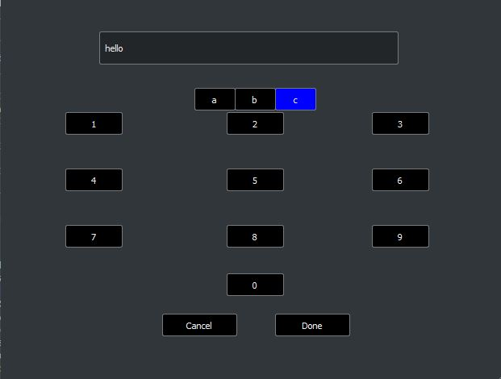

Figure 2.9: Keyboard control definition using eye blinks/eye gaze.

Figure 2.10: Specially designed eye gaze/blinks controlled virtual keyboard for SMS/Email.

**Audio/Video player:**

User can control the audio/video player using eye blinks. Such as- right blink will scroll through the audio/video lists, both blinks will select an option and right blink will pause or get out from the audio/video player.

**E-book reader:**

User can navigate and read by scrolling up/down any e-book using eye blinks. Such as – left blink works for scroll up and right blink works for scroll down.

**Web browser:**

User can browse through web using special eye controlled virtual keyboard and there has also some predefined webpages which can be navigated using eye blinks. Web pages can be scrolled using eye blinks

**Emergency alert:**

On the task manager there is an ‘Emergency Alert’ option. If the user select this option, a SMS will be sent to a fixed recipient asking emergency help for user.

**3. Software Design**



**Graphical User Interface:**

We used *PyQt5* framework to design our GUI for user. For styling our GUI we have used a library called *QdarkStyle*.

**Computer Vision:**

In the initial version of our system we had used two different model for eye gaze and eye blinks. We had used a *haarcascade classifier* model for eye gaze trained with 1000+ sample and for eye blinks we got an EAR value from pre-trained facial landmark recognizer with *dlib* and determined left blink, right blink and both blink.

For the present version of our system we developed a single *Convolutional Neural Network (CNN)* architecture that is a modified version of *VGG-8* architecture for classifying all four classes (left gaze, center gaze, right gaze, and blink).We used two separate model for left eye and right eye, final result is integrated with both of the results. We trained our model with 6000+ sample and got 97% accuracy on our own test set.

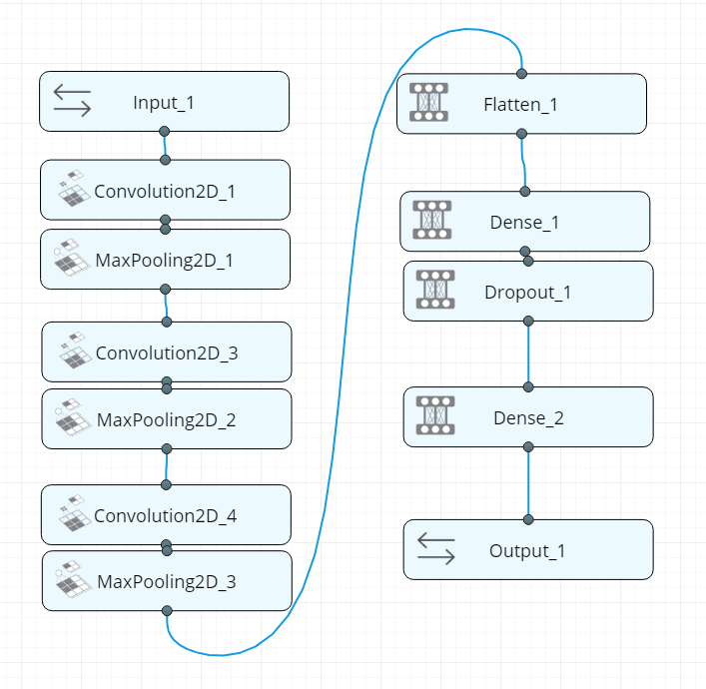

Figure 3.1: Modified version VGG-8 Neural Network Architecture of our system.

**SMS/Email API:**

For SMS, we used *Onnorokom SMS API* to send SMS anywhere in Bangladesh. For Email, We used the *Gmail API*.

**Voice API:**

We used Google voice API service to take the voice input (/voice command) in our system.

**4. Hardware Design**



In our system we have a wheelchair prototype car, light and fan for user. To implement our system we used different hardware components. Some main components used in our system are –

1. Raspberry PI 3 Model B (1 unit)
2. DC Motor 4V (1 unit)
3. DC Motor 9V (2 unit)
4. Lipo Battery 2200 mAh (1 unit)
5. Ultrasonic Sensor (1 unit)
6. L298N Dual Motor Controller (1 unit)
7. LED (1 unit)

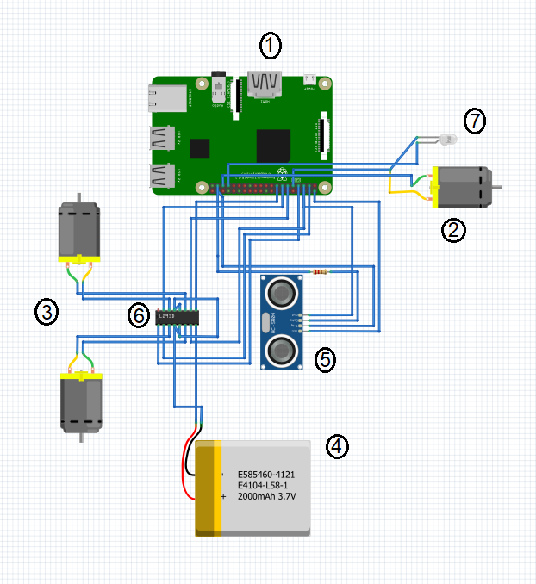

Figure 4.1: Hardware diagram of the system

**5. Future Plan and Conclusion**



In our system, the eye gaze/blink classifier model is working pretty well but still we want to train more sample data to this and make the model more accurate. We will also experiment our system with all other feasible model if they work better. We are now using a prototype wheel chair but in the future we have a plan to make an actual electric chair and test our system with it in a deployable scenario. Finally, we would like to add more real life feature to our system and make it more usable and robust for our targeted users.

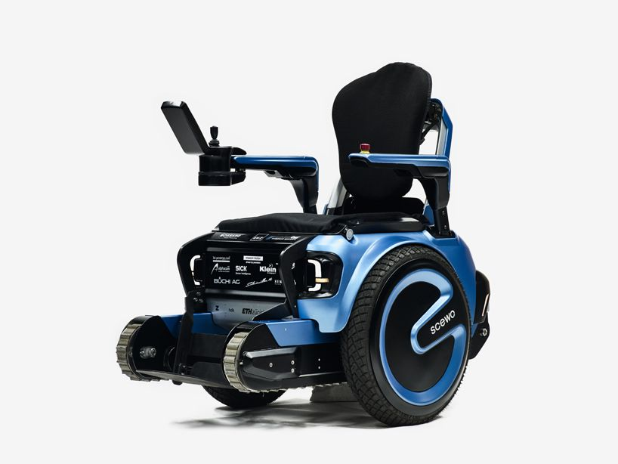

**End**