Name : RoshanPradhan
Date of Birth : 17th July 1977
Gendar : Male
Father`s name : Mathura Nath Pradhan
Adress : Tinkune Subidhanagar -32 Kathmandu
Country : Nepal
Email : roshanhanger71@gmail.com
Director of Pagoda Institute of Fine Arts,Tinkune Subhidanagar Kathmandu
Founder member of Pagoda Group.Nepalese Contemporary Artists' Guild.
DFEWA Representatives Woldwide , Nepal
FebrianoIn acquarello,Italy, Country representative. Nepal
International Island Country Arts Group,Turkey

Education : Master's Degree in Fine Arts from Tribhuvan University, Kirtipur, Nepal.

Personal Achievement:
- 2023 Lalitkala Special Award organized by Nepal Fine Art Academy
- 2020 Creative Artist of the Year 2020, Nanda Devi Khanal Lalitkala Smriti Award (Arupan Art Gallery) Nepal
- 2015 Araniko Youth Award (Gold Medal) ,National Youth Service Trust Nepal
- 2006 Fevicryl, Expert Teacher Pidilite Industries, Ltd.
- 2005 Lalitkala Special Award organized by Nepal Fine Art Academy

Solo Exhibition
- 2014 "Nodes Expression and Human Feelings" Nepal Art Council Gallery Babar Mahal Kathmandu Nepal
- 2013 "Hanger 2" Sakano Ueno Bijutsukan Art Gallery, Hokkaido Japan.
- 2007 "Hanger" Nepal Art Council Gallery Babar Mahal Kathmandu Nepal.

Selected Group Art Exhibitions

- 2026 Pagoda Group exhibition Changing Times kala Salon Chhaya Center,Thamel
- 2026 Hatyai International Art Camp,Thailand
- 2025" Deities of Nepal II Organized by Nepal Art Council Babar Mahal Kathmandu Nepal
- Group exhibition san Pablo city, phillipines, Kathmandu International Art Exhibition 2024,
- 2024" Deities of Nepal II Organized by Nepal Art Council Babar Mahal Kathmandu Nepal
- 2024" Reimagine: Himalayan Art Now, 659 Wrightwood Gallery Chicago
- 2024" Reimagine: Himalayan Art Now, Rubin Museum, New York USA
- 2023" A Tapestry of voices by Takpa Art Gallery
- 2023 “5th Global Friendship Art Festival Nepal 2023 by Embassy of the people’s Republic of Bangladesh Kathmandu Nepal
- 2023" Collective Expression by Pagoda Group in Siddharth Art Gallery
- 2022" 19th Asian Art Biennale Silpakala Academy Bangladesh
- 2022 “Freedom and Love” an Art Exhibition Philippines Organized by Filarts in NCCA Gallery ,Manila
- 2022 “Himalayan Art Festival” an Art Exhibition Organized by E-Arts Nepal in Nepal Art Council Babar Mahal Kathmandu Nepal
- 2022 “AgrajKaBimbaharu” an Art Exhibition Organized by pagoda Group and SushilKoirala Memorial Foundation in Nepal Art Council Babar Mahal Kathmandu Nepal
- 2022 “A Contemprorary Art Exhibition” Organized by Unnati Cultural Village,Chitwan
- 2021 “Art Unites” A Virtual Art Exhibition Between Philippines and Nepal Organized by FilArts and pagoda Group.
- 2021 “Looking Forward” A Virtual Exhibition of Nepali Art, LoyalaMarymont University, Los Angeles, California, USA
- 2021 " Moonlight Exhibition" International Online Art Exhibition Organized by Nada Fine Arts, Syria 2021 "
- 2nd Virtual Visual Expression" International Online Art Exhibition Organized by Pagoda Group, Nepal
- 2021 “Earth(1 Country 1 Artist) Organized by Rad Art” USA
- 2020 ATATURK AND EDIRNE INTERNATIONAL ONLINE GROUP EXHIBITION OF INVITED ARTISTS Organized byTrakyaUniversity,Faculty of Education, Turkey
- 2020 “Asian Contemporary Art Exchange Exhibition”Thousand Faces of Arts Organized by National Taiwan Art Education Center
- 2020 “2do. ENCUENTRO INTERNATIONAL DE ARTE CULTURA”Organized by Bellas Foundation, Ecuador
- 2020 “Extraordinaire World Records Organized by Rad Art”USA
- 2020 “Peace and Unity thru Art An International online Exhibition” Philippines
- 2020 “Timisoara 2020 International Biennial of Miniature Art Romania”
- 2020 " Virtual Vision Expression" International Online Art Exhibition. Organized by Pagoda Group Nepal
- 2020. " The Art of Our lives" Emerging Artist Exhibition. Organized by Royjatra Bangladesh.
- 2020. " Revived Emotion" Ratchadamnoen Contemporary Art Center Bangkok Thailand
- 2019. " A Space for Freedom and Equality" American Center, U S Embassy Nepal.
- 2019. " FebrianoAcquarello in Arte Culturale, International water color museum, Italy.
- 2019. "National Art and Craft Exhibition ( NAFA) Nepal Art Council Gallery Babar Mahal Kathmandu Nepal.
- 2019. "Coherence" Organized by Pagoda Group. Nepal Art Council Gallery Babar Mahal Kathmandu Nepal
- 2019. " Art and Friendship" International Art Exhibition. Asian Art Museum Japan
- 2018. " 3rd Tune of Art" International Art Festival, Organized by FOCUS Bangladesh.
- 2018. " Friendship Art Exhibition" Arma Museum Indonesia.
- 2018. "Symphonic Existence" Organized by Pagoda Group. Nepal Art Council Gallery Babar Mahal Kathmandu Nepal.
- 2017. " Korea Nepal contemporary art exchange exhibition. Nepal Academy, Kamaladi, Kathmandu Nepal.
- 2016. " Buddhist Art Fair" Beijing, China.
- 2015. " National Art and Craft Exhibition (NAFA) Nepal Fine Art Academy, Sitabhawan, Naxal, Kathmandu, Nepal.
- 2014. " National Art and Craft Exhibition (NAFA) Nepal Fine Art Academy, Sitabhawan, Naxal, Kathmandu, Nepal
- 2014. " Colour Passion" India Nepal Friendship Art Exhibition .Jamini Roy Gallery Kolkata India.
- 2013 "India Nepal Art Workshop ShantiniketanBholpur India"
- 2012 "National Art and Craft Exhibition (NAFA)" Nepal Fine Art Academy sitabhawanNaxal Kathmandu.
- 2010"Nepal Bangladesh Art exchange Exhibition" Zenual Art Gallery Bangladesh
- 2010" 14th Asian Art Biennale Silpakala Academy Bangladesh
- 2008"Kurintar Art workshop organized by camlin Ltd.
- 2005 "National Arts and Craft Exhibition NAFA" SitabhawanNaxal Kathmandu.
- 2004 "National Art and Craft Exhibition NAFA SitabhawanNaxal Kathmandu.
- 2003 "National Art and Craft Exhibition NAFA" SitabhawanNaxal Kathmandu.
- 2003 " Nepal Japan Art Exhibition Fukuwoka City Japan.
- 2002 " National Art and Craft Exhibition (NAFA)
- 2001 "Nepal Japan Art Exhibition Fukuwoka City Japan.
- 2001 "National Art and Craft Exhibition NAFA" SitabhawanNaxal Kathmandu.

Travel
India ,Bagladesh , Thailand , Philippines ,Chaina

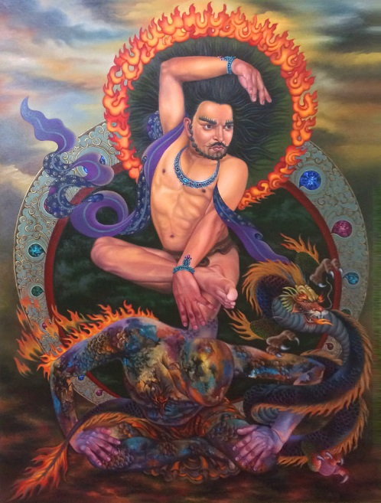
Title: Unconquerable soul
Medium: Acrylic on canvas
Size: 48” x 66”
Year of Production: 2018
UNCONQUERABLE SOUL
Anybody who takes birth on this earth, according to time and situation he/she starts to grow and develop and starts taking the responsibility. While taking the responsibility, his/her soul mobilizes him/ her. In this process the same soul sometimes takes the form of god sometimes demon. In the same way, I have taken my mind as the god to move forward. In the process of moving forward, I have shown the god dancing on me. I believe that our soul is god. We cannot conquer it, and the soul never dies. In this painting, I have used the motifs of Nepali painting (Thanka). I have been making the paintings by mixing the contemporary thoughts and traditional Thanka paintings

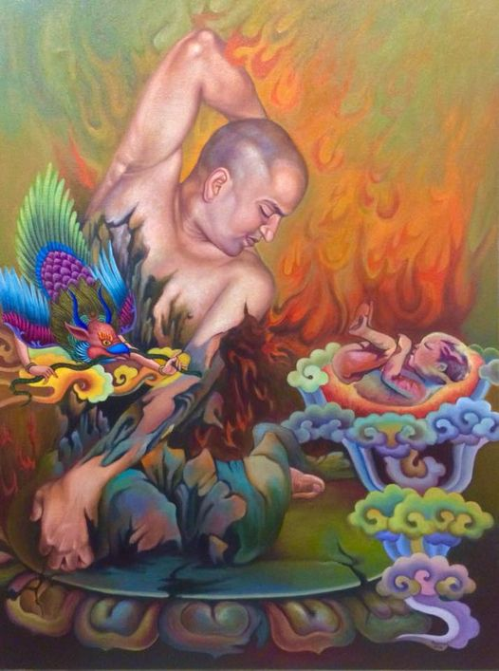
Title: Tudaal
Medium: Acrylic on canvas
Size: 30” x 40”
Year of Production: 2018

TUNDAAL
As we all know that while constructing a temple we make a roof. To give support to the roof we put wooden pole in a slanting way on four sides. That slanting wooden pole is called Tundal. That Tundal is new at first. We carve the statues of various forms of gods and goddesses in different positions on it. Though it is new and strong at first, it slowly becomes old and weak due to time and situation. One day, there forms cracks on the wooden poles, turn into pieces, unknowingly get destroyed and vanish from the earth. In the same way, our human body also vanishes from the earth by becoming old and weak.
After the birth of a baby on this earth, he/she learns, receives knowledge becomes perfect by nature, but unknowingly like the Tundal of the temple, our human body also gets stoop, old, weak and the existence vanishes from the earth. It shows that, nothing remains same forever. One day everything disappear. This is the law of nature.

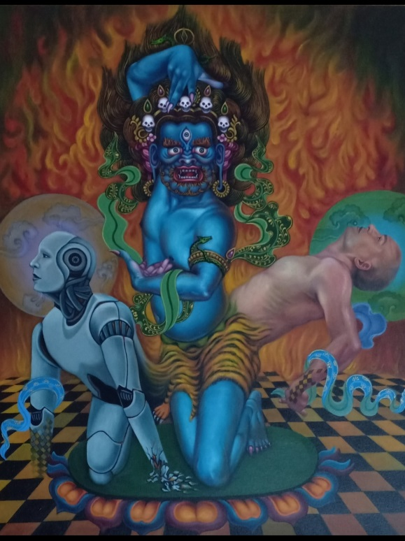
Title: Inner Power
Medium: Acrylic on canvas
Size: 24” x 30”
Year of Production: 2020
INNER POWER
As we all know that the universe is created by God. And the God has created human beings and other creatures on this earth .The human beings have created and discovered many things. There is a relation between God, human beings and the scientific inventions and discoveries. Everything in this universe is running smoothly by the grace of the God .Though human beings and scientific inventions have their own power but they cannot overcome and challenge the power of God .So they have to accept the creation of God. Science can never succeed without the blessing of God .Therefore, we should show respect and devotion to the inner power of god. The nature itself is God.

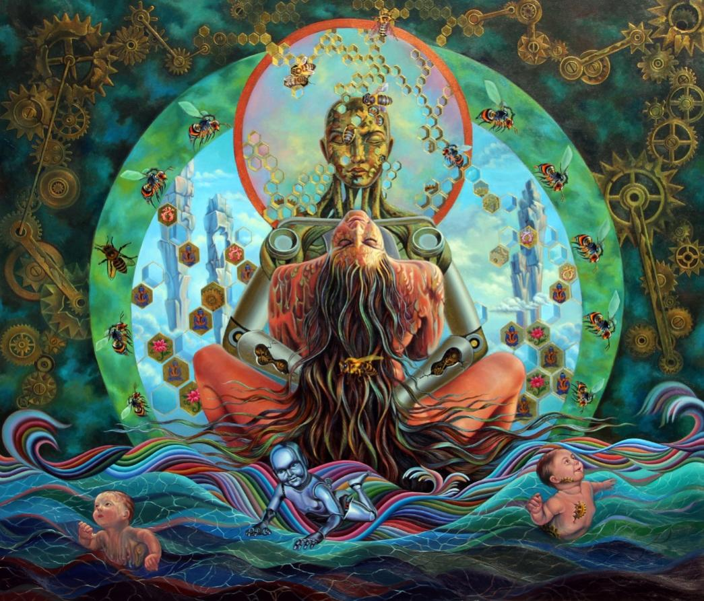
Title: A New World
Medium: Acrylic on canvas
Size: 60” x 72”
Year of Production: 2020
A New World
This painting is made by imagining about the new world .Now the technology has reached the top and has made robots of different kinds. Robot has started doing all the works that humans do. A robot does a variety of works like cooking ,lifting heavy loads ,guarding a house carrying medicines at hospital etc .Beside these other different types of model of robots are also being made. Such as bee, housefly, butterfly etc which have been doing work since long .In the future ,the number of robots will increase rapidly more than the population of human being and this present world will turn into the world of robotic age. In the days to come, the robots will be able to bear children like human being by keeping sexual intercourse with human being and will reach to that level. From this I was influenced and studied deeply about this subject matter and felt the beginning of the new era and made this painting. I have shown not only human beings, robots and natural insects as well. Because of this situation the coming generation will be affected greatly so we shouldnot let robots to take the place of human being .We should be careful about it.
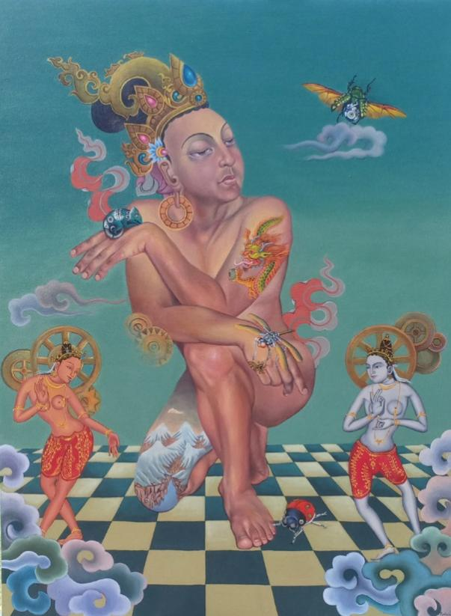
Title: Effects of Artificial World
Medium: Acrylic on canvas
Size: 36” x 48”
Year of Production: 2021
Effects of Artificial World
People need the environment around them to survive. People get chance to learn a lot from the same environment. But people are also destroying the same environment .The natural creatures around us like animals insects, trees, plants etc are gradually disappearing due to us. And these extinct animals will not be seen by our descendants .But due to the high development of science in the world various living beings are created by science and technology. The same artificial creatures have started to take the place of natural creatures.
The mobile phone, we use is also becoming very dear to us. Life without mobile is very difficult .Because everything is available on mobile .After a while, another new invention is made. That too will become just as popular.
If the same situation happens, I think that in a short time, artificial goods will cause great damage to the world market. Since the same artificial objects are used a lot, I have also created pictures using artificial animals in my painting.
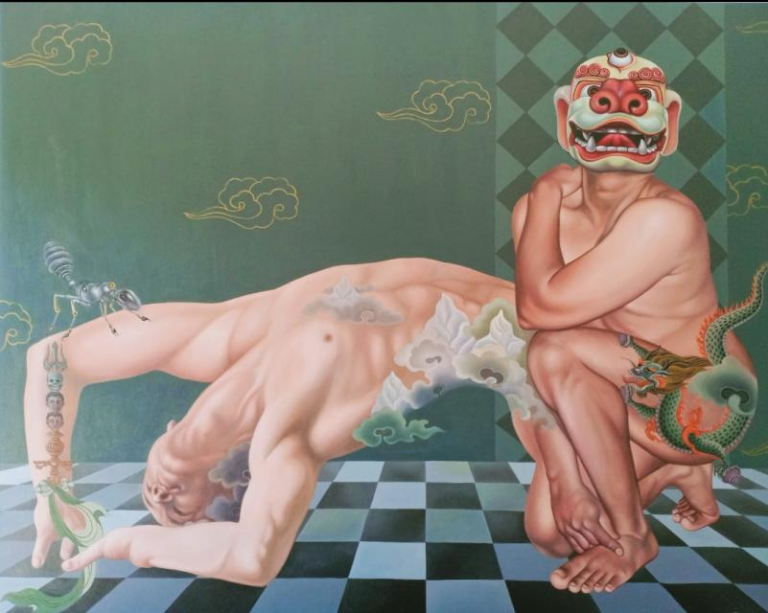
Title: The Mask
Medium: Acrylic on canvas
Size: 48” x 60”
Year of Production: 2022
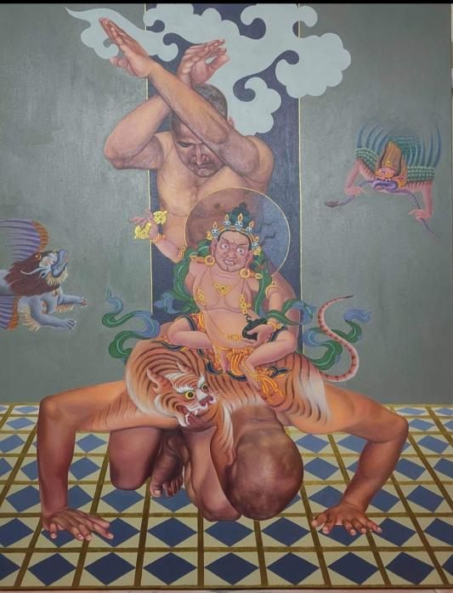
Title: The God
Medium: Acrylic on canvas
Size: 42” x 54”
Year of Production: 2022

