If you are using GRASP “Free and easy tool”: File -> New -> Java -> Choose LogicalExpressionCalculatorSource.java -> Ok

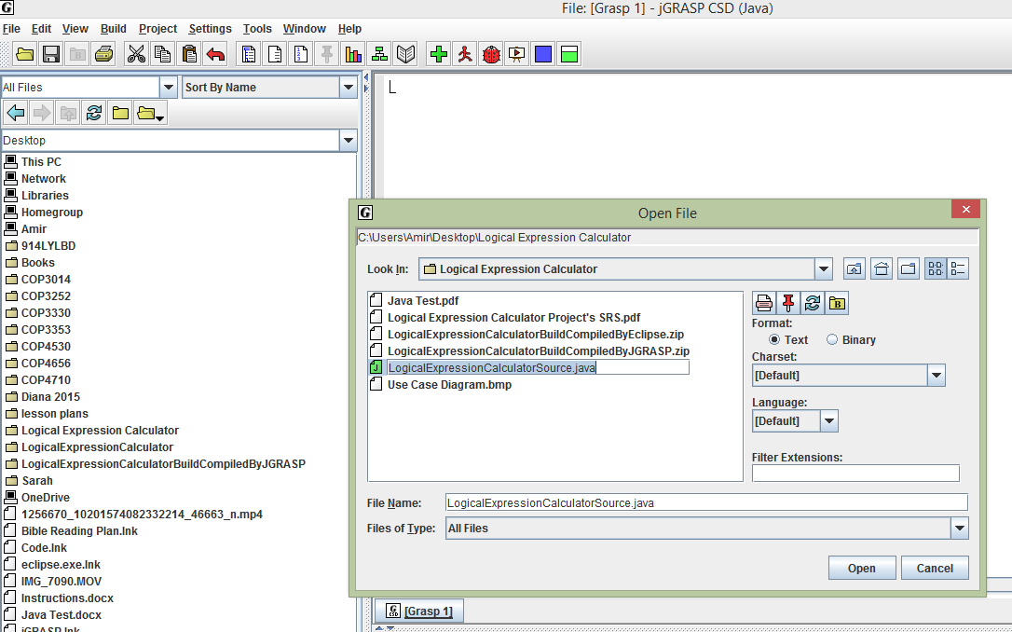

Click Build and select Run Arguments and Run in MSDOS Window to be able to see a new window to run the application.

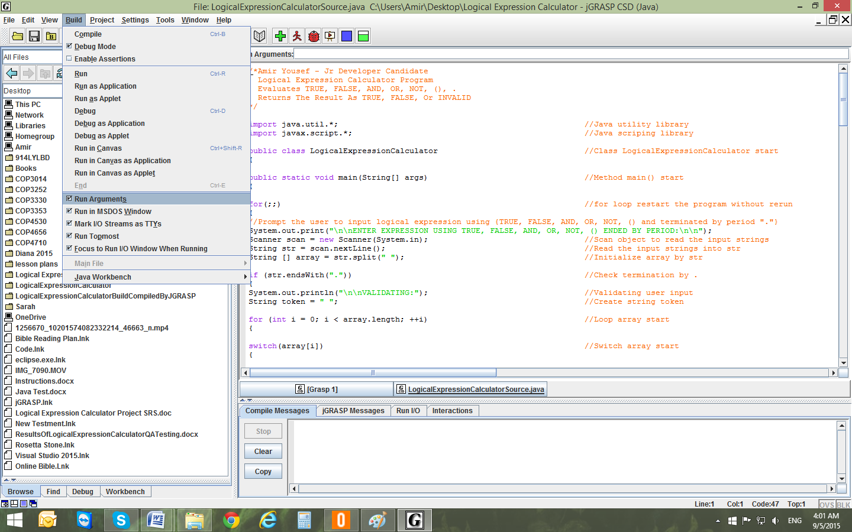

If you are using eclipse: File -> New Java Project -> Browse -> Choose Folder Location -> Ok -> Finish

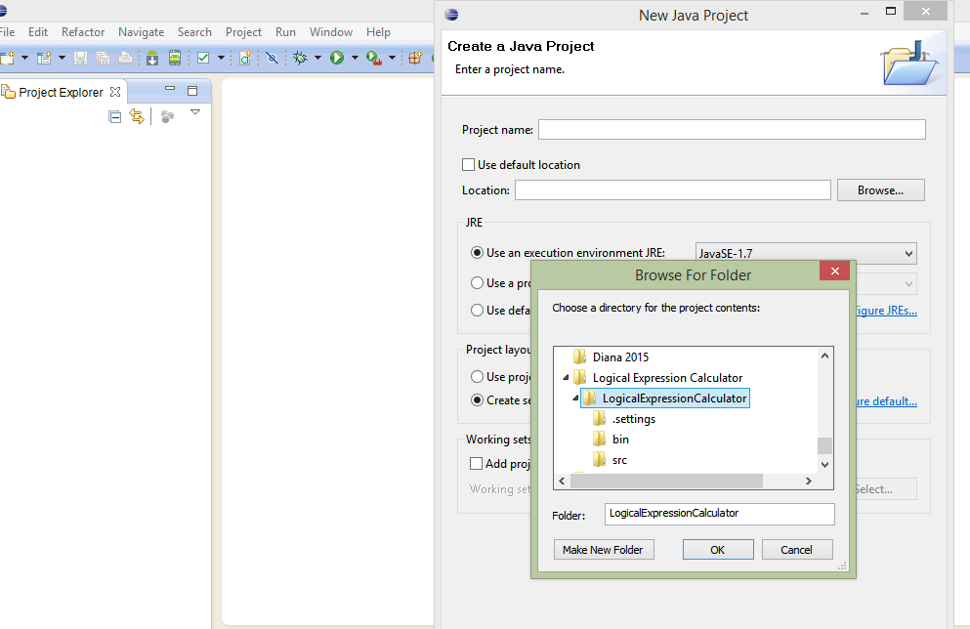

Click Run to execute: try ex: TRUE OR FALSE. Press enter

