Inven: A Web-Based ERP System for Brick Manufacturing Operations
Abrorbek Mirzaliyev
amirzaliyev@students.wiut.uz
BSc (Hons) Business Information Systems
Supervisor: Shirin Primkulova
A project undertaken as part of BSc (Hons) Business Information Systems Degree, Westminster International University in Tashkent
Module: 6BUIS007C-n Business Information Systems Project
Date of submission: 10 April 2026

Table of Contents
Abstract 2
1. Introduction 4
1.1 Purpose and Scope 4
1.2 Background 4
1.3 Problem Statement 5
1.4 Research Question 5
1.5 SMART Objectives 5
2. Literature Review 6
2.1 ERP Systems in SME manufacturing. 6
2.2 Agile Software Development 7
2.3 RESTful API Design 7
2.4 Password Security and Authentication. 8
2.5 Web Application Architecture in the modern world. 8
2.6 Continuous Deployment and Containerization. 8
3. Methodology – Business 9
3.1 Situation Analysis 9
3.2 Primary Research 10
3.3 SWOT Analysis 10
3.4 PESTLE Analysis 11
3.5 Competitor Analysis 12
3.6 Marketing Mix Elements 12
4. Methodology – Computing 13
4.1 Development Lifecycle 13
4.2 Technology Stack and Justification. 13
4.3 System Architecture 15
4.4 Database Design 15
4.5 Design Patterns 16
5. Results and Implementation 16
5.1 Authentication and user management. 17
5.2 Product Management 17
5.3 Batch Production Tracking 17
5.4 Inventory Management 18
5.5 Customer and Order Management. 18
5.6 Employee, Subversion and Payroll Modules. 19
5.7 Dashboard and Internationalization 19
5.8 Testing 20
5.9 Deployment 20
6. Conclusions 21
7. Critical Evaluation and Reflection 23
7.1 Limitations 24
7.2 Future Development 24
7.3 What is Different that would be done differently. 24
7.4 Lessons Learned 25
Appendices 27
Appendix A: System Architecture Overview 28
Appendix B: Database Schema Summary 28
Appendix D: System Screenshots 29
Appendix E: API Endpoints 35
Appendix F: Evidence of Manual Processes Prior to System Deployment 36

Abstract
The current project deals with the operational inefficiency witnessed in a small brick manufacturing firm in Uzbekistan by designing and developing an in-house web-based Enterprise Resource Planning (ERP), which is called Inven. The manufacturing sector on the small and medium enterprise (SME) level has been stuck with manual and paper based processes to track batches of production, worker pay on a commission basis, inventory and also customer order processing. Such practices bring in errors, slowness of payroll, and denies management a unified operational perspective.
The research is based on primary research, as the author conducted participant observation at a brick manufacturing family-owned company where the author was employed as an accountant, and secondary research, focusing on ERP systems in SMEs, agile development, RESTful API development, authentication standards, and containerized deployment. The gathering of requirements was done in an iterative fashion during the project and the system was built in an agile incremental fashion.
The system provided encompasses inventory control that includes all transaction audit trails, product batch control that includes worker attendance and a confirmation lock, order processing with a forced status workflow, employee and subdivision control, automatic payroll with per-product commission rates, and an operational dashboard. The stack includes FastAPI on the back end, React and TypeScript on the front end and PostgreSQL as the relational database. It is containerized using Docker, proxied via Nginx and uses SSL, and deployed using an automated pipeline in GitHub Actions. Role-based controlling access with per-user overrides and interface in English and Uzbek are available.
The primary conclusion is that custom-designed, lightweight ERP, which is specific to the precise business operations of an SME, can be more practically valuable than the customization of a generic commercial platform, especially when domain-specific logic like batch-based commission calculation is needed. The project finds that current open-source web technologies can be used to develop a low-cost, production-grade enterprise system, as long as stakeholder participation and incremental development are upheld.

1. Introduction

1.1 Purpose and Scope
This project aims at designing, developing and implementing an ERP system based on the web ready to serve the operational requirements of a brick manufacturing company that is based in Uzbekistan. The system is called Inven and it encompasses five business areas of inventory, production batch, customer order, employee and subdivision management as well as payroll generation with automated commission calculation. This is intentionally restricted to the internal activities of one organization; financial accounting, taxation and external integrations are out of scope in an attempt to ensure that the project deliverable is within the time frame available.

1.2 Background
Small and medium-sized brick producers that serve the domestic construction market control the manufacture of bricks in Uzbekistan, with the majority still using paper ledgers and informal communication on a daily basis to coordinate their operations. These manufacturers are between two types of ERP customer too small to warrant the cost of licensing and consulting services of a platform like SAP or Oracle, but too operationally specific to be able to purchase generic off-the-shelf products without substantial customization (Haddara and Zach, 2012).
The case organization is a family-owned brick manufacturer which manufactures various types of clay bricks to be sold to local wholesalers. Subdivisions are fixed teams of workers and are assigned to production batches. A part of the staff will be under a fixed monthly pay and the production staff will be under commission with their income depending on the quantity that their team produces and the number of members who attend the batch. The project was inspired by direct exposure to the manual form of this calculation of the commissions in the course of a summer job in an accounting position.

1.3 Problem Statement
During the observation within the case organization, a number of recurrent issues were determined. The output of production was entered manually in a log book, and there was no systematic connection between a batch and workers who worked on it. Manual calculation of commissions was done on paper at the end of every pay cycle, and the manual process of dividing the total in each batch by the number of workers present was slow and subject to error. Real time tracking of inventory was not done and as a result, the physical yard and the stock recorded did not match. Ordering was done verbally and did not leave a trail of audit, thus, it could be lost, replicated or partially complete. Lastly, the management was not able to refer to a single source of the operational information.

1.4 Research Question
What will a bespoke, web-based ERP system do to enhance operational accuracy and efficiency in a SME brick manufacturing scenario, with particular focus on batch-based production tracking and payroll based on commission?

1.5 SMART Objectives
There are five objectives to the module learning outcomes that cut across business analysis, computing and project management that guide the project:
To create a web based inventory management module that tracks stock on debit and credit transactions associated with sales, defects and production and has a full audit trail, by the end of the second semester.
To install a batch production tracking module which will automatically fill out worker attendance based on subdivision membership and will impose a confirmation lock to prevent retroactive changes on confirmed batches.
To develop an automated payroll system that calculates the commissions of each employee on a batch participation basis, commission rate per product and attendance and generates individual employee payslips with a breakdown of the contributions made.
To utilize a role-based access control system to have three roles (master administrator, administrator and employee) with granular per-user permissions override.
To implement the completed system to a production setup using Docker, an Nginx reverse proxy with SSL and a continuous deployment pipeline.

2. Literature Review
The literature review places the Inven project in the current literature on enterprise systems to SMEs, agile development methodology and the technical fields that pertain to the current web application engineering. It is not intended to survey all the contributions to these areas but to isolate the principles which directly influence the design decisions made in the project.

2.1 ERP Systems in SME manufacturing.
Enterprise Resource Planning systems combine the main business processes, which have traditionally been finance, human resource, procurement, inventory and production, to a single data model (Monk and Wagner, 2013). Large organizations are also targeted by established systems like SAP and Oracle which require huge licensing and consulting fees that most small manufacturers in less developed economies cannot afford (Haddara and Zach, 2012). Alternatives like Odoo and ERPNext are open-source and thus lower the financial cost, but according to Johansson and Sudzina (2008) the open-source ERP usage in SMEs is frequently constrained by the effort necessary to match generic modules to particular processes.
According to Zach and Munkvold (2012), the most value of systems to small organizations is where the data models and workflows of the systems are similar to the way business is actually conducted (as opposed to an overall platform that requires business processes to change to fit the software). This fact proves the very essence of the design of this project: instead of designing a generic ERP setup to support the batch-based commissioning model of a brick manufacturer, an easy-to-use custom-built application was created. The trade-off is that Inven loses breadth, especially in financial reporting, to provide an exact fit with the payroll and production processes of the case organization.

2.2 Agile Software Development
The Agile Manifesto (Beck et al., 2001) places working software, customer collaboration, and change responsiveness above detailed documentation and inflexible planning and Schwaber and Sutherland (2020) codify the philosophy in the Scrum framework. A complete Scrum process cannot be easily scaled down to a single developer undergraduate project since it presupposes separate roles within a team, but the philosophy of iterative development was very easily applied. The construction of Inven was done in modules, with each being deployed to a working environment to enable the next one to be developed without needing to rewrite the code massively to support changes in requirements around commission calculation. This solution aligns with the suggestion made by Dawson (2015) that student information systems projects must be designed to accommodate change and not presume a specific specification.

2.3 RESTful API Design
Representational State Transfer (REST) is an architectural style proposed by Fielding (2000) to provide description of distributed hypermedia systems, and stipulates a collection of constraints such as statelessness, uniform interface, and resource addressing. Richardson and Ruby (2007) converted these constraints into useful principles to include resource-oriented URLs, proper usage of HTTP methods, and JSON as a lightweight message format. Inven conventions are as follows: resources, like products, batches and orders, are displayed under stable URL endpoints, state changing operations are executed with POST, PUT and DELETE and all endpoints are automatically described with the OpenAPI schema generated by FastAPI.

2.4 Password Security and Authentication.
The specification of JSON Web Tokens (RFC 7519) (Jones, Bradley and Sakimura, 2015) defines a succinct system of claim transmission between parties, signed, so they are highly applicable to stateless API authentication. Recent recommendations suggest using short-lived access tokens alongside longer-lived refresh tokens stored in secure, HTTP-only cookies, such that a compromised access token has a limited lifetime risk, but the session is long and convenient to the user.
To store passwords the Open Web Application Security Project (OWASP, 2023) suggests using memory-hard hashing algorithms, namely Argon2id, as they cannot be accelerated using specialized hardware. Inven hashes all passwords with Argon2id and applies the above described dual-token pattern of authentication, but with a sixty minutes access token time and a seven days refresh token time.

2.5 Web Application Architecture in the modern world.
According to Gackenheimer (2015), React follows a component-based architecture where user interfaces are built out of tiny, reusable, state-driven and prop-driven components. This approach, used together with TypeScript, which introduces a static type system to JavaScript (Bierman, Abadi and Torgersen, 2014), detects quite a large number of bugs during compile time. It is based on Pydantic models to describe API request and response shapes, and the frontend reflects the shapes in TypeScript interfaces to generate end-to-end type safety with the same structure being validated at the database, API and interface layers.

2.6 Continuous Deployment and Containerization.
According to Merker (2014), Docker refers to a lightweight containerization system that bundles applications and their dependencies into lightweight images, avoiding environment drift between development and production. Humble and Farley (2010) say that automated deployment pipelines lower the risks associated with each release and release developers of the manual tediousness that discourages regular updates. Docker Compose can coordinate the database, API, web server and certificate manager as one, and GitHub Actions can be used to re-build and redeploy the application every time that a code is pushed to the main branch. This infrastructure investment was early in the project and this lessons learned section will revisit this as a decision that paid off many times over.

3. Methodology – Business

3.1 Situation Analysis
A case organization is a brick manufacturing privately owned company that has one production yard in Uzbekistan. The company manufactures a number of types of clay brick to be distributed to local construction wholesalers. Production is planned in batches: a group of workers (usually four to ten individuals) is dedicated to manufacturing a certain amount of a given product within a specified time. Pay is divided between salaried administrative employees, whose salaries are fixed and production employees, whose salaries are determined with regard to the batches in which they worked.
All the operational records were stored manually before this project. A physical book was used to write the batch logs at the yard, the supervisor of each batch would record attendance of the batch, and commission was to be computed by hand at the end of each month in an accounting ledger (see Appendix F). The orders of wholesale customers were settled by phone or telegraph message and written into a separate order book. The stock was also counted physically as questions arose as opposed to a running balance.

3.2 Primary Research
The primary research was in the form of participant observation where the author had been employed on a summer basis at the case organization where he worked in an accounting position involving monthly payrolls. This qualitative approach where the researcher becomes part of the activity under investigation is highly appropriate to comprehend tacit processes that might be challenging to describe by the participants in a formal interview. The order of the operations that constitute a production batch was recorded, the stepwise process of calculating commissions based on the batch log and attendance record was noted, and where mistakes were most frequently found in the workflow (Figure F3 in Appendix F shows an example of the manual commission calculation this section describes).
The following design was influenced by three observations. First, commission was easy at theory but tedious at practice, as each batch must be separated out against attendance and any absence must be included in the division. Second, one of the socially important events that could not be undone without controversy was the confirmation of a batch, and this was the direct inspiration of the confirmation-lock feature in section 5.3. Third, the amount of paper documentation created the historical queries, including finding out which employees worked on a batch of three months ago, unrealistically costly to resolve.

3.3 SWOT Analysis
The SWOT analysis is based on the Inven system as a product within the organizational context.
Strengths: The system is designed to be compatible with the actual production and payroll workflow of the brick-manufacturing industry, with the batch-based commission model that generic ERP systems would not handle without customization. The English and Uzbek interface is bilingual, eliminating a barrier to the local workforce and role-based permissions isolate administrative and shop-floor tasks.
Weaknesses: It is a single-tenant system; non-trivial changes to the data model would be needed to enable it to operate in a multi-tenant manner. It does not have an offline mode, which is a weakness in which connectivity to the production yard cannot be assumed. No external accounting software has an export path and financial reporting outside payroll is not provided.
Opportunities: The same software could be reconfigured to suit other SME brick producers in the region, which have the same compensation system. The modular design can be easily extended in the future to include a mobile app to supervise shifts or barcode support to inventory.
Threats: A cultural challenge that is realistic is the resistance to the adoption of digital because of a workforce that has been used to the paper records. There is a dependency on one developer, which is a key-person risk. Managing personal information such as salary details comes with regulatory obligations which will increase as local data protection systems are developed.

3.4 PESTLE Analysis
The PESTLE framework situates the project in its wider environment. On the political front, the Uzbek government has been actively engaging in digitalization of industry which has provided a favorable environment to SMEs to adopt software. Economically, the tailor-made solution removes the repeat licensing cost which would otherwise be a major barrier to a small scale manufacturer and manual payroll errors have a direct impact on costs. Socioculturally, the interface strings are offered in English and Uzbek, as it is the linguistic workforce reality. The open-source stack is technologically mature and well documented, and containerized cloud hosting keeps the cost of infrastructure low. The system legally processes employee personal information such as salary amounts, with role-based permissions and hash passwords. The environmental impact of substituting paper ledgers with electronic records yields a small decrease in the consumption of materials.

3.5 Competitor Analysis
An appraisal of an SME producer of bricks takes a short competitor analysis of Inven versus the alternatives that are realistically available. The qualitative comparison is not done in terms of features but in terms of practical fit.
Criterion | Inven | Odoo | SAP B1 | ERPNext
Brick industry fit | Purpose-built | Generic | Generic | Generic
Batch commission model | Native | Customize | Customize | Customize
Uzbek language | Full | Partial | No | No
Deployment effort | Low (Docker) | Medium | High | Medium
Licensing cost | None | Free/Paid | High | None
Maintenance model | Self-host | Self/SaaS | Vendor | Self-host
The comparison reveals that Inven is not to be a breadth competitor to comprehensive ERP platforms. Its strength is its precise fitting of its batch production and commission logic to the target industry and the low cost of operation and maintenance of hosting and maintaining it.

3.6 Marketing Mix Elements
Though Inven is not designed as a commercial product, but as a special product designed to serve a particular client, the four marketing elements are a valuable discipline. The product is a web-based ERP that is specific to brick production, and its characteristic attribute is batch based commission calculations. Delivery location is the public web, which is running on a single virtual private server that is adequate to serve the present scale. Promotion is not an issue of concern since the case organization commissioned the system on its own. With hosting and domain costs, effectively constrained at a price of zero, the cost of price is much less than commercial alternatives.

4. Methodology – Computing

4.1 Development Lifecycle
The process of development was done in an iterative lifecycle where one module was developed followed by the next and each module was developed through requirements refinement, changes in database schema, backend implementation and tests, frontend implementation, integration testing, and deployment. It implied that the deployed system was never out of service, feedback could be received at the case organization and compared to real behavior and not mock-ups and areas of uncertainty like commission calculation could be revisited without major rewrites. Version control was done using GIT and commits were associated with the features they introduced.

4.2 Technology Stack and Justification.
The stack was chosen based on the consideration of the needs of the project and the current competence of the author as a junior developer in the backend with a Python background. The principle to follow was reducing the new technologies to ensure that the effort can be focused on the domain modelling. The five major options are explained below.
FastAPI (Python backend). FastAPI is an async native, high-performance Python language that provides a native Python experience, automatic validation of requests and responses using Pydantic, and autogenerated OpenAPI documentation. The author already had some knowledge of Python, which is why it was the least dangerous option in case of a single developer with a tight deadline. Dependency injection as a first-class feature enabled request-scoped services to be cleanly wired without ad hoc global state.
React (frontend) with TypeScript. React offers a component-driven framework that is appropriate to an interface consisting of repetitive components like tables, forms and dialogues. TypeScript introduces compile-time type checking that detects many integration errors between frontend and backend prior to a runtime error. The mixture is well backed by libraries such as React Router, Axios, and i18next to internationalization.
PostgreSQL (database). In addition to its overall reliability, there were two reasons why PostgreSQL was selected. First, its support of EXCLUDE constraints enabled non-overlapping commission rate date ranges per product to be implemented at the database level, instead of in application code, eliminating on the one hand a class of data integrity bugs that would otherwise necessitate defensive programming across the backend. Second, its full-fledged support of the asynchronous FastAPI stack fitted with its mature async driver support.
Docker and Nginx (infrastructure). Docker has removed environment drift between production and development and has also allowed the entire stack to be reproduced with a single command. Nginx is used as a reverse proxy between FastAPI, which offers termination of the SSL and routes single pages applications, and serves up static assets. Certbot is a containerized application that provides Let's Encrypt certificates and renews them automatically.
Alembic (database migrations). The change in the schema was monitored using Alembic migrations since the initial working version, subsequent schema changes could be revisited, re-executed and undone, eliminating temptation to perform ad hoc changes against the production database.

4.3 System Architecture
The system is based on a traditional three-tier architecture. The presentation tier is a React single-page application that is served as statical files by Nginx and only interacts with the backend via HTTPS requests to a JSON REST API. The application tier is the FastAPI backend, which serves REST endpoints, provides authentication and permissions, carries out domain logic, and connects with the database via an asynchronous SQLAlchemy session. The database is a PostgreSQL database, which is subject to Alembic migrations. All four services along with the certificate manager are containers that work as Docker and are coordinated by a single Compose file.

4.4 Database Design
The schema will have 17 tables that are organized into identity, products, production, customers and orders, workforce, and payroll. Each table has a common base model that offers id, is_active, created, updated and deleted at columns, which generate consistent audit trails and facilitate soft deletion. Referential integrity is ensured by foreign key constraints with intentional cascade rules, and domain constraints are enforced at the database level where feasible: positive quantity and amount checks, unique SKU codes, unique employee numbers and EXCLUDE constraints on the commission rate table that two rows with different validity periods share the same product. This investment in data integrity was deliberate in enforcing these rules in the database and not just in the application layer.
(ER diagram https://dbdiagram.io/d/69d8def50f7c9ef2c0c7282f)

4.5 Design Patterns
On the backend, I have used a generic service pattern: a BaseModelService class provides type-safe CRUD operations, which are customized by concrete services to each domain entity. The Depends dependency injection mechanism of FastAPI gives every request handler request-scoped sessions and services. At the API boundary, domain exceptions are mapped to HTTP status codes, leaving the service layer unconcerned with framework matters. React Context and custom hooks are used on the frontend to share state authentication, notifications and confirmation dialogues. Authentication headers are added to axios interceptors and the rotation of a refresh token is handled automatically, and a protected-route component redirects unauthenticated users prior to accessing any restricted content.

5. Results and Implementation
This section gives the functional modules provided by this project, the testing approach, and the deployment setup in production. The modules have been described in the sequence in which they were developed that generally reflects the dependency relationships among them: identity and products were created first since nothing could be built on top of them, payroll was created last since it relies on practically all other modules.

5.1 Authentication and user management.
Authentication is by username and password (authenticated by hashes of the Argon2id algorithm). A successful login returns a signed JWT access token, with a lifetime of sixty minutes, in the response body which can be used in the Authorization header, and a refresh token in a secure cookie with a lifetime of seven days. This two-token construction adheres to the advice studied in 2.4: although an access token might be leaked, it would not take long to do so. Three roles are supported (master administrator, administrator and employee) and per-user permission expressed in pairs of resource and action can admit exceptional cases without adding new roles. Upon first launch the application makes a master administrator based on the environment variables, bootstrapping the system into a working condition.

5.2 Product Management
Products are the various kinds of bricks that are manufactured by the business. All products possess a SKU code, name, description and a row of zero or more commission rates, each with a description of how much one would pay per unit of that product within a particular period of time. The EXCLUDE restriction on the table of commission rates ensures that there are no two rows of the table that contain the same product, and whose date ranges overlap, so that there is at most one rate in the table that is applicable to any historical commission calculation. Full create, read, update and delete operations are exposed through the API.

5.3 Batch Production Tracking
A batch is a unit of production of a particular subdivision of a single product. On creating a batch, the attendance table is filled with the existing membership of the assigned subdivision automatically and the supervisor can then mark absent workers whose share in commission will be then left out. The most important workflow decision in this module is the confirmation lock: once a batch is confirmed, its quantity, attendance or product can never be changed, and the only method of fixing a mistake is to do an auditable reversal (see Figure D5). This reflects the social fact of the manual process, in which making sure that a batch is already committed is already a commitment, and avoids a entire set of conflicts that would otherwise be caused by ex post facto adjustments to finished work.

5.4 Inventory Management
A transaction ledger is used to track inventory instead of just a column with the quantity. Every transaction will be a credit, a transaction which increases stock, or a debit, a transaction which decreases stock, and identified by a source: sales, defect, or batch. A transaction is made up of a line item or items that recognizes an item and quantity. The current stock is obtained by adding the total amount of credit lines to the total amount of debit lines. With this design, some query complexity is added, but it yields a full and unfalsifiable audit trail. A debit transaction is automatically generated when an order is completed and a credit transaction is automatically generated when a batch is confirmed.

5.5 Customer and Order Management.
Customers are represented as a contact record including name, phone and free-text notes, and soft deletion. Orders are associated with a customer and are made up of line items providing product, amount and price at time of sale with financial values being represented as decimals(15,2) to avoid floating-point rounding. A status workflow is an order that follows a sequence with a starting point of a draft where it can be arbitrarily edited and enters a next phase of completed, where the line items are locked and the deduction of inventory described in section 5.4 is triggered, or cancelled. A reset operation will put a completed order back in draft status to be corrected.

5.6 Employee, Subversion and Payroll Modules.
Every employee possesses a type of employment either a salary or paid a fixed monthly amount or a commission paid depending on batch participation. The employees are subdivided and they are used as team identifiers as well as the source of attendance as a batch is generated.
The analytical center of the system is the payroll module. The generation, approval and payment of payroll is based on a specified period of time, usually a calendar month. In the case of salaried employees the base salary is directly carried to the payslip. In the case of commission employees, the system lists all the confirmed batches in the period where the worker roster includes the employee and calculates the per-batch contribution and logs it as a commission line on the payslip (see Figure D11) such that an employee can understand which batches comprised their pay. The implementation of the calculation is:
commission per worker = (quantity of batches x the product rate) / number of current workers.
Batches are only added when they have been confirmed and hence the significance of the confirmation lock of section 5.3: once a commission calculation has been executed, the inputs to the calculation cannot just magically adjust. Workers who do not work will present a zero to the divisor, and will present no share to that batch. Since commission rates are time-dependent and non-overlapping, the right rate of any historical batch can be looked up unambiguously even when the rate has since been varied on future batches.

5.7 Dashboard and Internationalization
The dashboard summarizes headline operational data into one screen: inventory of current stock by product, output of production in the current day, draft, completed and cancelled orders, current month revenue, payroll by status, and workforce totals by employment type. Individual figures are created through a specific query and not by loading entire tables to memory. The interface is presented in English and Uzbek that has more than four hundred and ninety translation keys including form labels, buttons, error messages and navigation.

5.8 Testing
An automated test suite, with pytest and pytest-asyncio, covers the backend. Under the permission system, five major test modules are used to test authentication flows such as token rotation and forced password change, batch creation and confirmation, state transitions between the order state and their interaction with the inventory, payroll generation with commission arithmetic, and general CRUD operations. The frontend is based on TypeScript compilation and ESLint static analysis instead of automated component tests, which has been recognized in the critical analysis.

5.9 Deployment
The production deployment uses four containers with Docker Compose (see Figure A1), which include: PostgreSQL with a persistent volume, the FastAPI application, an Nginx reverse proxy with two server blocks (https://inven.uz on the frontend and https://api.inven.uz on the backend) and a Certbot container to automatically renew Let's Encrypt certificates. Multi-stage Docker images maintain a small size. An action on a self-hosted runner is triggered by the push to the main branch and pulls the latest code, rebuilds all the affected images, performs migrations and restarts services such that the code change transitions between commit and live deployment automatically.

6. Conclusions
The project aimed at providing the answer to the question whether a custom-built web-based ERP system could enhance operational accuracy and efficiency in the SME of producing the bricks, with the specific focus on a batch-based production and a payroll system that is based on commissions. The facts provided by the presented system and its application in the case organization can be used to answer the question with a positive answer, albeit with certain qualifications, which will be discussed by the critical analysis.
All five SMART objectives as mentioned in the introduction have been achieved. The first objective is met by the inventory module that maintains a complete audit trail by keeping a debit and credit ledger that tracks stock. The second requirement is met by the batch module automatically filling in attendance based on subdivision membership and implementing a confirmation lock, which prevents retroactive change. The payroll module calculates commissions based on the batch quantity, the time-bound product rate and the number of workers present and generates per employee payslips with line-item contributions, satisfying the third. The fourth is satisfied by a role-based access control with overrides per user that is implemented at the API layer and is reflected in the interface. The fifth is met by the system being run in production as a Docker environment with an automated deployment pipeline and SSL encryption.
The general observation is that the unique characteristics of a niche manufacturing process are occasionally more effectively addressed by a customized lightweight system than by the design of a general-purpose ERP system. The commission logic at the core of this project is an example: it would take a few hundred lines of code to express it as native behavior of the system, and it would take a custom module, integration workarounds or spreadsheet appendages to achieve the same behavior in a generic ERP, which would themselves become a source of error. The trade-off is that Inven is a smaller functional area than a commercial platform; in the case organization which does not require generalized financial modules at this point, that trade-off is reasonable.

7. Critical Evaluation and Reflection

7.1 Limitations
There are a few weaknesses of the provided system that are worth mentioning. The architecture is single-tenant, i.e. each deployment is shared between one organization; this would need tenant identifiers embedded in the data model and the query layer, and it is a significant change and not a configuration switch. There is no offline mode which is a real weakness in an environment where the production yard does not ensure constant connection. Financial reporting is confined to payroll and inventory areas and therefore the system has information about what was produced, sold and paid but does not generate statements that would be accepted by an external accountant. With the frontend, there are no automated tests; there is only TypeScript compilation and static analysis that stand between the codebase and regression bugs that arise out of interface changes. Lastly, it has no mobile app, which means that even a web interface is responsive, a shift supervisor is still required to use a tablet or laptop but not a phone in a pocket.

7.2 Future Development
Financial reporting module including export to PDF and spreadsheet formats as well as notification system warning users about low stock levels, payrolls to be paid and orders completed would be the most immediately useful extensions. In addition to these, a mobile app with a specific focus on shift supervisors would lessen the tension at the batch creation and attendance marking point, and barcode or QR code scanning would accelerate inventory flows. The support of multi-tenants would open up the possibilities of providing the system to other manufacturers of bricks. The workflow would be finished with the help of integration with local accounting packages like 1C.

7.3 What is Different that would be done differently.
There are three things that in retrospect would be approached differently. First, user testing by real production staff instead of administrative staff alone would have started early in the first semester instead of later; this would have revealed usability problems much sooner with almost certainty. Second, even at the cost of slower initial development, automated frontend tests would have been written initially, since the later one instills a testing discipline the less of the codebase it will ultimately cover. Third, a more restrictive Git workflow, featuring feature branches and pull requests, even to a single developer, would have had a cleaner history and would have encouraged more deliberate code review.

7.4 Lessons Learned
The project has given a number of lessons that have become apparent. Making a little effort at constraining the database, e.g. by using the EXCLUDE constraint on commission rates, is compensated by bugs avoided and reduced complexity of application code; data integrity is cheapest to guarantee at the level nearest to the data. An asynchronous backend architecture provides the concurrency benefits of threading without the mental load of explicit threading. The iterative development with an actual stakeholder was not only an approach to the methodology, but the sole possible approach to finding the rules of calculating the commissions that the stakeholder herself had never had to formulate formally. The initial investment in Docker and continual deployment initially seemed like time wasted on features, but was many times over as deployment no longer became a source of stress. Lastly, it is much cheaper to implement bilingual support in the starting phases than to retrofit it.

References
Beck, K. et al. (2001). Manifesto for agile software development. Agile Alliance. Available from https://agilemanifesto.org [Accessed 8 April 2026].
Bierman, G., Abadi, M. and Torgersen, M. (2014). Understanding TypeScript. In: Jones, R., ed. ECOOP 2014 – Object-Oriented Programming. Berlin: Springer, 257-281.
Dawson, C.W. (2015). Projects in computing and information systems: a student's guide, 3rd ed. Harlow: Pearson Education.
Fielding, R.T. (2000). Architectural styles and the design of network-based software architectures. Doctoral dissertation. University of California, Irvine.
Gackenheimer, C. (2015). Introduction to React. Berkeley: Apress.
Haddara, M. and Zach, O. (2012). ERP systems in SMEs: an extended literature review. International Journal of Information Science, 2 (6), 106-116.
Humble, J. and Farley, D. (2010). Continuous delivery: reliable software releases through build, test, and deployment automation. Boston: Addison-Wesley.
Johansson, B. and Sudzina, F. (2008). ERP systems and open source: an initial review and some implications for SMEs. Journal of Enterprise Information Management, 21 (6), 649-658.
Jones, M., Bradley, J. and Sakimura, N. (2015). RFC 7519: JSON Web Token (JWT). Internet Engineering Task Force. Available from https://www.rfc-editor.org/rfc/rfc7519 [Accessed 8 April 2026].
Merkel, D. (2014). Docker: lightweight Linux containers for consistent development and deployment. Linux Journal, 2014 (239), 2.
Monk, E. and Wagner, B. (2013). Concepts in enterprise resource planning, 4th ed. Boston: Cengage Learning.
OWASP (2023). Password storage cheat sheet. OWASP Foundation. Available from https://cheatsheetseries.owasp.org/cheatsheets/Password_Storage_Cheat_Sheet.html [Accessed 8 April 2026].
Richardson, L. and Ruby, S. (2007). RESTful web services. Sebastopol: O'Reilly Media.
Schwaber, K. and Sutherland, J. (2020). The Scrum guide: the definitive guide to Scrum. Scrum.org. Available from https://scrumguides.org/scrum-guide.html [Accessed 8 April 2026].
Zach, O. and Munkvold, B.E. (2012). Identifying reasons for ERP system customization in SMEs: a multiple case study. Journal of Enterprise Information Management, 25 (5), 462-478.

Appendices

Appendix A: System Architecture Overview
The Inven system is implemented in four Docker containers that are configured with Docker Compose on a single virtual private server. The PostgreSQL container contains data on a named volume that is persistent. The FastAPI container is powered by the Python back-end and is not publically accessible to the internet. The Nginx container is the reverse proxy that ends the SSL and directs traffic to the frontend assets (static) (inven.uz) or the backend API (api.inven.uz). The Certbot container is periodically run to refresh Let’s Encrypt certificates. The self-hosted runner is configured to have GitHub Actions on a workflow that does rebuilds and restarts with each push to the main branch.
Figure A1: Deployment architecture of the Inven system. Four Docker containers run on a single VPS host: Nginx (reverse proxy and SSL termination), FastAPI (REST API backend), PostgreSQL (persistent data store, internal network only) and Certbot (automated Let's Encrypt renewal). Nginx routes inven.uz traffic to the React frontend and api.inven.uz traffic to the backend over HTTPS. GitHub Actions deploys over SSH via docker compose.

Appendix B: Database Schema Summary
The schema comprises the following major tables: users, user permissions, products, product commission rates, batches, batch workers, customers, orders, order items, employees, sub divisions, sub division member, inventory transactions, inventory transaction lines, payrolls, payslips, and payslip commission lines. Each table has inherited columns of id, is active, created at, updated at and deleted at. Referential integrity is ensured by explicit cascade rules on foreign keys, and domain constraints like positive quantities and non-overlapping ranges of commission rates date by check and EXCLUDE database-level constraints.

Appendix C: Commission Calculation Worked Example
In the case of a batch of 10,000 units of product P, which shows a commission rate of 500 soum per unit on the batch date. The total commission pool for the batch is therefore 10,000 × 500 = 5,000,000 soum. Should the designated subdivision contain eight members with two indicated as absent, then there are six workers on the batch. Each present worker receives 5,000,000 ÷ 6 ≈ 833,333 soum from this batch. It does not provide anything to absent workers. The total commission of such contributions of the same worker in the month is the total of such contributions in all the known batches in which they were presented as present.

Appendix D: System Screenshots
The figures below demonstrate the implemented Inven system deployed. The screenshots are all taken in the production environment of inven.uz. The interface language may be set to either English or Uzbek, the majority of figures below are displayed in the Uzbek locale, the default language of the case organisation, with one figure to illustrate the English locale.
Figure D1: Employee creation form. The 'Ish turi' (employment type) selector offers Belgilangan maosh (fixed salary) and Komissiya (commission) as described in Section 5.6.
Figure D2: Employees list showing two employment types side by side: a commission worker (Komissiya) and a fixed-salary worker with a base amount of 3,000,000 soum.
Figure D3: Batch creation dialog. The supervisor selects the production date, the product (here Shlakoblok 20×40), and the target quantity.
Figure D4: Batch in pending state (KUTILMOQDA). While pending, the Tahrirlash (edit) and Tasdiqlash (confirm) actions remain available.
Figure D5: Batch after confirmation (TASDIQLANGAN). Both edit and confirm actions are hidden, illustrating the confirmation lock described in Section 5.3 that prevents retroactive modification.
Figure D6: Order creation dialog. Line items specify the product, quantity and per-unit selling price (Narxi), with the total computed live.
Figure D7: Order in draft state (Qoralama). Edit, Complete (Bajarish) and Cancel (Bekor qilish) actions are available, consistent with the workflow rules in Section 5.5.
Figure D8: Order after completion (Bajarilgan). The only remaining action is Qayta ochish (reset to draft), and an inventory debit transaction has been created automatically.
Figure D9: Inventory transactions ledger. Each movement is recorded as a Kirim (credit) or Chiqim (debit) transaction tagged with its source: Sotuv (sales), Ishlab chiqarish (batch production) or defect, as described in Section 5.4.
Figure D10: Payroll list view showing a generated payroll in Qoralama (draft) state awaiting approval, with total amount and payslip count.
Figure D11: Payslip detail dialog showing per-employee breakdown with columns Asosiy maosh (base salary), Komissiya (commission) and Jami (total). The commission calculation follows the formula in Section 5.6.
Figure D12: User and permissions administration in the Uzbek locale (Foydalanuvchilar), demonstrating the bilingual interface described in Section 5.7. The same page in English is labelled 'Users'.

Appendix E: API Endpoints
The backend exposes a RESTful API documented through an automatically generated OpenAPI schema, served at /docs by FastAPI. Endpoints are grouped by resource and use standard HTTP methods: GET for retrieval, POST for creation, PUT for full update, PATCH for partial or state-changing operations, and DELETE for removal. Authentication uses a bearer JWT access token in the Authorization header, with refresh handled through a secure HTTP-only cookie. Figure E1 shows a subset of the live API documentation covering the authentication, dashboard, batch and customer resources. Similar endpoint groups exist for products, orders, inventory, employees, subdivisions, payroll and users.
Figure E1: Live OpenAPI (Swagger UI) documentation at /docs, showing endpoint groups for authentication, dashboard, batches and customers. Batch confirmation is implemented as PATCH /v1/batches/{batch_id}, reflecting the state-change semantics of the confirmation lock described in Section 5.3.

Appendix F: Evidence of Manual Processes Prior to System Deployment
The following figures are photographs of the paper ledgers used at the case organisation before the Inven system was deployed. They are included as direct evidence for the primary research described in Section 3.2 and for the problem statement in Section 1.3. The records are kept in Uzbek, mixing Cyrillic and Latin scripts; the captions below explain the column structure for readers unfamiliar with the language.
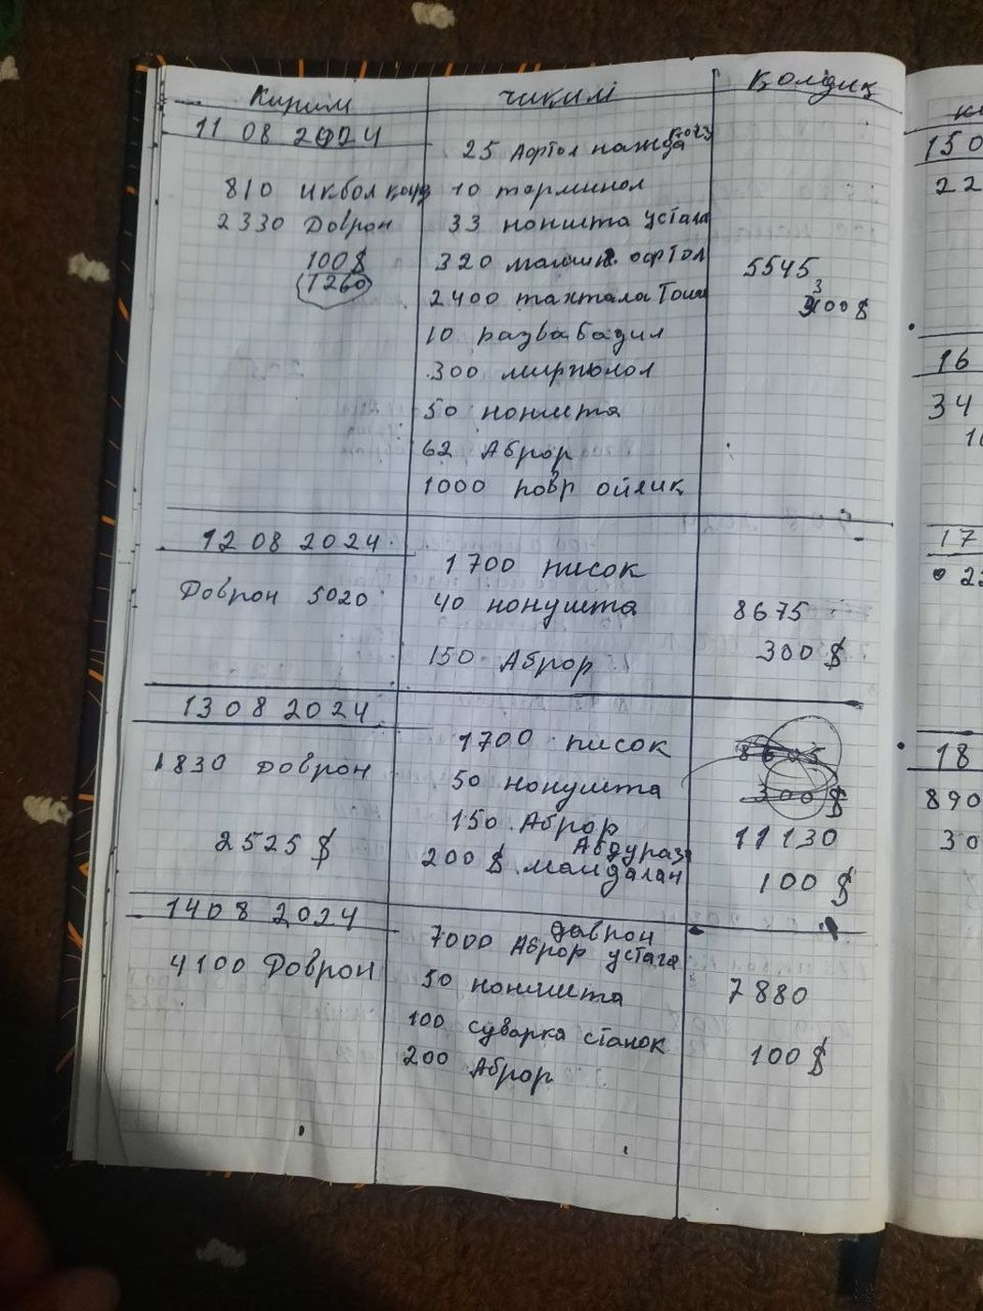
Figure F1: Page from the manual cashflow ledger. Three columns: Кирим (Kirim — income / incoming), Чиқим (Chiqim — expenses / outgoing) and Қолдиқ (Qoldiq — running balance). Dated 11–14 August 2024. Each row is a single day's mixed entries written longhand. The ledger replaces a real-time inventory and cash view that the Inven dashboard now provides automatically.
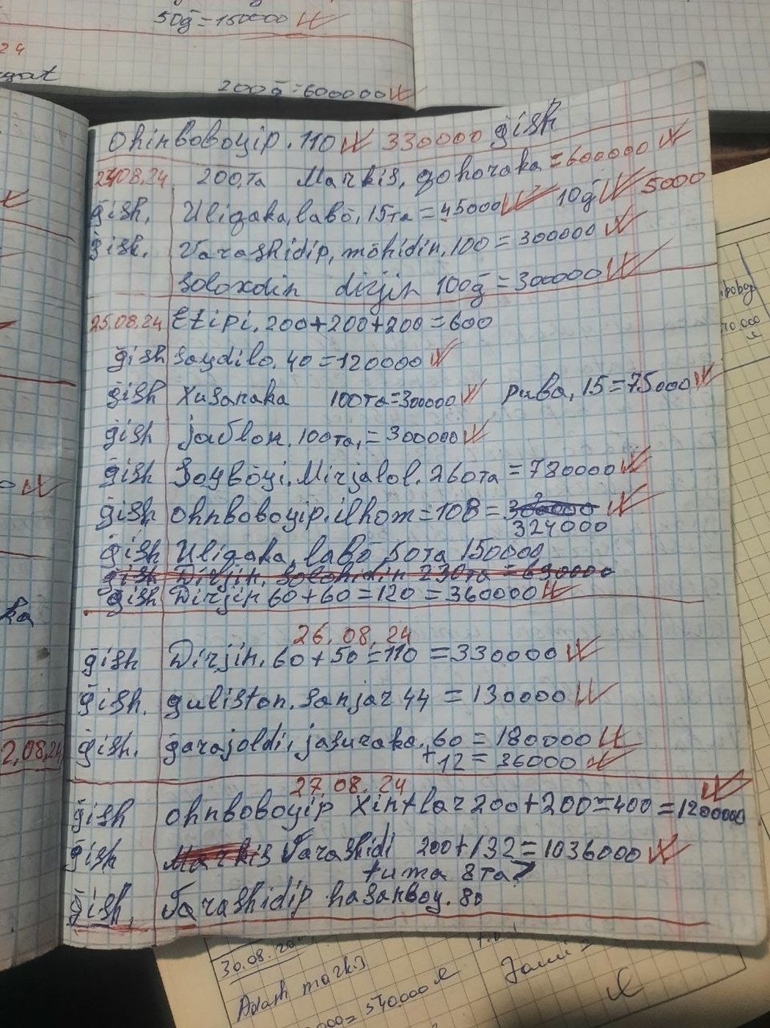
Figure F2: Page from the manual sales and delivery book, dated 24–27 August 2024. Each line records a customer delivery in free-form Uzbek text ("gish" = brick), with quantity and price written as plain arithmetic expressions (for example, "200+200+200=600" or "100 = 300000"). No status, no auditable identifier, no structured customer record — the workflow that Section 5.5 describes digitising.
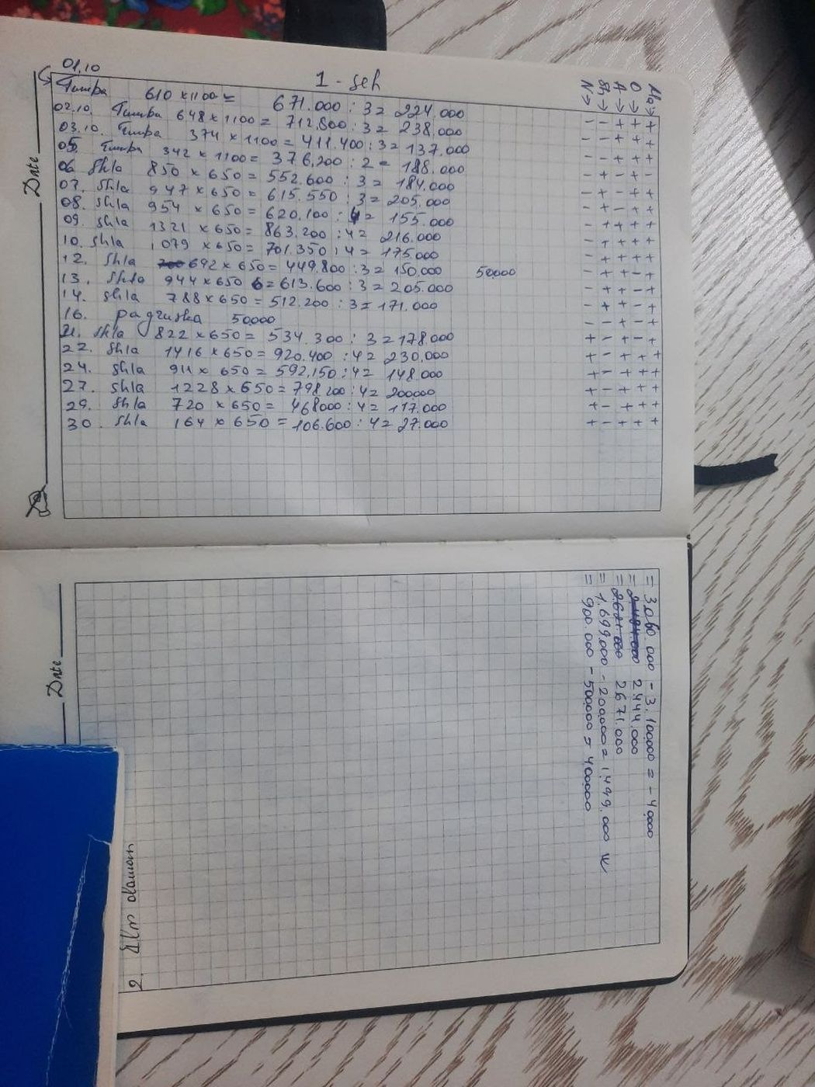
Figure F3: Page from the manual commission calculation ledger for October. Each row records a production batch: product (Tumba or Shla for shlakoblok), quantity produced, the per-unit rate (650 soum), the batch total, and a division by the number of workers present expressed as ": 3 = 224,000" or ": 4 = 202,000". The right-hand columns record attendance per worker with plus and minus marks. This is the literal manual execution of the commission formula in Section 5.6, performed by hand at month end; automating this calculation is the core motivation of the project.

