Patient classification

Tabular data

Ami Samyra Ouedraogo

Id :314132

**Business understanding**

When a patient arrives at the hospital following a malaise or simply because he feels unwell, for him to be taken care a certain number of tests are performed to give a diagnosis, these results also allow the doctor to know the next treatment. These tests are interpreted from certain parameters of certain standards, to facilitate and accelerate certain diagnosis, this analysis can be automated.

Our work here will therefore consist in setting up a model that will be able to predict if a patient should be taken in charge.

**Data Set Information:**

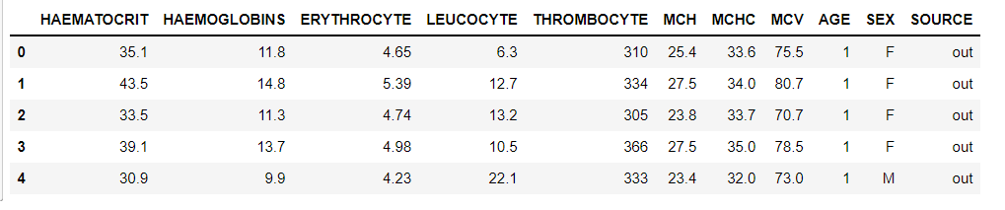

The dataset is Electronic Health Record Predicting collected from a private Hospital in Indonesia. It contains the patient's laboratory test results used to determine next patient treatment whether in care or out of care. The task embedded in the dataset is classification prediction.

**Attribute Information:**

Given is the attribute name, attribute type, the measurement unit and a brief description. The number of rings is the value to predict: either as a continuous value or as a classification problem.

Name / Data Type / Value Sample/ Description  
-----------------------------

HAEMATOCRIT /Continuous /35.1 / Patient laboratory test result of haematocrit

HAEMOGLOBINS/Continuous/11.8 / Patient laboratory test result of haemoglobins

ERYTHROCYTE/Continuous/4.65 / Patient laboratory test result of erythrocyte

LEUCOCYTE /Continuous /6.3 / Patient laboratory test result of leucocyte

THROMBOCYTE/Continuous/310/ Patient laboratory test result of thrombocyte

MCH/Continuous /25.4/ Patient laboratory test result of MCH

MCHC/Continuous/33.6/ Patient laboratory test result of MCHC

MCV/Continuous /75.5/ Patient laboratory test result of MCV

AGE/Continuous/12/ Patient age

SEX/Nominal – Binary/F/ Patient gender

SOURCE/Nominal/ {in,out}/The class target in.= in care patient, out = out care patient

Modeling

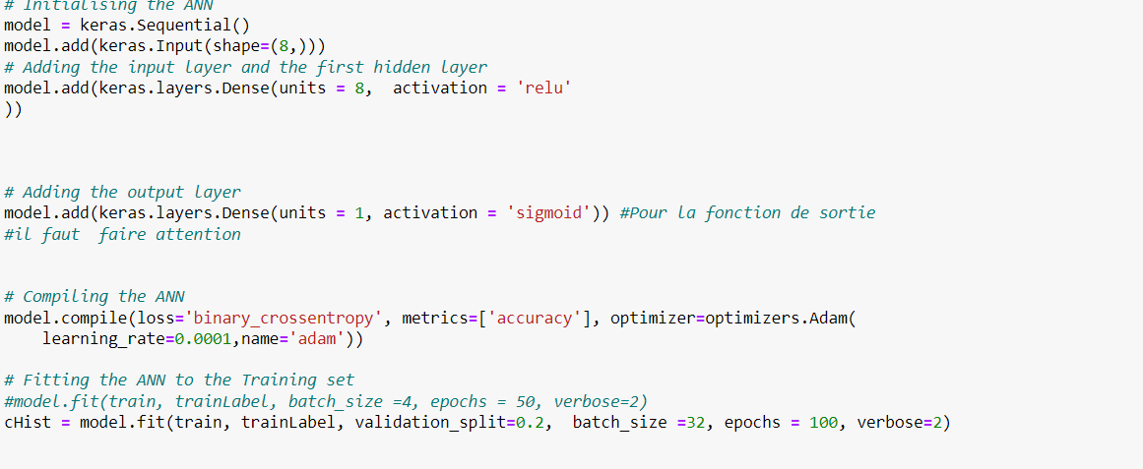

Evalution

