Install

Reference:

<https://learnopencv.com/opencv-dnn-with-gpu-support/>

Windows:

<https://learnopencv.com/how-to-use-opencv-dnn-module-with-nvidia-gpu-on-windows/>

<https://machinelearningprojects.net/build-opencv-with-cuda-and-cudnn/#Step_2_%E2%80%93_Download_Visual_Studio>

1. Install anaconda
2. Clone opencv & opencv-contib repository

git clone <https://github.com/opencv/opencv.git>

git clone <https://github.com/opencv/opencv_contrib.git>

1. Run Cmake GUI

* In Where is the source code, Select the main opencv extracted folder.
* In Where to build the binaries, Select the empty build folder we created above.

* Click on the Configure button.
* I have Visual Studio 2022 installed, so I selected Visual Studio 17 2022.
* In the Optional platform for the generator, select x64.

* Click on Finish and it will start configuring.
* Once done you will see a screen like this.

***Now search the following***…

* **WITH_CUDA**and tick/check it.



* **OPENCV_DNN_CUDA**and tick/check it.



* **ENABLE_FAST_MATH**and tick/check it.

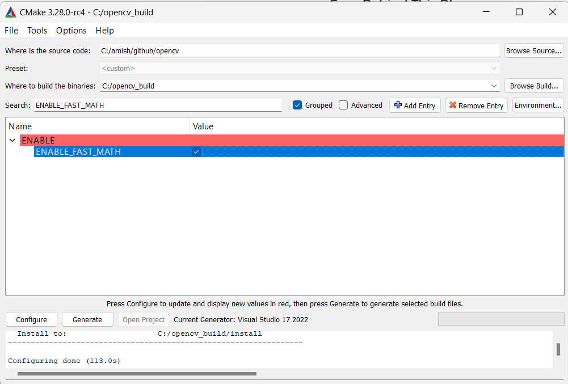

* **OPENCV_EXTRA_MODULES_PATH:** and browse to the module folder in opencv-contrib we extracted in step 3.



**And now again hit on the Configure button.**

* Once you see, **Configuring done**, check **CUDA_FAST_MATH** also.

* Now go to [this link](https://en.wikipedia.org/wiki/CUDA#:~:text=GPUs%20supported%5Bedit%5D) and check your compute capability against your graphic card.
* Mine is **NvidiaRTX 4060**, so my arch is **8.9**

* Delete all values except your Compute Capability.

* **Again hit on the Configure button for the final time.**
* **Once done, finally hit the Generate button.**



* Now you will see a lot of files in your **build**folder.

**Step 4 – Build OpenCV with CUDA**

* We will have a file like this **OpenCV.sln**.

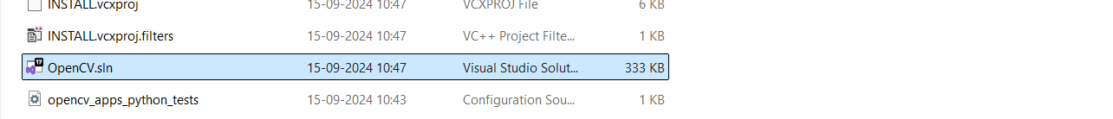

* Now open the CMD Terminal in **Administrator mode** from the start menu.
* Change the directory to your build folder using **cd**command and run **OpenCV.sln**.
* It will open up Visual Studio.

* Once Visual Studio is opened, change**Debug to Release**.





* Now in the right sidebar, open the**CMake Targets** dropdown and you will see **ALL_BUILD**.
* Right click on it and select **build**and it will start building our binaries.
* This process will take some time.

