[SmartOp: Modelling and Prediction for Energy Optimization](http://localhost/cs62/)

**Web Application Explanation:**

Files :

1. Index.php : Displays the data from the data.txt in real time.
2. Read.php : Reads the data in real time and passes data to index.php for displaying.
3. Data.txt : Contains the real time data which gets updated by the backend program.
4. meter1_Jan6_Feb6.csv : File containing per second data of AC consumption(Real-Time stream of data can be used every second with input directly to back-end program)
5. ReadCVS.java : Back-end program which reads real-time data every second, aggregates the data for an hours` consumption, predicts trend for current day from previous days data, Models consumption for user for each hour of the remaining days of the month based on
   1. Slab thresholds
   2. Electricity rate for each slab
   3. Occupancy Schedule to give weights to hours
   4. More weight to peak hours predicted from previous data
   5. Updating these consumption models after every hour

Provide processed information for front end visualization of predicted, actual and modeled consumptions

Explanation of parts of the interface:



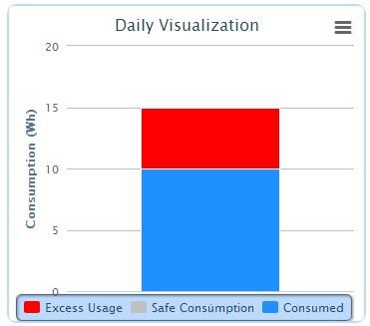

* Red bar indicates the exceeded consumption value by the user per day from the allocated quota by the backend model.
* Gray bar indicates the safe consumption. It’s the saved consumption for the day.
* Blue bar indicates the consumed data for the day.

These bars changes per hour as the energy is consumed in real time by user.



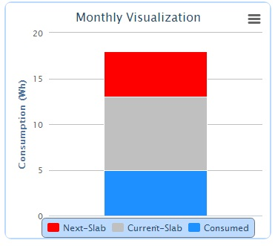

This is the slab wise distribution of energy consumed by the user. Its shows the quota of current slab and next slab. When user consumes energy of one slab then it will display energy for next two slabs.

* Red bar indicates the next slab quota.
* Gray bar indicates the remaining energy of current slab.
* Blue bar indicates the total consumed energy till the present day of the month.



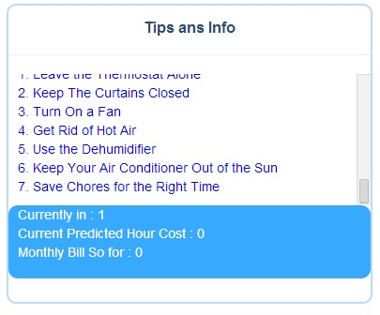

Tips and info contains two divisions:

* First division warns user whenever he exceeds the consumption beyond the allotted quota in a day or whenever he exceeds the slabs. It also gives tips to user to reduce his/her consumptions.
* Second division provides real time information about current slab of user, predicted price for next hour depending on previous trend of consumption and monthly bill so far.



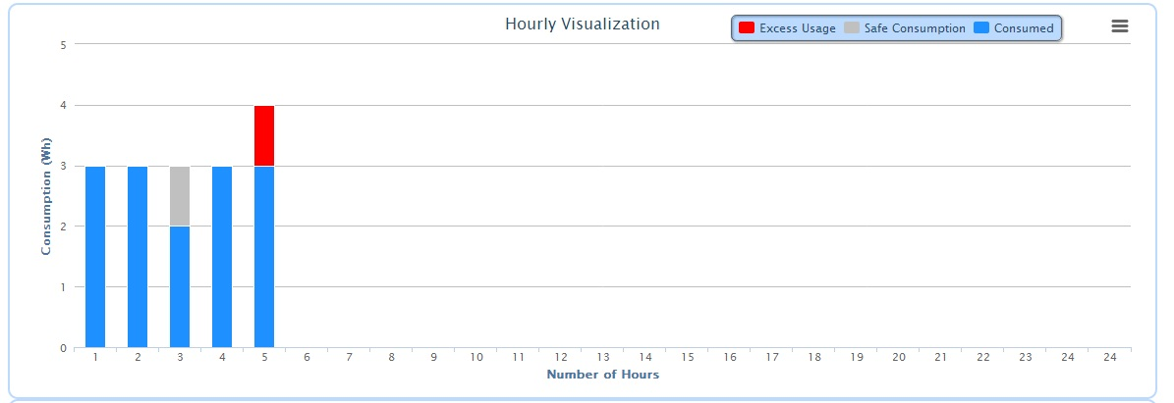

This chart shows hourly consumption for the whole day so user can monitor his electric consumption.

* Red bar indicates the exceeded consumption value in Watt-hr (wh) by the user per hour from the allocated quota by the backend model.
* Gray bar indicates the safe consumption. It’s the saved consumption for the hour.
* Blue bar indicates the consumed data for the hour.



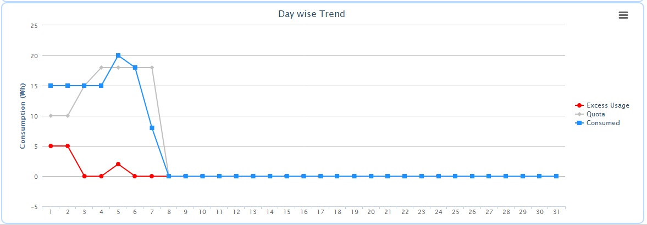

This chart shows electric consumption per day for the current month, red line shows the exceeded consumption for the day, gray line shows the allocated energy, and blue line shows the consumed energy by the user.

Very Basic Overview of steps involved in the prediction and modeling algorithm:

1. Previous data of day and week to predict trend of consumption for current day towards assigning weights to each hour
2. Get predicted consumption for current hour
3. Model consumption for remaining hours and days based on:
   1. Slab thresholds
   2. Electricity rate for each slab
   3. Occupancy Schedule to give weights to hours
   4. Peak hours
   5. Overflow or deficit from previous consumptions
4. Get modeled consumption for current hour along with considering overflow or deficit from previous hours
5. Realtime update model after every hour based on current actual consumption
6. Checking if current slab is crossed
7. Inform user on slab crossing and update model again based on remaining slabs and price