1

1. 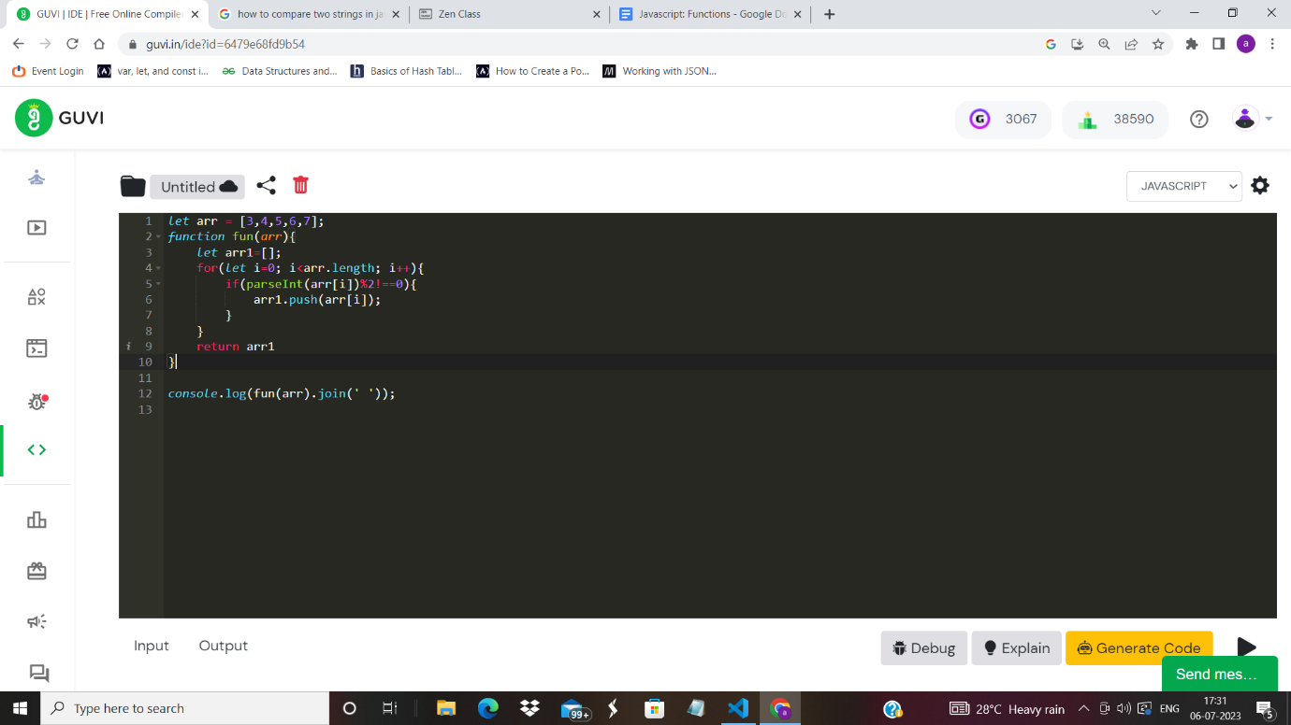
2. let arr = ['apple', 'mango', 'banana', 'kiwi'];

function fun(arr){

let arr1=[];

for(let i=0; i<arr.length; i++){

let str = arr[i][0].toUpperCase() + arr[i].slice(1);

arr1.push(str);

}

return arr1;

}

console.log(fun(arr));

1. let arr = [2,4,2,3,6,10,12];

function fun(arr){

let sum=0;

for(let i=0; i<arr.length; i++){

sum=sum+parseInt(arr[i]);

}

return sum;

}

console.log(fun(arr));

1. let arr = [2, 3, 5, 7, 4, 10, 12, 19];

function fun(arr){

let arr1=[];

for(let i=0; i<arr.length; i++){

let count=0;

for(let j=1; j<=parseInt(arr[i]); j++){

if(parseInt(arr[i])%j===0){

count++;

}

}

if(count===2){

arr1.push(arr[i]);

}

}

return arr1;

}

console.log(fun(arr).join(' '));

1. arr = ['aabaa', 'aabaaa', 'ababa']

arr1=[]

def fun(arr):

for str in arr:

reversedStr = str[::-1]

if str==reversedStr:

arr1.append(str)

return arr1

print(' '.join(fun(arr)))

1. let arr1 = [1, 12, 15, 26, 38];

let arr2 = [2, 13, 17, 30, 45];

function fun(arr1, arr2, n){

let arr = [...arr1, ...arr2];

let arrSorted = arr.sort(function(a, b){return a-b});

let arrLeft = arrSorted.slice(0, arrSorted.length/2);

let arrRight = arrSorted.slice((arrSorted.length+2)/2-1, arrSorted.length);

let median = (arrLeft[arrLeft.length-1] + arrRight[0])/2;

return median;

}

let n = arr1.length;

console.log(fun(arr1, arr2, n));

1. let arr = ['apple', 'mango', 'apple', 'orange', 'kiwi'];

let newArray = [...new Set(arr)];

console.log(newArray);

1. let arr = [1,2,3,4,5];

let k=2;

for(let i=1; i<=k; i++){

let poppedItem = arr.pop();

arr.unshift(poppedItem)

}

console.log(arr);

2.

a. let newArray = (arr) => {

let arr1=[];

for(let i=0; i<arr.length; i++){

if(parseInt(arr[i])%2!==0){

arr1.push(arr[i]);

}

}

return arr1;

};

let arr = [1,2,3,4,5];

console.log(newArray(arr).join(' '));

b. let arr = ['apple', 'mango', 'orange', 'kiwi'];

let newArray = (arr) => {

let arr1=[];

for(let i=0; i<arr.length; i++){

let newStr = arr[i][0].toUpperCase() + arr[i].slice(1);

arr1.push(newStr);

}

return arr1;

};

console.log(newArray(arr));

c. let arr = [1,2,3,4,5,6];

let num = (arr) => {

let sum=0;

for(let i=0; i<arr.length; i++){

sum=sum+parseInt(arr[i]);

}

return sum;

};

console.log(num(arr));

d. **let** arr = [2, 3, 5, 4, 12, 7];

**let** newArray = (arr) **=>** {

**let** arr1 = [];

  for (**let** i = 0; i < arr.length; i++) {

**let** count = 0;

    for (**let** j = 1; j <= parseInt(arr[i]); j++) {

      if (parseInt(arr[i]) % j === 0) {

        count++;

      }

    }

    if (count == 2) {

      arr1.push(arr[i]);

    }

  }

  return arr1;

};

console.log(newArray(arr).join(" "));

e. **let** arr = ["aabaa", "aabaaa", "ababa"];

**let** newArray = (arr) **=>** {

**let** arr1 = [];

  for (**let** i = 0; i < arr.length; i++) {

**let** array = arr[i].split("");

**let** reversedArray = array.reverse();

**let** reversedStr = reversedArray.join("");

    if (reversedStr === arr[i]) {

      arr1.push(arr[i]);

    }

  }

  return arr1;

};

console.log(newArray(arr).join(" "));