**Circuit Simulation Project**

[**https://esim.fossee.in/circuit-simulation-project**](https://esim.fossee.in)

**Name of the participant :** Amisha Srivastava

**Title of the circuit :**  2-Bit Multiplier Circuit

**Theory/Description :**  The 2-Bit Multiplier or Binary Multiplier is a digital circuit used to multiply two binary numbers and it provides the multiplication of the two numbers as its output.

The multiplication of decimal numbers is based on calculating the partial products of the individual digits, shifting them and then adding them together. A similar approach is used to multiply two binary numbers.

Let the two binary numbers be (a1 ao) and (b1 bo).

They are multiplied together to produce a 4-bit output namely (c3 c2 c1 co).

The multiplication table for them looks like the following:

**a1 ao**

**X b1 bo**

**------------------------------------------------------------------**

**(bo a1) (bo ao)**

**+ (b1 a1) (b1 ao) x**  
  **---------------------------------------------------------------------**

**c3 c2 c1 co**

The partial products obtained will be:

co= (ao*bo)

c1= (ao*b1) xor (a1*bo) ; the carry moves forward to the next stage

c2 = (a1*b1) xor ((ao*b1)*(a1*bo))

c3 = (a1*b1) and ((ao*b1)*(a1*bo))

The inputs given to this multiplier are 4 DC voltages with V1= 1V, V2 = 0V , V3 = 1 V and V4 = 0V (i.e a1 = 1, ao = 0, b1 = 1, bo = 0, after passing through the analog to digital converter ADC).

Thus the inputs are 1 0 and 1 0, which is equal to multiplication of 2 by 2 in decimal system.

The Multiplier block is added by using the NGHDL feature of eSim. The VHDL code for the same has been uploaded in the Github repositery. After the numbers have been multiplied in the multiplier, they are converted back to analog signals via a DAC (digital to analog converter) and passed via 1k resistors for testing. The circuit is then simulated to obtain the input and output plots.

**Circuit Diagram(s) :**

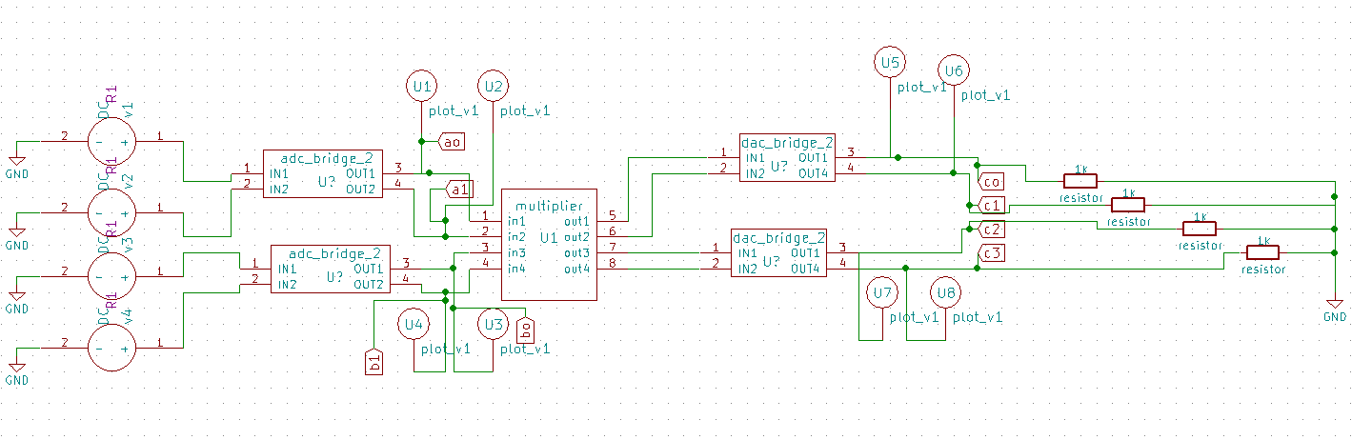

**Results (Input, Output waveforms and/or Multimeter readings) :**

Input waveform -

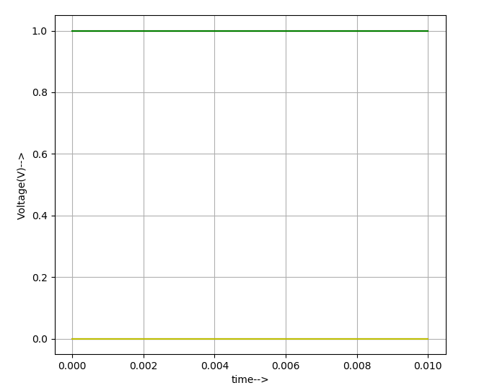

Here, the green line displays a1 and b1 which are both equal to 1 V and the yellow line displays ao and bo which are both equal to 0V.

Output waveform -

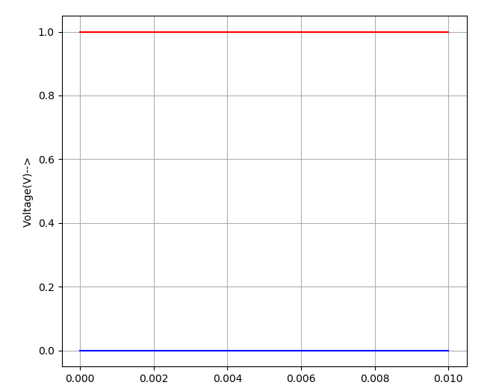

Here, the red line at 1V shows c3 and the blue line at 0V shows co, c1 and c2 (all these lines overlap at 0V, therefore only one of them is visible).

The final output is c3 c2 c1 c0 = 1 0 0 0 , which can be seen in the graph.

It is equal to 4 in decimal system (and 2x2 = 4, so the result is verified).

By observing the above results, it can be concluded that the multiplier circuit is correct.

**Source/Reference(s):**

1. Digital Design – M. Morris Mano, Michael D. Ciletti
2. eSim official website URL: <https://esim.fossee.in/>
3. eSim usermanual