

***DEPARTMENT OF COMPUTER ENGINEERING***

**Experiment No. 01**

|  |  |
| --- | --- |
| Semester | T.E. Semester V – Computer Engineering |
| Subject | Computer Network |
| Subject Professor In-charge | Prof. Amit K. Nerurkar |
| Assisting Teachers | Prof. Amit K. Nerurkar |
| Laboratory | M310 B |

|  |  |  |
| --- | --- | --- |
| Student Name | Amisha Baraskar | |
| Roll Number | 17102A0022 | |
| Grade and Subject Teacher’s Signature |  |  |

**Title:** Study of networking, historical perspective, types of network, networking devices, topologies in packet tracer and current trends in networking services

**Objective:** To know types of networks, networking devices andnetworktopologies.

**New Concepts to be learned**:

In this we will learn different types of topologies as well as we would get idea of different network devices and types of network.

**Explanation:**

The **Computer** **Network** allows computers to connect and communicate with different computers via any medium. LAN, MAN and WAN are the three major types of the network designed to operate over the area they cover. There are some similarities and dissimilarities between them. One of the major differences is the geographical area they cover, i.e. LAN covers the smallest area; MAN covers an area larger than LAN and WAN comprises the largest of all.

**TYPES OF NETWORK**

**LAN(Local Area Network):**

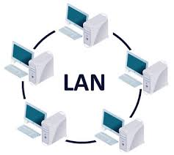

* Local Area Network is a group of computers connected to each other in a small area such as building, office.
* LAN is used for connecting two or more personal computers through a communication medium such as twisted pair, coaxial cable, etc.
* It is less costly as it is built with inexpensive hardware such as hubs, network adapters, and ethernet cables.
* The data is transferred at an extremely faster rate in Local Area Network.
* Local Area Network provides higher security.

**PAN(Personal Area Network):**

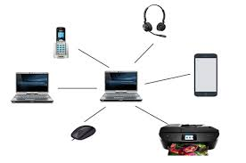

* Personal Area Network is a network arranged within an individual person, typically within a range of 10 meters.
* Personal Area Network is used for connecting the computer devices of personal use is known as Personal Area Network.
* Personal computer devices that are used to develop the personal area network are the laptop, mobile phones, media player and play stations.

**There are two types of Personal Area Network:**

* Wired Personal Area Network
* Wireless Personal Area Network

**a. Wireless Personal Area Network:** Wireless Personal Area Network is developed by simply using wireless technologies such as WiFi, Bluetooth. It is a low range network.

**b. Wired Personal Area Network:** Wired Personal Area Network is created by using the USB.

### Examples Of Personal Area Network:

* **Body Area Network:** Body Area Network is a network that moves with a person. **For example**, a mobile network moves with a person. Suppose a person establishes a network connection and then creates a connection with another device to share the information.
* **Offline Network:** An offline network can be created inside the home, so it is also known as a **home network**. A home network is designed to integrate the devices such as printers, computer, television but they are not connected to the internet.

## MAN(Metropolitan Area Network):

## C:\Users\ALankar\AppData\Local\Microsoft\Windows\INetCache\Content.MSO\60A2004E.tmp

* A metropolitan area network is a network that covers a larger geographic area by interconnecting a different LAN to form a larger network.
* Government agencies use MAN to connect to the citizens and private industries.
* In MAN, various LANs are connected to each other through a telephone exchange line.
* The most widely used protocols in MAN are RS-232, Frame Relay, ATM, ISDN, OC-3, ADSL, etc.
* It has a higher range than Local Area Network(LAN).

**Uses Of Metropolitan Area Network:**

* MAN is used in communication between the banks in a city.
* It can be used in an Airline Reservation.

## WAN(Wide Area Network):

## C:\Users\ALankar\AppData\Local\Microsoft\Windows\INetCache\Content.MSO\1637A18C.tmp

* A Wide Area Network is a network that extends over a large geographical area such as states or countries.
* A Wide Area Network is quite bigger network than the LAN.
* A Wide Area Network is not limited to a single location, but it spans over a large geographical area through a telephone line, fibre optic cable or satellite links.
* The internet is one of the biggest WAN in the world.

**Examples Of Wide Area Network:**

* **Mobile Broadband:** A 4G network is widely used across a region or country.
* **Last mile:** A telecom company is used to provide the internet services to the customers in hundreds of cities by connecting their home with fiber.

**NETWORKING DEVICES**

**1. Repeater –** A repeater operates at the physical layer. Its job is to regenerate the signal over the same network before the signal becomes too weak or corrupted so as to extend the length to which the signal can be transmitted over the same network. An important point to be noted about repeaters is that they do not amplify the signal. When the signal becomes weak, they copy the signal bit by bit and regenerate it at the original strength. It is a 2 port device.

**2. Hub** – A hub is basically a multiport repeater. A hub connects multiple wires coming from different branches, for example, the connector in star topology which connects different stations. Hubs cannot filter data, so data packets are sent to all connected devices. In other words, collision domain of all hosts connected through Hub remains one. Also, they do not have intelligence to find out best path for data packets which leads to inefficiencies and wastage.

**Types of Hub:**

1. Active Hub :- These are the hubs which have their own power supply and can clean , boost and relay the signal along the network. It serves both as a repeater as well as wiring center. These are used to extend maximum distance between nodes.
2. Passive Hub :- These are the hubs which collect wiring from nodes and power supply from active hub. These hubs relay signals onto the network without cleaning and boosting them and can’t be used to extend distance between nodes.

**3. Bridge** – A bridge operates at data link layer. A bridge is a repeater, with add on functionality of filtering content by reading the MAC addresses of source and destination. It is also used for interconnecting two LANs working on the same protocol. It has a single input and single output port, thus making it a 2 port device.

**4. Switch** – A switch is a multi port bridge with a buffer and a design that can boost its efficiency(large number of ports imply less traffic) and performance. Switch is data link layer device. Switch can perform error checking before forwarding data, that makes it very efficient as it does not forward packets that have errors and forward good packets selectively to correct port only. In other words, switch divides collision domain of hosts, but broadcast domain remains same.

**5. Routers** – A router is a device like a switch that routes data packets based on their IP addresses. Router is mainly a Network Layer device. Routers normally connect LANs and WANs together and have a dynamically updating routing table based on which they make decisions on routing the data packets. Router divide broadcast domains of hosts connected through it.

**6. Gateway** – A gateway, as the name suggests, is a passage to connect two networks together that may work upon different networking models. They basically works as the messenger agents that take data from one system, interpret it, and transfer it to another system. Gateways are also called protocol converters and can operate at any network layer. Gateways are generally more complex than switch or router.

**7. Brouter** – It is also known as bridging router is a device which combines features of both bridge and router. It can work either at data link layer or at network layer. Working as router, it is capable of routing packets across networks and working as bridge, it is capable of filtering local area network traffic.

## NETWORK TOPOLOGIES

## BUS Topology:

Bus topology is a network type in which every computer and network device is connected to single cable. When it has exactly two endpoints, then it is called **Linear Bus topology**.

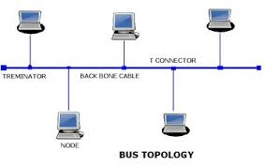

#### Features of Bus Topology:

1. It transmits data only in one direction.
2. Every device is connected to a single cable

#### Advantages of Bus Topology:

1. It is cost effective.
2. Cable required is least compared to other network topology.
3. Used in small networks.
4. It is easy to understand.
5. Easy to expand joining two cables together.

#### Disadvantages of Bus Topology:

1. Cables fails then whole network fails.
2. If network traffic is heavy or nodes are more the performance of the network decreases.
3. Cable has a limited length.
4. It is slower than the ring topology.

## RING Topology

It is called ring topology because it forms a ring as each computer is connected to another computer, with the last one connected to the first. Exactly two neighbours for each device.

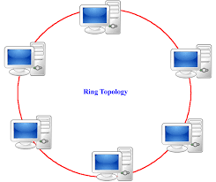

#### Features of Ring Topology:

1. The transmission is unidirectional, but it can be made bidirectional by having 2 connections between each Network Node, it is called Dual Ring Topology.
2. In Dual Ring Topology, two ring networks are formed, and data flow is in opposite direction in them. Also, if one ring fails, the second ring can act as a backup, to keep the network up.
3. Data is transferred in a sequential manner that is bit by bit. Data transmitted, has to pass through each node of the network, till the destination node.

#### Advantages of Ring Topology:

1. Transmitting network is not affected by high traffic or by adding more nodes, as only the nodes having tokens can transmit data.
2. Cheap to install and expand

#### Disadvantages of Ring Topology:

1. Troubleshooting is difficult in ring topology.
2. Adding or deleting the computers disturbs the network activity.
3. Failure of one computer disturbs the whole network.

**STAR Topology**

In this type of topology all the computers are connected to a single hub through a cable. This hub is the central node and all others nodes are connected to the central node.

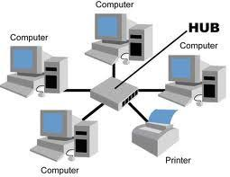

#### Features

1. Every node has its own dedicated connection to the hub.
2. Hub acts as a repeater for data flow.
3. Can be used with twisted pair, Optical Fibre or coaxial cable.

#### Advantages

1. Fast performance with few nodes and low network traffic.
2. Hub can be upgraded easily.
3. Easy to troubleshoot.
4. Easy to setup and modify.
5. Only that node is affected which has failed, rest of the nodes can work smoothly.

#### Disadvantages

1. Cost of installation is high.
2. Expensive to use.
3. If the hub fails then the whole network is stopped because all the nodes depend on the hub.
4. Performance is based on the hub that is it depends on its capacity.

**Mesh Topology :**

In mesh topology, every device is connected to another device via particular channel.

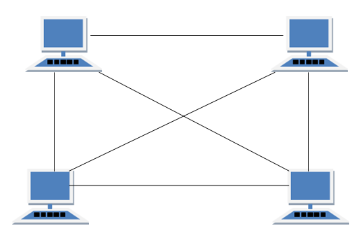

Every device is connected with another via dedicated channels. These channels are known as links.

If suppose, N number of devices are connected with each other in mesh topology, then total number of ports that is required by each device is N-1 and total number of dedicated links required to connect them is NC2 i.e. N(N-1)/2.

**Advantages** **:**

1. It is robust. Fault is diagnosed easily. Data is reliable because data is transferred among the devices through dedicated channels or links.
2. Provides security and privacy.

**Problems with this topology :**

1. Installation and configuration is difficult.
2. Cost of cables are high as bulk wiring is required, hence suitable for less number of devices.
3. Cost of maintenance is high.

**Conclusion:** Hence we have learned about networking devices, topologies and types of network.