Autocomplete linux
finish looking at commands
install chrome using terminal
finish linux istructions from wildcard – see link on teams for jupyter

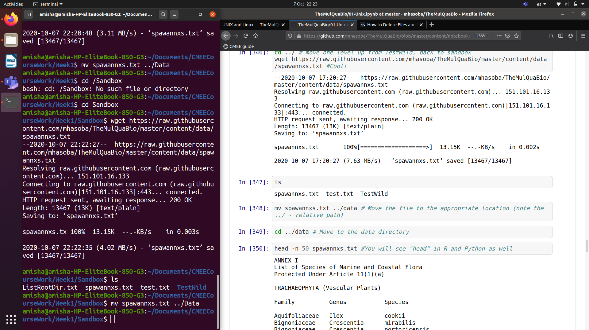
what would happen if we want tomove a file to data having saved spawannxs.txt in week1 aand not sandbox

variables in shell scripts / shellscripting chapter

