**INTERNITY FOUNDATION**

**TASK-10**

**Submitted By:**

**Amisha Singhal**

**Java Batch**

**JSP  
JSP basics**

**Ans-** Java Server Pages (JSP) is a server-side programming technology that enables the creation of dynamic, platform-independent method for building Web-based applications. JSP have access to the entire family of Java APIs, including the JDBC API to access enterprise databases.

* In this JSP tags are used to insert JAVA code into HTML pages.
* It is an advanced version of Servlet Technology.
* It is a Web based technology helps us to create dynamic and platform independent web pages.
* In this, Java code can be inserted in HTML/ XML pages or both.
* JSP is first converted into servlet by JSP container before processing the client’s request.

**JSP Engine(Conversion to Servlet)**

**Ans-** JSP and Servlet has 3 different life cycle methods - init, service and destroy. Init and destroy are called only once during the initial and final phase of execution whereas the service method is called repeatedly for every request of the same JSP page / Servlet.

When a JSP page is called, it will be compiled (by the JSP engine) into a Java servlet. At this point the servlet is handled by the servlet engine, just like any other servlet. The servlet engine then loads the servlet class (using a class loader) and executes it to create dynamic HTML to be sent to the browser. The servlet creates any necessary object, and writes any object as a string to an output stream to the browser.

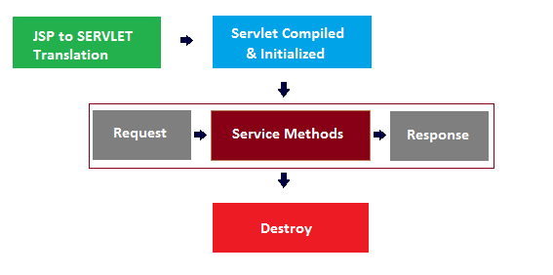

**Expressions and Declarations  
Directives**

## Ans – JSP Expression

* Expression tag evaluates the expression placed in it.
* It accesses the data stored in stored application.
* It allows create expressions like arithmetic and logical.
* It produces scriptless JSP page.

**Syntax:**

**<%= expression %>**

## JSP Declaration

* A declaration tag is a piece of[Java](https://www.guru99.com/java-tutorial.html)code for declaring variables, methods and classes. If we declare a variable or method inside declaration tag it means that the declaration is made inside the servlet class but outside the service method.
* We can declare a static member, an instance variable (can declare a number or string) and methods inside the declaration tag.

**Syntax of declaration tag:**

**<%! Dec var %>**

# JSP directives

JSP directives are the elements of a JSP source code that guide the web container on how to translate the JSP page into it’s respective servlet.  
**Syntax:**

**<%@ directive attribute = "value"%>**

Directives can have a number of attributes which you can list down as**key-value pairs** and separated by commas. The blanks between the @ symbol and the directive name, and between the last attribute and the closing %>, are optional.

There are three types of directives:

* page directive
* include directive
* taglib directive

**Includes and Forwards**

**Ans- include()** method includes the content of a resource in the response, the resource could be another Servlet, JSP or HTML file. include() method is that former is often used to include common boilerplate text of template markup which might be included by many Servlets e.g. header or footer.

### Syntax of jsp:include action tag with parameter

<jsp:include page="relativeURL | <%= expression %>">

<jsp:param name="parametername" value="parametervalue | <%=expression%>" />

</jsp:include>    
  
**forward()** method is used to forward the request to another resource. forward() method is often used where a servlet is taking a controller role; processing some input and deciding the outcome by returning a particular response page.

### Syntax of jsp:forward action tag with parameter

<jsp:forward page="relativeURL | <%= expression %>">

<jsp:param name="parametername" value="parametervalue | <%=expression%>" />

</jsp:forward>

**JSTL**

**Ans-** **JSTL** stands for[Java](https://www.guru99.com/java-tutorial.html)server pages standard tag library, and it is a collection of custom JSP tag libraries that provide common web development functionality. JSTL has support for common, structural tasks such as iteration and conditionals, tags for manipulating XML documents, internationalization tags, and SQL tags. It also provides a framework for integrating the existing custom tags with the JSTL tags.

**Advantage of JSTL:**

* **Fast Development** JSTL provides many tags that simplify the JSP.
* **Code Reusability** We can use the JSTL tags on various pages.
* **No need to use scriptlet tag** It avoids the use of scriptlet tag.

## Classification of The JSTL Tags

The JSTL tags can be classified, according to their functions, into the following JSTL tag library groups that can be used when creating a JSP page:

* **Core Tags**
* **Formatting tags**
* **SQL tags**
* **XML tags**
* **JSTL Functions**