**INTERNITY FOUNDATION**

**TASK-11**

**Submitted By:**

**Amisha Singhal**

**Java Batch**

**Introduction to MVC architecture**

**Ans-**The **Model-View-Controller (MVC)** framework is an architectural pattern that separates an application into three main logical components Model, View, and Controller. MVC separates the business logic and presentation layer from each other. It was traditionally used for desktop graphical user interfaces (GUIs). Nowadays, MVC architecture in web technology has become popular for designing web applications as well as mobile apps. It also allows multiple developers to work on the same project.

**The MVC framework includes the following components:**

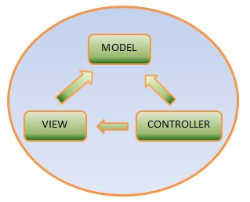  
  
**Models:** Model implements the logic for the application's data. Basically **model** is a C# or VB.NET class and it retrieves and stores model state in a database. Suppose that you have an Employee table in a SQL Server database. The Employee object might retrieve information from a database, use the information, and then write update information back to an Employee table.  
  
**Views:** A view represents the user interface (UI) in your application. In general, your UI is mapped with model data. Suppose that your model data is employee object then you can create a UI that displays text boxes, drop-down lists, GridView and check boxes based on the current state of an Employee object.  
  
**Controllers:** Controller is a heart of the entire MVC architecture. Controllers are the components that coordinate the link between the view and the model. Controller process the input, work with the model, and rendering the view. In an MVC application, the view only displays information; the controller handles and responds to user input and interaction.

**ORM Basics**

**Ans-** ORM stands for **O**bject-**R**elational **M**apping (ORM) is a programming technique for converting data between relational databases and object oriented programming languages such as Java, C#, etc. It is capable to handle various database operations easily such as inserting, updating, deleting etc.

**Advantages are:**

* No need to deal with the database implementation.
* Entities based on business concepts rather than database structure.
* Transaction management and automatic key generation.
* Fast development of application.
* Hides details of SQL queries from OO logic.
* Based on JDBC 'under the hood.'

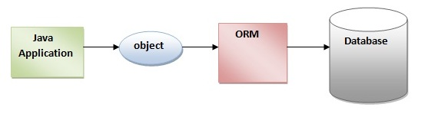

**Introduction to Hibernate**

**Ans-** Hibernate is a Java framework that simplifies the development of Java application to interact with the database. It is an open source, lightweight, ORM (Object Relational Mapping) tool.Hibernate implements the specifications of JPA (Java Persistence API) for data persistence. Hibernate not only takes care of the mapping from Java classes to database tables (and from Java data types to SQL data types), but also provides data query and retrieval facilities.

The Hibernate architecture is categorized in four layers.

* Java application layer
* Hibernate framework layer
* Backhand api layer
* Database layer

Hibernate framework uses many objects such as session factory, session, transaction etc. along with existing Java API such as JDBC (Java Database Connectivity), JTA (Java Transaction API) and JNDI (Java Naming Directory Interface).

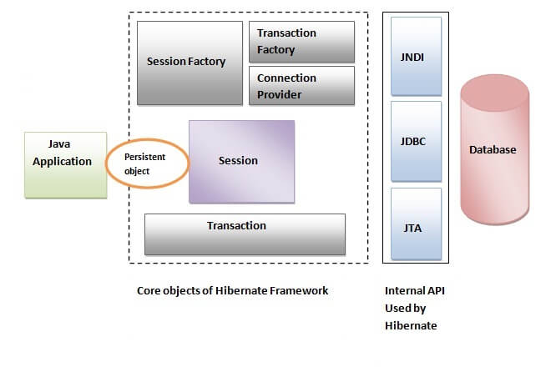

**Advantages of Hibernate:**

**1) Open source and Lightweight:** Hibernate framework is open source under the LGPL license and lightweight.

**2) Fast performance:** The performance of hibernate framework is fast because cache is internally used in hibernate framework. There are two types of cache in hibernate framework first level cache and second level cache. First level cache is enabled by default.

**3) Database Independent query:** HQL (Hibernate Query Language) is the object-oriented version of SQL. It generates the database independent queries. So you don't need to write database specific queries. Before Hibernate, If database is changed for the project, we need to change the SQL query as well that leads to the maintenance problem.

**4) Automatic table creation:** Hibernate framework provides the facility to create the tables of the database automatically. So there is no need to create tables in the database manually.

**5) Simplifies complex join:** To fetch data from multiple tables is easy in hibernate framework.

**6) Provides query statistics and database status:** Hibernate supports Query cache and provide statistics about query and database status.