**INTERNITY FOUNDATION**

**TASK-7**

**Submitted By:**

**Amisha Singhal**

**Java Batch**

**JEE basics  
JEE 2-tier, 3-tier, n-tier architecture**

**Ans-**

**2-Tier Architecture:**

It is like Client-Server architecture, where communication takes place between client and server.

In this type of software architecture, the presentation layer or user interface layer runs on the client side while dataset layer gets executed and stored on server side.

There is no Business logic layer or immediate layer in between client and server.

**3-tier architecture**has three different layers.

* Presentation layer
* Business Logic layer
* Database layer

**Presentation Layer-** In a typical Web application, a browser running on the client machine handles presentation.

**Business Access Layer -**

This is the function of the business layer which accepts the data from the application layer and passes it to the data layer.

* Business logic acts as an interface between Client layer and Data Access Layer
* All business logic – like validation of data, calculations, data insertion/modification are written under business logic layer.
* It makes communication faster and easier between the client and data layer
* Defines a proper workflow activity that is necessary to complete a task.

**Data Access Layer-**

This is the data layer function, which receives the data from the business layer and performs the necessary operation into the database.

N-tier architecture would involve dividing an application into 3 different tiers.  These would be the:

1. logic tier,
2. the presentation tier, and
3. the data tier.

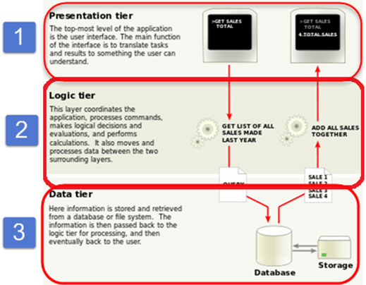

**JEE application components-EJB, Servlets & JSP**

**Ans-** The components are:

### Enterprise JavaBeans (EJB)

EJB is a component technology that helps developers create business objects in the middle tier. These business objects (enterprise beans) consist of fields and methods that implement business logic. EJBs are the building blocks of enterprise systems. They perform specific tasks by themselves, or forward operations to other enterprise beans. EJBs are under control of the J2EE application server.

### Java Servlets

This component technology presents a request-response programming model in the middle tier. Servlets let you define HTTP-specific servlet classes that accept data from clients and pass them on to business objects for processing. Servlets run under the control of the J2EE application server and often extend applications hosted by web servers.

### Java Server Pages (JSP)

A JSP page is a text-based document interspersed with Java code. A JSP engine translates JSP text into Java Servlet code. It is then dynamically compiled and executed. This component technology lets you create dynamic web pages in the middle tier. JSP pages contain static template data (HTML, WML, and XML) and JSP elements that determine how a page constructs dynamic content. The JSP API provides an efficient, thread-based mechanism to create dynamic page content.

**JEE runtime environment-Web Server and Application Server.**

**Ans-** Web servers are responsible for serving static content e.g. HTML over HTTP protocol.Web server to provide HTTP protocol level service. Web Server is mostly designed to serve static content, though most Web Servers have plugins to support scripting languages like Perl, PHP, ASP, JSP etc. through which these servers can generate dynamic HTTP content.  
**Apache and IIS are two popular web servers.**  
  
Application server is responsible for serving dynamic content, managing EJB pool, facilitating distributed transaction, facilitating application lookup over JNDI, application security and others. Application server is supposed to provide more powerful and dynamic Web service and business level service via EJB (Enterprise Java Beans). Most of the application servers have Web Server as integral part of them,that means App Server can do whatever Web Server is capable of. Additionally App Server has components and features to support Application level services such as Connection Pooling, Object Pooling, Transaction Support, Messaging services etc. **Popular application servers are IBM WebSphere, Oracle WebLogic, Glassfish and Redhat's JBoss.**