MedTrack — AWS Cloud-Enabled Healthcare Management System

Project Description:
MedTrack is a full-stack, cloud-based healthcare management platform designed to streamline interactions between patients, doctors, and administrators through a unified and secure digital interface. Built using Flask as the backend framework, the application is deployed on Amazon EC2 and leverages Amazon DynamoDB for the efficient, high-performance storage of sensitive patient data, medical histories, and appointment schedules.
The platform provides a comprehensive suite of features, including secure user registration, role-based login, and dynamic appointment booking where patients can select specific doctors and time slots. Doctors are equipped with a dedicated dashboard to manage their schedules and upload lab reports, while an Admin dashboard provides a full system overview.
To ensure real-time engagement and critical information delivery, MedTrack integrates AWS Simple Notification Service (SNS). This allows the system to send instant email alerts for appointment confirmations, cancellations, and billing updates, keeping both patients and healthcare providers informed. By combining cloud scalability, responsive design, and robust IAM (Identity and Access Management) security, MedTrack delivers a seamless, reliable, and modern healthcare management experience.
Scenario 1: Seamless Patient-Doctor Appointment Scheduling
MedTrack provides a centralized platform for patients to manage their healthcare needs without the need for manual phone calls or physical visits. For instance, a patient can log in to their personal dashboard, browse through a list of available doctors, and select a preferred time slot based on real-time availability. The Flask backend processes the request and instantly updates the Amazon DynamoDB database, ensuring that the schedule is locked and preventing any double-bookings. This automated flow provides a hassle-free experience for patients seeking immediate medical attention.
Scenario 2: Secure Role-Based Management for Healthcare Providers
The system is designed with strict security and role-based access control to protect sensitive medical data. Doctors have a dedicated interface where they can view their daily schedules, access patient medical histories, and upload lab reports directly to the system. Simultaneously, an Administrator can access a high-level overview of all system activities, including billing and total user registrations. By using AWS IAM roles, MedTrack ensures that each user (Patient, Doctor, or Admin) only accesses the data relevant to their specific role, maintaining high standards of data privacy and organizational efficiency.
Scenario 3: Real-Time Patient Engagement via AWS SNS
Effective communication is critical in healthcare. Whenever a patient books an appointment, cancels a visit, or when a doctor uploads a new lab report, the system triggers a notification via AWS Simple Notification Service (SNS). The patient receives an automated email confirmation in real-time, providing them with peace of mind and reducing the likelihood of missed appointments. This integration ensures that the healthcare provider and the patient stay synchronized throughout the entire treatment process, improving the overall quality of care.

AWS ARCHITECTURE:
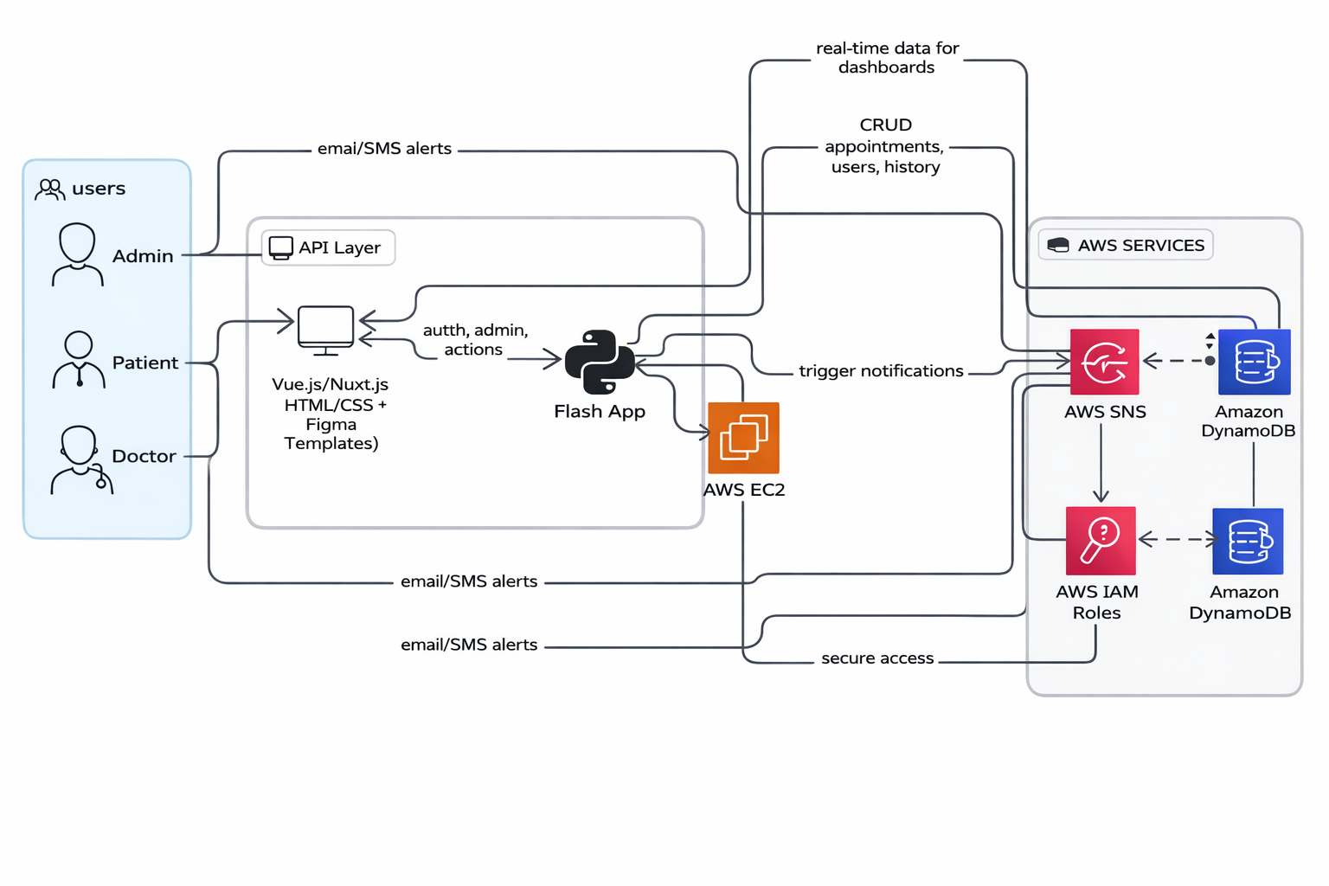

Entity Relationship (ER)Diagram:
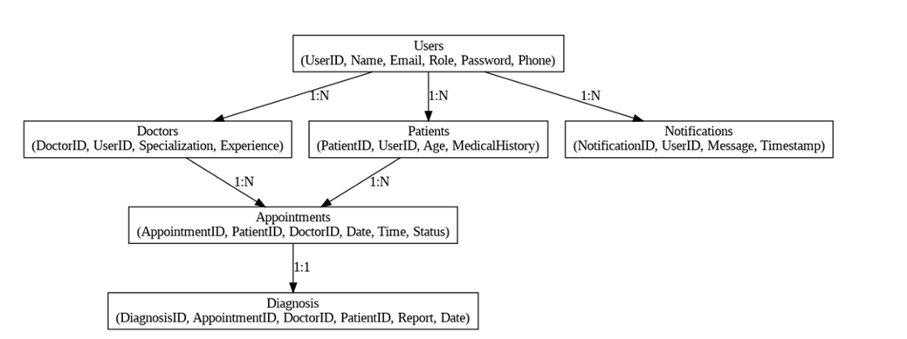

Pre-requisites:
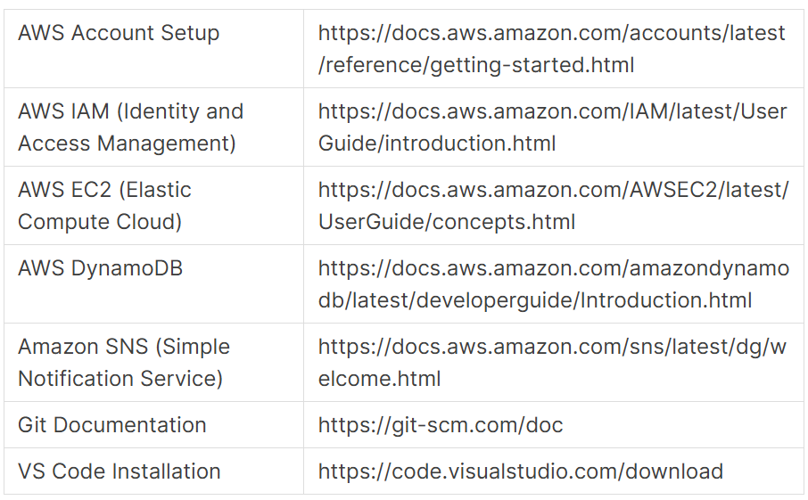

Project Workflow
1. AWS Account Setup and Login
- Set up an AWS account (Free Tier) if not already done.
- Log in to the AWS Management Console to access cloud services.
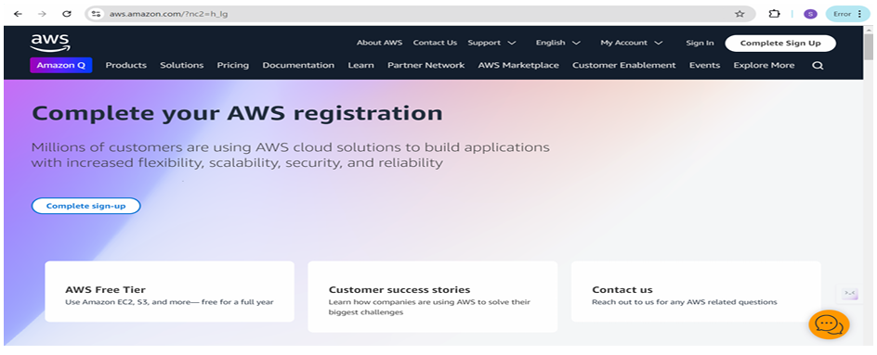
2. DynamoDB Database Creation and Setup
- Create DynamoDB Tables for the healthcare ecosystem.
- Configure Partition and Sort Keys for the following tables:
  - Patients (Partition Key: email)
  - Doctors (Partition Key: doctor_id)
  - Appointments (Partition Key: patient_email, Sort Key: appointment_id)
  - Billing (Partition Key: billing_id)
  - LabReports (Partition Key: patient_email, Sort Key: report_id)
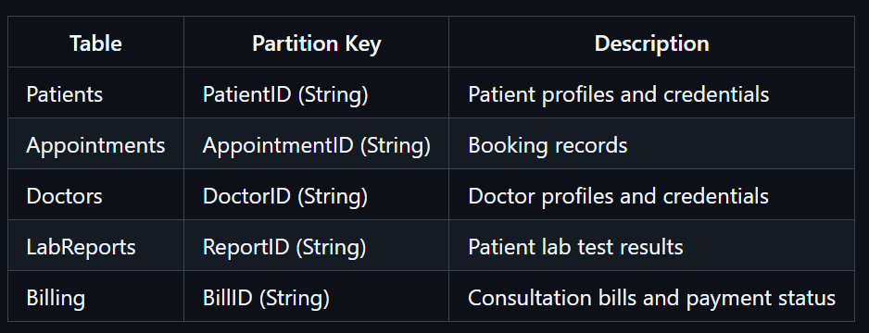
3. SNS Notification Setup
- Create an SNS Topic named MedTrackNotifications for sending automated healthcare alerts.
- Subscribe patient and doctor email addresses to the topic to receive appointment and billing alerts.
- Confirm the subscription via the verification email to enable real-time messaging.
4. Backend Development and Application Setup
- Develop the Backend logic using the Flask framework to manage user roles (Patient, Doctor, Admin).
- Integrate AWS Services using the boto3 library to handle data storage in DynamoDB and triggers for SNS.
5. IAM Role Setup
- Create an IAM Role (e.g., MedTrack-EC2-Role) specifically for EC2 service access.
- Attach Policies: AmazonDynamoDBFullAccess and AmazonSNSFullAccess to ensure secure communication between the server and AWS services.
6. EC2 Instance Setup
- Launch an EC2 instance (Ubuntu/Linux) to act as the production server for the MedTrack application.
- Configure Security Groups to allow incoming traffic on Port 80 (HTTP) and Port 22 (SSH).
7. Deployment on EC2
- Connect to the instance via SSH and clone the Flask project files from the GitHub repository.
- Install environment dependencies and run the Flask app using Gunicorn and Nginx for production stability.
1. Launch EC2 Instance
- AMI: Amazon Linux 2 or Ubuntu 22.04
- Instance type: t2.micro
- Security group: Allow HTTP (80), HTTPS (443), SSH (22)
2. Install dependencies
3. Attach IAM Role to EC2
- Create IAM role with these policies:
  - AmazonDynamoDBFullAccess
  - AmazonSNSFullAccess
- Attach role to EC2 instance

4. Run with Gunicorn
5. Configure Nginx
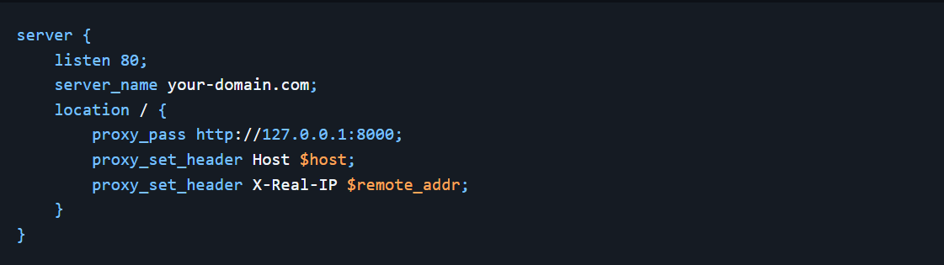

8. Testing and Final Deployment
- Perform end-to-end testing by registering a patient and booking an appointment to verify the SNS email trigger.
- Finalize the cloud deployment and verify the system is accessible via the EC2 Public IP.

Home Page :
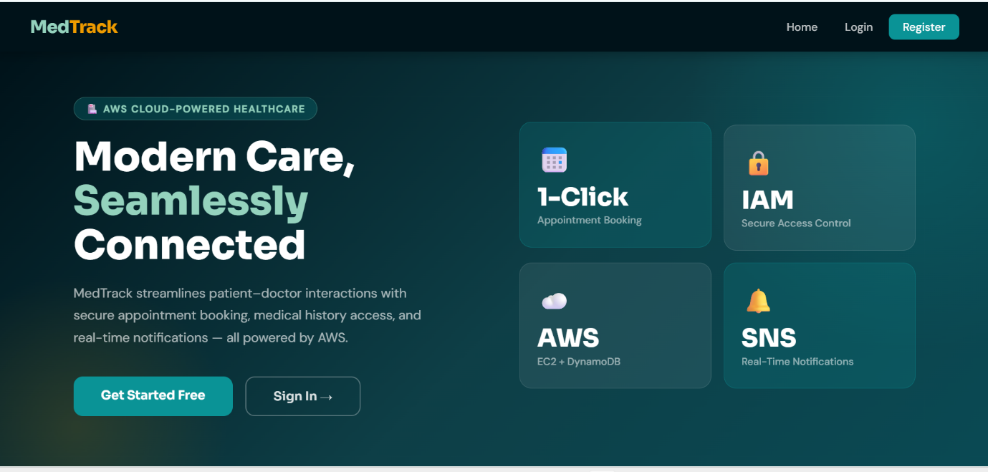

Login Page :
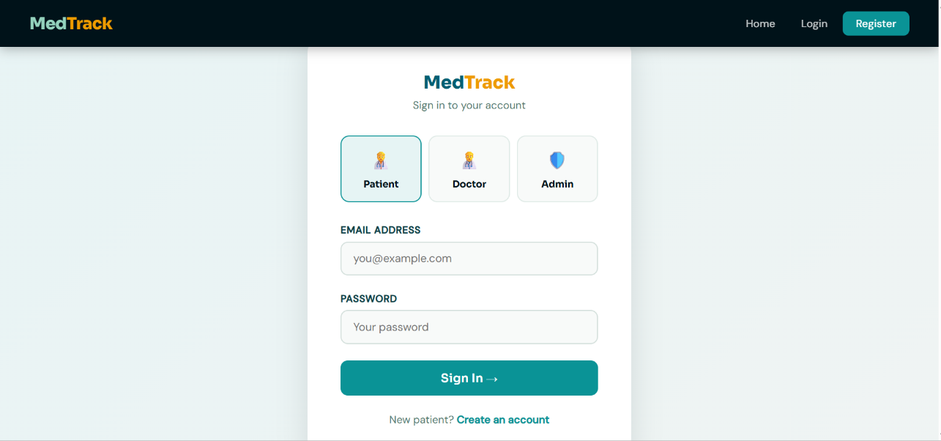
Patient Dashboard:
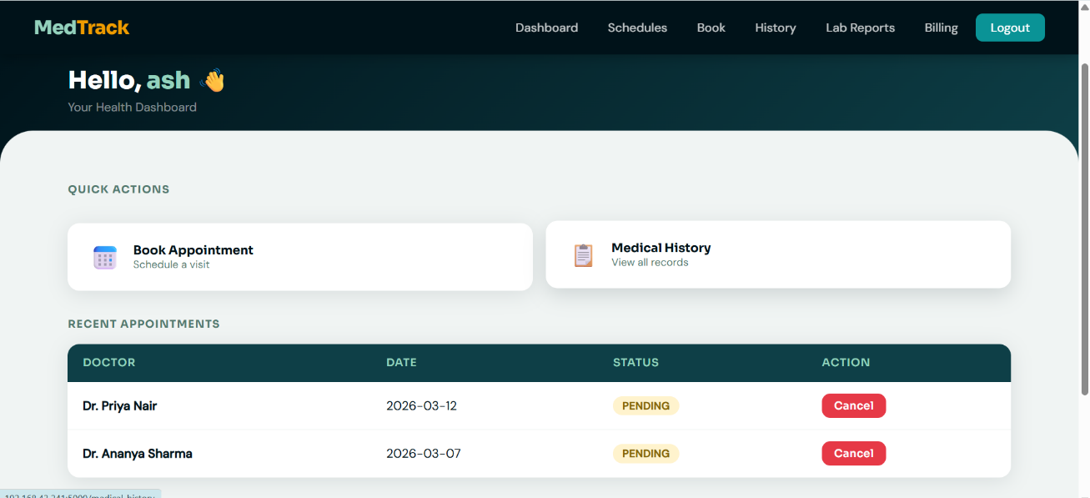
Book Appointment:
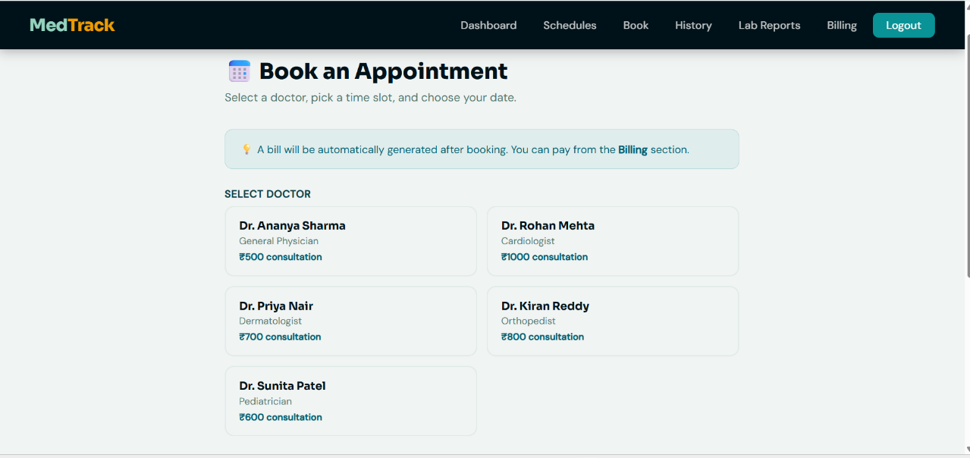
Doctor Dashboard:
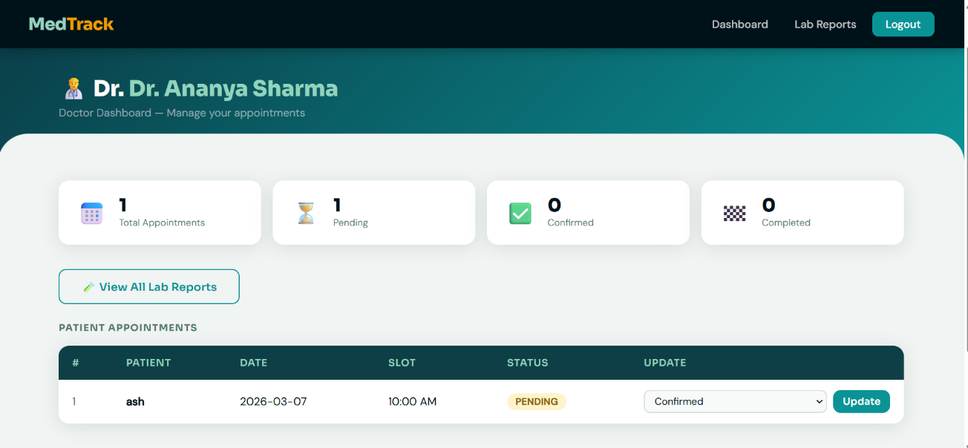
Admin Dashboard:
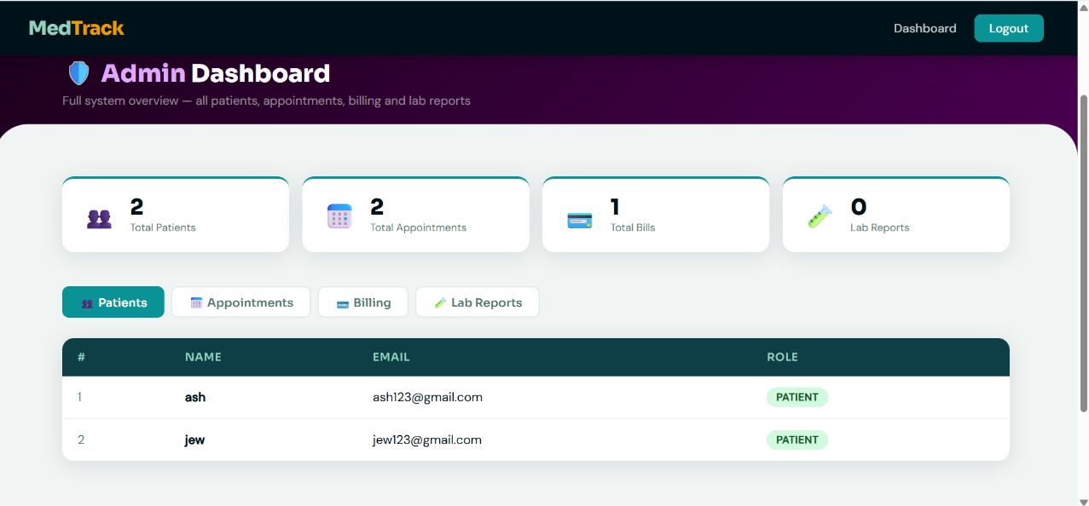
Billing:
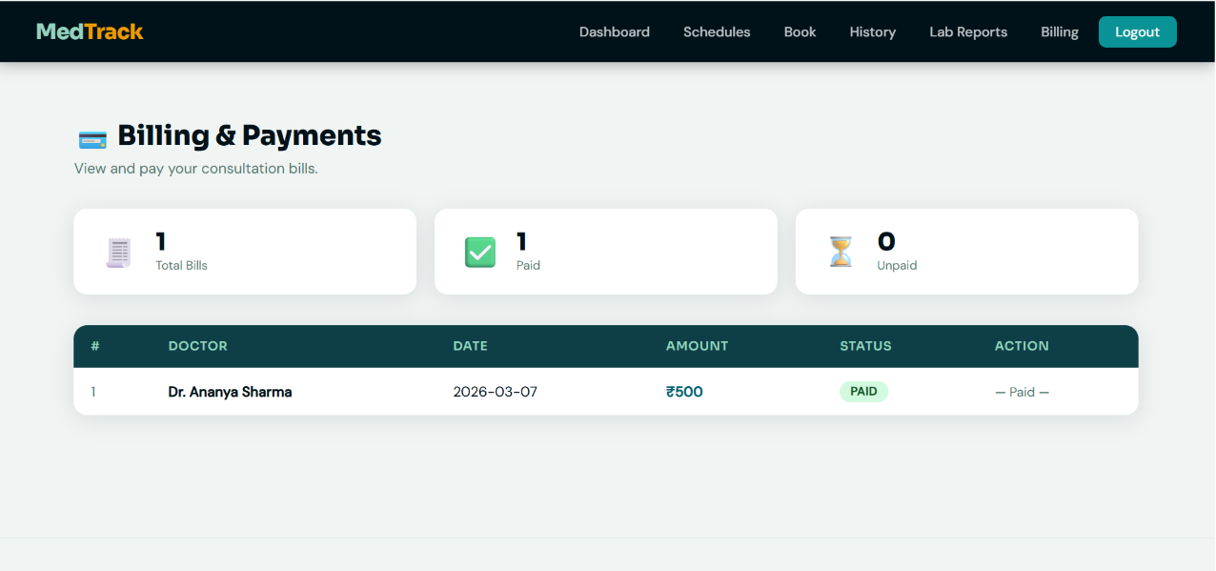
Conclusion
The MedTrack Healthcare Management System has been successfully developed and deployed using a scalable, cloud-native architecture. By leveraging AWS services such as EC2 for high-performance hosting, DynamoDB for real-time NoSQL data management, and SNS for instant automated notifications, the platform provides a seamless and reliable experience for patients, doctors, and administrators alike.
MedTrack eliminates the traditional complexities of healthcare administration by offering a centralized interface where patients can manage their medical journeys—from secure registration and doctor selection to viewing lab reports and tracking billing—all in one place. The integration of AWS SNS ensures that critical updates, such as appointment confirmations or medical alerts, reach users immediately via email, significantly improving patient engagement and reducing missed consultations.
The cloud-based infrastructure ensures high availability and consistent performance, even during periods of high traffic, while the Flask backend provides efficient handling of role-based authentication and dynamic data transactions. Furthermore, the use of AWS IAM roles ensures that sensitive medical data is handled with the highest security standards.
In summary, the MedTrack platform offers a modern, efficient, and robust solution for healthcare management, demonstrating how cloud technology can be utilized to streamline medical services and improve the overall quality of patient care.

