**Vnet Peering**

**Step#1 : First of all we need to create two virtual networks so that we can establish the connection between them.**

**For that we need to go to azure portal and select the service called “Vnet”**

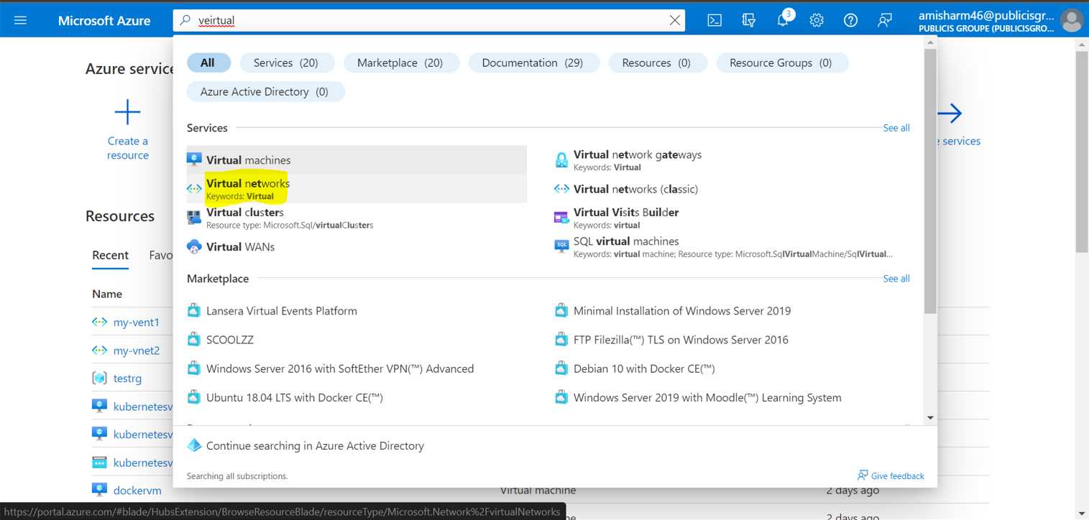

**Step#2 : after that we need to select add network and provide the required inputs**

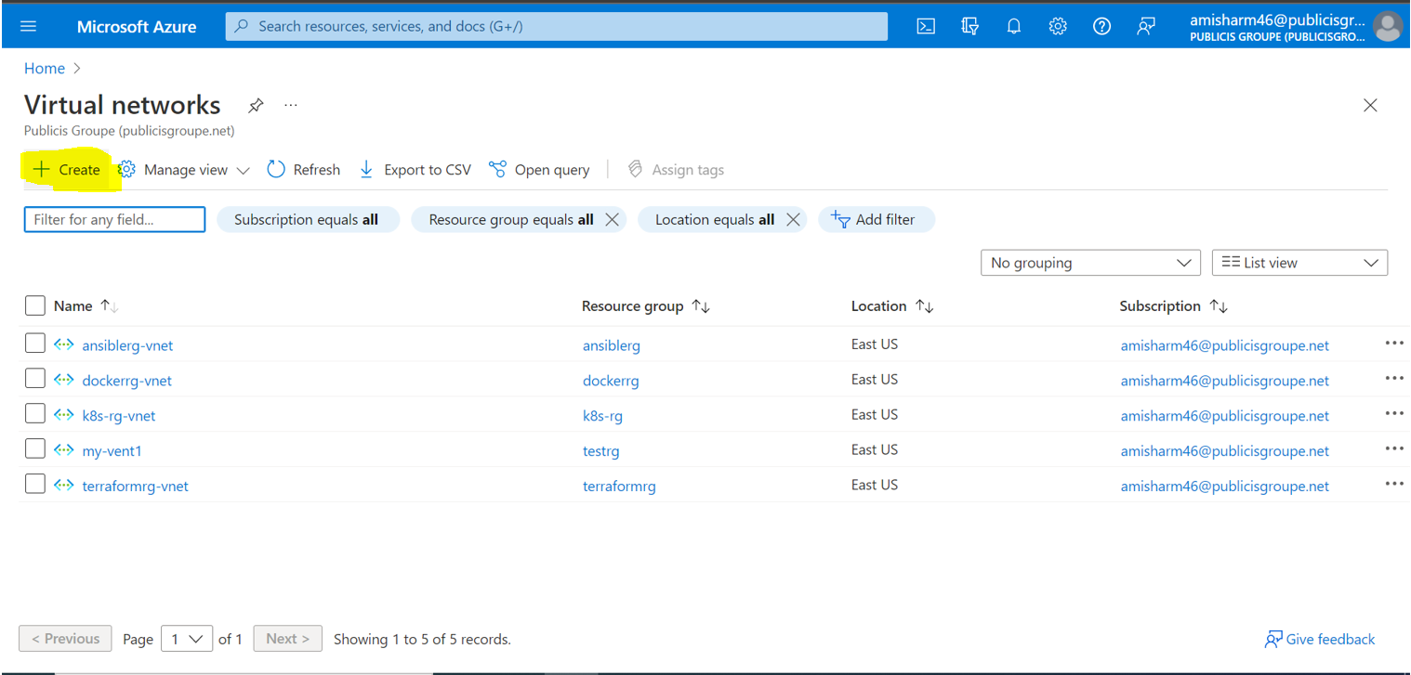

**And once we are done with all the inputs correctly click on review+create and if all validation got passed the click on create.**

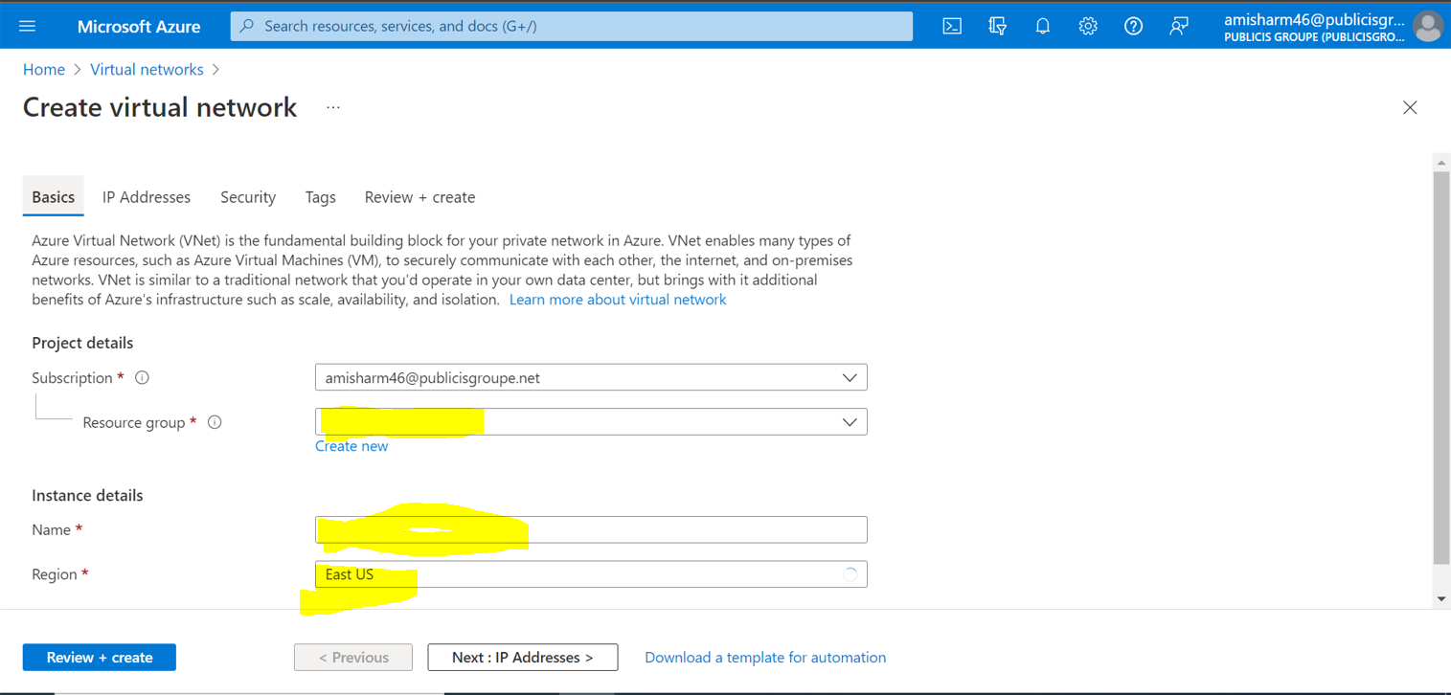

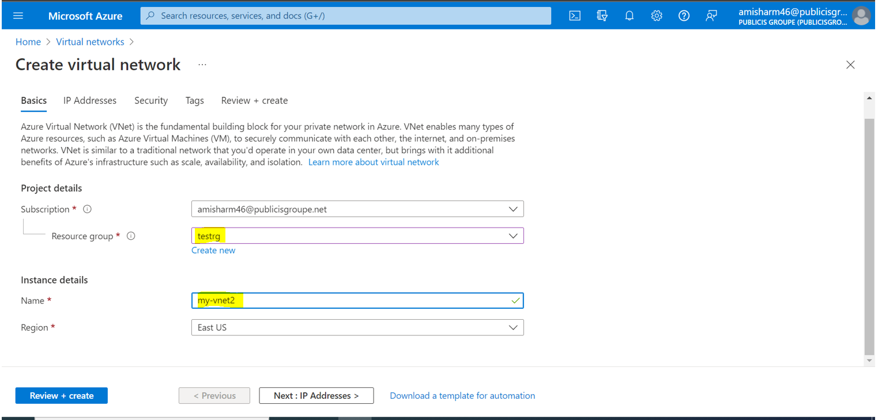

**After that wait for sometime and let the resources be get deployed.**

**Same way we have to create another vnet to establish connection between them.**

**Step#3 : Now Select the first Vnet and in the left hand side scroll and u will find the option called**

**“Vnet Peerings”**

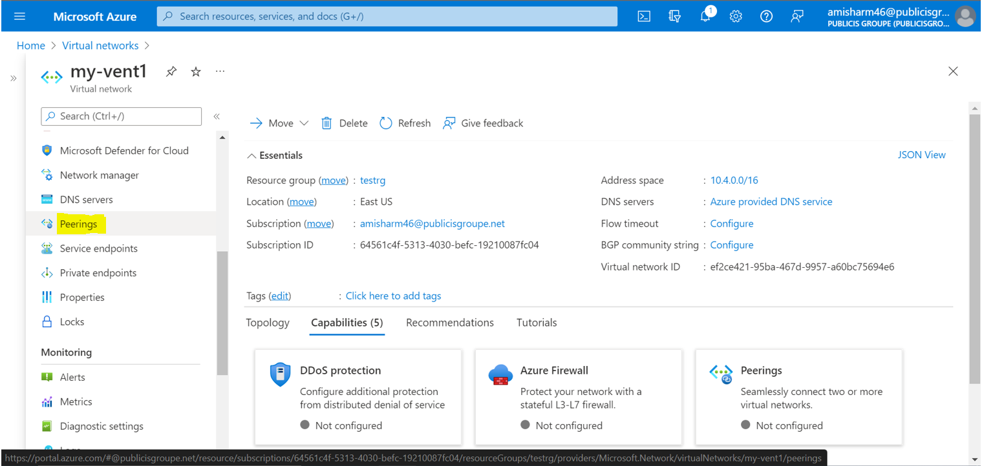

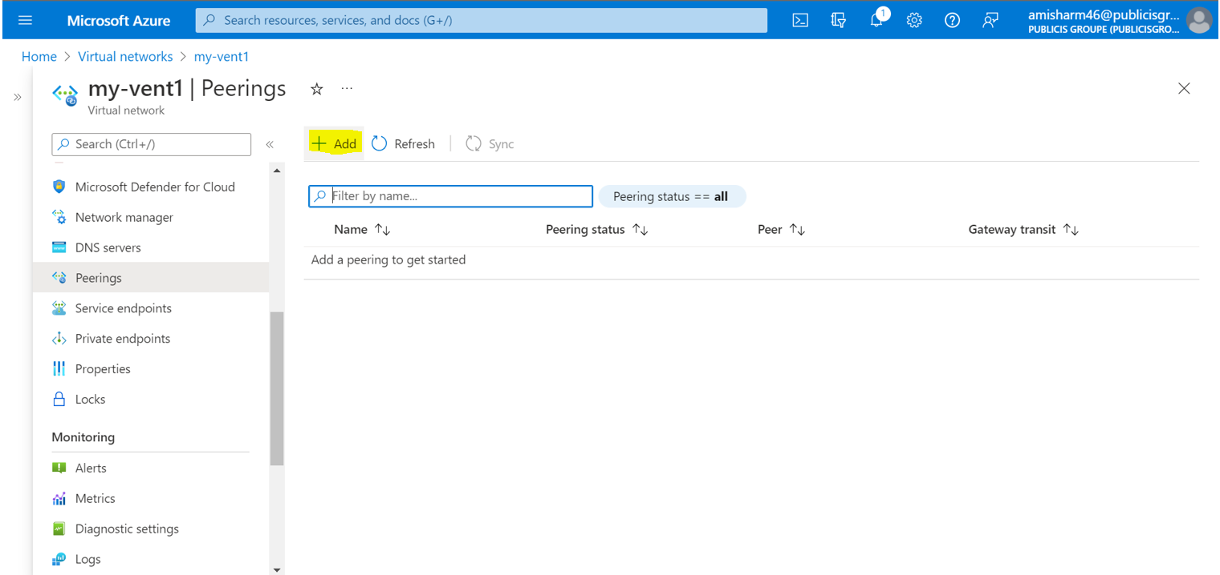

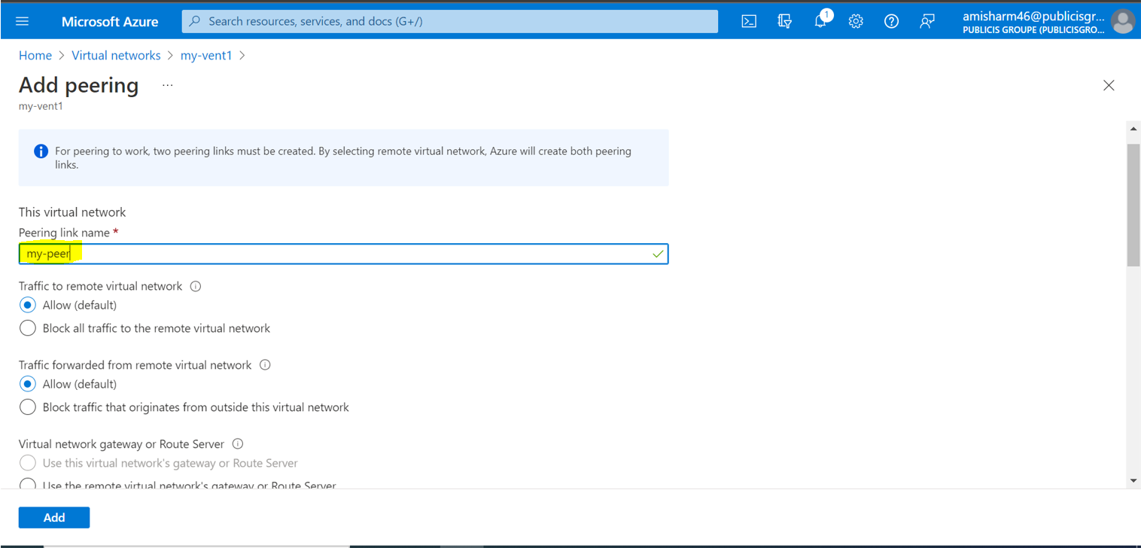

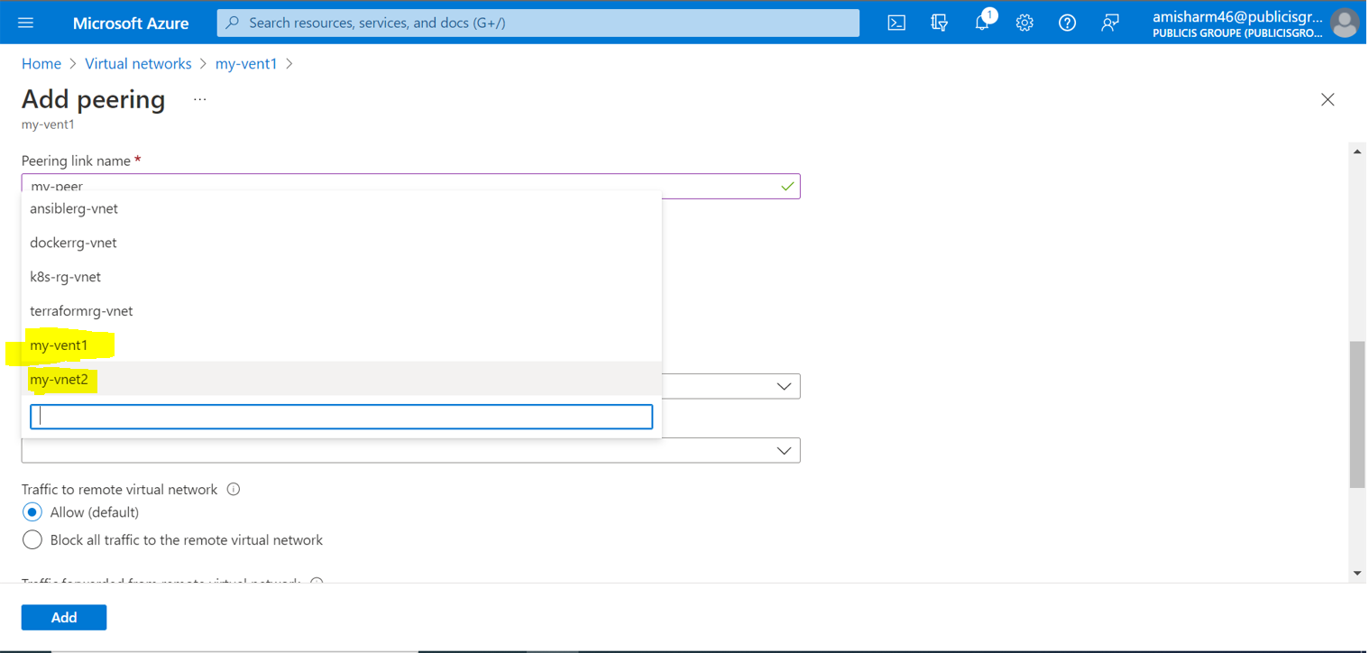

**Select the vnet which you want to peer from the dropdown.**

**And click on add.**

**Once you are done with adding the vnet you will be able to see below page.**

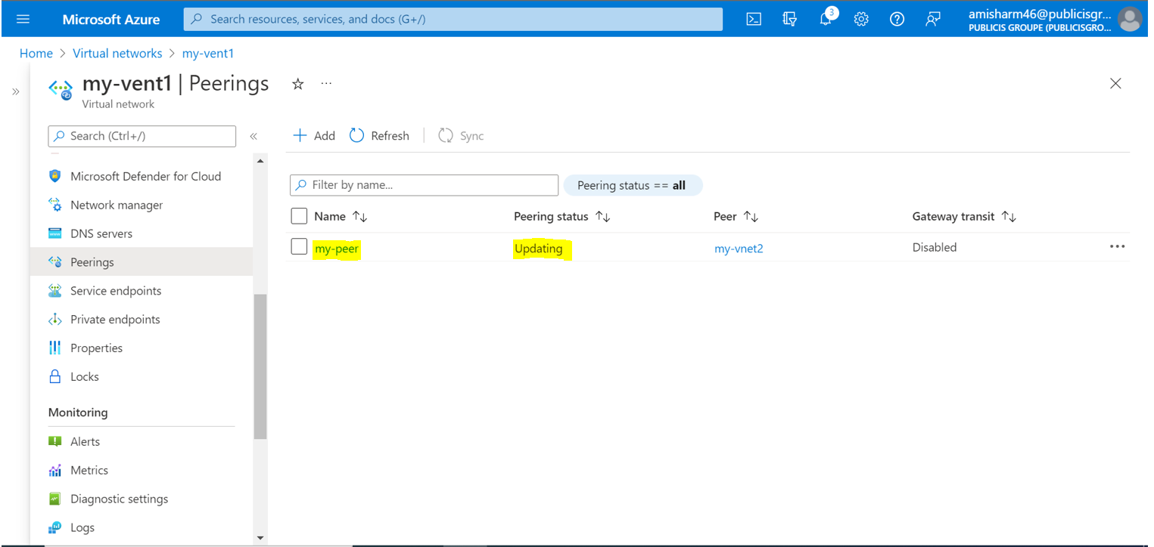

**Now wait for sometime and refresh and check the peering the status will be Connected after some time.**

