Title:
Rule-Based Chatbot Using Java

1. Introduction
A chatbot is a computer program designed to simulate conversations with users. Chatbots are widely used in customer service, websites, applications, and virtual assistants.
In this assignment, a simple rule-based chatbot is implemented using Java.
A rule-based chatbot works by matching user input with predefined keywords or patterns. If a keyword is detected, the chatbot gives the appropriate response.

2. Objective
The objective of this project is to:
- Develop a simple chatbot using Java
- Use if-else / conditional logic for responses
- Understand how user input and text matching works
- Display interactive question-answer conversation on the console

3. Tools and Technologies Used
- Java (JDK)
- NetBeans IDE
- GitHub (for submitting the project)

4. Methodology
This chatbot uses a rule-based approach, meaning it checks the user’s message for keywords using:
- toLowerCase()
- contains()
- simple if-else blocks
The chatbot keeps running in a loop until the user types "bye".

5. Source Code
import java.util.Scanner;
public class Chatbot {
public static void main(String[] args) {
Scanner sc = new Scanner(System.in);
System.out.println("Hello! I am Chatbot. Ask me anything!");
System.out.println("Type 'bye' to exit.\n");
while (true) {
System.out.print("You: ");
String input = sc.nextLine().toLowerCase();

if (input.equals("bye") || input.equals("exit")) {
System.out.println("Chatbot: Goodbye! Have a nice day!");
break;
}

String response = getResponse(input);
System.out.println("Chatbot: " + response);
}
sc.close();
}
// Rule-based response method
public static String getResponse(String input) {
if (input.contains("hello") || input.contains("hi")) {
return "Hello! How can I help you?";
}
if (input.contains("how are you")) {
return "I'm just a program, but I'm doing great!";
}
if (input.contains("name")) {
return "I am Chatbot, your simple Java assistant.";
}
if (input.contains("time")) {
return "I can't show the real time, but you can check your device!";
}
if (input.contains("college")) {
return "College is a place to learn, grow, and explore yourself.";
}
if (input.contains("java")) {
return "Java is a popular, object-oriented programming language.";
}
if (input.contains("chatbot")) {
return "A chatbot is a program that responds to user messages.";
}
return "Sorry, I don't understand that yet. Try asking something else!";
}
}
6. Output Screenshot
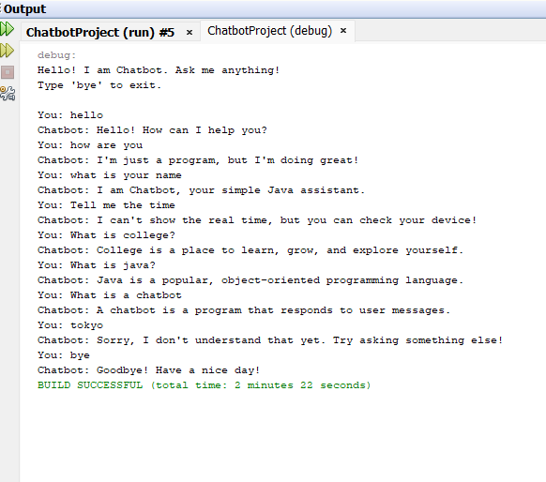

7. Results
The chatbot responded successfully to:
- Greetings
- Basic questions
- Name queries
- Exit command
It displayed correct rule-based behavior and produced meaningful output.

8. Conclusion
This project helped in understanding the basic working of chatbots and user interaction using Java.
By using simple rule-based logic, we created a chatbot capable of answering basic queries.
This assignment also helped to learn about string handling, loops, and decision-making statements in Java.

9. References
- Java Official Documentation
- Classroom lecture notes
- Online tutorials on Scanner and if-else logic

