Power BI Dashboard Report: Employee Data Insights
This report presents key visual insights generated from the Power BI dashboard. Each visualization highlights specific aspects of employee data such as attrition, gender distribution, performance, and departmental metrics.
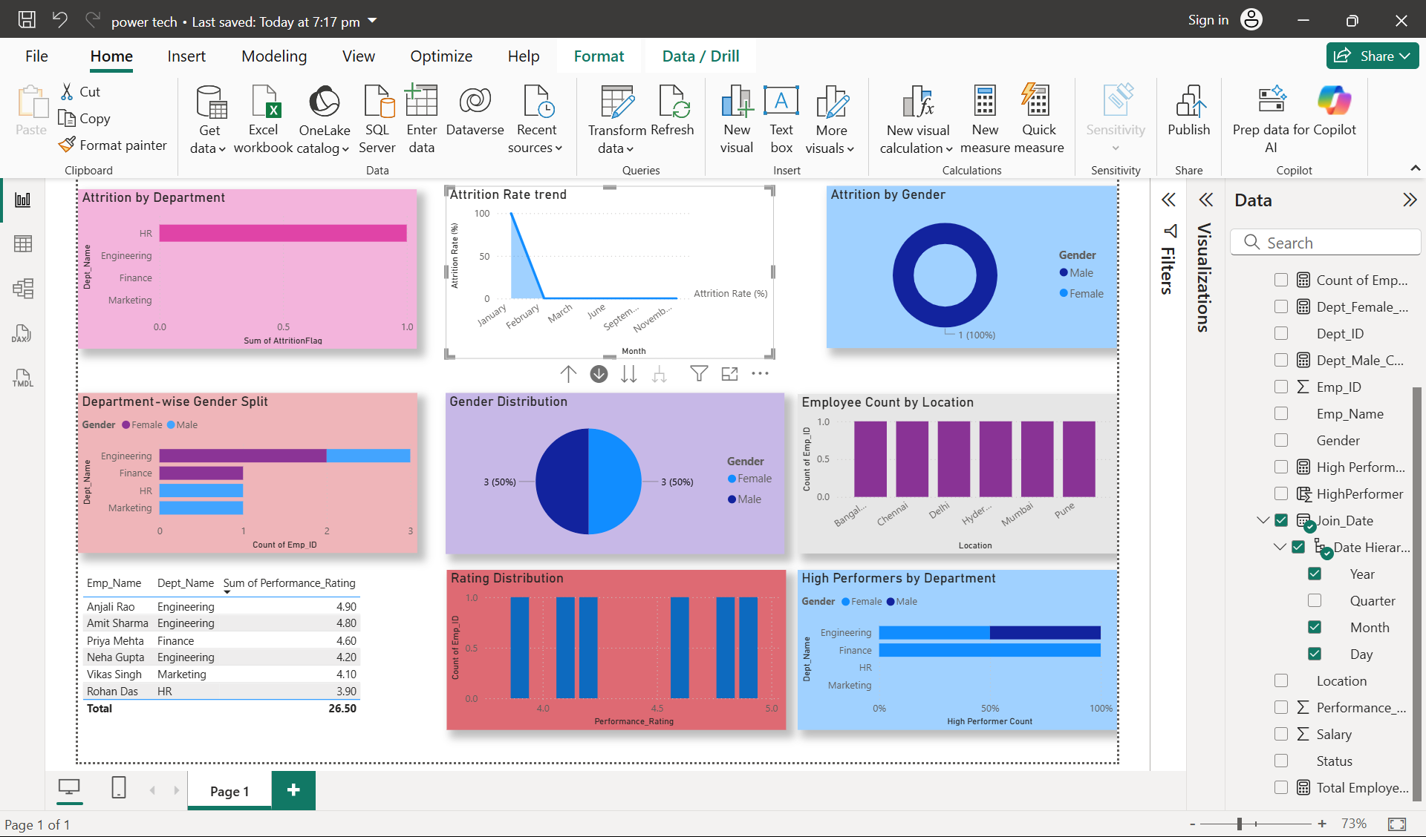
**Dashboard Overview**: The Power BI dashboard visualizes multiple metrics related to employees, including attrition by department, gender distribution, performance ratings, and employee count by location. Each visualization provides valuable insights for HR analytics and workforce planning.
INTERPRETATIONS

Attrition by Department
This bar chart highlights that the HR department has the highest attrition rate among departments. Engineering, Finance, and Marketing show minimal or no attrition, indicating better employee retention.

Attrition Rate Trend
The line chart depicts a sharp decline in attrition rate after January, stabilizing at zero in subsequent months. This suggests that recent retention initiatives or hiring freezes may have successfully reduced employee exits.

Attrition by Gender
The donut chart indicates that attrition is solely among females. This points to potential gender-related workplace challenges that may need attention from HR management.

Department-wise Gender Split
The bar chart compares male and female employee counts across departments. Engineering and Finance have higher male representation, whereas HR and Marketing show balanced gender ratios.

Gender Distribution
The pie chart reflects an equal 50-50 split between male and female employees, representing overall gender balance in the organization.

Employee Count by Location
This bar chart shows that employee distribution across cities (Bangalore, Chennai, Delhi, Hyderabad, Mumbai, and Pune) is relatively even, suggesting a well-distributed workforce.

Rating Distribution
The bar chart displays employee performance ratings concentrated between 4.0 and 5.0, indicating strong overall performance levels across the workforce.

High Performers by Department
This bar chart reveals that Engineering and HR have the highest concentration of high-performing employees. Finance and Marketing show moderate performance, reflecting departmental differences in productivity or evaluation standards.

Conclusion
The analysis reveals that the organization maintains a balanced gender ratio and high employee performance levels. However, attention is needed to address the high attrition rate among HR and female employees. Future HR strategies should focus on employee engagement, gender inclusivity, and retention improvement initiatives.

