**Unit 1 – Alina's Project ideas**

Main idea – A box stacking game

Secondary idea – A memory game (starts page 5)

**Main idea:**

Stack to Escape

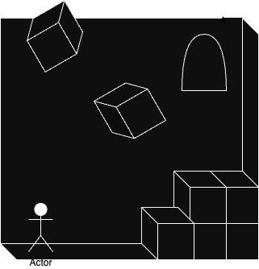

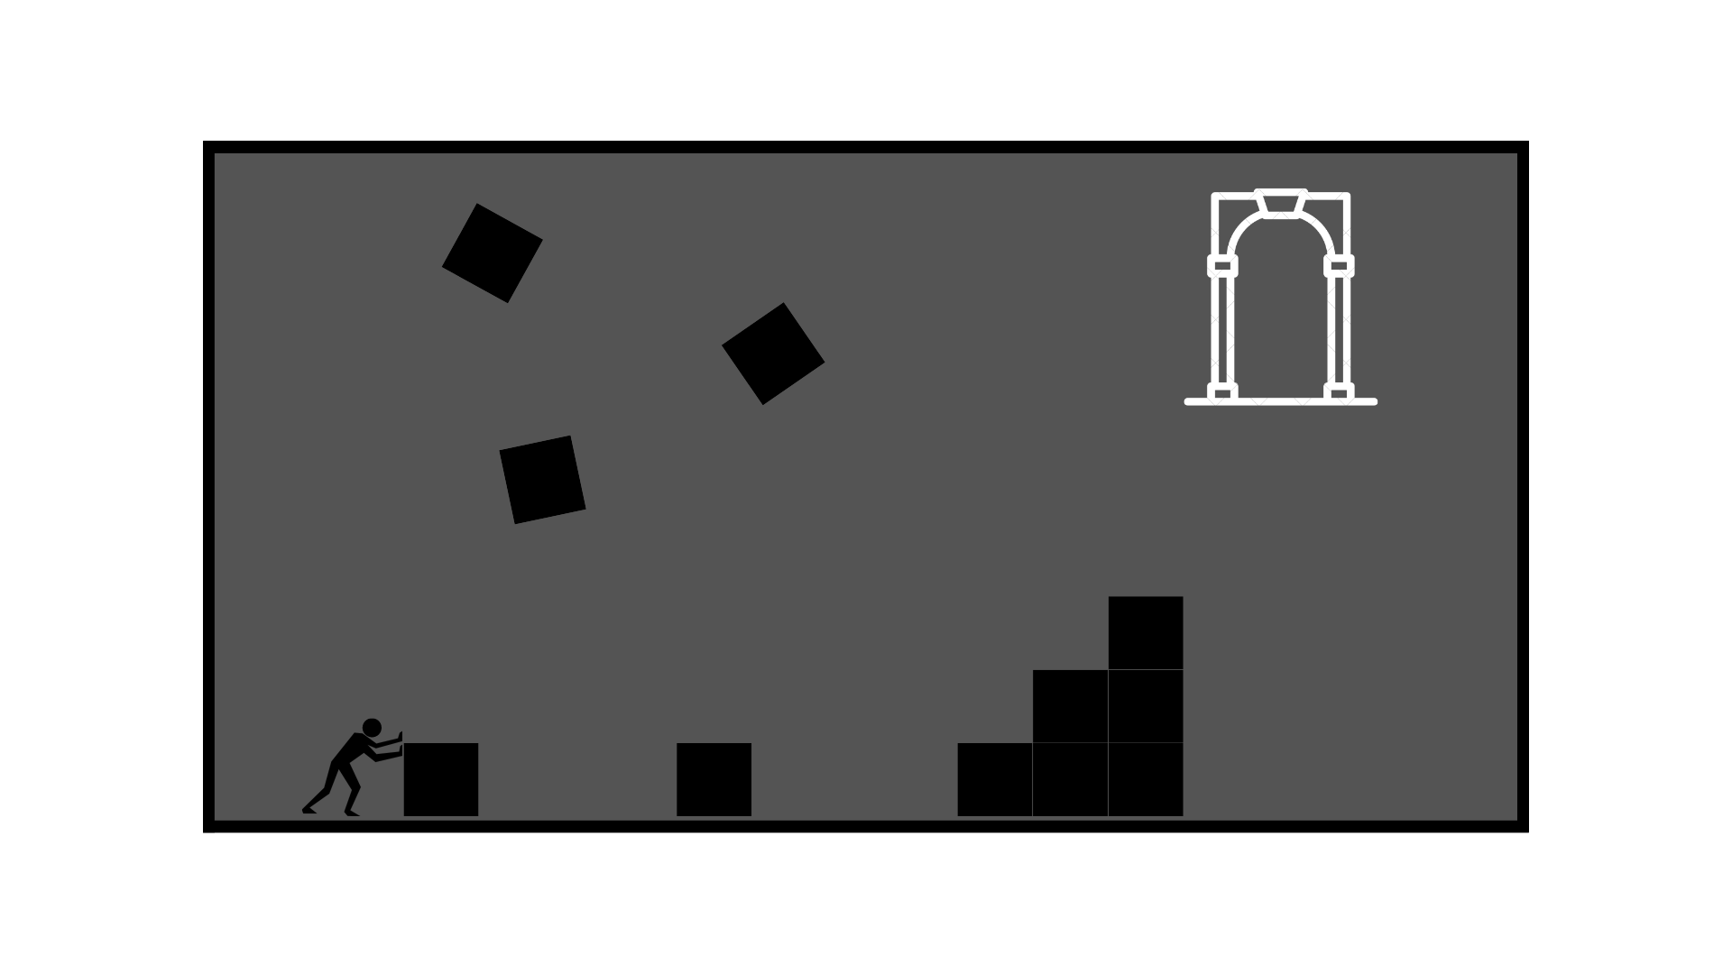

The world is made of black and white. A black background with white lines. There is a door that is hard to reach and there are boxes falling from above. The player must push and stack the boxes in order to escape. The player must also avoid falling boxes because the impact is deadly. Once the player reaches the doorway, the world becomes multi-colored, and the player sprite does a little dance.

Technologies used:

* HTML5
* CSS
* JavaScript

User Story:

As a player, I want the ability to...

* move left and right
* jump
* push boxes
* lift boxes
* stack boxes
* drop boxes
* climb boxes
* reach mysterious, but promising doorway
* win the game

Wire frames:

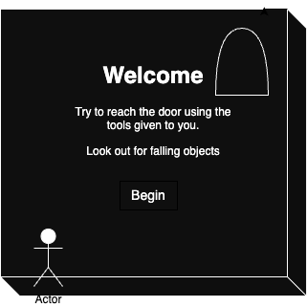

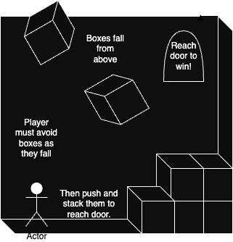

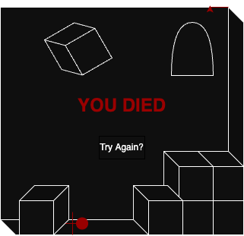

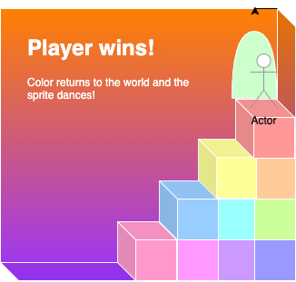

ERDs:

Player: {

X: (x location on the canvas)

Y: (y location on the canvas)

Height: (should be about the same as the boxes)

Width: (should be smaller than the boxes)

Color: white (red if dead, gray when game is won)

Alive: (a boolean that determines if game is in progress)

Render: (a method that displays the player on the screen)

}

Boxes: {

X: (x changeable locations for boxes to fall from)

Y: (y changeable locations for boxes to fall from)

Height: (should be about the same as the player)

Width: (same as height)

Color: black

Alive: (a boolean that determines if game is in progress)

Render: (a method that displays the boxes are on the screen)

}

function – gameloop – holds the entire logic that runs the game  
function – detectCrash – used to see if a box has fallen on the player  
function – movementHandler – used to move the player around, should be attached to arrow or wasd keys, and spacebar

Function – detectTouch – used to help the player move boxes around

Second Idea:

Memory Labyrinth:

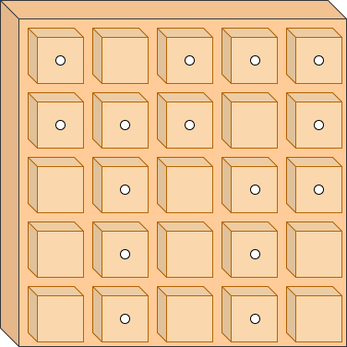

A simple puzzle game that starts with a grid of blank squares. The player must flip the squares to find the correct pathway to the MacGuffin. There are multiple pathways, but only one will lead to victory. If the player flips a square that does not contain a path piece, the squares flip back over, and the player must try again. If the player follows the wrong path to the dead end, the squares will flip back over, and the player must try again. When the player reaches the end of the labyrinth, the player wins a virtual MacGuffin!

Technologies used:

* HTML5
* CSS
* JavaScript

User Story:

As a player, I want the ability to...

* click on squares and have them react
* win the game

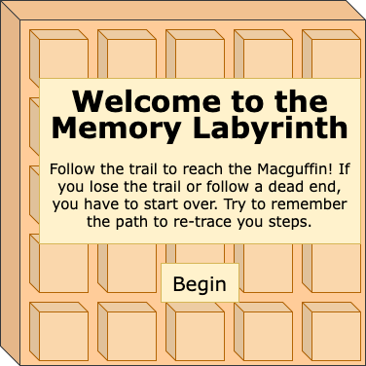

(Behind the scenes overview)

