**Monitoring Linux Servers Health**

Open Putty by double clicking on putty.exe.

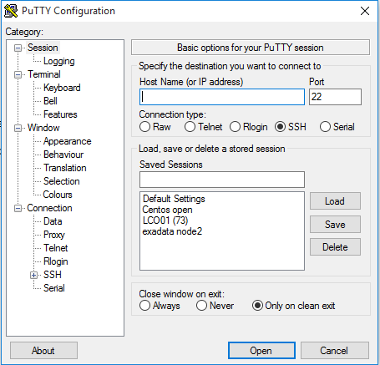

Type Server ip address and select SSH as Connection type and press Enter.

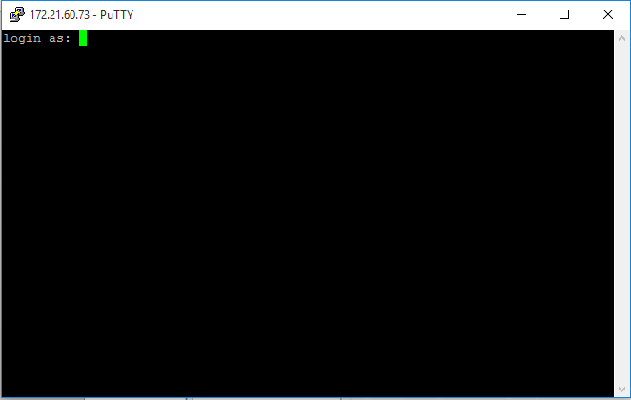

Provide User Credential and Login Into server.

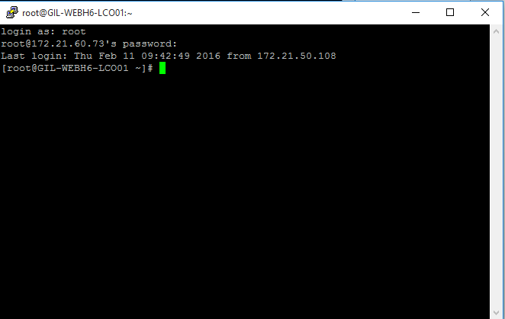

Check Disk space type command **“df -kTh”**

You will get output as shown in below image. And Concentrate on Highlighted Area in which red area showing total free space of partition and green portion showing network mount point.

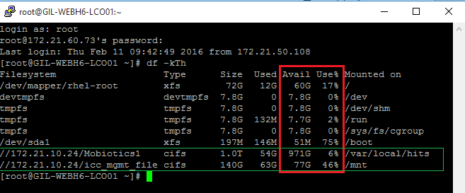

Check Network Time Status (NTP) type command **“ntpstat”**

You will get following output.

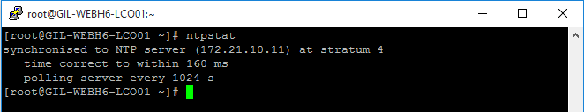

Check Server Performance type command **“top”**

You will get following output

