1. What exactly is []?

Sol. **It is representation of LIST (Empty List)**

1. In a list of values stored in a variable called spam, how would you assign the value 'hello' as the third value? (Assume [2, 4, 6, 8, 10] are in spam.)

Sol. **It is used to insert value at any required index by ( spam(3,(”Hello”) )**

Let's pretend the spam includes the list ['a', 'b', 'c', 'd'] for the next three queries.

1. What is the value of spam[int(int('3' * 2) / 11)]?

Sol. **Final output is ‘d’**

1. What is the value of spam[-1]?

Sol. **value of spam[-1] is ‘d’**

1. What is the value of spam[:2]?

Sol. **the value of spam[:2] is [‘a’ , ’b’]**

Let's pretend bacon has the list [3.14, 'cat,' 11, 'cat,' True] for the next three questions.

1. What is the value of bacon.index('cat')?

Sol. **Output 1**

1. How does bacon.append(99) change the look of the list value in bacon?

Sol. [3.14, 'cat', 11, 'cat', True, 99] it will append the element at the last index

1. How does bacon.remove('cat') change the look of the list in bacon?

Sol. [3.14, 11, 'cat', True, 99] It will the remove the element from the list from starting

1. What are the list concatenation and list replication operators?

Sol. “+” operator is used to concatenate the multiple list and

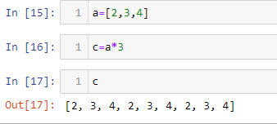

1. What is difference between the list methods append() and insert()?

Sol. **Append by default add the element at the last and for Insert it is required to specify the index**

1. What are the two methods for removing items from a list?

Sol. 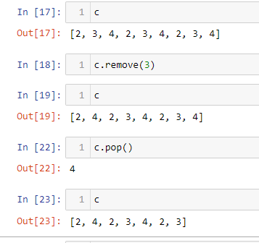

Remove() and pop() are used to remove the element from the list

1. Describe how list values and string values are identical.

Sol. **Both list and string indexing in slicing can be performend using same method and to find the length of both len() is used for both**.

1. What's the difference between tuples and lists?

Sol. Tuples are immutable and list are mutable

1. How do you type a tuple value that only contains the integer 42?

Sol.

1. How do you get a list value's tuple form? How do you get a tuple value's list form?

Sol. 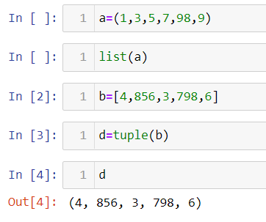

1. Variables that "contain" list values are not necessarily lists themselves. Instead, what do they contain?

Sol. Contains the reference the value

1. How do you distinguish between copy.copy() and copy.deepcopy()?

Sol. In two types of copy Shallow copy and Deep copy in shallow copy the new variable only contains the reference of the original variable and if it required to change it changes it changes the original variable

And in deep copy it constructs the new object and in case of any change it will not affect the original variable