1. What are escape characters, and how do you use them?

Sol. to insert any character in string which is not allowed to insert we use escape character

It can be used like [ **\”char\”**]

1. What do the escape characters n and t stand for?

Sol. **n stands for new line**

**t stands for tab between two**

1. What is the way to include backslash characters in a string?

Sol. **giving double \\**

1. The string "Howl's Moving Castle" is a correct value. Why isn't the single quote character in the word Howl's not escaped a problem?

Sol. **As the given string is quoted in double comma i.e ”” if it was in single comma then we have to use escape character for it.**

1. How do you write a string of newlines if you don't want to use the n character?

Sol. **quoting it in triple comma [ ‘’’My name is ayush ‘’’]**

6. What are the values of the given expressions?

'Hello, world!'[1] - **e**

'Hello, world!'[0:5]- **Hello**

'Hello, world!'[:5] - **Hello**

'Hello, world!'[3:] - **lo, world!**

7. What are the values of the following expressions?

'Hello'.upper() -**HELLO**

'Hello'.upper().isupper() - **True**

'Hello'.upper().lower()- **hello**

8. What are the values of the following expressions?

'Remember, remember, the fifth of July.'.split()

'-'.join('There can only one.'.split())

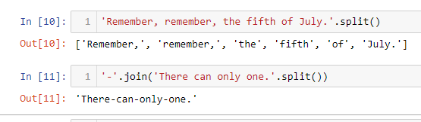

9. What are the methods for right-justifying, left-justifying, and centering a string?

Sol. **The rjust(),ljust(),center() string methods, respectively**

10. What is the best way to remove whitespace characters from the start or end?

Sol. **strip() method is used to remove whitespace between string.**