Name: Amit Kumar Sharma

Roll No: M20AIE213

Assignment: Build a Web application and deploy the application to docker container.

**Steps for Installing Docker:**

**----------------------------------**

$ sudo apt-get update

$ sudo apt install docker.io

$ sudo snap install docker

**Clone the code from GitHub:**

**--------------------------------------**

amit@VM-M20AIE213-1:~/WebApp$ git clone https://github.com/amishrm/cloud_m20aie213.git

Cloning into 'cloud_m20aie213'...

remote: Enumerating objects: 16, done.

remote: Counting objects: 100% (16/16), done.

remote: Compressing objects: 100% (14/14), done.

remote: Total 16 (delta 4), reused 0 (delta 0), pack-reused 0

Unpacking objects: 100% (16/16), 5.59 KiB | 1.12 MiB/s, done.

**Build an Image:**

**--------------------**

amit@VM-M20AIE213-1:~/WebApp$ cd cloud_m20aie213/

amit@VM-M20AIE213-1:~/WebApp/cloud_m20aie213$ sudo docker build --tag cloud_m20aie213:v1.0.0 .

Sending build context to Docker daemon 101.9kB

Step 1/10 : FROM python:3.8-slim-buster

---> 4594dc5e9028

Step 2/10 : RUN apt-get update -y

---> Using cache

---> e5118d0aa44c

Step 3/10 : RUN apt-get install -y default-libmysqlclient-dev python3-pip python3-dev build-essential

---> Using cache

---> 7b3c69f25abe

Step 4/10 : LABEL maintainer="Amit Sharma <sharma.95@iitj.ac.in>"

---> Using cache

---> 1694761b6e4a

Step 5/10 : EXPOSE 5000

---> Using cache

---> 6cb2ec5d622d

Step 6/10 : COPY requirements.txt .

---> Using cache

---> a97d64c73b11

Step 7/10 : RUN python3 -m pip install -r requirements.txt

---> Using cache

---> 9734315e818c

Step 8/10 : WORKDIR /app

---> Using cache

---> cc6e66019cc9

Step 9/10 : COPY . /app

---> d3501b4c3461

Step 10/10 : CMD ["gunicorn", "--bind", "0.0.0.0:5000", "app:app"]

---> Running in abb15269f8fa

Removing intermediate container abb15269f8fa

---> fe459e64a0b0

Successfully built fe459e64a0b0

Successfully tagged cloud_m20aie213:v1.0.0

**Check Docker Images:**

**------------------------------**

amit@VM-M20AIE213-1:~/WebApp/cloud_m20aie213$ sudo docker images

REPOSITORY TAG IMAGE ID CREATED SIZE

cloud_m20aie213 v1.0.0 fe459e64a0b0 38 seconds ago 554MB

m20aie213 v1.0.0 5b71453007fb 43 minutes ago 554MB

amit-docker latest 72c63a44ccc2 53 minutes ago 556MB

<none> <none> 8bd004befd1d About an hour ago 525MB

python-docker v1.0.0 83b39b2c084f About an hour ago 443MB

<none> <none> 27908b66d0ea 2 hours ago 114MB

python 3.8-slim-buster 4594dc5e9028 12 days ago 114MB

ubuntu 20.04 1318b700e415 4 weeks ago 72.8MB

hello-world latest d1165f221234 5 months ago 13.3kB

**Run the Container:**

**-------------------------**

amit@VM-M20AIE213-1:~/WebApp/cloud_m20aie213$ sudo docker run --publish 5000:5000 cloud_m20aie213:v1.0.0

[2021-08-29 18:48:05 +0000] [1] [INFO] Starting gunicorn 20.1.0

[2021-08-29 18:48:05 +0000] [1] [INFO] Listening at: http://0.0.0.0:5000 (1)

[2021-08-29 18:48:05 +0000] [1] [INFO] Using worker: sync

[2021-08-29 18:48:05 +0000] [9] [INFO] Booting worker with pid: 9

**Check whether Container is running or not:**

**----------------------------------------------------------**

amit@VM-M20AIE213-1:~$ curl localhost:5000

<html>

<head>

<meta charset="UTF-8">

<title> Login </title>

<link rel="stylesheet" href="../static/style.css">

</head>

<body>

<div class="logincontent" align="center">

<div class="logintop">

<h1>Login</h1>

</div></br></br></br></br>

<div class="loginbottom">

<form action="/login" method="post" autocomplete="off">

<div class="msg"></div>

<input type="text" name="username" placeholder="Enter Your Username" class="textbox" id="username" required></br></br>

<input type="password" name="password" placeholder="Enter Your Password" class="textbox" id="password" required></br></br></br>

<input type="submit" class="btn" value="Login">

</form></br></br>

<p class="worddark">New to this page? <a class="worddark" href="/register">Register here</a></p>

</div>

</div>

</body>

</html>

**Build an Image using Git Repository:**

**-----------------------------------------------**

amit@VM-M20AIE213-1:~/WebApp/temp$ sudo docker build https://github.com/amishrm/cloud_m20aie213.git#main --tag cloud_m20aie213:main

Sending build context to Docker daemon 99.33kB

Step 1/10 : FROM python:3.8-slim-buster

---> 4594dc5e9028

Step 2/10 : RUN apt-get update -y

---> Using cache

---> e5118d0aa44c

Step 3/10 : RUN apt-get install -y default-libmysqlclient-dev python3-pip python3-dev build-essential

---> Using cache

---> 7b3c69f25abe

Step 4/10 : LABEL maintainer="Amit Sharma <sharma.95@iitj.ac.in>"

---> Using cache

---> 1694761b6e4a

Step 5/10 : EXPOSE 5000

---> Using cache

---> 6cb2ec5d622d

Step 6/10 : COPY requirements.txt .

---> Using cache

---> 23a3aeddf081

Step 7/10 : RUN python3 -m pip install -r requirements.txt

---> Using cache

---> cc2374b3ac2a

Step 8/10 : WORKDIR /app

---> Using cache

---> f9b37dc06531

Step 9/10 : COPY . /app

---> d588effd9640

Step 10/10 : CMD ["gunicorn", "--bind", "0.0.0.0:5000", "app:app"]

---> Running in f7501be2e045

Removing intermediate container f7501be2e045

---> 39df5f8c257b

Successfully built 39df5f8c257b

Successfully tagged cloud_m20aie213:main

**Run the Container:**

**-------------------------**

amit@VM-M20AIE213-1:~/WebApp/temp$ sudo docker run --publish 5000:5000 cloud_m20aie213:main

[2021-08-29 19:08:11 +0000] [1] [INFO] Starting gunicorn 20.1.0

[2021-08-29 19:08:11 +0000] [1] [INFO] Listening at: http://0.0.0.0:5000 (1)

[2021-08-29 19:08:11 +0000] [1] [INFO] Using worker: sync

[2021-08-29 19:08:11 +0000] [10] [INFO] Booting worker with pid: 10

**About the Web application:**

In this application, user can register themselves, update their details and view their details. I am updating user details in MySQL DB which is installed and configured in their VM (VM-M20AIE213).

Register User page:

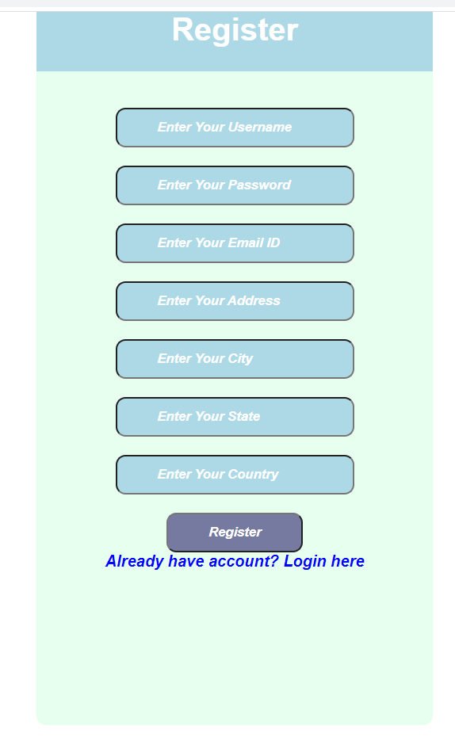

Login Page:

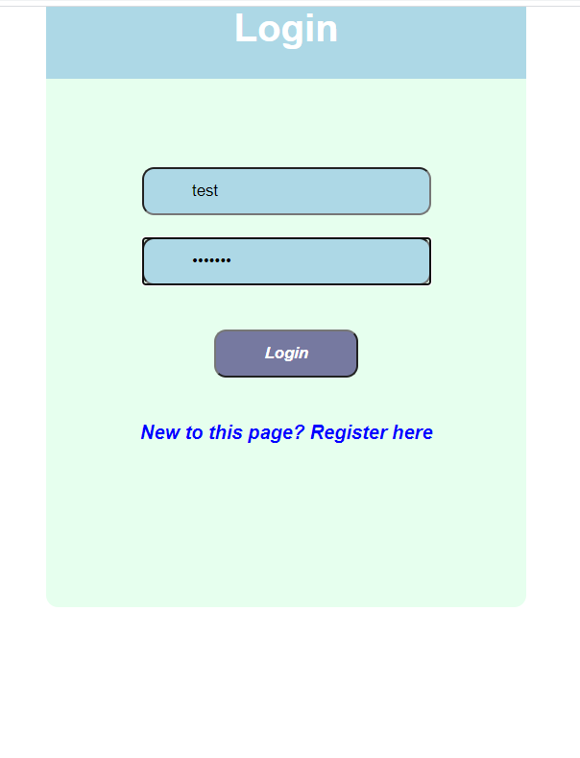

After successfully login, application will be redirected to Index page.

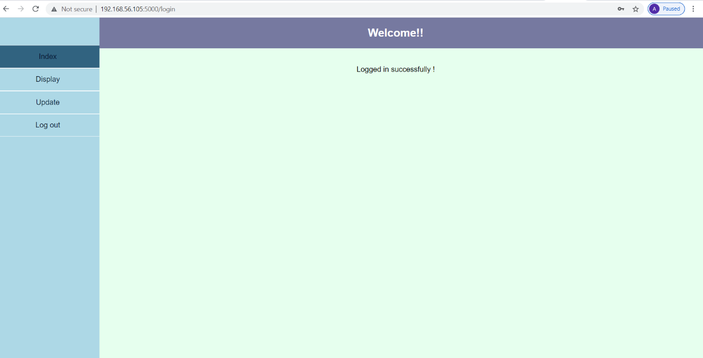

When user clicks on Display link, then webapplication will fetch the user details from database and display user details in this page.

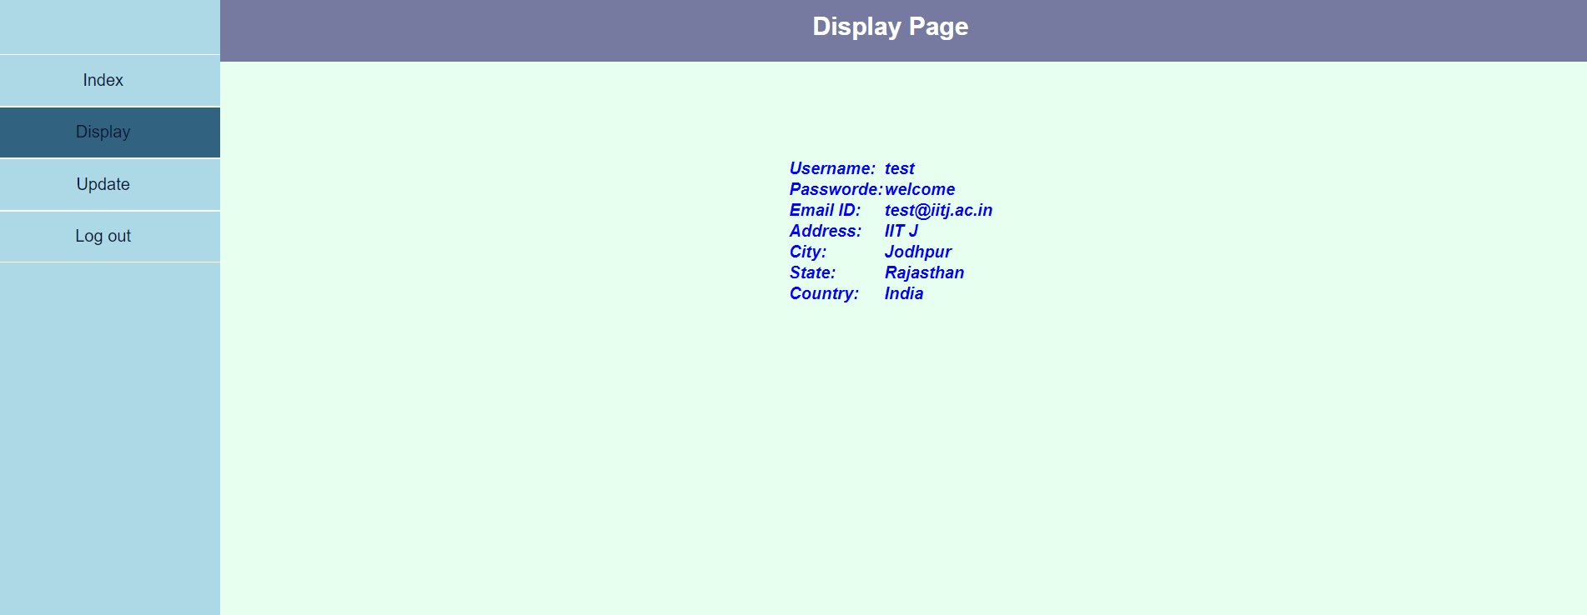

When user clicks on Update link, then web application will redirect to Update page. In this page, user can update his/her details.

