HCM UNIVERSITY OF TECHNOLOGY AND EDUCATION

**FACULTY OF INFORMATION TECHNOLOGY**



**FINAL PROJECT**

**PHONE MANAGEMENT SYSTEM**

**Course name: IT_PROJECT**

**Lecturer name**: Dr. Le Van Vinh

**Nhóm:**

**List of members:**

|  |  |  |
| --- | --- | --- |
| **Student ID** | **Student name** | **Contribution (%)** |
| **20110396** | **Đặng Phước Trường Tài** | **100%** |
| **20110394** | **Danh Trường Sơn** | **100%** |

***Ho Chi Minh City, October 2022***

# Acknowledgment

We express our sincere thanks to **Mr. Le Van Vinh**, our project in charge, who guided us through the project. He gave valuable suggestions and guidance for completing the project, helped us to understand the intricate issues involved in project-making besides effectively presenting it. These intricacies would have been lost otherwise. Our project has been a success only because of his guidance.

Although this is the first time that the members of the group have studied this course, our knowledge is still limited, but thanks to the teacher's teaching, we were able to pass the lessons and absorb the knowledge and skills. Complete the project as required.

Projects are made within ten weeks. However, due to much new knowledge as well as the time we do through each week is not optimal, the project will have many errors, which is inevitable. However, in order to complete this report on time set by the school as well as the department, our group also made a lot of efforts. We are looking forward to receiving all the comments of our teacher to help our limited knowledge better.

Sincerely thanks.

# Preface

Today with the development of technology entering the 4.0 era. Managing products with a large amount of human memory is always a challenge, to make it easy, management software was born to support people and software. Phone management is a fairly familiar software that helps us check as well as manage phones most effectively.

The purpose and objective of this training and mainly the content is time-being, and with this training, we have gained some confidence regarding introducing the application. We also believe that way we gained some sorts of IT knowledge, and if we practice much and having some expertise in the field, then we will be able to survive smartly in today’s competitive environment.

The effort to write the report is a partial fulfilment to complete the course. In the report, I try my best to represent all the content that we learned in a great deal in the program in a systematic and presentable order. I divided each of the topics as an individual chapter to reflect the entire topic more prominently and clearly. In reference, I have used the citation method in the entire report. Finally, I am very hopeful that the structure and topic of the report will be a useful material for all the reader, especially to the user.

# Project description

## ***1. Objectives***

Every profession requires people to process huge amount of information, an urgent problem is how to process that data. So, we choose “Phone management system” to help users to manage phones and staff in the store easily.

## ***2. User benefits***

Similar to other system, the phone management system provides users with the abilities to add, print, delete, find, sort by name, sort by price,statistic buy the phone and add employee of store.

* Add: add a phone or an employee to system.
* Delete: delete a phone or an employee from system.
* Find: find phone, employee by name or id.
* Sort: sort drug phone name or by price.
* Buy: buy the phone and print bills.
* Statistical: statistics of buyed phone.

# DATABASE DIAGRAMS

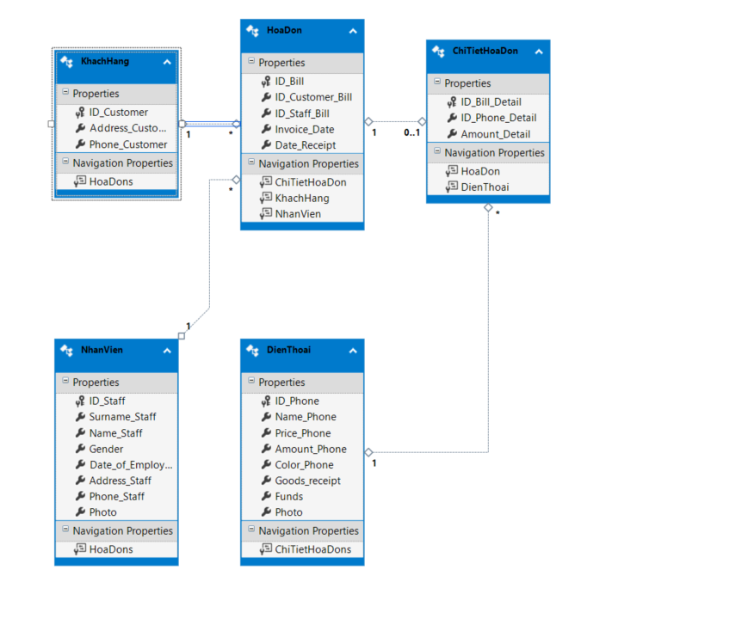

## **DienThoai**

|  |  |
| --- | --- |
| Column Name | Data Type |
| ID_Phone | nvarchar(50) |
| Name_Phone | nvarchar(50) |
| Price_Phone | int |
| Amount_Phone | int |
| Color_Phone | nvarchar(50) |
| Goods_receipt | date |
| Funds | int |
| Photo | nvarchar(200) |

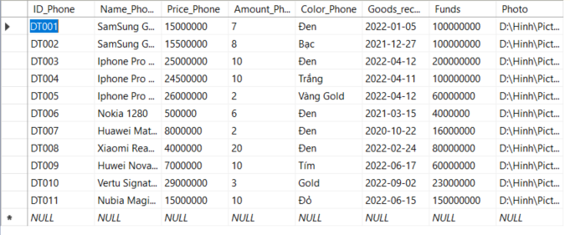

Image 1 - DienThoai Database

The DienThoai table includes :

+ ID_Phone : is the primary key of the table , not null

+ Name_Phone : contain the name of the phone , not null

+ Price_Phone : contain the price of the phone , not null

+ Amount_Phone : contain the amount of the phone which have in store , can be null

+ Color_Phone : color of the phone , can be null

+ Goods_receipt : contain the date which entering the phone to the store , not null

+ Funds : contain the original money which was spent to buy the phone , not null

+ Photo : contain the photo of the phone , can be null

## **NhanVien**

|  |  |
| --- | --- |
| Column Name | Data Type |
| ID_Staff | nvarchar(50) |
| Surmame_Staff | nvarchar(50) |
| Name_Staff | nvarchar(50) |
| Gender | bit |
| Date_of_Employment | date |
| Address_Staff | nvarchar(50) |
| Phone_Staff | int |
| Photo | nvarchar(200) |

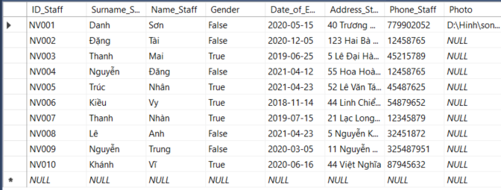

Image 2- NhanVien Database

The NhanVien table includes :

+ ID_Staff : is the primary key of the table , not null

+ Surname_Staff : contain the first name of the employee , not null

+ Name_Staff : contain the last name of the employee , not null

+ Gender : contain the gender of employee return true or false , not null

+ Date_of_Employment : contain the date which the employee start to work , not null

+ Address_Staff : contain address of the employee , not null

+ Phone_Staff : contain the phone of the employee , not null

+ Photo : contain the photo of the employee , can be null

## **KhachHang**

|  |  |
| --- | --- |
| Column Name | Data Type |
| ID_Customer | nvarchar(50) |
| Address_Customer | nvarchar(50) |
| Phone_Customer | int |

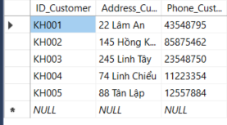

Image 3 - KhachHang Database

The KhachHang table includes :

+ ID_Customer : is the primary key of the table , not null

+ Adrress_Customer : contain the address of the customer , not null

+ Phone_Customer : contain the phone of the customer , not null

## **HoaDon**

|  |  |
| --- | --- |
| Column Name | Data Type |
| ID_Bill | nvarchar(50) |
| ID_Customer_Bill | nvarchar(50) |
| ID_Staff_Bill | nvarchar(50) |
| Invoice_Date | date |
| Date_Receipt | date |

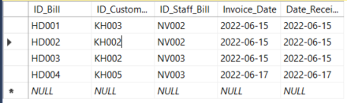

Image 4 - HoaDon Database

The HoaDon table includes :

+ ID_Bill : is the primary key of the table , not null

+ ID_Customer_Bill : contain the id of the customer reference to the KhachHang table , not null

+ ID_Staff_Bill : contain the id of the employee reference to the NhanVien table , not null

+ Invoice_Date : contain the date create the bill , not null

+ Date_Receipt : contain the date receipt the bill , not null

## **ChiTietHoaDon**

|  |  |
| --- | --- |
| Column Name | Data Type |
| ID_Bill_Detail | nvarchar(50) |
| ID_Phone_Detail | nvarchar(50) |
| Amount_Detail | int |

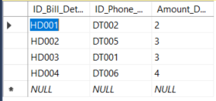

Image 5 - ChiTietHoaDon Database

The HoaDon table includes :

+ ID_Bill_Detail : is the primary key of the table ,contain the id of the bill reference to the HoaDon table, not null

+ ID_Phone_Detail : contain the id of the phone reference to the DienThoai table , not null

+ Amount_Detail : contain the amount of the phone , not null

# PHONE MANAGEMENT SYSTEM

## **Class Diagrams**

**Our phone management system** is designed based on a 3-layer model, so it can be easily changed and upgraded, easily distributed data and divided work for each person in the group.

System is divided into 3 layers : **BS** , **DB** and **WF**

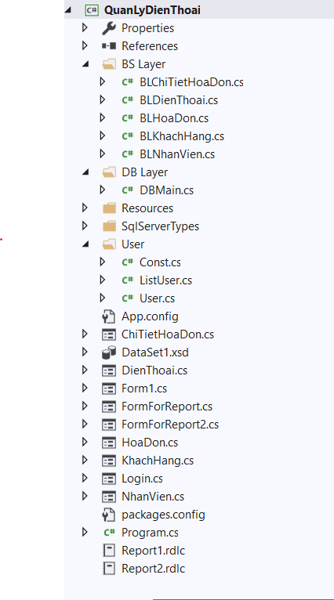

**ADO.NET**

**BS LAYER :**

|  |  |
| --- | --- |
| Class Name | Purpose |
| BLChiTietHoaDon | Make request from ChiTietHoaDon Form and acess to DB Layer |
| BLDienThoai | Make request from DienThoai Form and acess to DB Layer |
| BLHoaDon | Make request from HoaDon Form and acess to DB Layer |
| BLKhachHang | Make request from KhachHang Form and acess to DB Layer |
| BLNhanVien | Make request from NhanVien Form and acess to DB Layer |

**DB LAYER :**

|  |  |
| --- | --- |
| Class Name | Purpose |
| DBMain | Access the database SQL |

|  |  |
| --- | --- |
| BLNhanVien | Make request from NhanVien Form and acess to DB Layer |

**USER :**

|  |  |
| --- | --- |
| Class Name | Purpose |
| User | Declare values for users |
| ListUser | Create list of users |
| Const | User authorization |

## **User Interfaces ( Form )**