

**Employee spotlight**



**CDO Birthdays**



**Security as a culture**

CDO INDIA March 2025

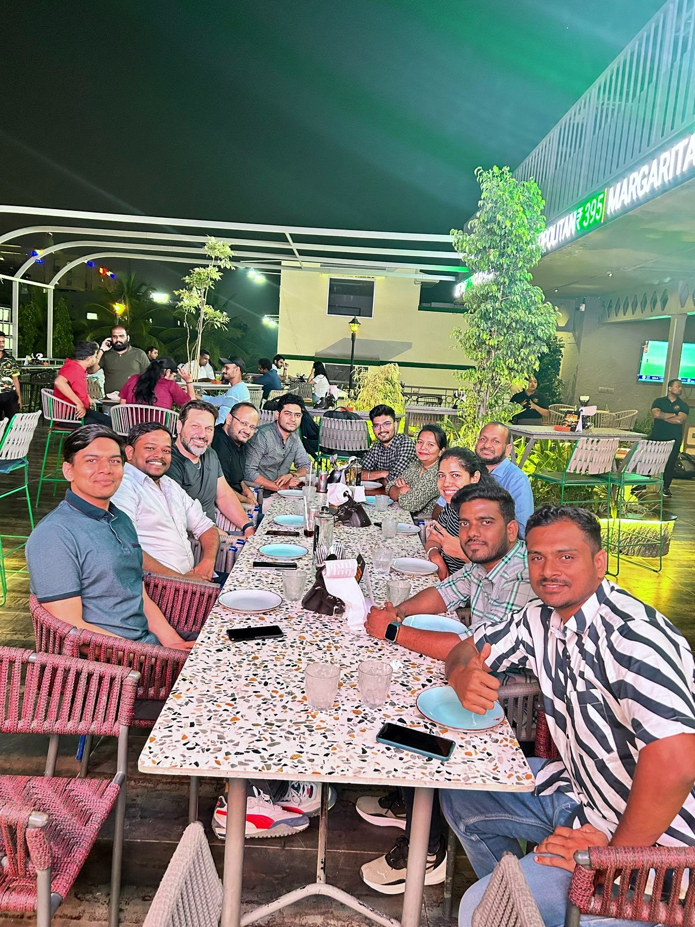



CDO INDIA March 2025

**Lorem Ipsum** is simply dummy text of the printing and typesetting industry. Lorem Ipsum has been the industry's standard dummy text ever since the 1500s, when an unknown printer took a galley of type and scrambled it to make a type specimen book. It has survived not only five centuries, but also the leap into electronic typesetting, remaining essentially unchanged. It was popularised in the 1960s with the release of Letraset sheets containing Lorem Ipsum passages, and more recently with desktop publishing software like Aldus PageMaker including versions of Lorem Ipsum.

**Lorem Ipsum** is simply dummy text of the printing and typesetting industry. Lorem Ipsum has been the industry's standard dummy text ever since the 1500s, when an unknown printer took a galley of type and scrambled it to make a type specimen book. It has survived not only five centuries, but also the leap into electronic typesetting, remaining essentially unchanged. It was popularised in the 1960s with the release of Letraset sheets containing Lorem Ipsum passages, and more recently with desktop publishing software like Aldus PageMaker including versions of Lorem Ipsum.

**Lorem Ipsum** is simply dummy text of the printing and typesetting industry. Lorem Ipsum has been the industry's standard dummy text ever since the 1500s, when an unknown printer took a galley of type and scrambled it to make a type specimen book. It has survived not only five centuries, but also the leap into electronic typesetting, remaining essentially unchanged. It was popularised in the 1960s with the release of Letraset sheets containing Lorem Ipsum passages, and more recently with desktop publishing software like Aldus PageMaker including versions of Lorem Ipsum.

**Lorem Ipsum** is simply dummy text of the printing and typesetting industry. Lorem Ipsum has been the industry's standard dummy text ever since the 1500s, when an unknown printer took a galley of type and scrambled it to make a type specimen book. It has survived not only five centuries, but also the leap into electronic typesetting, remaining essentially unchanged. It was popularised in the 1960s with the release of Letraset sheets containing Lorem Ipsum passages, and more recently with desktop publishing software like Aldus PageMaker including versions of Lorem Ipsum.

**Senior Leadership TouR**

**Enhancing Collaboration and Innovation at COMPANY**

AUTHOR NAME

BUZZ BUZZ



CDO INDIA March 2025

**Employees in Spotlight**

**TOPIC NAME**

**A LINE ABOUT THE TOPIC**

**Lorem Ipsum** is simply dummy text of the printing and typesetting industry. Lorem Ipsum has been the industry's standard dummy text ever since the 1500s, when an unknown printer took a galley of type and scrambled it to make a type specimen book. It has survived not only five centuries, but also the leap into electronic typesetting, remaining essentially unchanged. It was popularised in the 1960s with the release of Letraset sheets containing Lorem Ipsum passages, and more recently with desktop publishing software like Aldus PageMaker including versions of Lorem Ipsum.

**Lorem Ipsum** is simply dummy text of the printing and typesetting industry. Lorem Ipsum has been the industry's standard dummy text ever since the 1500s, when an unknown printer took a galley of type and scrambled it to make a type specimen book. It has survived not only five centuries, but also the leap into electronic typesetting, remaining essentially unchanged

AUTHOR NAMES

Learning @ CDO

**As we strive for Operational Excellence and work towards establishing ourselves as a world-class organisation, the CDO IDC team holds a pivotal role in driving this vision forward. Continuous up-skilling and fostering strong collaboration will serve as the cornerstone of our success on this transformative journey.**

SOME HACKATHON WINNERS

**NAME**

**NAME**

**NAME**



**NAME OF AUTHOR**

CDO INDIA March 2025

**Employees in Spotlight**

**TECH ARTICLE NAME**

**ONE LINER ABOUT ARTICLE**

**Lorem Ipsum** is simply dummy text of the printing and typesetting industry. Lorem Ipsum has been the industry's standard dummy text ever since the 1500s, when an unknown printer took a galley of type and scrambled it to make a type specimen book. It has survived not only five centuries, but also the leap into electronic typesetting, remaining essentially unchanged. It was popularised in the 1960s with the release of Letraset sheets containing Lorem Ipsum passages, and more recently with desktop publishing software like Aldus PageMaker including versions of Lorem Ipsum.

**Lorem Ipsum** is simply dummy text of the printing and typesetting industry. Lorem Ipsum has been the industry's standard dummy text ever since the 1500s, when an unknown printer took a galley of type and scrambled it to make a type specimen book. It has survived not only five centuries, but also the leap into electronic typesetting, remaining essentially unchanged. It was popularised in the 1960s with the release of Letraset sheets containing Lorem Ipsum passages, and more recently with desktop publishing software like Aldus PageMaker including versions of Lorem Ipsum.

**Lorem Ipsum** is simply dummy text of the printing and typesetting industry. Lorem Ipsum has been the industry's standard dummy text ever since the 1500s, when an unknown printer took a galley of type and scrambled it to make a type specimen book. It has survived not only five centuries, but also the leap into electronic typesetting, remaining essentially unchanged. It was popularised in the 1960s with the release of Letraset sheets containing Lorem Ipsum passages, and more recently with desktop publishing software like Aldus PageMaker including versions of Lorem Ipsum.

**Lorem Ipsum** is simply dummy text of the printing and typesetting industry. Lorem Ipsum has been the industry's standard dummy text ever since the 1500s, when an unknown printer took a galley of type and scrambled it to make a type specimen book. It has survived not only five centuries, but also the leap into electronic typesetting, remaining essentially unchanged. It was popularised in the 1960s with the release of Letraset sheets containing Lorem Ipsum passages, and more recently with desktop publishing software like Aldus PageMaker including versions of Lorem Ipsum.

[***Read Full Article***](https://engage.cloud.microsoft/main/org/att.com/threads/eyJfdHlwZSI6IlRocmVhZCIsImlkIjoiMzI3NDA0NTk1MDk2NzgwOCJ9?trk_copy_link=V2_HTML)

Tech TIDBITS



CDO INDIA March 2025

**Employees in Spotlight**

**CHAI pe charcha -q?**

**ONE LINER ABOUT SECURITY**

AUTHOR

Security as a Culture



CDO INDIA March 2025

**Employees in Spotlight**

**Lorem Ipsum** is simply dummy text of the printing and typesetting industry. Lorem Ipsum has been the industry's standard dummy text ever since the 1500s, when an unknown printer took a galley of type and scrambled it to make a type specimen book. It has survived not only five centuries, but also the leap into electronic typesetting, remaining essentially unchanged. It was popularised in the 1960s with the release of Letraset sheets containing Lorem Ipsum passages, and more recently with desktop publishing software like Aldus PageMaker including versions of Lorem Ipsum.

**Lorem Ipsum** is simply dummy text of the printing and typesetting industry. Lorem Ipsum has been the industry's standard dummy text ever since the 1500s, when an unknown printer took a galley of type and scrambled it to make a type specimen book. It has survived not only five centuries, but also the leap into electronic typesetting, remaining essentially unchanged.

**WHAT ACHIEVEMENT**

**ACHIEVEMENT**

NAME

NAME

TEAM DETAILS:

**Lorem Ipsum** is simply dummy text of the printing and typesetting industry. Lorem Ipsum has been the industry's standard dummy text ever since the 1500s, when an unknown printer took a galley of type and scrambled it to make a type specimen book. It has survived not only five centuries, but also the leap into electronic typesetting, remaining essentially unchanged. It was popularised in the 1960s with the release of Letraset sheets containing Lorem Ipsum passages, and more recently with desktop publishing software like Aldus PageMaker including versions of Lorem Ipsum.

AUTHOR

Employees in Spotlight



NAME

NAME

NAME

NAME

NAME

NAME

NAME

NAME

NAME

NAME

NAME

NAME

NAME

NAME

NAME

NAME

CDO INDIA March 2025

**Employees in Spotlight**

Celebrating our wonderful teams important milestones

AUTHOR

CDO Birthdays