NumPy (short for Numerical Python) is a powerful Python library used for numerical computations, especially when working with large arrays, matrices, or multi-dimensional data. It forms the foundation of many data science, machine learning, and scientific computing tools in Python.

How to install NUMPY
Open VS CodeCreate new file give any name to file(numpy.py)
Go to TerminalGo to New Terminal
PS C:\Users\amitk> python --version
Python 3.13.1
PS C:\Users\amitk> pip install numpy (press Enter)
It will automatically install numpy.
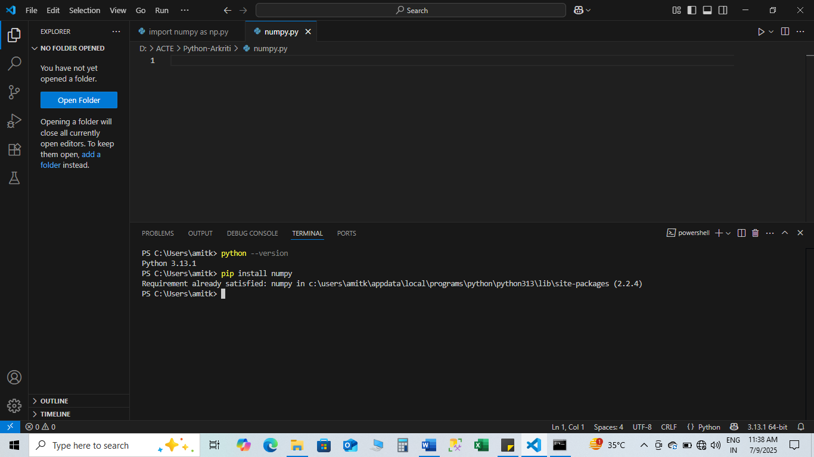
Array Manipulation using NumPy
NumPy Basics for Data Analysis
- Importing NumPy
import numpy as np

- Creating Arrays
1D, 2D, 3D Arrays:

a = np.array([1, 2, 3]) # 1D array
b = np.array([[1, 2], [3, 4]]) # 2D array
c = np.array([[[1], [2]], [[3], [4]]]) # 3D array

Special arrays:

- np.zeros((2, 3)) # 2x3 array of zeros

import numpy as np
# Create a 2x3 array filled with zeros
arr = np.zeros((2, 3))
print("2x3 array of zeros:")
print(arr)

- np.ones((2, 3)) # 2x3 array of ones
- np.eye(3) # Identity matrix
- np.arange(10) # [0 1 2 3 ... 9]
- np.linspace(0, 1, 5) # 5 values from 0 to 1

- Array Attributes
a = np.array([[1, 2, 3], [4, 5, 6]])

print(a.shape) # (2, 3)
print(a.ndim) # 2 (number of dimensions)
print(a.size) # 6 (total elements)
print(a.dtype) # data type, e.g., int64

4. Array Indexing and Slicing
Accessing elements:

a[0, 1] # row 0, column 1

Slicing:

a[:, 1] # All rows, column 1
a[1, :] # Row 1, all columns
a[0:2, 1:3] # Subarray

Example:-
import numpy as np

# Create a 2D array
a = np.array([
[10, 20, 30],
[40, 50, 60],
[70, 80, 90]
])
# Select all rows, column 1
result = a[0:2, 1:3]
print(result)

5.Array Operations
1.Element-wise operations:

a = np.array([1, 2, 3])
b = np.array([4, 5, 6])

a + b # [5 7 9]
a * b # [4 10 18]
a ** 2 # [1 4 9]

2.Aggregate functions:

a = np.array([[1, 2], [3, 4]])

np.sum(a) # 10
np.mean(a) # 2.5
np.max(a) # 4
np.min(a) # 1
np.std(a) # Standard deviation

3.Reshaping and Flattening
a = np.array([[1, 2, 3], [4, 5, 6]])

a.reshape((3, 2)) # Change shape
a.flatten() # Convert to 1D

4.Filtering and Boolean Indexing

a = np.array([1, 2, 3, 4, 5])
a[a > 3] # [4 5]

5.Axis in Aggregations

a = np.array([[1, 2], [3, 4]])

np.sum(a, axis=0) # Sum columns → [4 6]
np.sum(a, axis=1) # Sum rows → [3 7]

6.Stacking Arrays

a = np.array([[1, 2], [3, 4]])
b = np.array([[5, 6]])

np.vstack((a, b)) # Vertical stack

a = np.array([[1, 2]])
b = np.array([[5, 6]])

np.hstack((a, b)) # Horizontal stack

- Matrix product
In Python, you can perform matrix product (also called matrix multiplication) using:

1. Using @ Operator (Python 3.5+)

import numpy as np

A = np.array([[1, 2], [3, 4]])
B = np.array([[5, 6], [7, 8]])

result = A @ B
print(result) #[[1*5 + 2*7, 1*6 + 2*8],
#[3*5 + 4*7, 3*6 + 4*8]]

2. Using np.dot()

import numpy as np

A = np.array([[1, 2], [3, 4]])
B = np.array([[5, 6], [7, 8]])

result = np.dot(A, B)
print(result)

- Using np.matmul()

import numpy as np
A = np.array([[1, 2], [3, 4]])
B = np.array([[5, 6], [7, 8]])

result = np.matmul(A, B)
print(result)

- Array manipulation
Array manipulation in Python typically involves operations like creating, accessing, updating, reshaping, sorting, and performing arithmetic or logical operations on arrays.
While you can use native Python lists for basic manipulation, the NumPy library is most commonly used for efficient array operations.
1. Using Python Lists (Basic)

# Create an array (list)
arr = [10, 20, 30, 40]

# Access elements
print(arr[1]) # 20

# Update element
arr[2] = 99
print(arr[0:4])

# Append a value
arr.append(50)
print(arr[0:5])

# Remove an element
arr.remove(10)
print(arr[0:5])

# Slice the array
print(arr[1:3])

2. Using NumPy (Recommended for Efficiency)

import numpy as np

# Create a NumPy array
arr = np.array([10, 20, 30, 40])

# Access elements
print(arr[2]) # 30

# Update value
arr[1] = 99

# Add arrays
arr2 = np.array([1, 2, 3, 4])
result = arr + arr2 # Element-wise addition

# Reshape array
reshaped = arr.reshape(2, 2)

# Filter elements
filtered = arr[arr > 20]

print("Original:", arr)
print("Result:", result)
print("Reshaped:\n", reshaped)
print("Filtered:", filtered)

3. Common NumPy Functions for Manipulation
Function | Purpose
np.reshape() | Change shape of array
np.concatenate() | Join arrays
np.split() | Split arrays
np.sort() | Sort array
np.unique() | Get unique values
np.delete() | Delete elements
np.insert() | Insert elements
np.append() | Append elements

1.)np.concatenate()
import numpy as np

# Create two NumPy arrays
arr1 = np.array([10, 20, 30])
arr2 = np.array([40, 50, 60])

# Concatenate them
result = np.concatenate((arr1, arr2))

print("Concatenated Array:", result)

2.)np.split()
import numpy as np

# Create a NumPy array
arr = np.array([10, 20, 30, 40, 50, 60])

# Split into 3 equal parts
result = np.split(arr, 3)

print(result)

3.)np.sort()
import numpy as np

arr = np.array([30, 10, 50, 20, 40])
sorted_arr = np.sort(arr)

print("Original Array:", arr)
print("Sorted Array:", sorted_arr)

4.)np.unique()
import numpy as np

arr = np.array([10, 20, 10, 30, 20, 40, 30])

unique_values = np.unique(arr)

print("Original Array:", arr)
print("Unique Values:", unique_values)

5.)np.delete()
import numpy as np

arr = np.array([10, 20, 30, 40, 50])

# Delete the element at index 2 (which is 30)
new_arr = np.delete(arr, 2)

print("Original Array:", arr)
print("After Deletion:", new_arr)

6.)np.insert()
import numpy as np

arr = np.array([10, 20, 30, 40])

# Insert value 25 at index 2
new_arr = np.insert(arr, 2, 25)

print("Original Array:", arr)
print("After Insertion:", new_arr)

File handling using NumPy

File handling using NumPy in Python typically involves reading from and writing to files — especially for numerical data — using NumPy’s built-in functions such as:
- np.loadtxt()
- np.savetxt()
- np.genfromtxt()
- np.save() / np.load() (for binary .npy files)
- np.savez() / np.load() (for compressed .npz files)

✅ 1. np.loadtxt() – Reading from a Text File
import numpy as np

# Reading data from a text file
data = np.loadtxt('data.txt')
print(data)

Example content of data.txt:
1.0 2.0 3.0
4.0 5.0 6.0

✅ 2. np.savetxt() – Writing to a Text File

import numpy as np

arr = np.array([[10, 20, 30], [40, 50, 60]])
np.savetxt('output.txt', arr, fmt='%d')

This creates a file output.txt like:
10 20 30
40 50 60

✅ 3. np.genfromtxt() – Handling Missing Data

data = np.genfromtxt('data_with_missing.txt', delimiter=',', filling_values=0)
print(data)

File (data_with_missing.txt):
1,2,3
4,,6
7,8,9

✅ 4. np.save() and np.load() – For Binary .npy Files

arr = np.array([100, 200, 300])
np.save('array_data.npy', arr)

loaded_arr = np.load('array_data.npy')
print(loaded_arr)

✅ 5. np.savez() and np.load() – For Multiple Arrays (Compressed)

a = np.array([1, 2, 3])
b = np.array([4, 5, 6])
np.savez('data.npz', arr1=a, arr2=b)

loaded = np.load('data.npz')
print(loaded['arr1'])
print(loaded['arr2'])

Summary Table
Function | Purpose | File Type
np.loadtxt() | Load text files | .txt, .csv
np.savetxt() | Save arrays to text files | .txt, .csv
np.genfromtxt() | Load text files with missing data | .txt, .csv
np.save() | Save binary array (efficient) | .npy
np.load() | Load .npy or .npz files | .npy, .npz
np.savez() | Save multiple arrays in one file | .npz

