- Day 1

- What is internet
- How internet works
- what is ISP(internet service provider)
- types of internet service provider
      - tier 1 (tata, airtel, jio)
      - tier 2 (Vodafone, jio, airtel)
      - tier 3 (people or user)
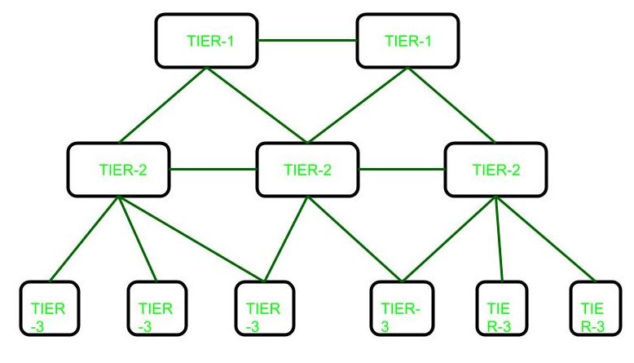
- what is hybrid development (Hybrid development allows you to create your application once and then deploy it across different platforms, including iOS, Android, or Windows.)
- how to implement hybrid development.
Flutter

- Day 2
- Introduction to application.
Why any computer program are called as application?
In the year 1983 software developer . Software developers Richard Brodie and Charles Simonyi released a multi – tool document processing software “Microsoft office”.
Search lots of dictionary found one word – “apply”.
Then from apply word to application.
What are mobile apps?
They are software application that are installed on mobile devices or table with a specific function which can be personal professional, leisure entertainment.

- Importance of mobile app
- Allows to handle information instantly and in real-time.
- It is not necessary to change a laptop, every thing can be counselled from the cell phone.
- It is an excellent communication channel between organization and their user or client.
- They allow the sending of notification using email.
- Improve the SEO position of the organization.
( Search engine optimization: the process of making your site better for search engines. Also the job title of a person who does this for a living: We just hired a new SEO to improve our presence on the web.).

- What is flatter.
Flutter is an open source cross platform mobile application development framework.
Flutter enables developer to create apps for android, ios, web, desktop and other platform from single codebase.

*Flutter uses programming language called as dart.

- History of Flutter.
In October 2014, the team of Google developers heard the call to 'Open The Sky,' and thus The Sky Engine was born. With time, it evolved into what we know today as Flutter - an open source UI development kit that has taken the mobile app development world by storm
- Need of Flutter.
- Single codebase for all platform.
- Reduce development time.
- Native like performance.
- Power full community.
- Own rendering engine.
- Hot reload feature( You can change CSS files while the app is running, and changes are applied immediately to the running app as you type).
- Responsive UI.

- What are types of mobile application.
- Native app.( are created for one specific platform or operating system.)
- Web app.( are responsive versions of websites that can work on any mobile device or OS because they’re delivered using a mobile browser.)
- Hybrid app.( are combinations of both native and web apps, but wrapped within a native app, giving it the ability to have its own icon or be downloaded from an app store.)

- Day 3
Types of programing language.
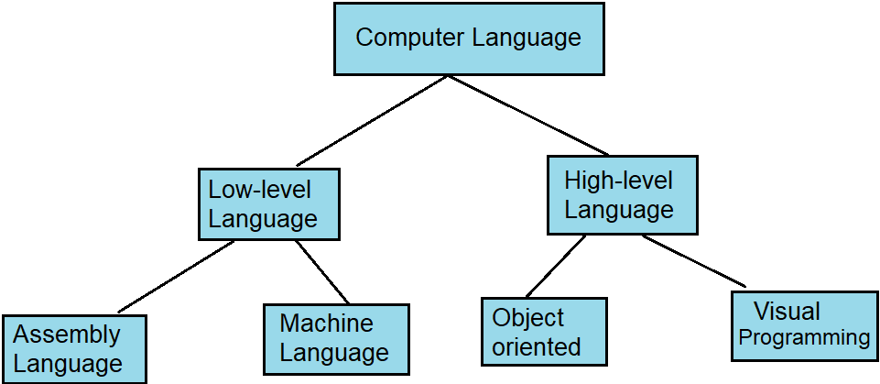

- Low level language are the language which are totally compatible with computer only.
- Where as high level language are completely human understandable and readable code.
- There are total three types of translate in the programing world(assembler, compiler, interpreter).
- Assembler: Converts the machine language into assembly language and vice versa.
- Compiler: compiler is responsible for converting high level language into machine language by scanning entire code at a time.
- Interpreter : like compiler it also converts high level language to machine language but only difference is that it converts only one statement at a time.
- Benefits of dart programming.
- Extensive library
Dart comes with many helpful pre-built libraries, including Math, Convert, HTML, SDK, Core, and others. Dart also enables developers to properly name-space and group Dart code into the necessary libraries. Developers can reuse the libraries by using the import statement.

- Versatile compilation
Dart has the resilience needed to compile code at lightning speed. It supports the JIT (Just in Time) and AOT (Always on Time) compilation techniques. This feature makes it simple for developers to transmit and effectively run the Dart programming language in web browsers.
For apps targeting mobile and desktop devices, Dart includes both a Dart VM with just-in-time (JIT) compilation and an ahead-of-time (AOT) compiler for producing machine code.

Void main(){

}
10010100100100010010100101100001
Mov al,bl
Interpreter
Complier
Assembler
Assembler language
Machine language
pop
oop
High level language
Low level language
Programing language

- Day 4
Just in time(JIT):
In java programing language JIT compiler which is part of JVM converts program source code into native machine code just before program execution. The dart VM has a just in time compiler (JIT) that supports both pure interpretation (as required on ios device, for example) and runtime opitmization.

Ahead of time(AOT):
The AOT compiler works by compiling your code before it is “deliver” to where runtime environment runs the code. The AOT compiler is typically used when the app is read to be deployed.

- Developer all rounder
Dart language act like frontend tool for designing an UI application and backend tool for applying logic.
- no configuration and installing
dart includes a simple user interface called dart pad. This interface does not require installation of configuration before use.
Some dart script work in ios and android native apps without modification.
1.write a basic dart program to display hello world on the out screen.

Void main()
{
Print(‘hello world’);
}

- Format input and output in dart.
1.Starting input in dart:-
In dart programming language the readLineSync() is used to accept input from the user.
The definition of this function is stored in dart:io library, therefore to use its function you need to import dart:io library.
The readLineSync() read a string value compulsory, for integer value we use int.parse() along with readLineSync() as its argument.

2. write a dart program that demonstrate the use of readLineSync() function.
Import dart:io;
Void main()
{
Print(‘welcome’);
Stdout..write(‘Enter your name’);

String name = Stdin.readLineSync();
Print(‘hello $name’);
}

OUTPUT:
Welcome
Enter your name:Aryan
Hello Aryan

- Write a dart program to make the addition of two numbers by accepting tow numbers by the user.

Import dart:io
Void main()
{
Print(‘Enter x’);
Var x=int.parse(Stdin.readLineSync());
Print(‘Enter y’);
Var y=int.parse(Stdin.readLineSync());
Var output = x+y;
Print(‘addition of two numers is $output’);
}

- Day 5
Install android
Install flutter

Null safety
- When you specify a type for a variable, parameter, or another relevant component, you can control whether the type allows null. To enable nullability, you add a ? to the end of the type declaration.
- String? name // Nullable type. Can be `null` or string.

String name // Non-nullable type. Cannot be `null` but can be string.

- Day 6
1.write a program to find addition of two numbers.
import 'dart:io';
void main()
{
print("enter x");
var x=int.parse(stdin.readLineSync()!);
print("enter y");
var y=int.parse(stdin.readLineSync()!);
var output = x+y;
print("additon of two numbers is $output");
//this is new
}

2.write a program to find string input.
import 'dart:io';
void main()
{
print("Enter your name?");
String? name = stdin.readLineSync();
print("Hello, $name! \n Welcome to the party!!");
}
output:
Enter your name?
aryan
Hello, aryan!
Welcome to to the party!!
3.piramid in output.
import 'dart:io';
void main()
{
print("Enter number");
var x= int.parse(stdin.readLineSync()!);
for(int i=0;i<=x;i++) {
for(int y=1;y<=i;y++){
stdout.write("a");
}
print('\n');
}
}

First Week Complete.

