The file is over 3 GB

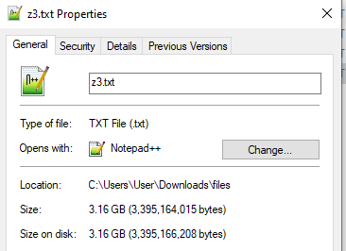

The file contains 125522925 lines.

A line contains the following: <increasing number> <random data>

10,000 entries are fetched in less than 2 seconds.

Note the descending numbers in the response.

Image 1 is the last few lines

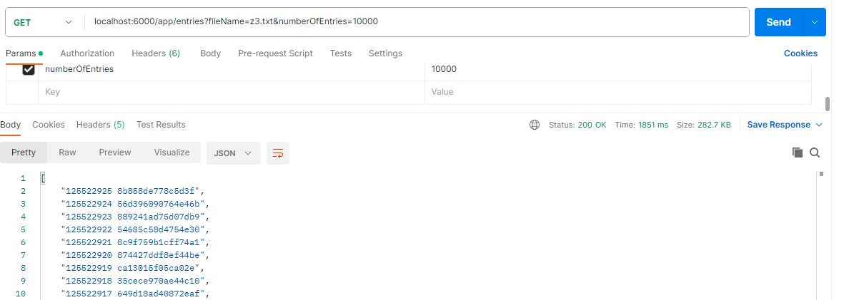

Image 2 is the first few lines

