1. Right click on FileProcessingApplication
2. Run As
3. Java Application

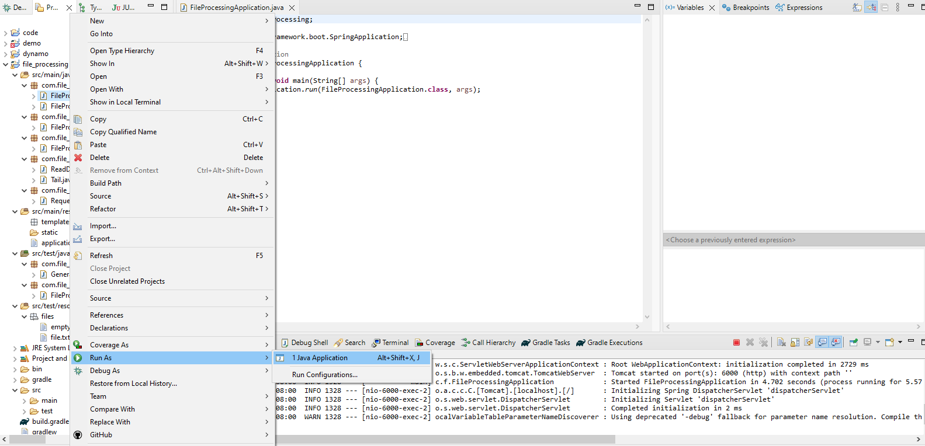

Once the application is running, this should appear

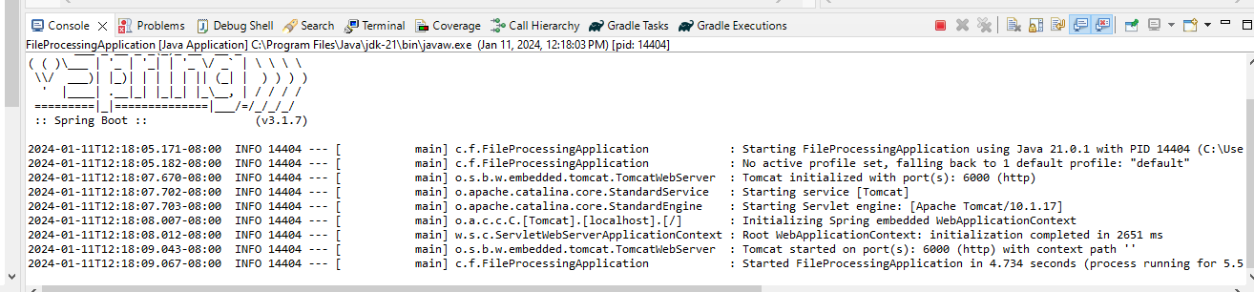

Application uses port 6000. It is defined in application.properties

