SS-1 (Git Configuration)
git --version
git config --global user.name "Your Name"
git config --global user.email "youremail@gmail.com"
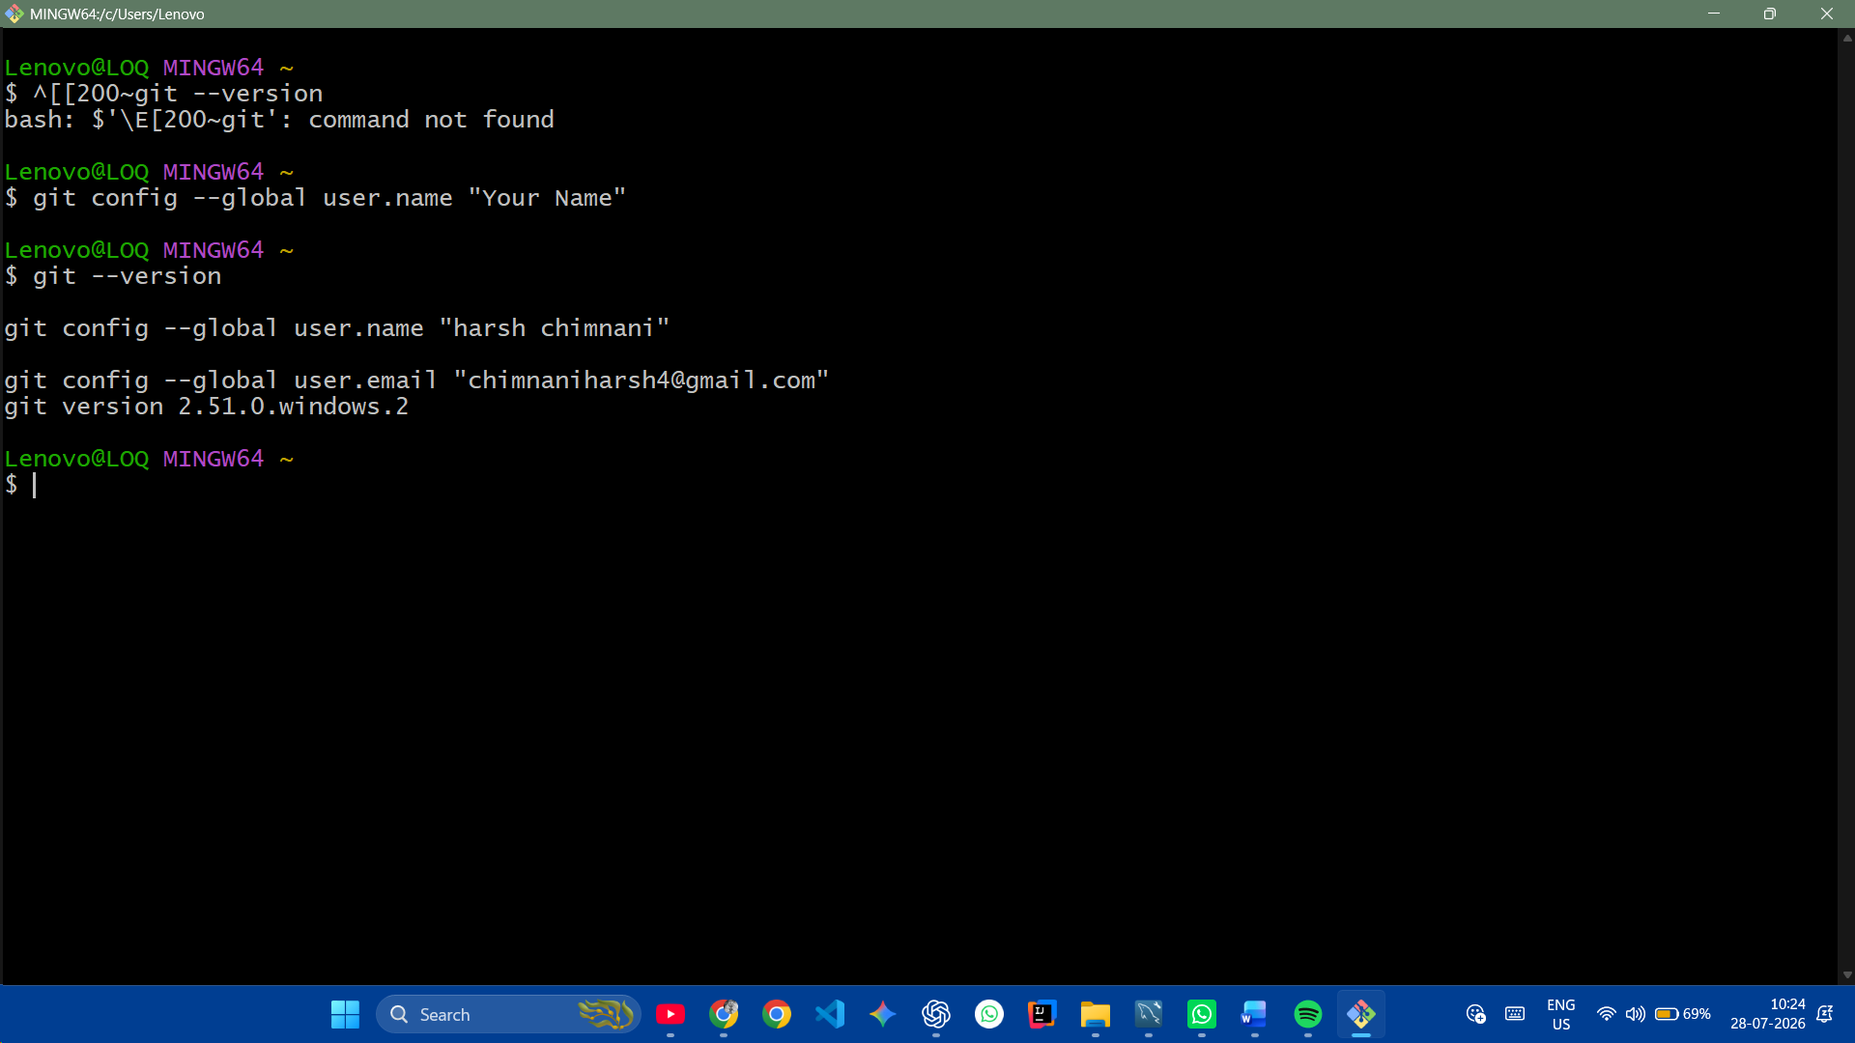

SS-2 (Verify Configuration)
git config --list
git config --global -e
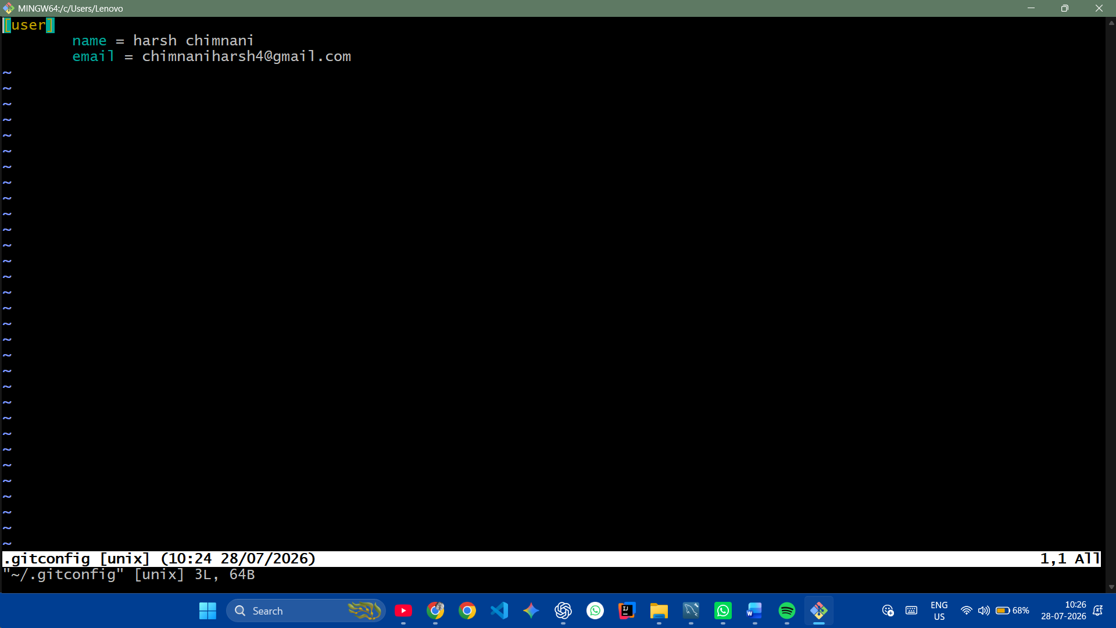
SS-3 (Repository Create)
mkdir GitDemo
cd GitDemo
git init
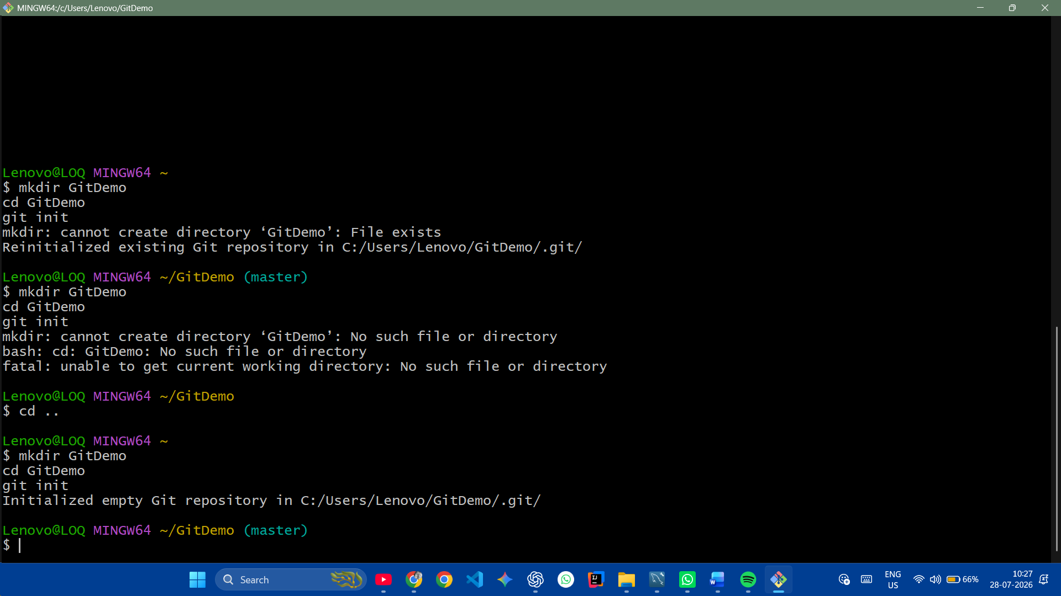
SS-4 (Create File)
echo "Welcome to Git" > welcome.txt
ls
cat welcome.txt
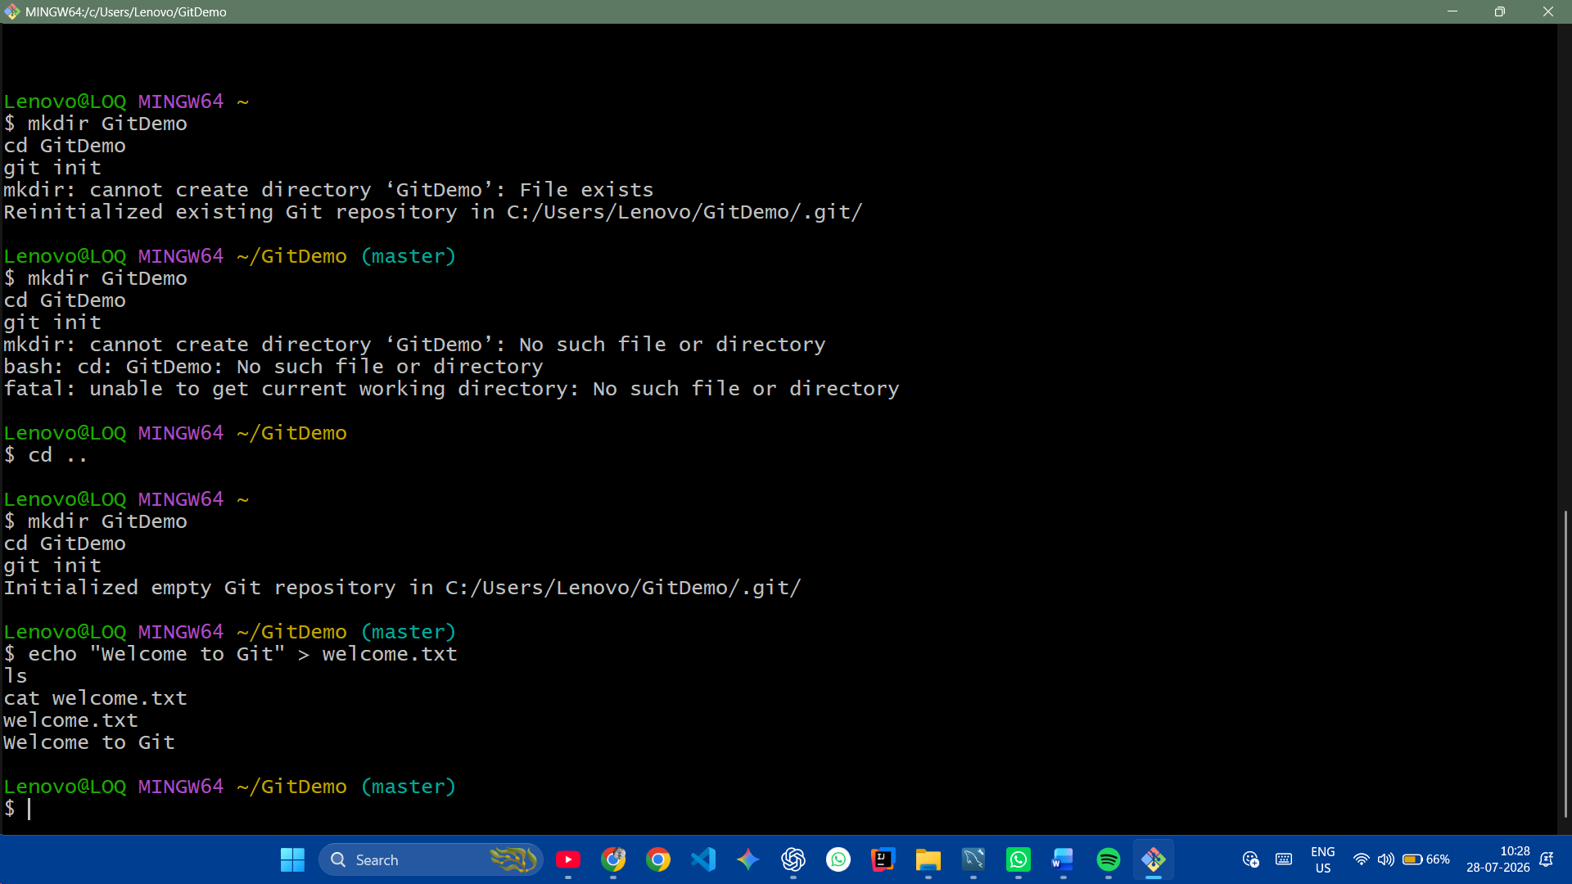
SS-5 (Git Status & Add)
git status
git add welcome.txt
git status
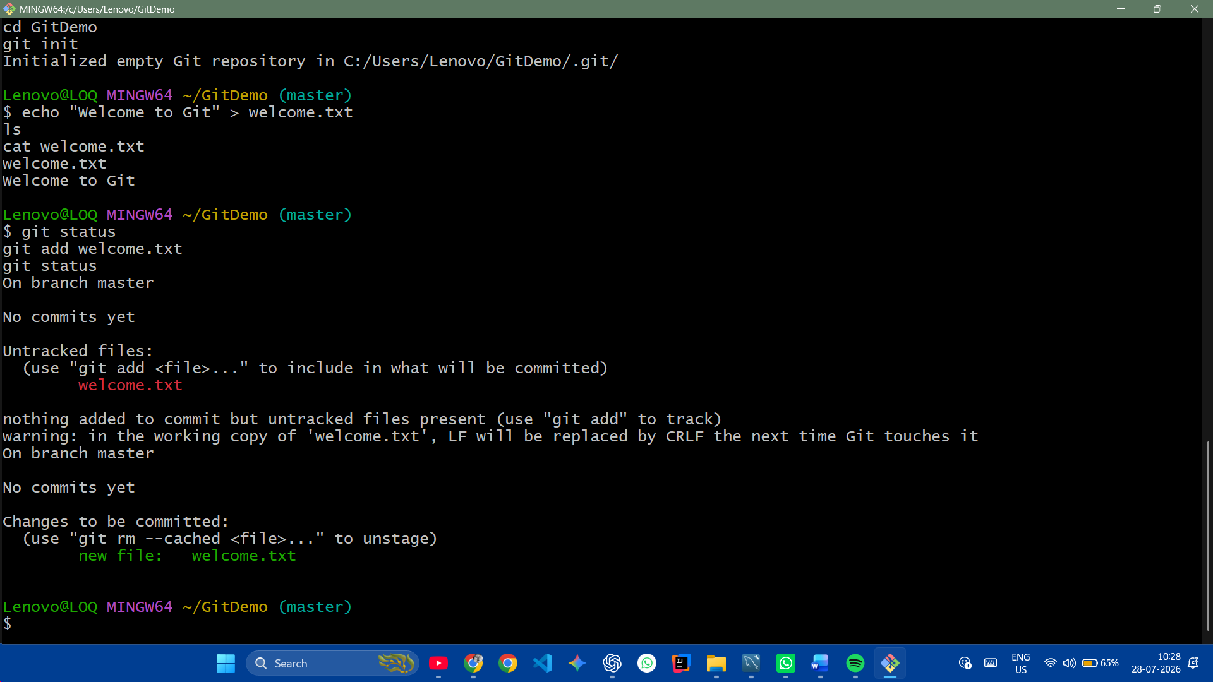
SS-6 (Commit)
git commit -m "Initial Commit"
git status
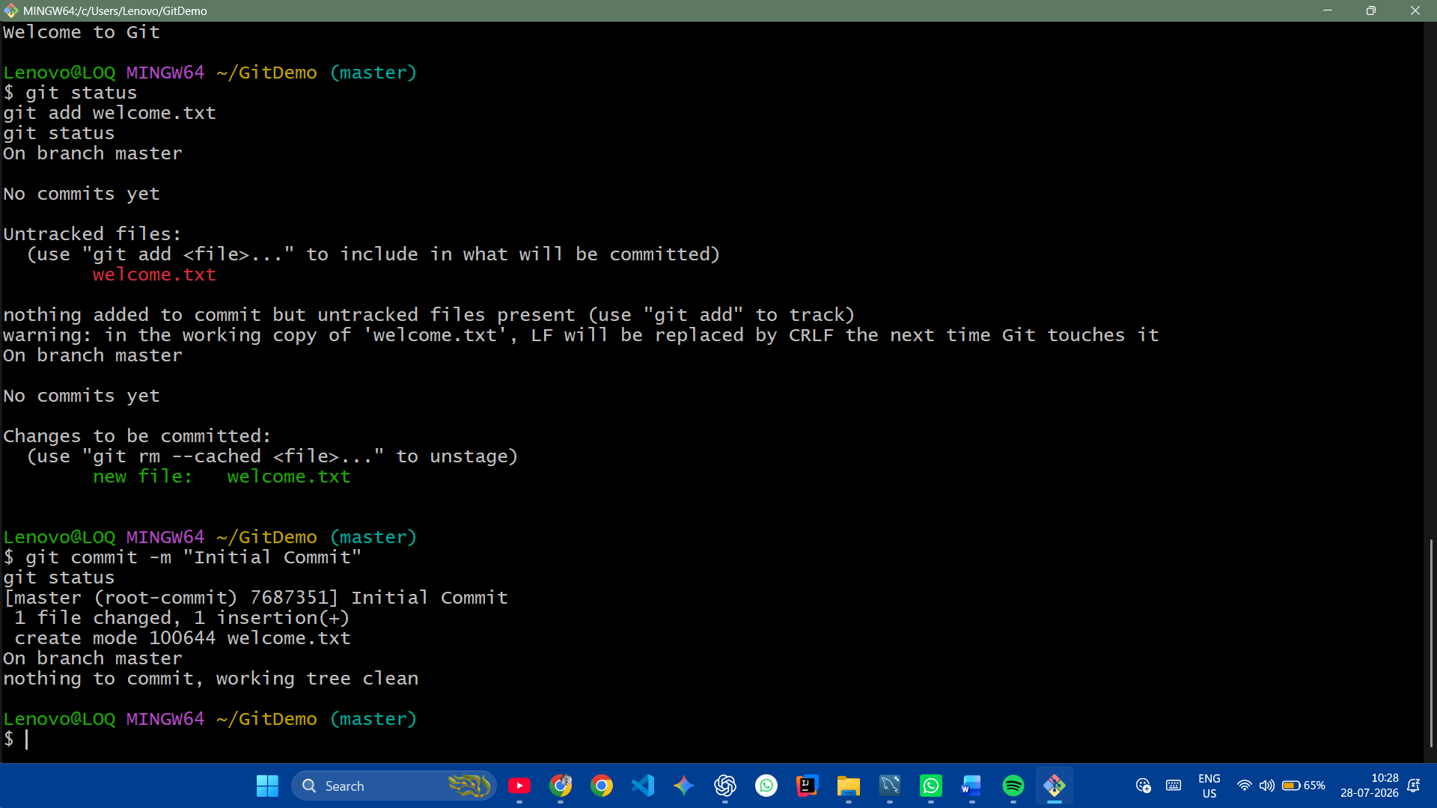
SS-7 (Remote)
git pull origin master
git push origin master
