==========================
GIT HOL-2
==========================

Screenshot 1

touch test.log
mkdir log
echo "Error Log" > test.log
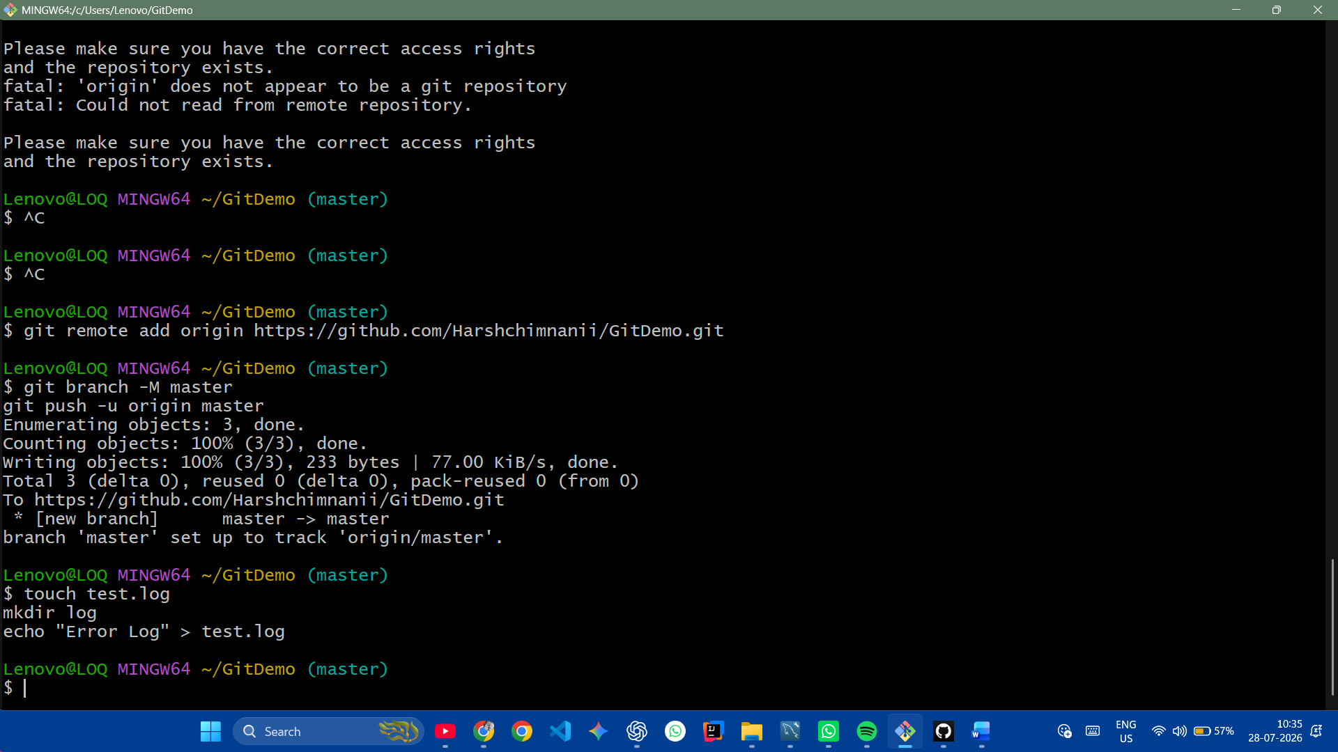

-----------------------------------------

Screenshot 2

echo "*.log" > .gitignore
echo "log/" >> .gitignore
cat .gitignore
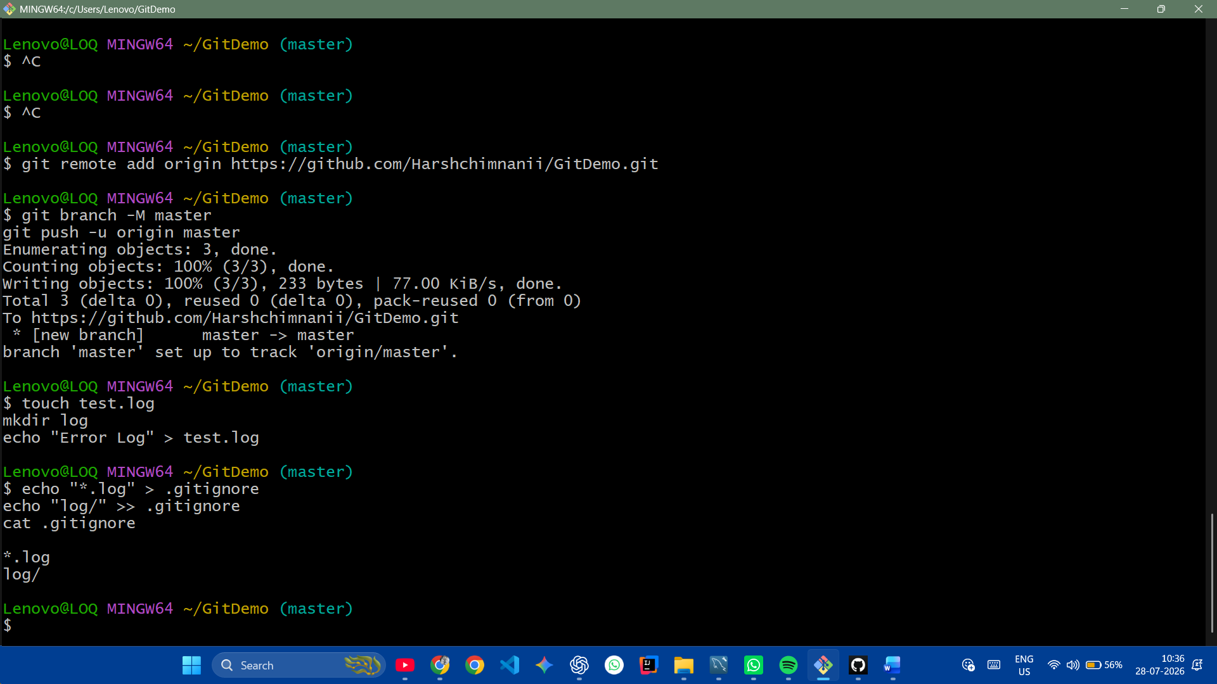

-----------------------------------------

Screenshot 3

git status
git add .gitignore
git status
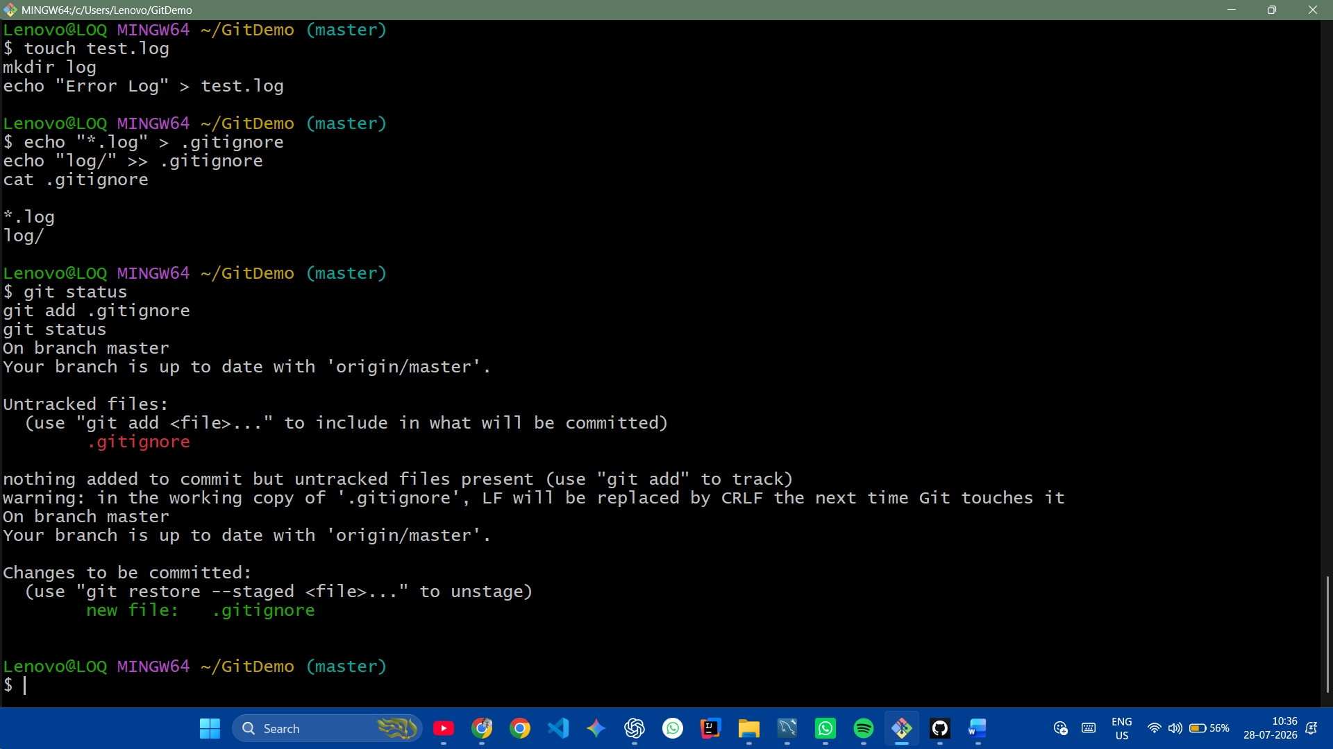
-----------------------------------------

Screenshot 4

git commit -m "Added .gitignore"
git status
