==========================
GIT HOL-3
==========================

Screenshot 1

git branch GitNewBranch
git branch -a

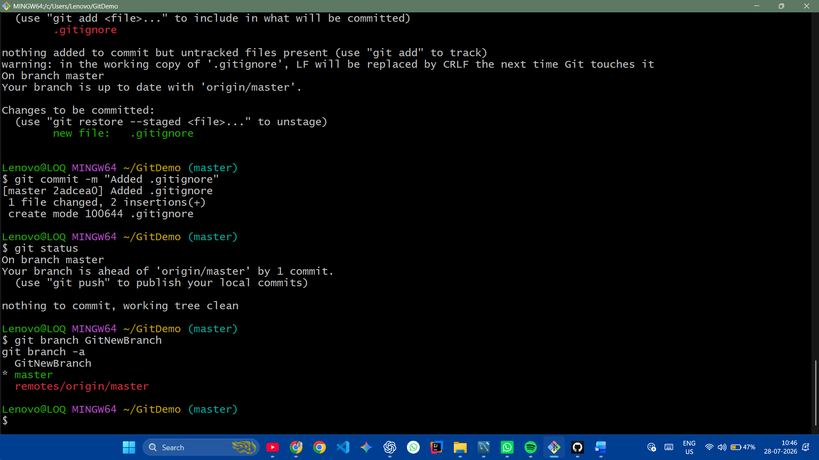

-----------------------------------------

Screenshot 2

git checkout GitNewBranch
echo "Branch File" > branch.txt
git add branch.txt
git commit -m "Added file in branch"
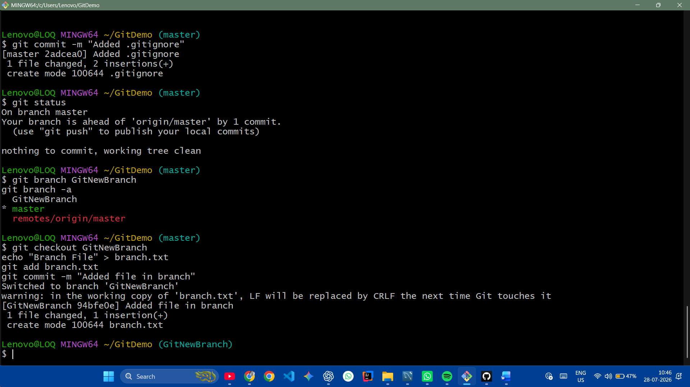

-----------------------------------------

Screenshot 3

git status
git checkout master
git diff master GitNewBranch

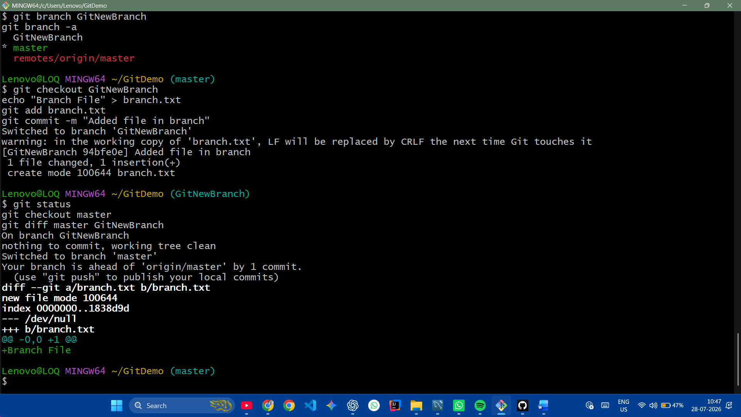

-----------------------------------------

Screenshot 4

git mergetool
git merge GitNewBranch
git log --oneline --graph --decorate

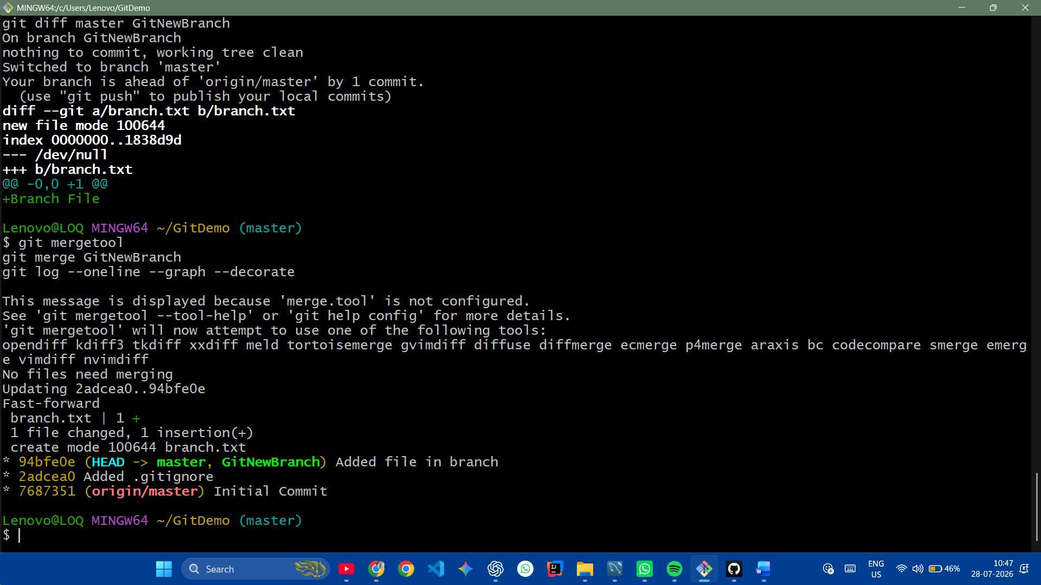
-----------------------------------------

Screenshot 5

git branch -d GitNewBranch
git status
