==========================
GIT HOL-4
==========================

Screenshot 1
git status
git checkout -b GitWork
echo "<hello>Branch</hello>" > hello.xml
git add hello.xml
git commit -m "Added hello.xml in GitWork"
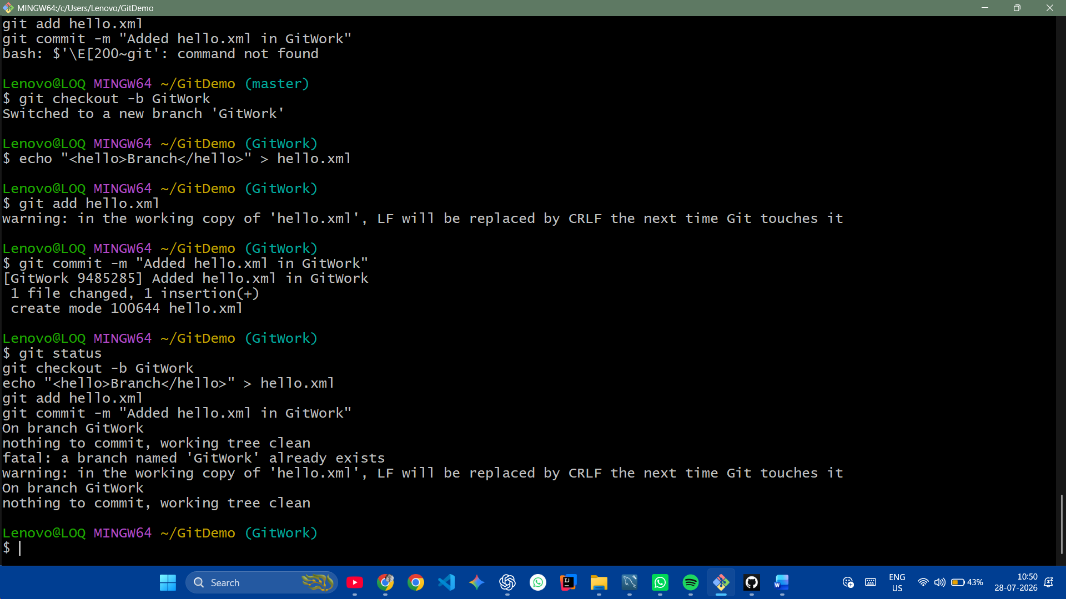

-----------------------------------------

Screenshot 2

git checkout master
echo "<hello>Master</hello>" > hello.xml
git add hello.xml
git commit -m "Added hello.xml in master"
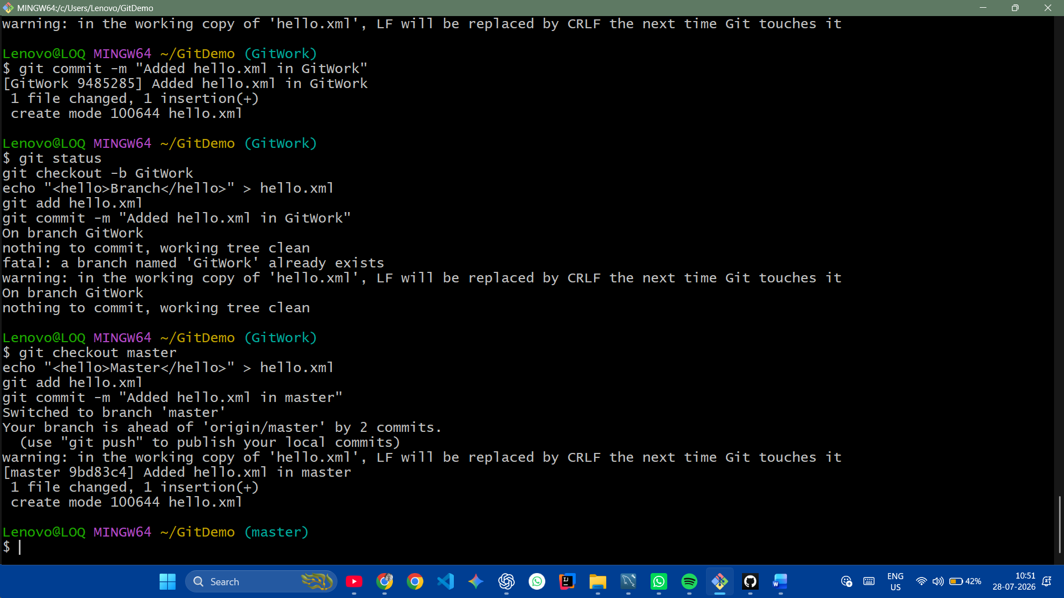

-----------------------------------------

Screenshot 3

git log --oneline --graph --decorate --all
git diff master GitWork
git mergetool
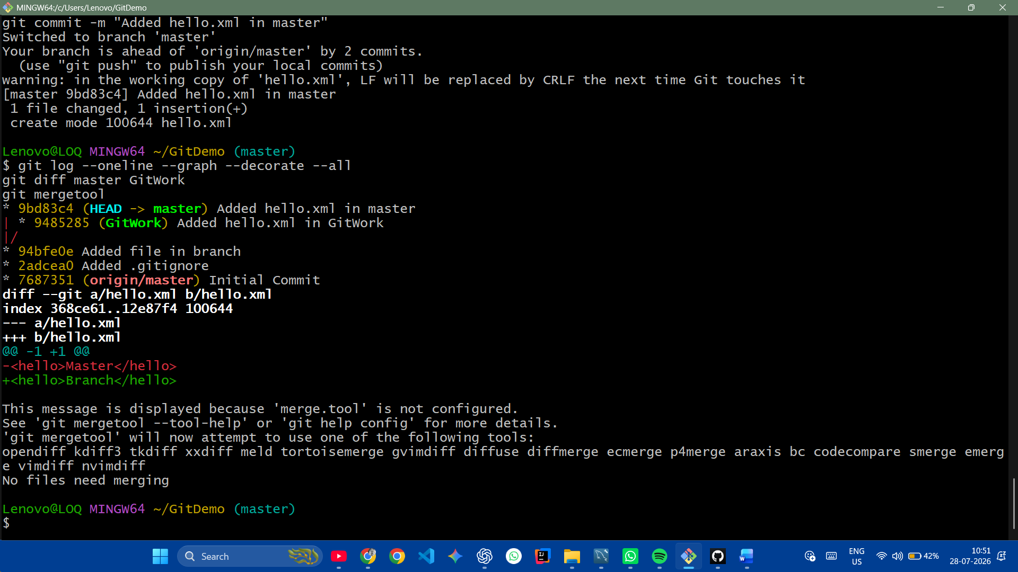

-----------------------------------------

Screenshot 4

git merge GitWork
git status

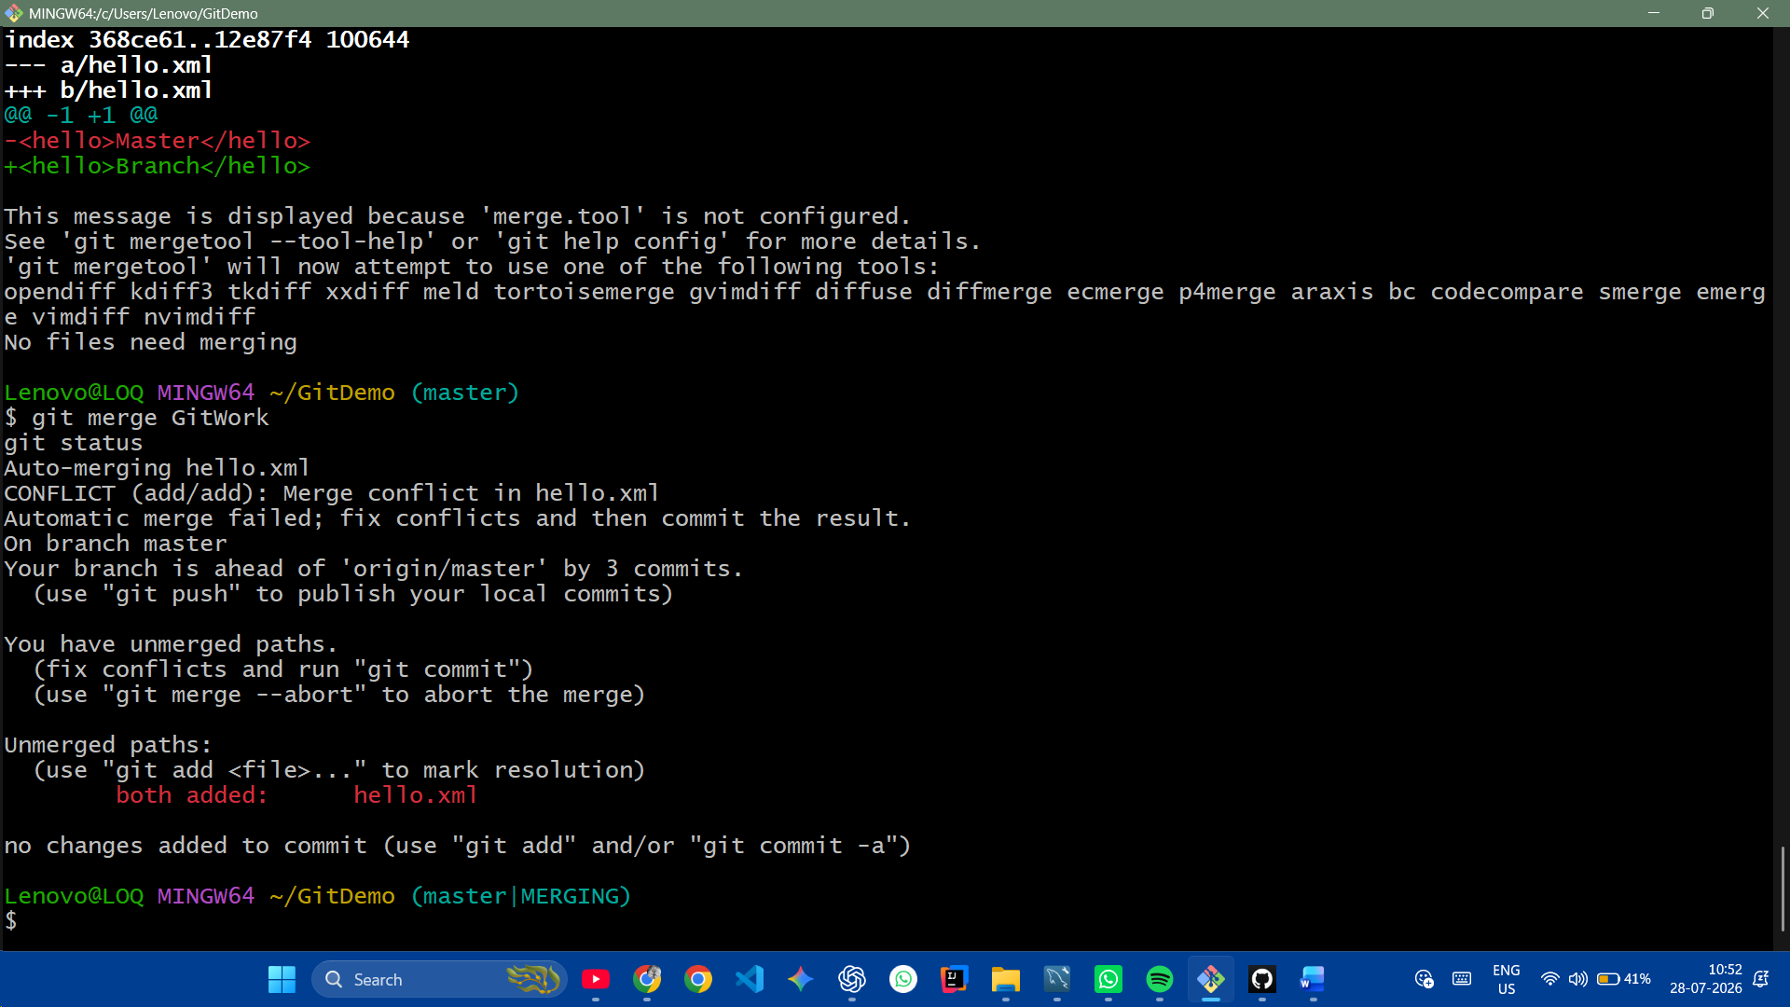

-----------------------------------------

Screenshot 5

echo "*.bak" >> .gitignore
git add .gitignore
git commit -m "Updated .gitignore"
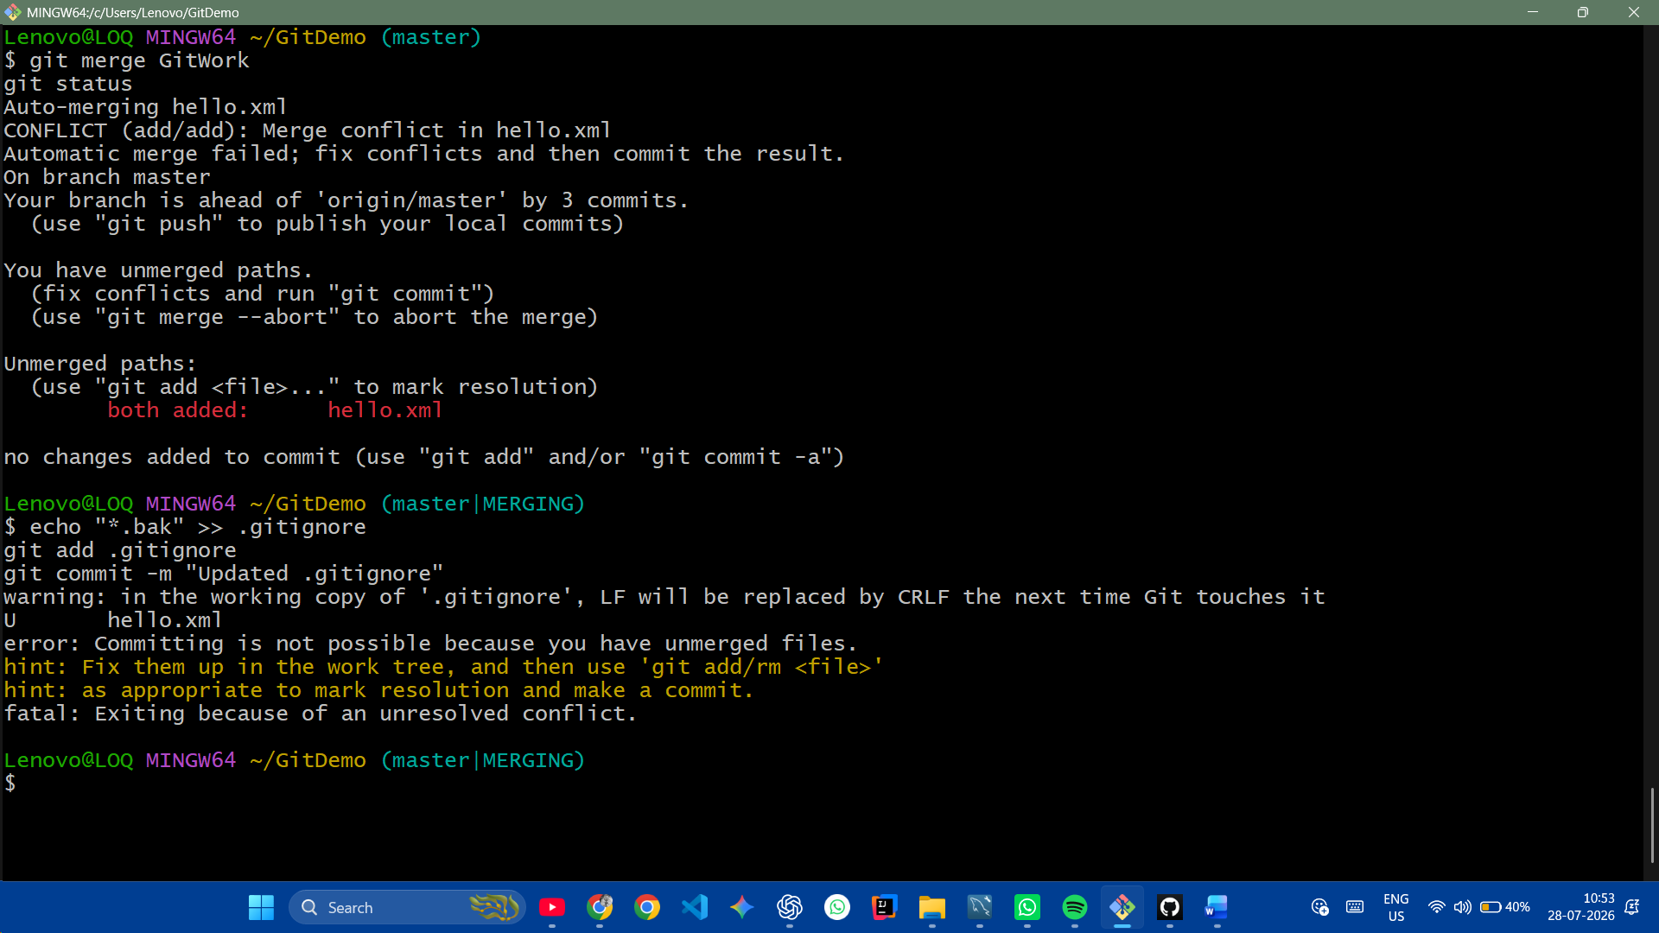

-----------------------------------------

Screenshot 6

git branch
git branch -d GitWork
git log --oneline --graph –decorate
