==========================
GIT HOL-5
==========================

Screenshot 1

git status
git branch
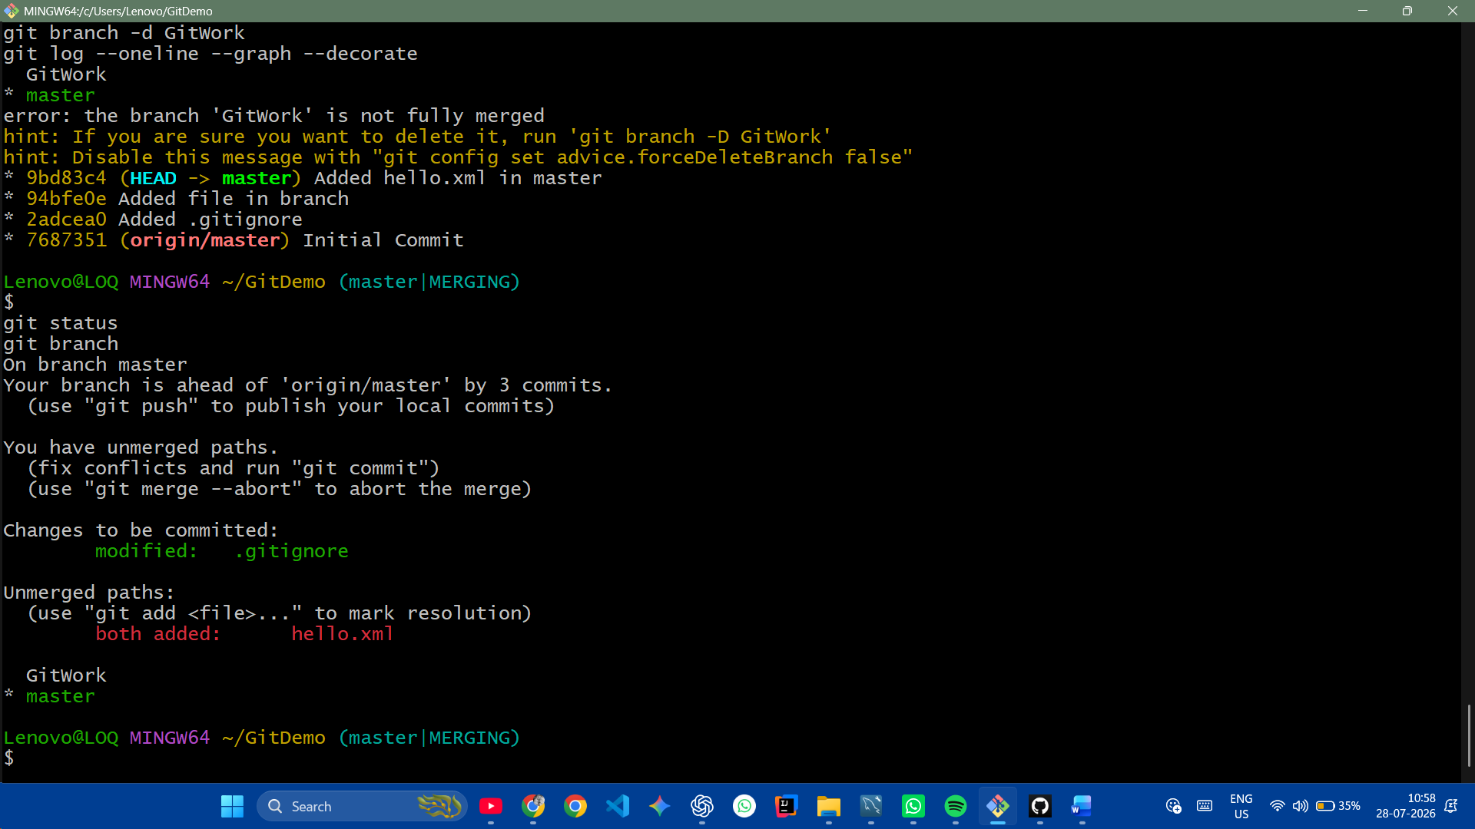

-----------------------------------------

Screenshot 2

git pull origin master
git status

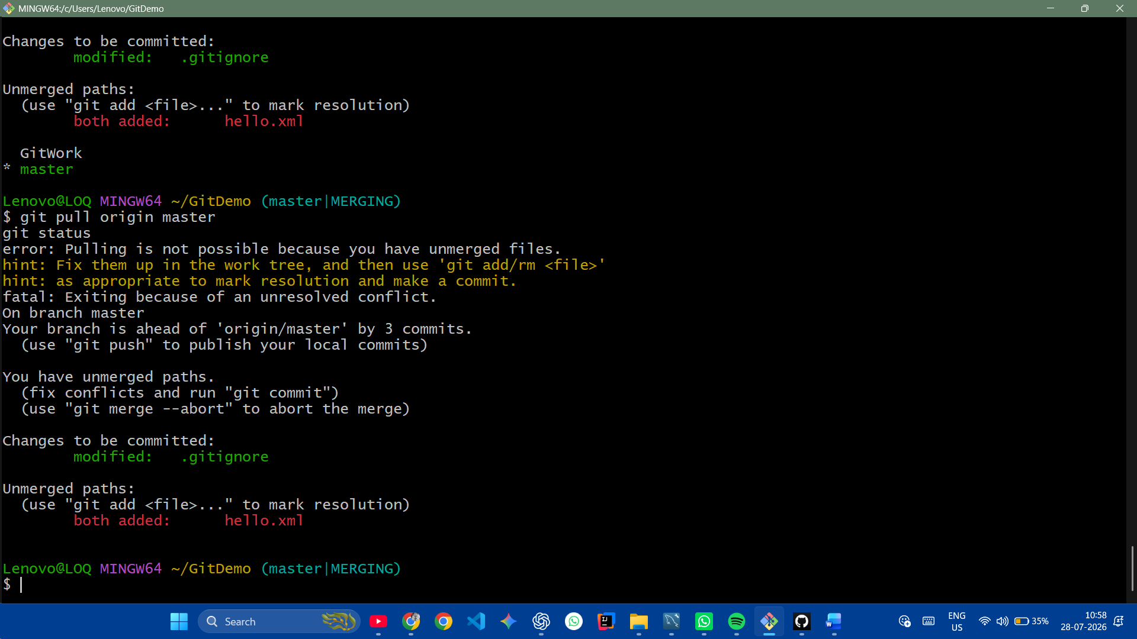

-----------------------------------------

Screenshot 3

git push origin master
git status

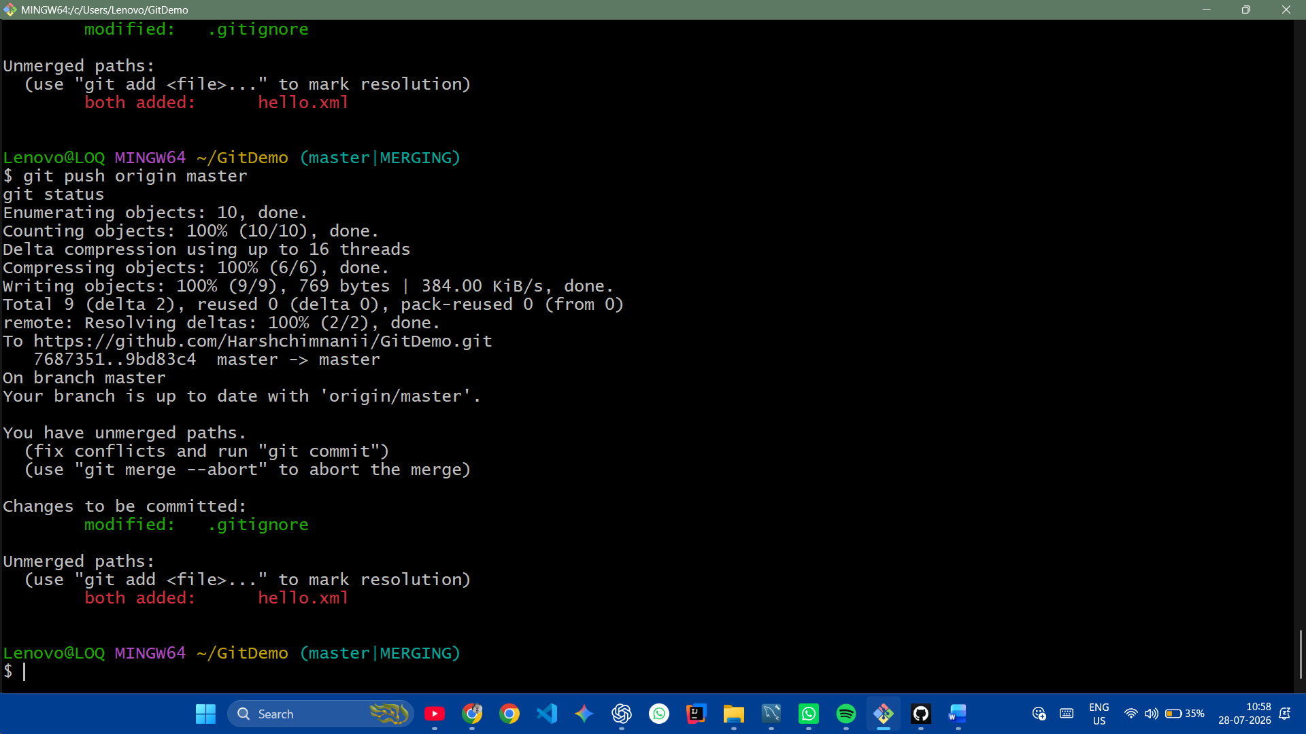

-----------------------------------------

Screenshot 4

git log --oneline --graph –decorate
