EASY REPORT ERP
Enterprise Wholesale & Retail Inventory, Billing & Khata Management Web Application
★ COMPLETE ILLUSTRATED USER MANUAL & HOW-TO-USE TRAINING GUIDE ★
🏢 Organization / Parent Company: Made Under ATSFY Technologies
📦 Software Edition: Easy Report ERP v2.0 (Fiscal Year 2026-27 Edition)
🌐 Architecture & Sync: Google Cloud Firebase Firestore (Real-Time Cloud) + Offline LocalStorage Fallback
🎯 Target Users: Store Owners, Cashiers, Warehouse Managers, Accountants & Inventory Auditors

1. Introduction & System Overview
Easy Report ERP is an enterprise-grade web application built under ATSFY Technologies to eliminate manual paperwork, prevent stock overselling, safeguard profit margins against excessive discounting, and provide instant real-time Khata (ledger) reconciliation for wholesale distributors and retail merchants.
Universal System Principles:
- Strict Stock Validation: You can only sell products that have been inwarded into the warehouse. Items with 0 stock cannot be added to bills, and entered quantities cannot exceed available inventory.
- Dynamic Stock Equation: Live Warehouse Stock is mathematically calculated in real-time as: Live Stock = Total Purchased Qty − Total Sold Qty.
- Loss Protection Warning: If a cashier applies a discount that makes the effective selling price lower than the landing purchase rate, the system shows an immediate amber warning explaining the exact unit loss, while allowing authorized staff to proceed.

2. Stock Inward (Purchase Module) — Step-by-Step Guide
The Stock Inward module is located at the '/purchase' URL and accessed via the sidebar menu under 'Stock Inward (Purchase)'. This is where all incoming stock shipments from distributors, suppliers, and manufacturers are logged.
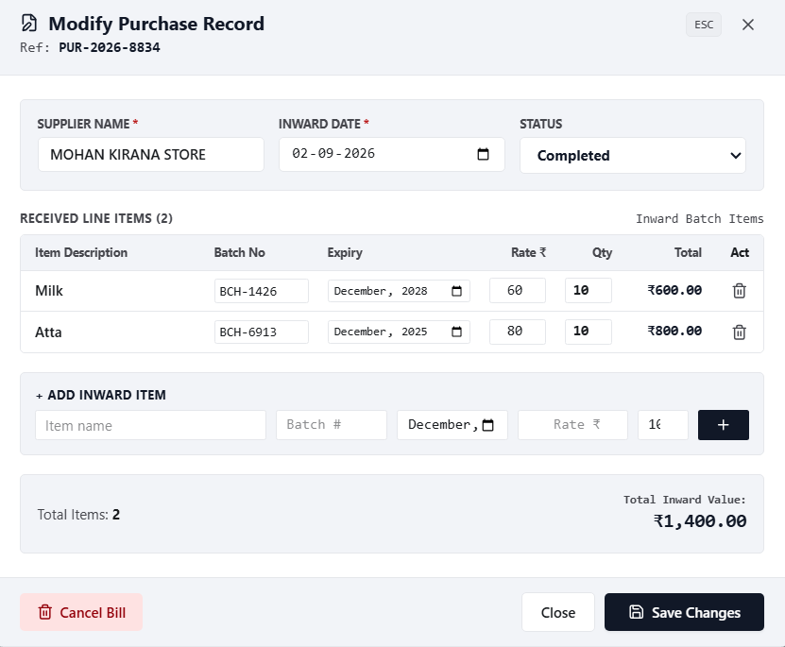
Figure 1: Stock Inward Record & Supplier Item Inward Table (Mohan Kirana Store Bill Example)

How to Use Which One — Inward Controls & Inputs:
Control / Input Name | Location & Type | What It Does & How To Use It
Supplier Name / Vendor | Top Header (Left Input) | Type to search existing suppliers. If vendor is new, click '+ Add Supplier' directly above it. Cannot log purchase without entering supplier name.
+ Add Supplier Button | Above Supplier input | Opens a 5-field pop-up modal: (1) Supplier Name, (2) Address, (3) Phone Number, (4) Shop License, (5) GST No. Click 'Save Supplier' to auto-select and register vendor.
Supplier Invoice # | Top Header (Middle Input) | Enter the physical bill/invoice number from the supplier (e.g. PUR-2026-8834 or INV-9912) for tracking and Khata reference.
Inward Date | Top Header (Right Input) | Date picker for the receipt date of the goods. Defaults to today's date.
Item Name / Description | Entry Row (Left Column) | Type product name. Dropdown displays all catalog products with company, packing, MRP, and purchase rate. Typing an existing item auto-fills Rate & MRP.
+ Add Item Button | Above Item Name input | Opens 5-field pop-up modal: (1) Item Name, (2) Packing (e.g. 10x10, 1kg), (3) Company (e.g. Sun Pharma, Tata), (4) Purchase Rate ₹, (5) MRP ₹. Adds to catalog and auto-fills row.
Batch Code & Expiry | Entry Row (Columns 2 & 3) | Enter batch number (e.g. BCH-6913) and expiry month (e.g. 2028-12). Typing an existing batch automatically pulls its product details!
Rate (₹) & MRP (₹) | Entry Row (Columns 4 & 5) | Rate is what you paid the supplier per unit. MRP is the package printed selling price. Both are stored for profit and billing calculations.
Qty Input & [+] Button | Entry Row (Right Side) | Enter shipment quantity and click '+' to stage the item into the Staged Inventory list below.
Log Purchase & Synchronize Stock | Bottom Action Bar | Finalizes inward: increases live warehouse stock, adds credit transaction to Supplier Khata ledger, and opens Printable Inward Voucher.

3. Active Billing (Sale Module & POS) — Step-by-Step Guide
The Active Billing module (/sale) is the high-speed point-of-sale checkout system. It is designed for daily retail counters and wholesale invoicing with real-time stock and margin protections.
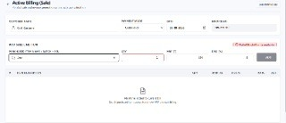
Figure 2: Active Billing POS Interface showing Live Stock Indicators & Strict Stock Validation
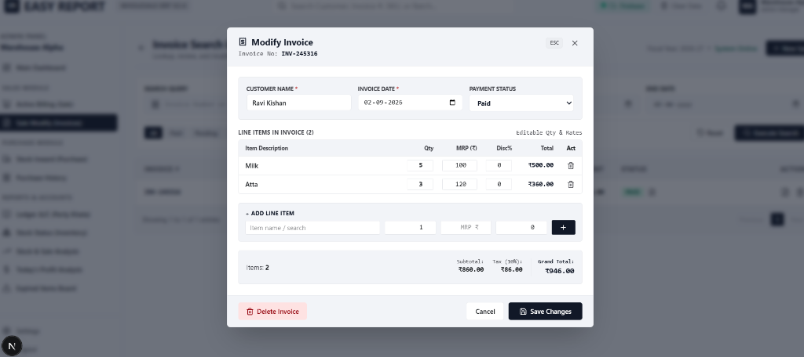
Figure 3: Invoice Modification & Line Items Breakdown Screen (Ravi Kishan Sale Bill Example)

How to Use Which One — Billing Controls & POS Actions:
POS Control / Button | Screen Position | How to Use & Business Rule
Customer Name Input | Top Header (Left) | Type any customer name (e.g. 'Ravi Kishan', 'Acme Enterprises'). Defaults to 'Cash Customer'. Invoices are saved under the exact typed name.
Payment Mode Dropdown | Top Header (Middle) | Select 'Cash (Paid)' for immediate settlement. Select 'Credit (Khata)' to post the bill to the customer's ledger as an outstanding balance.
Purchased Item Search | Item Entry Row (Left) | Search product name or scan barcode. Auto-retrieves MRP directly from inward purchases. Unpurchased items cannot be billed.
Live Stock Indicator Badge | Above Qty / Entry Row | 🟢 'Warehouse Stock: X Pcs' indicates available units. 🔴 'Out of Stock (0 units)' indicates item cannot be added.
Qty Input (Strict Stock) | Item Entry Row (Qty) | Enter sale quantity. If entered quantity exceeds available stock (e.g. stock is 7 and you type 8), ADD is blocked with Insufficient Stock warning.
Disc (%) & Loss Warning | Item Entry Row (Disc) | Enter discount %. If effective rate drops below purchase rate, an amber 'Selling at a Loss' banner appears. You can still click ADD to proceed.
ADD Button | Item Entry Row (Right) | Adds line item to the bill table below. Disabled when stock is 0.
HOLD / Restore Button | Bottom Action Bar | Puts active bill on hold if customer steps away. Click 'Restore' in the top header to recall held items instantly.
CLEAR Button | Bottom Action Bar | Clears all line items from the active bill to start fresh.
SAVE & PRINT Button | Bottom Action Bar (Primary) | Validates all line items against live warehouse stock, deducts inventory, records the sale, and opens the Printable Receipt Modal (ESC to close, Ctrl+P to print).

4. Live Inventory & Universal Stock Formula
The Stock Status grid (/inventory) ensures zero discrepancy between physical shelves and computer records using automatic reconciliation:
Live Available Stock = Total Purchased Qty − Total Sold Qty
Stock Badge | Stock Range | Operator Action Required
🟢 OPTIMAL | 10 or more units | Healthy inventory. Normal sales billing permitted.
🟠 LOW STOCK | 1 to 9 units | Reorder recommended. Use Product Performance to generate supplier Purchase Order (PO).
🔴 CRITICAL | 0 units in warehouse | Out of stock. Sale billing blocked until new purchase shipment is inwarded.
🟣 EXPIRED | Expiry date < System date | Unsafe for sale. Go to Expiry Board to generate Supplier Return Voucher.

5. Additional Management Modules
• Party Accounts / Khata (/ledger): Select customer or vendor. View complete debit/credit transaction statement, balance breakdown, and click 'Record Payment' to log cash/bank settlements.
• Today's Profit Analysis (/profit): View today's revenue, cost of goods sold (COGS), gross profit ₹, and net margin % dynamically reconciled from sales and purchases.
• Product Performance Matrix (/performance): Analyzes sales velocity (Fast Moving, Steady, Slow Moving, Dead Stock Risk) and features a 1-click Smart Purchase Order (PO) creator.
• Expiry Alert Board (/expiry): Monitors near-expiry batches (60 Days / 90 Days) and generates Supplier Purchase Return Credit Vouchers.

6. ATSFY Technologies Support & Maintenance
Easy Report ERP is an intellectual property engineered and maintained under ATSFY Technologies. For technical support, custom hardware integrations (thermal printers, barcode scanners, weighing scales), or database backup services, contact ATSFY Technologies customer engineering.
Company: ATSFY Technologies
Product: Easy Report ERP v2.0 (Fiscal Year 2026-27 Edition)
Documentation: Illustrated User Manual & SOP (Version 2.2)
— End of Manual • Engineered Under ATSFY Technologies —

